**AZ-104.exam-labs.premium.exam.240q**

Number: AZ-104 Passing Score: 800 Time Limit: 120 min File Version: 8.0



# AZ-104

Microsoft Azure Administrator Version 8.0

This file was created using VCE Simulator from Avanset.com

Manage Azure identities and governance Question Set 1

# QUESTION 1

Note: This question is part of a series of questions that present the same scenario. Each question in the series contains a unique solution that might meet the stated goals. Some question sets might have more than one correct solution, while others might not have a correct solution.

After you answer a question in this section, you will NOT be able to return to it. As a result, these questions will not appear in the review screen.

You have an Azure subscription that contains the following users in an Azure Active Directory tenant named contoso.onmicrosoft.com:

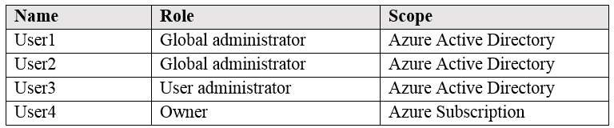

User1 creates a new Azure Active Directory tenant named external.contoso.onmicrosoft.com. You need to create new user accounts in external.contoso.onmicrosoft.com.

Solution: You instruct User2 to create the user accounts. Does that meet the goal?

1. Yes
2. No

Correct Answer: A Section: (none) Explanation

Explanation/Reference:

Explanation:

Only a global administrator can add users to this tenant.

Reference:

https://docs.microsoft.com/en-us/azure/devops/organizations/accounts/add-users-to-azure-ad

# QUESTION 2

Note: This question is part of a series of questions that present the same scenario. Each question in the series contains a unique solution that might meet the stated goals. Some question sets might have more than one correct solution, while others might not have a correct solution.

After you answer a question in this section, you will NOT be able to return to it. As a result, these questions will not appear in the review screen.

You have an Azure subscription that contains the following users in an Azure Active Directory tenant named contoso.onmicrosoft.com:



Only two pages were converted.

Please **Sign Up** to convert the full document.

[**www.freepdfconvert.com/membership**](https://www.freepdfconvert.com/membership)