STUDENT

Education
School,Bhiwandi.
Year of Passing : 2021 Percentage : 91.00%
12th Grade, B.N.N. college of
Arts,Science And commerce, Bhiwandi.
Year of Passing : 2023
Percentage : 68.67%
Currently pursuing Engineering in Computer Science and Data Science.
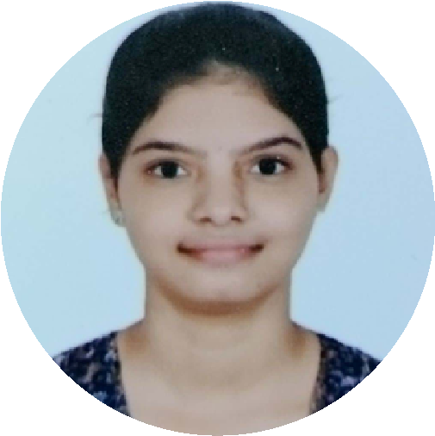
Vidyavardhini’s College of Engineering and Technology,Mumbai.
S
HOBBIES
CONTACT
8208841402
bijjaakhila123@gmail.com
1345
,Bhandari Compound,
narpoli,Bhiwandi-421305.
Listening and singing
songs
Playing

Badminton
10
th Grade
, The Scholar’s English High
Program languages
: C, Java,HTML.
Team Work.
Time Management.
Effective Communication.
Leadership
SKILLS

Proffesional Summary
"Motivated and detail-oriented Computer Science and Data Science engineering student with hands-on experience in software development, data analysis, and problem-solving. Skilled in programming languages like Java and C, and proficient in tools and techniques for data manipulation and visualization. Known for strong analytical abilities and collaborative skills, demonstrated through various projects and leadership roles in college organizations. Currently expanding expertise in building efficient, user-focused solutions for real-world challenges.”

