System Design Document
for
Computerization of Faculty Advisor System
Prepared By
Amburi Gunasekhar B150496CS a.gunasekhar007@gmail.com
Karupally Bharath B150429CS karupallybharath@gmail.com
Sai Krishna Ponnam B150729CS saikrishna_b150729cs@nitc.ac.in
Dowrla Ashok B151042CS ashokdowarla6593@gmail.com

Instructor: Dr. Abdul Nazeer K A
Course: DBMS
Date: 19 October 2017


NATIONAL INSTITUTE OF TECHNOLOGY CALICUT

Contents
Revisions iii
1 Introduction 1
1.1 Document Purpose 1
1.2 Product Scope 1
1.3 Overview ………………………………………………………………………………………………...1
1.4 Reference material 1
1.5 Definitions, Acronyms and Abbreviations 1
2 System overview 3
3 System Architecture 5
3.1 Architectural design 5
3.2 decomposition description 6
3.3 Design Rationale 7
4 Data Design 9
4.1 Data Description 9
4.3 ER Diagram
4.2 data dictoinary 9
5 Component Design 9
6 Human interface design 9
6.1 overview of user interface Error: Reference source not found
6.2 screen images 4
6.3 Screen objects and actions 7

Revisions
Version | Description of Version | Date Completed
1.0 | This is the first major version of SDD for CFA System. It contains product information and data definition, data the system stores, ER diagram and architecture design | 20/10/2017

Introduction

Purpose
This document provides a comprehensive architectural overview of the system, using a number of different architectural views to depict different aspects of the CFA system.

And it expands the functionality described by the features in the Software Requirements Specifications (SRS) v1.0. Each feature discussed will describe the existing functionality of Computerisation of Faculty Advisor System(CFA), and describe the additional classes, attributes and methods to be implemented.

Product Scope
This document takes the features as outlined in the SRS and expands each of the features to include the design issues of user interface, data flow, process analysis and then module design.

The CFA system enables the users to store and view information. It serves as an interface between the two parties, namely FA’s and students, administered by an admin in the back-end.

1.3 Definitions, Acronyms and Abbreviations
ERD: Entity Relationship Diagram

DFD: Data Flow Diagram

CFA: Computerisation of Faculty Advisor System

FA: Faculty Advisor

HOD: Head of the Department

SRS: System Requirement Specification

1.4 References and Acknowledgments

- IEEE SDD Format
- MySQL from Tutorial point
- MySQL Workbench reference manual
- HTML, CSS from W3schools
- http://php.net/manual/en/
- Fundamentals of Database Systems by Elmasri & Navathe.

1.5 Overview

In the following sections we outline the system in higher detail. Starting by defining the key features that will be implemented. We will the discuss the robustness, fault tolerance and usability of the CFA system among the users. We will provide the user case view of the CFA system which describes the functionalities of the system in a diagrammatic view. We will then expand the functions and discuss them in detail. The back-end work of the system will be discussed.

System Overview
The CFA system is designed to act as a platform between two groups of users, namely FA’s and Students, of a certain educational institution. And the system is administered by an admin.

To discuss further, the functionalities of FA include accessing student’s information, updating bonafide details of students, manage appointments and messages.

The functionalities of students include updating educational information at the start of every semester, request appointments and send messages.

The admin acts as the Superusers with the total access to the system.

System Architecture

Architectural Design

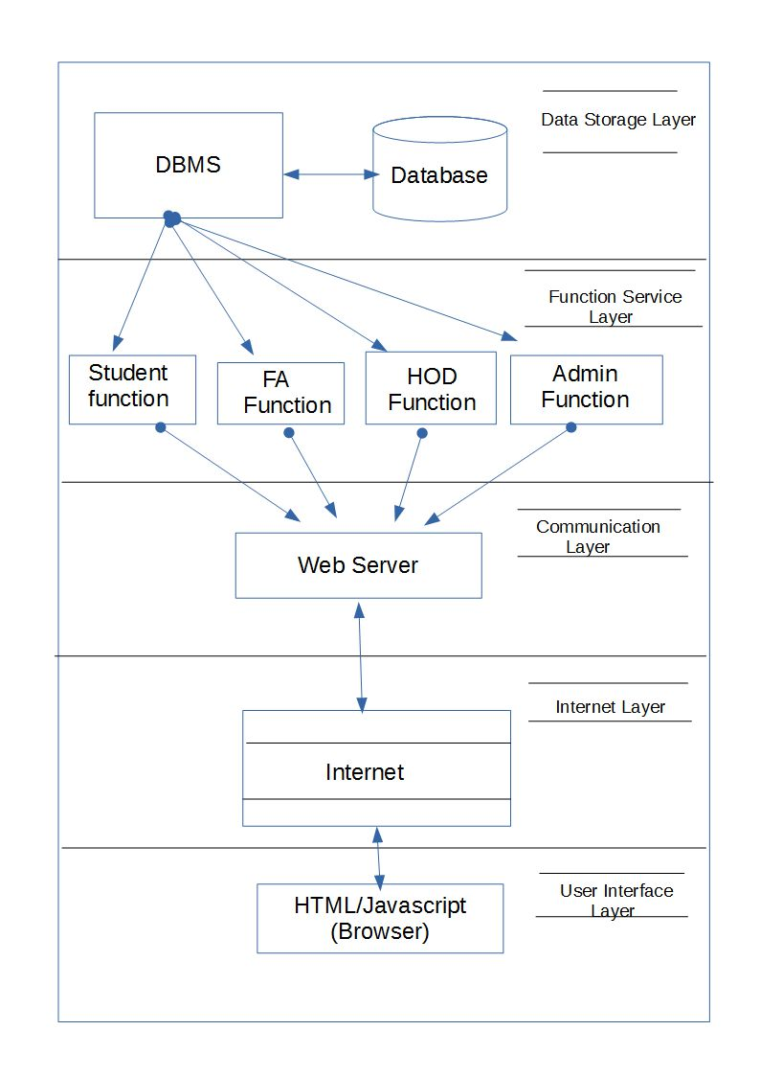

Homepage: Web Page
Homepage contains the text boxes to enter the username and password of the users and admin. It contains a login button, which on click, will check the credibility of the users and if authenticate will redirect to a respective homepage based on the kind of users.

Student Homepage: Web Page
Student Homepage contains options to update profile, update academic details, request appointment, send message, request documentation approval. By selecting one of the options mentioned student will be redirected to another web pages where he can view or edit the details based on the option. Any changes made in those web pages will be further stored or updated in the database.
Student Homepage will also contain a logout option to come back to the home page.
Student can view the notifications on the student homepage.

FA Homepage: Web Page
FA Homepage contains the options to update his profile, view student details, Process appointments, respond to messages, update bonafide details of students under him, check the correctness of the student’s details. In the same way as Student Homepage, FA will be redirected to different web pages where FA can update or view the details requested through queries. FA also contains a logout button to go back to the homepage.

HOD Homepage: Web Page
HOD Homepage contains the options to update his profile, view student details, Process appointments, respond to messages. In the same way as Student Homepage, FA will be redirected to different web pages where FA can update or view the details requested through queries. FA also contains a logout button to go back to the homepage.

Update Profile: Web Page
Update Profile Web Page will be different for different users based on their role. The attributes to be entered is different for different users. The details entered are thus updated in the corresponding tables in the database based on the users.

View Details: Web Page
View details web page also varies depending on the users and the details he/she wants to view. The web pages thus contain the details of the requested query retrieved from the database from the requested table. This page does not contain options to edit.

Request Appointment Page: Web Page
Request appointment page is accessed by the student. And this web page contains option to select the FA or HOD he/she wants an appointment with. And a button to request and another to check the status of the appointment

Process Appointment: Web Page
Process Appointment page is accessed by the FA and HOD to accept or reject the appointments requested by the student. He can thus directly send a message to a certain student who requested an appointment on the details of the meeting.

Messages Web Page: Web Page
The format for the web pages accessed by HOD, FA and students is the same. It contains a Text Area to send a message and view received messages.

Update Bona fide: Web Page

Update Bona fide web page is used by the FA to update certain details of a student based on the student's performance.

Constraints
- CFA system will run on a dedicated platform with access to a SQL database
- Database save all information that is provided
- The internet must be able to communicate with a browser client in HTML, PHP as well as JavaScript.

Decomposition Description
- Function 1: Login Function (Shared function): This function provides the security and authenticity to the user.
- Function 2: Update Profile (User specific Function): This function provides the user with the facility to enter their data. The data entered can later be viewed and updated by the users.
- Function 3: View Profile (Shared Function): This function is shared between FA and HOD and allows them to view the details of a student.
- Function 4: Appointment Request (Shared Function): This function allows students to request an appointment with the FA and HOD and for HOD or FA to accept or reject the appointment.
- Function 5: Update Student record (Student Specific function): This function allows student to update the academic details. This updated record can be viewed by the FA and HOD.
- Function 6: Update Student Details: (FA specific function): This function allows FA to update the bona fide details of the student. These updated details can only be viewed by student with a permission from FA.
- Function 7: Verify Grades (FA specific function): This function allows FA to verify the student record for any discrepancy in the details entered by the student.

Data Design

Data Description
- Student

Student_roll
password
dob
nationality
caste
fa_name
mother_name
contact_no
father_name
local_guardian
present_address
religion
permenant_addresss
email_id
parent_contact
parent_email
name
student

- Contains personal information of students
- Contact details
- Contact details of student’s parents

fa
- FA
fa_id
password
name
email_id
designation
appointments
messages
notifications
mobile

- Contains information related to FA
- Appointments requested by students
- Notifications for students from HOD and themselves
- Messages received from students

- HOD
username
notifications
designation
password
email_id
mobile
Name

hod

- Contains information about HOD
- Notifications from FAs

- Student Record
sgpa
placement_details
disciplinary_activities
achivments
dept_association_activitiers
extra_ciricular_activities
mediacal_discontinuation
probation_details
no_of_condonations
condonation
project
project_guide
internship
student_
record

- Contains student’s information on academics
- Course Project details
- Condonation details
- Campus placement details
- Disciplinary activities

course_details
grade
attendance
student_
academic_
details
- Student academic record

- Contains academic performance of students
- Courses taken by them in semesters
- Grades obtained
4.2 ER Diagram

admin

Creates
HOD
FA

send/receive

send/receive
Student

messages

updates

view

accepts/rejects
Student Record

request
notifications
appointments

updates

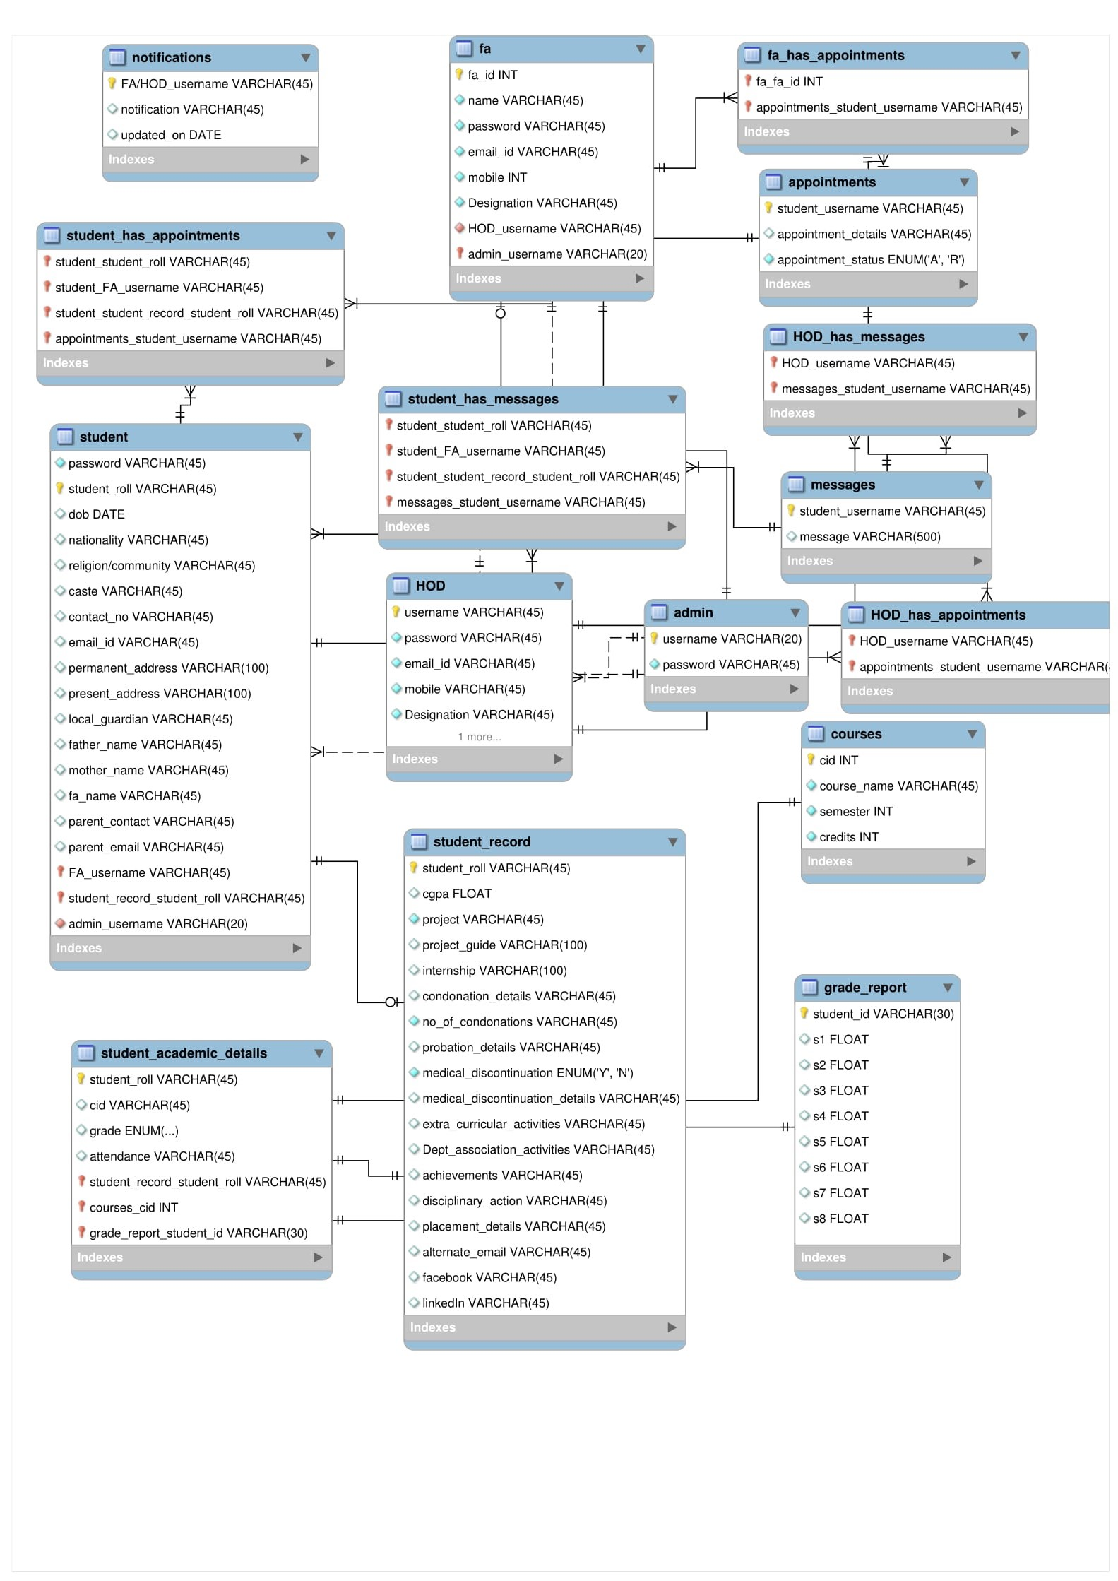

Data Dictionary
The data dictionary contains the metadata of the system.
The metadata for the CFA is

Table Name: admin. And table contains
1.username VARCHAR () PRIMARY KEY NOT NULL.
2.password VARCHAR () NOT NULL.

Table Name: FA. and table contains
- fa_id INT PRIMARY KEY NOT NULL
- name VARCHAR () NOT NULL
- Password VARCHAR () NOT NULL
- email_id VARCHAR () NOT NULL
- mobile VARCHAR () NOT NULL
- Designation VARCHAR () NOT NULL
- HOD_username VARCHAR () NOT NULL

Table Name.HOD and table contains
- username VARCHAR () PRIMARY KEY NOT NULL
- password VARCHAR () NOT NULL
- Email_id VARCHAR () NOT NULL
- Mobile VARCHAR () NOT NULL
- Designation VARCHAR () NOT NULL

Table Name: notifications
- FA/HOD_username VARCHAR () PRIMARY KEY NOT NULL
- notification VARCHAR ()
- Updated_on DATETIME

Table Name: appointments
- Student_username VARCHAR () PRIMARY KEY NOT NULL
- Appoinment_details VARCHAR ()
- Appointment_status ENUM () NOT NULL

Table Name: messages
- student_username VARCHAR () PRIMARY KEY NOT NULL
- message VARCHAR ()

Table Name: FA_has_messages
- FA_username VARCHAR () PRIMARY KEY NOT NULL
- FA_HOD_username VARCHAR () PRIMARY KEY NOT NULL
- Messages_students_username VARCHAR () PRIMARY KEY NOT NULL

Table Name: student_has_messages
- Student_student_roll VARCHAR () PRIMARY KEY NOT NULL
- student_FA_username VARCHAR() PRIMARY KEY NOT NULL
- Student_student_record_student_roll VARCHAR() PRIMARY KEY NOT NULL
- Messages_student_username VARCHAR() PRIMARY KEY NOT NULL

Table Name: courses
- cid VARCHAR() PRIMARY KEY NOT NULL
- Course_name VARCHAR() NOT NULL
- Semester INT NOT NULL
- Credits INT NOT NULL

Table Name: student
- password VARCHAR() NOT NULL
- student_roll VARCHAR() PRIMARY KEY NOT NULL
- nationality VARCHAR()
- dob VARCHAR()
- religion/community VARCHAR()
- Caste VARCHAR()
- Contact_no VARCHAR()
- Email_id VARCHAR()
- permanent _address VARCHAR()
- present_address VARCHAR()
- local_gaurdian VARCHAR()
- Father_name VARCHAR()
- Mother_name VARCHAR()
- Parent_contact VARCHAR()
- Parent_email VARCHAR()

Table Name: student_record
- Student_roll VARCHAR() PRIMARY KEY NOT NULL
- Cgpa FLOAT
- Project VARCHAR() NOT NULL
- Project_guide VARCHAR()
- Internship VARCHAR()
- Condonation_details VARCHAR()
- no_of_condonations INT NOT NULL
- Probation_details VARCHAR()
- Medical_discontinuation ENUM()
- Medical_discontinuation_details VARCHAR()
- Extra_cirricular_activities VARCHAR()
- Dept_association_activities VARCHAR()
- Achievements VARCHAR()
- disciplinary _actions VARCHAR()
- Placement_details VARCHAR()
- Alternate_email VARCHAR()
- facebook VARCHAR()
- linkedIn VARCHAR()

Table Name: student_academic_details
- student _roll VARCHAR() PRIMARY KEY NOT NULL
- Cid VARCHAR()
- Grade ENUM()
- Attendance ENUM()

Table Name: grade_report
- Student_roll VARCHAR() PRIMARY KEY NOT NULL
- S1 FLOAT
- S2 FLOAT
- S3 FLOAT
- S4 FLOAT
- S5 FLOAT
- S6 FLOAT
- S7 FLOAT
- S8 FLOAT

Component Design

Will be updated in later version

Human Interface Design

Overview of User Interface
The Homepage consists of dropdown to select the kind of user you are going to be. In the system CFA the dropdown consists Admin, HOD, FA, student. There will be two input types to enter the username and password. A login button completes the login function of the users.
The after-login pages of the user’s look differently based the kind of user. For student, the after-login page contains his name with a welcome message. A sidebar on the left of the page which shows the notifications updated by the FA and HOD. The navigation bar on the right has the options in the form of text links. The links available for in the student page are Request appointment, Message, Update profile, FA profile.
The after-login page of FA has the same welcome user message. A notification sidebar on the left where he can view notifications. The navigation bar on the right side consists of the text links specific for the FA. The links are View student profile, Update Profile, Update notifications, Appointments, Messages, Update student profile.
The user view of the page after login for HOD is same as that of FA but a few options in the navigation bar changes for HOD. The HOD can access and view student profile, Appointments, Update Profile, Update notifications, Messages.
The login page contains a Header which consists of the institution name and address.
And a footer contains the institution's copyright message.
All the options once accessed will be redirected to other webpages whose view is the same as after login pages but varies in the section part. Where forms appear for updating profile and table appear for viewing options. The appointment page consists of option to type in the FA or HOD name or for FA/HOD to enter student’s name. And contains buttons to request appointment for student. And for FA/HOD approve or reject button appear on the screen.
The messages pages look almost same for all the users. A large text area to type in the message. An input text box to enter the FA or HOD name or ID. And a send button. View recent messages is a button on the messages through which the users and view the messages he received.

Screen images
Will be updated in later version

Future Upgrades
The system is developed for webservers only, can be done for Application server also.

