Requirments:

Python

Tkinter

Xmldiff

How to run:

In cmd naviagate to folder where xml_cmp_app.py file is

Run:

python xml_cmp_app.py

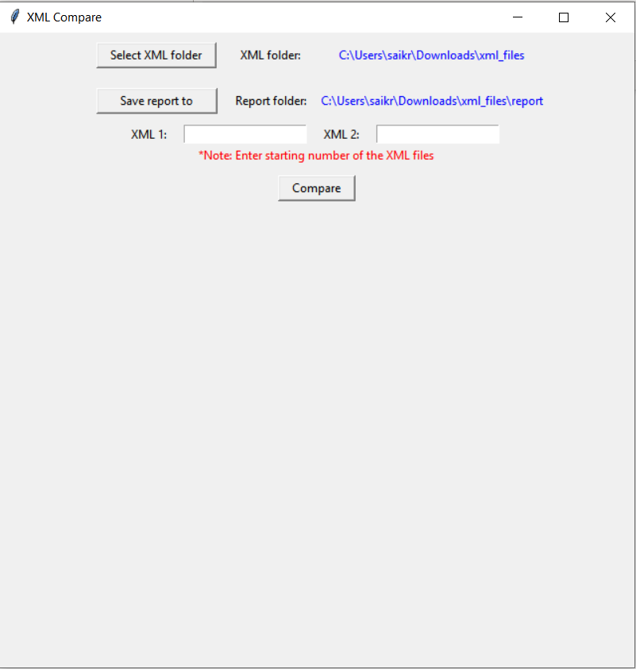 

Button to set xml folder where report of non identical files should be saved

Button to set xml files folder





Enter xml files number

Eg.: if files are 06014820-001.00-FabModule

enter 6014820

