Use Case and Design -Booking a Doctor Consultation
Project – Booking a Doctor Consultation

Author: Sai Krishna
Document Number: Use Case and Design Specification Booking a Doctor Consultation V1.0
Document Version Number: Version V1.0 Last Modified: 10th May 2021

Table of Contents

1. Name 2
1.1 Brief Description 2
1.2 Actor Description 2
1.3 Screen mock-up 2
2. Pre Conditions 2
3. Flow of Events 3
3.1 Basic Flow 3
4. Post Conditions 3
5. Sequence Diagram 3
6. Document Change History 3

Use Case Specification- sample

Name
Booking a doctor consultation

Brief Description
This use case describes the booking of an doctor consultation online through which a user or patients can access the Online doctor consultation website/system, and through the online software, patients can easily make their appointments with doctors based on the available slot.

Actor Description
Patient, Doctor

Screen mock-up

Login Screen

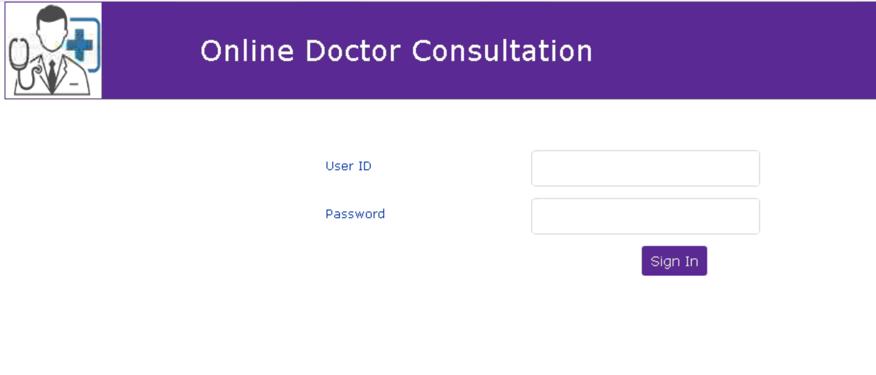

Specialist Selection:

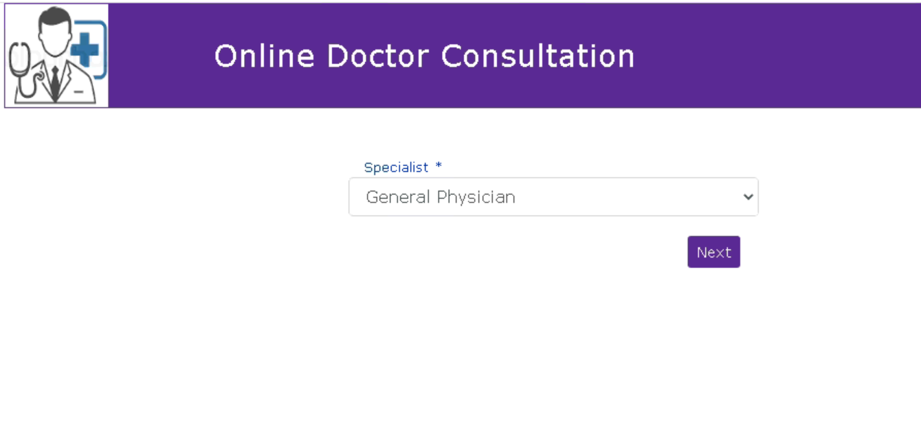

User Details

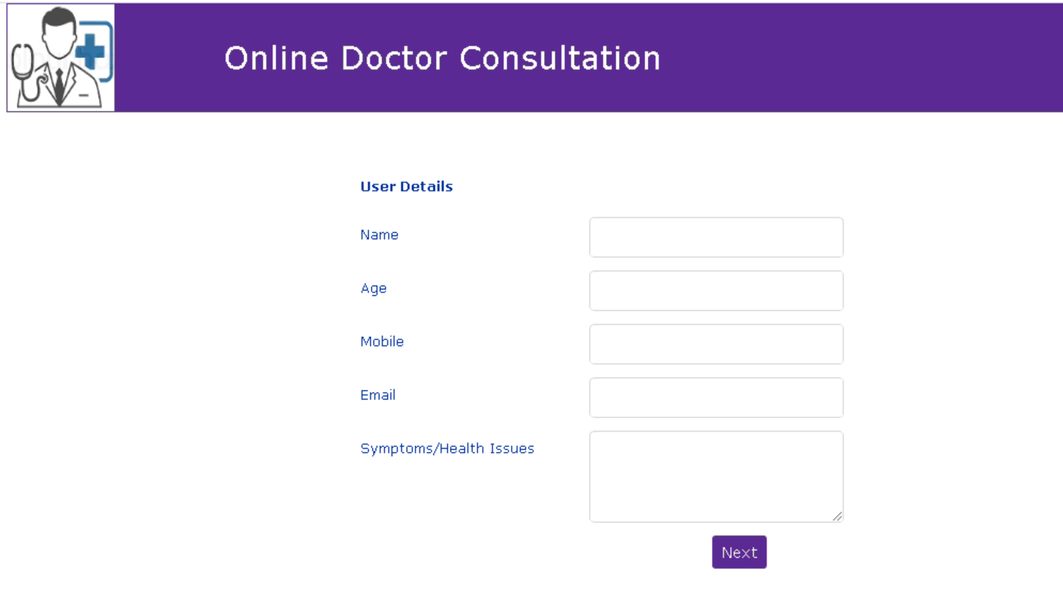

Appointment Slot selection and Confirmation

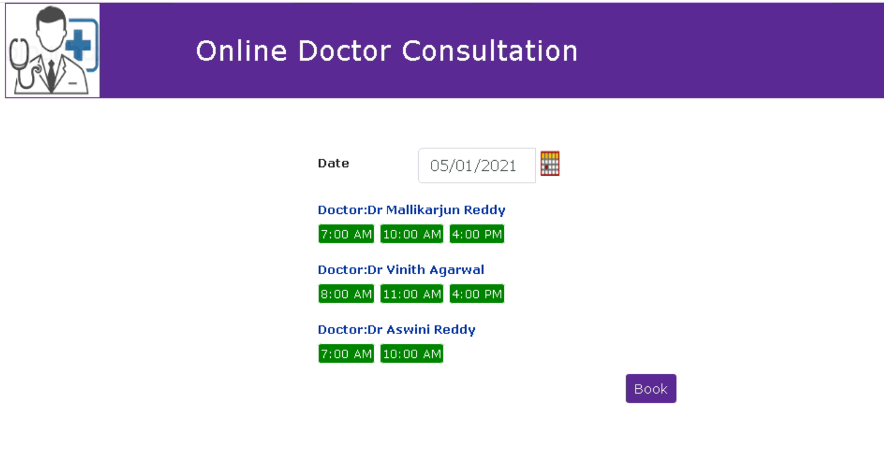

Pre Conditions
The user/patient needs to be registered prior to booking a doctor consultation online.

Flow of Events

Basic Flow
- User logins to the Online Doctor Consultation system (User needs to be registered for the first time consultation).
- Chooses the doctors speciality.
- User enters their details (Name, Age , symptom or health problem etc..).
- System will provides the availability slot of Doctor.
- System will send the consultation details in email/sms/whatsapp to the user once the user selects the slot and confirms.
- Final Online Consultation.
- Doctor submits online prescription containing observation or medicines etc.
- User or Patient has the facility to enter reviews of his experience towards the consultation.

Post Conditions
- Doctor submits the online prescription containing observation or medicines etc in the system which then will be visible to the respective user or patient.
- User can provide the review for the consultation.

Sequence Diagram

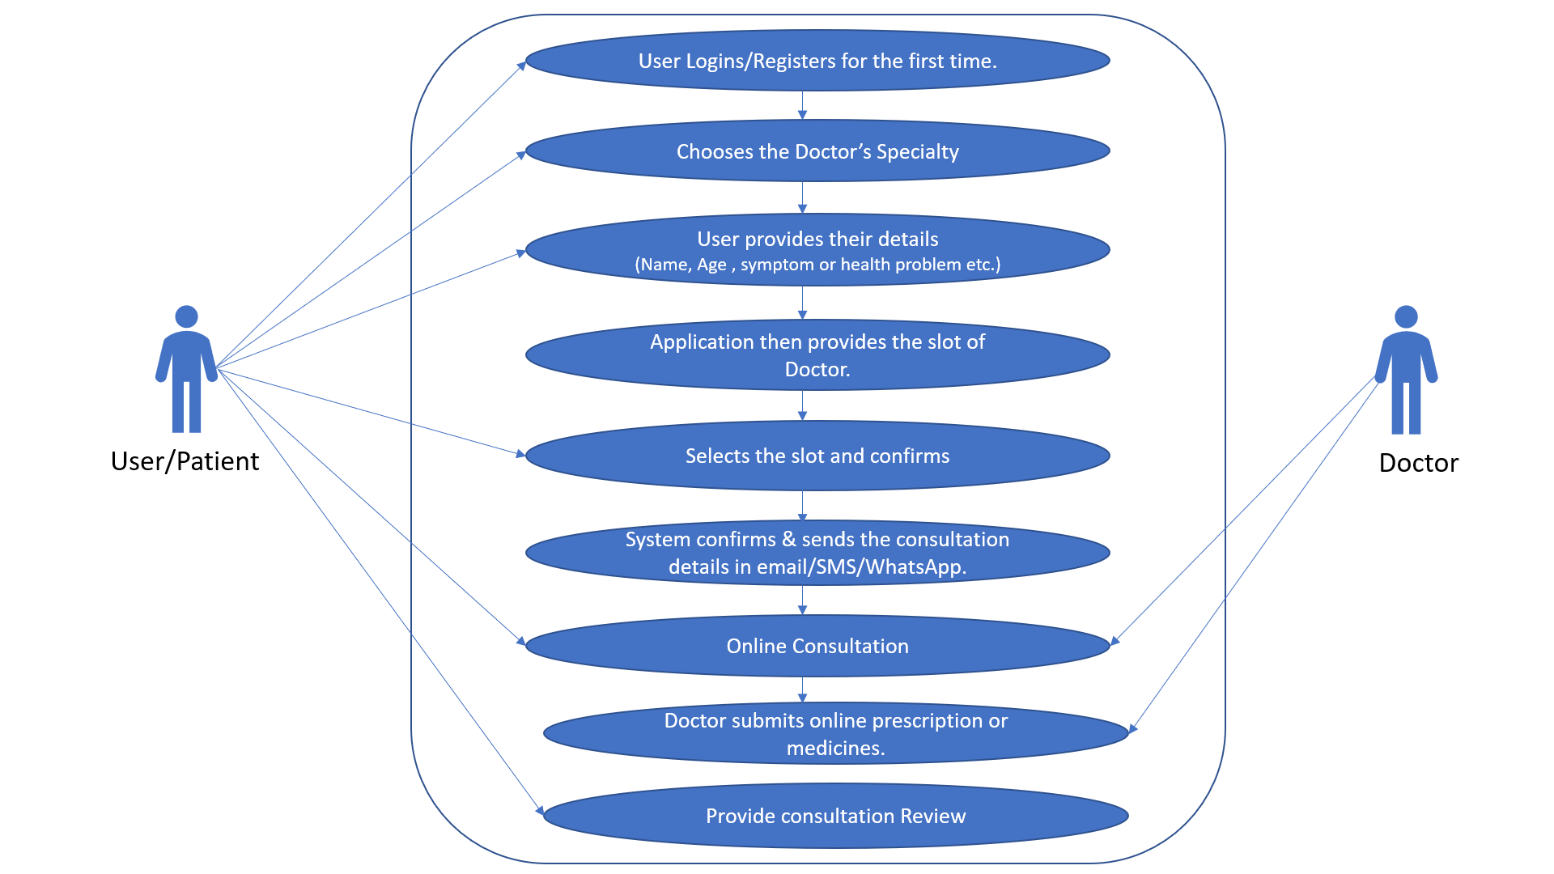

Document Change History

Date | Author/Editor | Description of Change(s)
10/05/2021 | Sai Krishna | Version 1.0

