**Objective**

To create a android application with below features.

**Feature**

1. Create login and register pages
2. OAuth login from Google
3. converting speech to text and then text to speech.(Hardware used:mic)

**Steps**

1. create appId for google login and enable it so that OAuth login can be used using google.
2. create login and signup pages.
3. Using apis convert speech to text and from text to speech. User can click on any of the features and use.

**Screenshots With Explanations**

**welcome page**

User can either register or signin directly if already registered. User can also signIn directly using Google login.

The user can enter the details and signup.

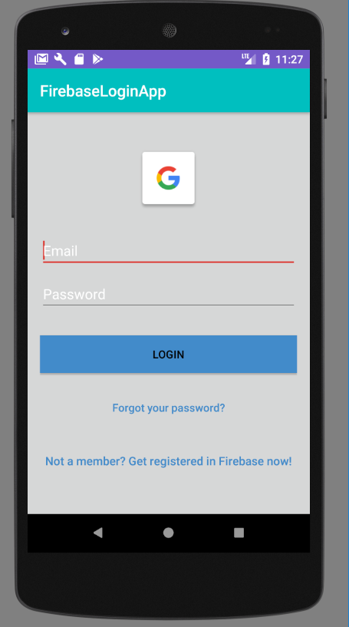

**Code snippet for firebase**

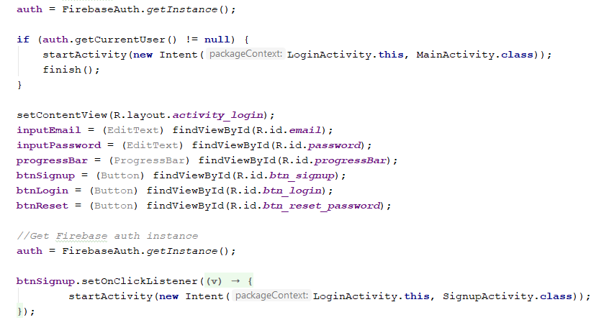

Or the user can login using google credentials

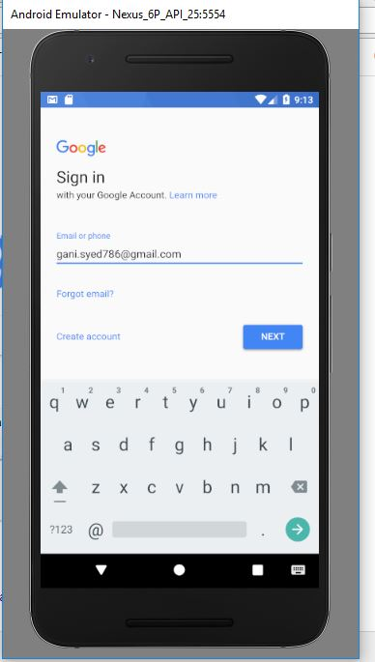

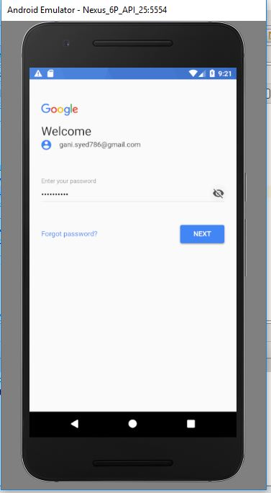

If the user is already logged in using goolge, it will show like this during login

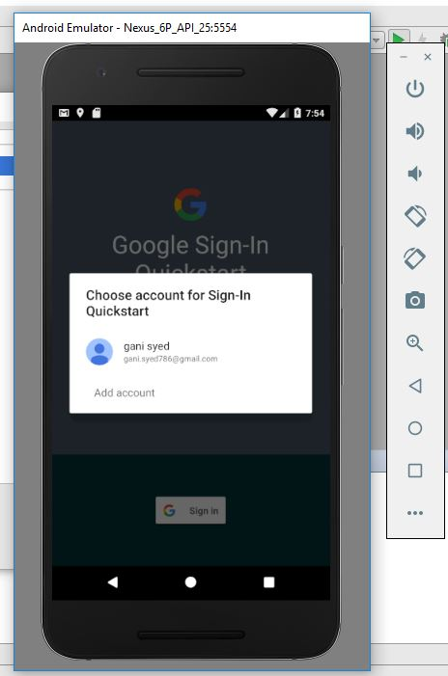

**Home Page**

Once the user is logged in, he/she will enter into the below page

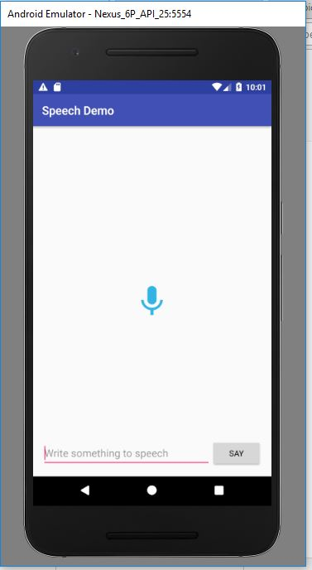

The user can press the mic icon and start speaking. The api will convert into text and display. Similarly, the user can also enter text in the input text area and the text can be converted to speech on clicking the "say" button.