Get All Products with associated category (one to one relation)

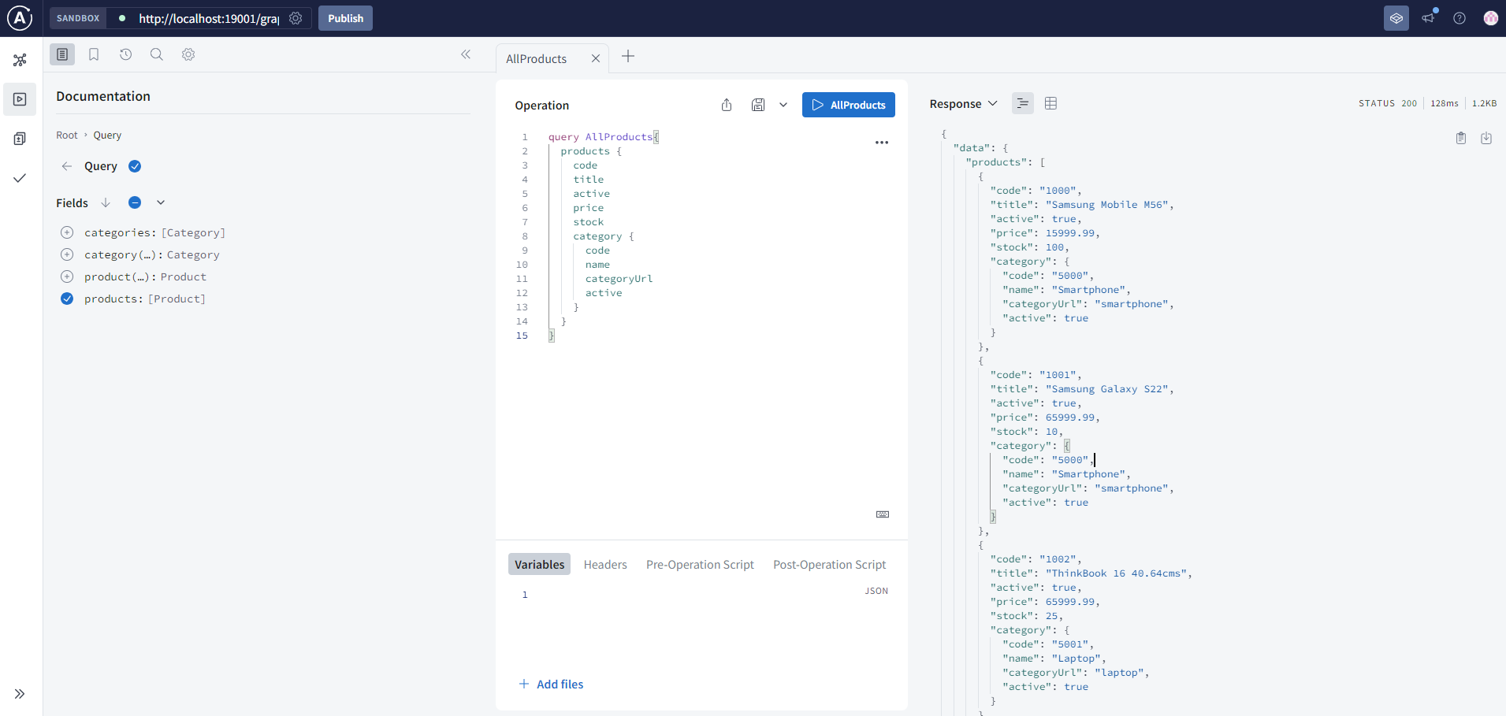

Get All Categories:

Query – find Product By Code

Query – find Category By Code

Mutation - createCategory() – Code 5013

Find Category (code : 5013)

