Session Facade

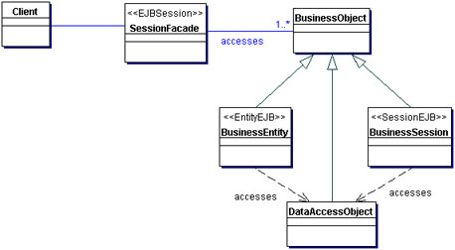

Business Delegate

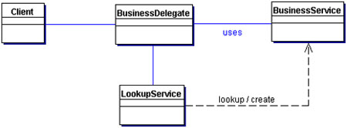

Service locator

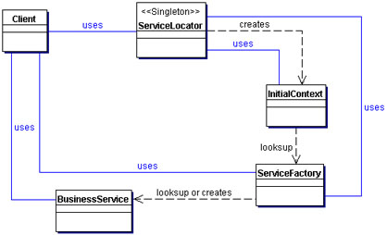

Intercepting Filter

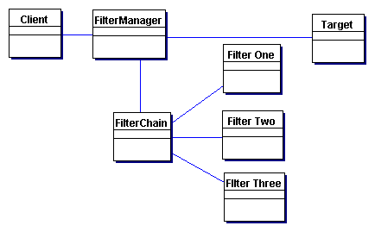

MVC

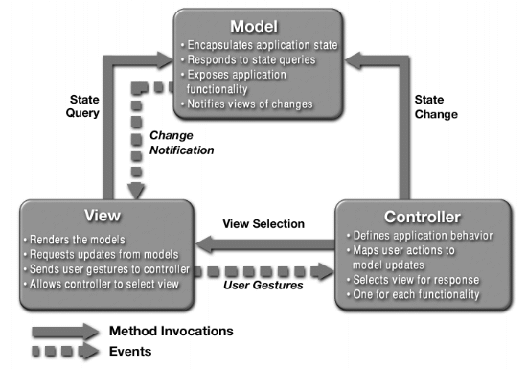
Front Controller

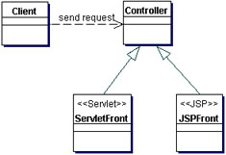

View Helper

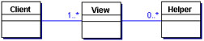

Dispatcher view

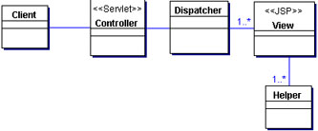

Composite View

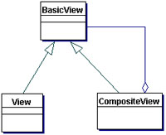

Filter

package filter;

import javax.servlet.*;
import javax.servlet.http.*;
import java.io.IOException;

public class welcomeFilter implements Filter
{
FilterConfig fg;
public void init(FilterConfig filterConfig){
System.out.println("welcomeFilter initializing.......");
fg = filterConfig;
System.out.println("filter name:"+fg.getFilterName() );
System.out.println("filter initialization parameters");
System.out.println("value:"+fg.getInitParameter("greeting"));
}

public void doFilter(ServletRequest req,ServletResponse res,FilterChain chain) throws IOException,ServletException
{
System.out.println("welcomeFilter in action.......");
chain.doFilter(req,res);
System.out.println("welcomeFilter after chaining ......");
}

public void destroy(){
System.out.println("welcomeFilter going to die.......");
}
}

web.xml entry

<filter>
<filter-name>welcomeFilter</filter-name>
<filter-class>filter.welcomeFilter</filter-class>
<init-param>
<param-name>greeting</param-name>
<param-value>Hello World</param-value>
</init-param>
</filter>
<filter-mapping>
<filter-name>welcomeFilter</filter-name>
<url-pattern> /test</url-pattern>
</filter-mapping>

