SIMATS ENGINEERING
ASSESSMENT TOOL 1
COURSE NAME: Artificial Intelligence COURSE CODE: CSA1737

COURSE OUTCOME COVERED
CO1: Apply AI basics such as intelligent agents and uninformed search methods to solve problems effectively. (BL3)
Assessment Tool Weightage: 35%

QUESTIONS: 5 Duration: 1 Hour
Total Marks: 50
Annexure A
Analytical Problem Solving

Code of Conduct:
I Y. Sai kumar (192425218) certify that this submission is my original work and that I have adhered to the guidelines specified for this assessment. I understand that any violation of academic integrity rules will result in disciplinary action.
Y. Sai kumar
Signature of the student:
Question 1 – Water Jug Problem [10 marks]

1. Problem understanding
Two jugs (4-gal and 3-gal) with no markings, a pump and a drain. Goal: exactly 2 gallons in the 4-gallon jug. Represent a state as (x, y) where x = water in the 4-gal jug (0–4) and y = water in the 3-gal jug (0–3). Initial state = (0, 0); goal state = (2, n) for any n.

2. Method – state-space search (BFS)
Every legal operation moves the system from one state to another. Breadth-First Search explores all states level by level, so the first time it reaches (2, n) it has found the shortest sequence of operations.
# | Condition | New state | Operation
1 | x < 4 | (4, y) | Fill the 4-gal jug from the pump
2 | y < 3 | (x, 3) | Fill the 3-gal jug from the pump
3 | x > 0 | (0, y) | Empty the 4-gal jug on the ground
4 | y > 0 | (x, 0) | Empty the 3-gal jug on the ground
5 | x + y ≥ 4, y > 0 | (4, y − (4 − x)) | Pour 3-gal into 4-gal until the 4-gal is full
6 | x + y ≥ 3, x > 0 | (x − (3 − y), 3) | Pour 4-gal into 3-gal until the 3-gal is full
7 | x + y ≤ 4, y > 0 | (x + y, 0) | Pour all of the 3-gal into the 4-gal
8 | x + y ≤ 3, x > 0 | (0, x + y) | Pour all of the 4-gal into the 3-gal

3. Solution (6 operations)
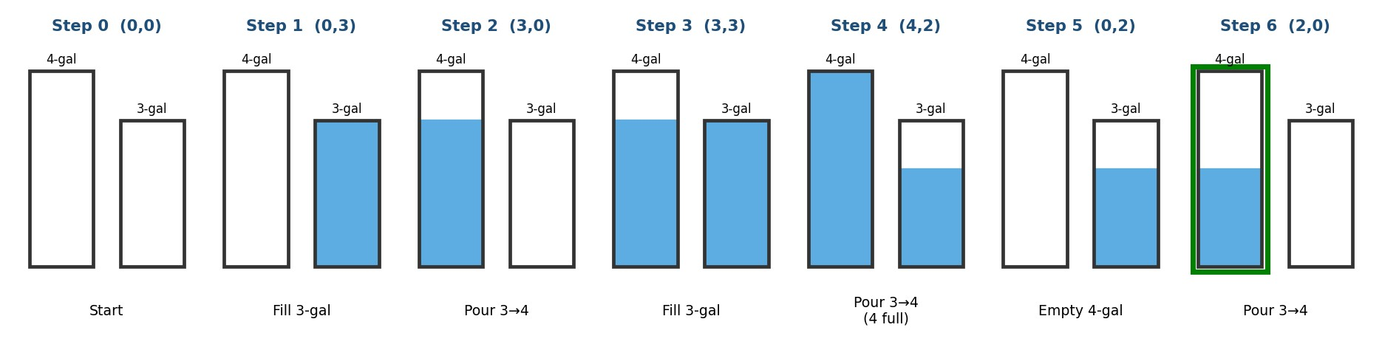
Step | Rule applied | State (x, y) | Meaning
1 | Rule 2 – fill 3-gal | (0, 0) → (0, 3) | 3-gal jug is full
2 | Rule 7 – pour 3 → 4 | (0, 3) → (3, 0) | 4-gal now holds 3
3 | Rule 2 – fill 3-gal | (3, 0) → (3, 3) | Both jugs hold 3
4 | Rule 5 – pour 3 → 4 until full | (3, 3) → (4, 2) | Only 1 gal fits, 2 gal remain in 3-gal
5 | Rule 3 – empty 4-gal | (4, 2) → (0, 2) | 4-gal is empty
6 | Rule 7 – pour 3 → 4 | (0, 2) → (2, 0) | Goal: 2 gallons in the 4-gal jug

4. Interpretation
The goal (2, 0) is reached in the minimum of 6 steps. Check: 3 + 3 − 4 = 2 gal. This works because gcd(4, 3) = 1, so any whole number of gallons up to 4 can be measured. A second 6-step solution also exists: (0,0)→(4,0)→(1,3)→(1,0)→(0,1)→(4,1)→(2,3).
2 Mars Rover Agent [10 marks]

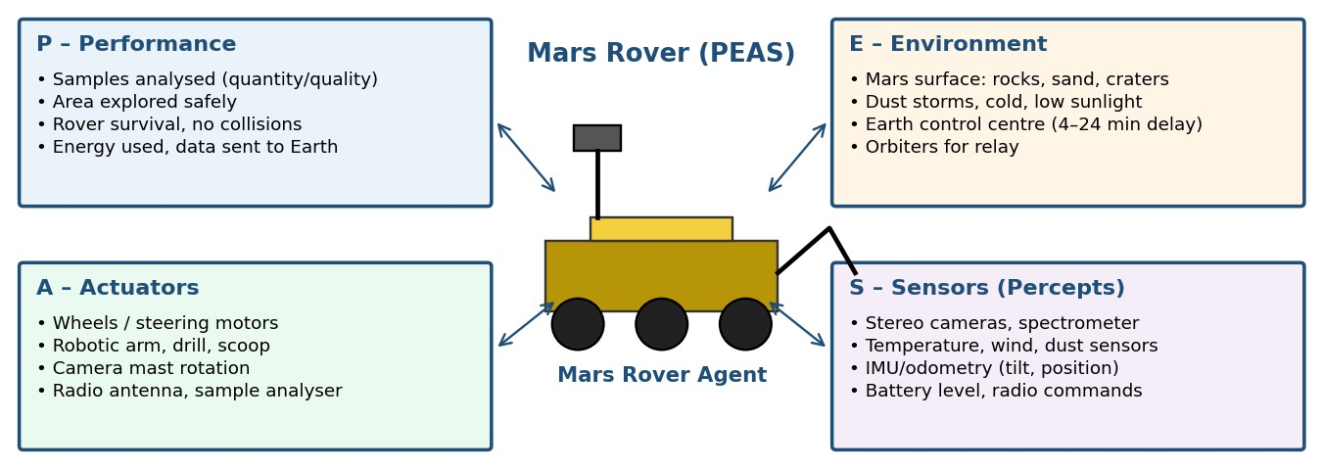 i. Percepts
Stereo/panoramic camera images; spectrometer and chemical readings of rocks and soil; temperature, wind and dust sensor values; wheel odometry and IMU data (position, tilt, slope); motor current (wheel stuck/slipping); battery and solar-panel level; radio commands from Earth. ii. Operating environment
Property | Value | Reason
Observable | Partially | Sensors see only nearby terrain; hidden rocks, craters and sand pits are unseen
Agents | Single agent | No competing agents; Earth only sends high-level commands
Deterministic | Stochastic | Wheel slip, dust storms and sensor noise make outcomes uncertain
Episodic | Sequential | A driving decision affects later position, energy and sampling choices
Static | Dynamic | Weather, light and temperature change while the rover is deciding
Discrete | Continuous | Terrain, position, time and sensor values are continuous
Known | Largely unknown | Unexplored terrain, so the rover must learn; 4–24 min radio delay forces autonomy

iii. Actions
Move forward/backward, steer/turn, stop; rotate mast and camera; extend robotic arm; drill or scoop a sample; place sample in analyser and run spectrometer; store or discard sample; avoid obstacle / re-plan route; transmit data to Earth or orbiter; sleep and recharge.

iv. Performance measure
Performance = w1·(samples analysed × scientific value) + w2·(area explored safely) + w3·(data returned) − w4·(damage/risk) − w5·(energy used). Also judged by rover survival time (mission life) and number of collisions or stuck events.

v. Suitable architecture – hybrid goal-based + utility-based, model-based, layered learning agent
- Model-based: the environment is only partially observable, so it keeps an internal map, position and battery state.
- Goal-based: with a 4–24 minute delay it cannot be remote-controlled; it must plan by itself (reach rock X, drill, analyse).
- Utility-based: it must trade off science value, energy and safety, which a utility function handles.
- Reflex layer + learning: reflexes (stop at a cliff edge, tilt limit) give instant safety; learning improves terrain handling. A simple reflex agent alone would fail.

8-Queens Problem [10 marks]
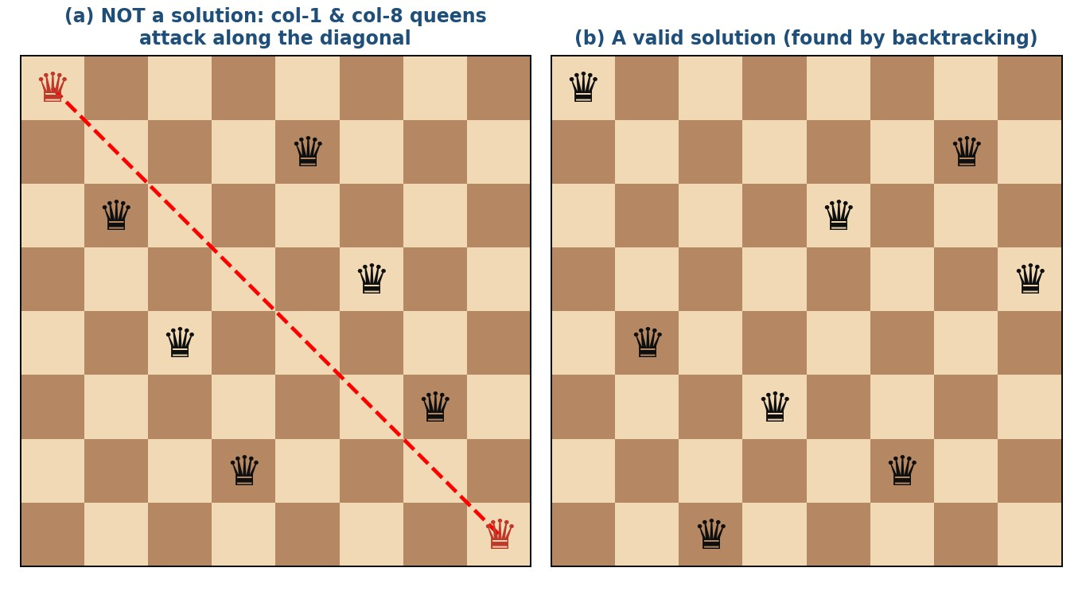
Figure (a) is not a solution: the queen in the first column and the queen in the last column are on the same diagonal (red). Figure (b) is a valid solution.

Problem formulation (incremental)
Component | Definition
Initial state | Empty board (0 queens)
States | Any arrangement of 0 to 8 queens on the board in which no queen attacks another (queens added column by column)
Actions | Add a queen to the leftmost empty column, in a row not attacked by any queen already placed
Transition model | Returns the board with the new queen added
Goal test | 8 queens on the board and no two share a row, column or diagonal
Path cost | Not important (only the final arrangement matters); each step costs 1

Exploring the search space
Formulation | States | Comment
Complete-state, any 8 queens placed anywhere | ≈ 1.8 × 10¹⁴ | Hopelessly large
One queen per column (8 rows each) | 8⁸ ≈ 16.7 million | Large
Incremental, no attacked placement | 2,057 states | Small, practical

- BFS is complete but must hold every partial board at each level in memory (large frontier).
- DFS with backtracking is best: every solution is at depth exactly 8, memory is only O(8), and a dead end (a column with no safe row) simply backtracks to the previous column.
- Result: 92 solutions exist (12 distinct if rotations/reflections are ignored). Example solution (row of queen in columns 1–8): 1, 5, 8, 6, 3, 7, 2, 4.

OLA Cab Booking Agent [10 marks]

Type of agent
A goal-based problem-solving agent (with a utility-based element for choosing the cab type). The goal is to reach the destination; the agent formulates a problem, searches for the best (cab type, route) and then executes the plan.
Formulation | OLA example
Percepts | Pickup, drop, time, available cab types, fare, ETA, traffic
Initial state /  Goal | Customer at pickup location P / Customer at destination D
Actions | Select cab (mini, micro, sedan, shared, prime…), confirm booking, ride along route
Cost / utility | Fare, ETA and comfort; the best cab maximises the score
Environment | Observable (app shows all cabs), mostly deterministic, dynamic (traffic), single customer
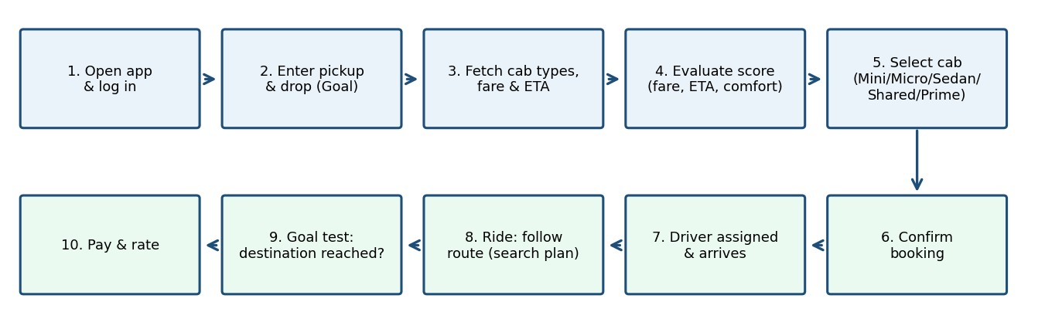
Pseudocode
function OLA-PROBLEM-SOLVING-AGENT(percept) returns an action
persistent: seq, an action sequence (initially empty)
state, goal, problem
state <- UPDATE-STATE(state, percept) // pickup P, drop D, cab list
if seq is empty then
goal <- FORMULATE-GOAL(state) // be at destination D
problem <- FORMULATE-PROBLEM(state, goal)
seq <- SEARCH(problem) // = BOOK-CAB below
if seq = failure then return NO-CAB-AVAILABLE
action <- FIRST(seq); seq <- REST(seq)
return action

procedure BOOK-CAB(P, D, user_preference)
cabs <- {mini, micro, sedan, shared, prime, ...}
best <- null; best_score <- -infinity
for each c in cabs do
if AVAILABLE(c, P) then
fare <- FARE(c, P, D); eta <- ETA(c, P)
score <- w1*COMFORT(c) - w2*fare - w3*eta
if score > best_score then best <- c; best_score <- score if best = null then return failure // retry / change pickup
chosen <- (user selects cab) or best
CONFIRM-BOOKING(chosen); ASSIGN-DRIVER(chosen)
repeat TRACK-RIDE() until current_location = D // goal test
PAY-AND-RATE(); return success

Uniform Cost Search (UCS) [10 marks]

1. Problem understanding
Find the least-cost path from S to G in a weighted directed graph. Edges: S→A 1, S→G 12, A→B 3, A→C 1, B→D 3, C→D 1, C→G 2, D→G 3.
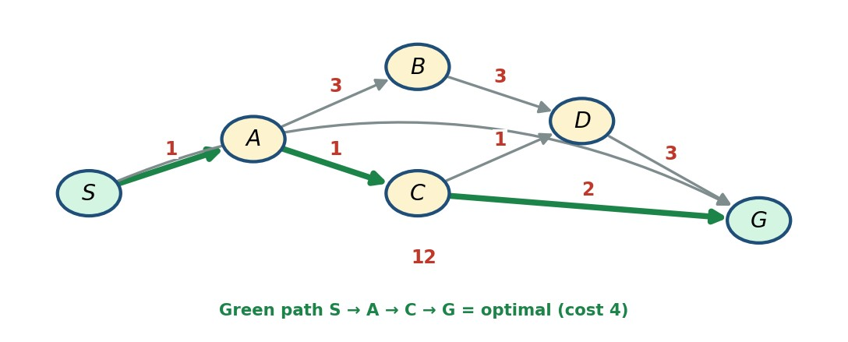

2. Method – why UCS
Edge costs differ, so BFS (fewest edges) would pick S→G (cost 12). UCS always expands the node with the lowest path cost g(n) from a priority queue, so the first time G is removed from the queue its path is optimal. 3. Solution process
Step | Node expanded  (g) | Children generated (g) | Frontier (priority queue)
1 | S (0) | A (1), G (12) | A1, G12
2 | A (1) | B (4), C (2) | C2, B4, G12
3 | C (2) | D (3), G (4) – cheaper than 12, so G is updated | D3, B4, G4
4 | D (3) | G (6) – rejected, 6 > 4 | B4, G4
5 | B (4) | D (7) – rejected, D already expanded at 3 | G4
6 | G (4) | Goal removed from queue – stop | –

Order of expansion: S, A, C, D, B, G. Path found: S → A → C → G, cost = 1 + 1 + 2 = 4.
Other paths | Cost | Result
S → A → C → D → G | 6 | Costlier
S → A → B → D → G | 10 | Costlier
S → G (direct) | 12 | Costliest

4. Interpretation
The cheapest delivery route is S → A → C → G with a total cost of 4 units (fuel + time). This saves 8 units (about 67%) compared with the direct route S → G. UCS is complete and optimal because every edge cost is positive.

