SIMATS ENGINEERING (SAVEETHA SCHOOL OF ENGINEERING)
Department of Artificial Intelligence and Data Science
ASSESSMENT TOOL 3 – DESIGN TASK

Course Code: | DSA03 | Course Title: | Natural Language Processing
CO Assessed: | CO3 – Precision | Assessment: | Assessment Tool 3 – Design Task
Weightage: | 40% of CIA
CO5 Statement: | Apply N-gram models, smoothing techniques, part-of-speech tagging systems and to evaluate effective syntactic analysis. (BL-3)
Student Name: | Y. Sai kumar | Reg. No.: | 192425218
Section / Batch: | 2024 BTech AIML | Date:

Code of Conduct
I Y. Sai kumar 192425218 (Name / Reg No) certify that this submission is my original work and that I have adhered to the guidelines specified for this assessment. I understand that any violation of academic integrity rules will result in disciplinary action.
Signature of the Student: _________________________

Instructions
- Implement the assigned NLP Design Task using Python with appropriate algorithms and a suitable dataset/application.
- Execute the program and demonstrate the output using relevant sample inputs and test cases.
- Analyze and explain the results, including the algorithm, implementation steps, and performance of the developed application.
- Duration: 30 minutes.

Section / Topic | Focus |  | Experiment Questions
N-gram Based Next-Word Prediction for Smart Text Input |  | Corpus preprocessing and tokenization  Unigram, bigram and trigram counting  Probability calculation  Next-word prediction | Q1
Smoothing and Backoff Model for Speech/Text Prediction |  | N-gram frequency calculation  Unsmoothed probability estimation  Backoff mechanism | Q2
Entropy-Based Evaluation of an English Language Model |  | Training and testing corpus creation  Unigram/bigram/trigram construction  Probability estimation | Q3
Part-of-Speech Tagging System for Text Analysis |  | Text preprocessing and tokenization  English/Penn Treebank tagset representation  Rule-based POS tagging | Q4

Annexure A – Design Task

Task 1 – N-gram Based Text Prediction
Design and implement a Python-based N-gram language model that predicts the next word in a given sentence using an English text corpus. The system should preprocess the corpus, perform sentence segmentation and tokenization, and construct unigram, bigram, and trigram models by calculating word-frequency counts and maximum-likelihood probabilities.
For an incomplete sentence such as:
"Artificial intelligence is"
the system should identify and display the top-5 most probable next words.
The program should allow the user to select N = 1, 2, or 3, display the corresponding N-gram frequency counts and probabilities, and demonstrate the behavior of the model when an unseen N-gram is encountered. Finally, test the model using multiple incomplete sentences, calculate the prediction accuracy, and discuss the limitations of using an unsmoothed N-gram model for real-world language prediction.
CODE
from collections import Counter

text = """
Artificial intelligence is useful.
Artificial intelligence is growing.
Machine learning is useful.
Machine learning can solve problems.
Language models can predict words.
The model can learn patterns.
"""
s = text.lower().replace(".", "").split()
u = Counter(s)
b = Counter(zip(s, s[1:]))
t = Counter(zip(s, s[1:], s[2:]))
print("1. Unigram")
print(u)
print("\n2. Bigram")
print(b)
print("\n3. Trigram")
print(t)
print("\nBigram Probabilities")
for x in b:
print(x, "=", round(b[x] / u[x[0]], 3))
print("\nTrigram Probabilities")
for x in t:
p = t[x] / b[x[:2]]
print(x, "=", round(p, 3))
n = int(input("\nEnter N (1, 2 or 3): "))
sentence = input("Enter incomplete sentence: ").lower().split()
ans = []
if n == 1:
for w in u:
ans.append((w, u[w] / sum(u.values())))
elif n == 2:
w = sentence[-1]
for x in u:
p = b[(w, x)] / u[w] if u[w] else 0
if p > 0:
ans.append((x, p))
elif n == 3:
w1, w2 = sentence[-2], sentence[-1]
for x in u:
p = t[(w1, w2, x)] / b[(w1, w2)] if b[(w1, w2)] else 0
if p > 0:
ans.append((x, p))
ans.sort(key=lambda x: x[1], reverse=True)
print("\nTop 5 predictions:")
for x in ans[:5]:
print(x[0], "=", round(x[1], 3))
print("\nUnseen trigram probability:",
t[("artificial", "intelligence", "banana")])

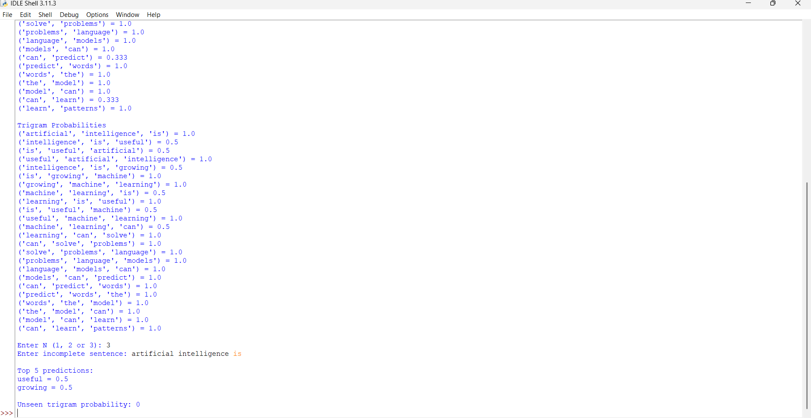
Task 2 – Backoff and Interpolation for Language Prediction
Design and implement a Python-based enhanced language prediction system that addresses the zero-probability problem of an unsmoothed N-gram model. The system should construct unigram, bigram, and trigram models from an English corpus and accept an incomplete sentence such as:
"Machine learning can"
When the required trigram is unavailable, the system should use a backoff strategy by first checking the trigram model, then the bigram model, and finally the unigram model. Extend the system using Deleted Interpolation to combine unigram, bigram, and trigram probabilities using predefined interpolation weights.
The system should generate the top-5 next-word predictions using:
- Unsmoothed N-gram model
- Backoff model
- Deleted Interpolation model
Compare the three approaches in terms of zero probabilities, prediction coverage, and prediction accuracy, and explain why backoff and interpolation are useful for sparse language data.
CODE
from collections import Counter
text = """
Machine learning can solve problems.
Machine learning is useful.
Machine learning can analyze data.
Artificial intelligence can solve problems.
Language models can predict words.
The model can learn patterns.
"""

s = text.lower().replace(".", "").split()
u = Counter(s)
b = Counter(zip(s, s[1:]))
t = Counter(zip(s, s[1:], s[2:]))
total = sum(u.values())
def p1(w):
return u[w] / total
def p2(w1, w2):
return b[(w1, w2)] / u[w1] if u[w1] else 0
def p3(w1, w2, w3):
return t[(w1, w2, w3)] / b[(w1, w2)] if b[(w1, w2)] else 0
s = input("Enter incomplete sentence: ").lower().split()
w1 = s[-2]
w2 = s[-1]
a = []
b1 = []
c = []
for w in u:
x = p3(w1, w2, w)
if x > 0:
a.append((w, x))
x = p3(w1, w2, w)
if x == 0:
x = p2(w2, w)
if x == 0:
x = p1(w)

b1.append((w, x))
x = (.2 * p1(w) +
.3 * p2(w2, w) +
.5 * p3(w1, w2, w))
c.append((w, x))
a.sort(key=lambda x: x[1], reverse=True)
b1.sort(key=lambda x: x[1], reverse=True)
c.sort(key=lambda x: x[1], reverse=True)
print("\nUnsmoothed:")
print(a[:5])
print("\nBackoff:")
print(b1[:5])
print("\nInterpolation:")
print(c[:5])
print("\nUnseen trigram:",
p3(w1, w2, "banana"))
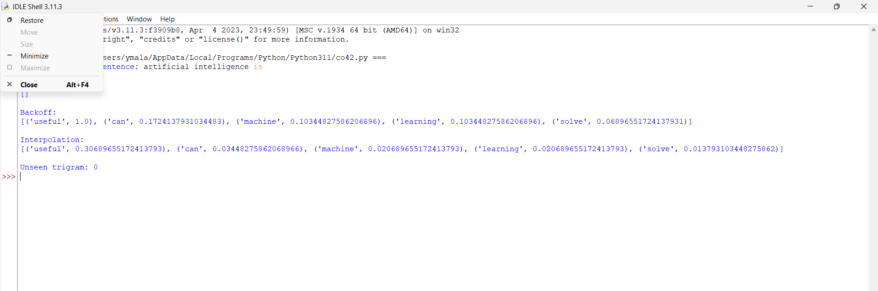
Task 3 – Entropy-Based Evaluation of Language Models
Design and implement a Python program for measuring the uncertainty of N-gram language models using entropy. Given separate training and testing corpora, construct unigram, bigram, and trigram language models and calculate the probabilities assigned to words in the test sentences. For each test sentence, calculate its entropy and classify the sentence as having relatively high or low predictive uncertainty.
For example, compare sentences such as:
"The cat sits on the mat."
and
"The quantum processor redesigned the..."
The system should evaluate how predictable the next word is based on the trained language model.
The program should also compare entropy values obtained using:
- Unigram model
- Bigram model
- Trigram model
- Smoothed model
Finally, interpret the results and explain how entropy can be used to measure prediction uncertainty and evaluate the reliability of a language model.
CODE
import math
from collections import Counter
train = """
The cat sits on the mat.
The cat eats food.
The dog sits on the mat.
The dog eats food.
The boy plays with the ball.
"""
test = [
"The cat sits on the mat",
"The quantum processor redesigned the"
]
s = train.lower().replace(".", "").split()
u = Counter(s)
b = Counter(zip(s, s[1:]))
t = Counter(zip(s, s[1:], s[2:]))
total = sum(u.values())
def unigram(w):
return u[w] / total if u[w] else 0.0001
def bigram(w1, w2):
return b[(w1, w2)] / u[w1] if b[(w1, w2)] else 0.0001
def trigram(w1, w2, w3):
return t[(w1, w2, w3)] / b[(w1, w2)] if t[(w1, w2, w3)] else 0.0001
def entropy(s, n):
x = s.lower().split()
h = 0

for i in range(len(x)):
if n == 1:
p = unigram(x[i])
elif n == 2 and i > 0:
p = bigram(x[i-1], x[i])
elif n == 3 and i > 1:
p = trigram(x[i-2], x[i-1], x[i])
else:
continue
h -= math.log2(p)
return round(h / len(x), 2)
for s in test:
print("\nSentence:", s)
a = entropy(s, 1)
b1 = entropy(s, 2)
c = entropy(s, 3)
print("Unigram Entropy :", a)
print("Bigram Entropy :", b1)
print("Trigram Entropy :", c)
if c > 8:
print("High uncertainty")
else:
print("Low uncertainty")
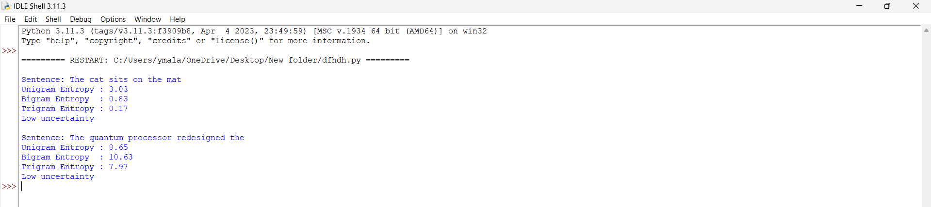
Task 4 – Comparative POS Tagging System
Design and implement a Python-based POS tagging system that assigns grammatical tags to words in English sentences.
The system should implement three approaches:
1. Rule-Based POS Tagging
Use a combination of lexical dictionaries, word patterns, and grammatical rules to assign POS tags.
2. Stochastic POS Tagging
Construct a statistical POS tagger using:
- Word/tag frequencies
- Tag transition probabilities
- Probabilities obtained from a training corpus
3. Transformation-Based Tagging
Initially assign tags using a simple tagging strategy and subsequently apply transformation rules to correct likely tagging errors.
For example:
"I book a ticket."
and
"I read a book."
The system should demonstrate how the same word can receive different POS tags depending on its context. Use an appropriate English corpus such as the Brown Corpus or another publicly available tagged corpus. The program should accept user-entered sentences, display the POS tags produced by all three approaches, and compare their results using suitable evaluation measures such as tagging accuracy. Finally, analyze the differences among the three approaches and explain the advantages and limitations of rule-based, stochastic, and transformation-based POS tagging.
CODE
import nltk
from collections import Counter
nltk.download('brown')
from nltk.corpus import brown
data = brown.tagged_words()
d = Counter()
for w, t in data:
d[(w.lower(), t)] += 1
def stochastic(w):
a = []
for (x, t), c in d.items():
if x == w.lower():
a.append((t, c))
if a:
return max(a, key=lambda x: x[1])[0]
return "NN"
def rule(w):
x = w.lower()
if x in ["i", "he", "she", "we", "they"]:
return "PRP"
if x in ["a", "an", "the"]:
return "DT"
if x.endswith("ing"):
return "VBG"
if x.endswith("ed"):
return "VBD"
if x.endswith("ly"):
return "RB"
if x.endswith("s"):
return "NNS"
return "NN"
def transform(words):
a = [rule(w) for w in words]
for i in range(len(words)):
if i > 0 and words[i-1].lower() == "i":
if words[i].lower() == "book":
a[i] = "VB"
if i > 0 and words[i-1].lower() in ["a", "an", "the"]:
a[i] = "NN"
if i > 0 and words[i-1].lower() == "can":
a[i] = "VB"
return a
s = input("Enter sentence: ").split()
print("\nRule Based:")
for w in s:
print(w, "->", rule(w))
print("\nStochastic:")
for w in s:
print(w, "->", stochastic(w))
print("\nTransformation Based:")
a = transform(s)
for i in range(len(s)):
print(s[i], "->", a[i])

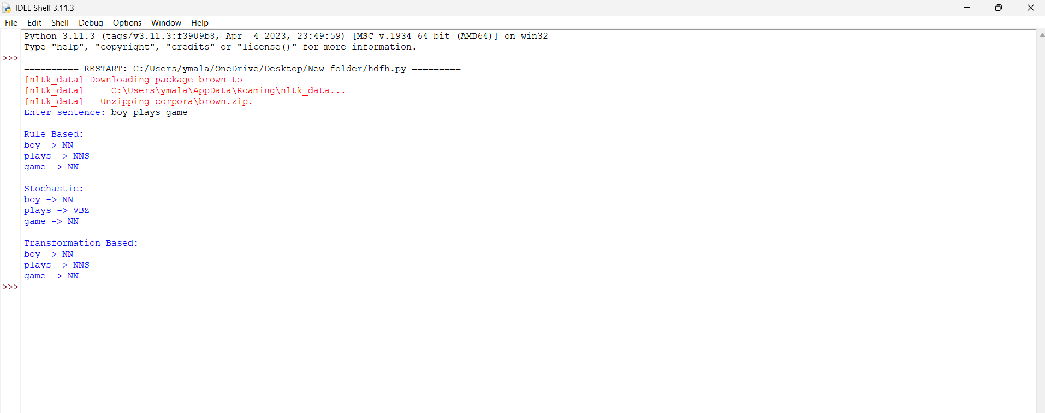
Rubrics for Calculation

Criteria | Weightage (%) | Level 4 – Exemplary (4) | Level 3 – Proficient (3) | Level 2 – Developing (2) | Level 1 – Beginning (1)
Understanding of Concept | 25% | Demonstrates complete understanding of design requirements and concepts | Good understanding with minor gaps | Basic understanding with some errors | Poor understanding or incorrect concepts
Design / Implementation | 30% | Well-structured, efficient, and responsive design implementation | Correct implementation with minor issues | Basic implementation with inconsistencies | Incorrect or incomplete implementation
Use of Tools | 20% | Effective and advanced use of tools/techniques | Appropriate use of tools | Limited or inconsistent use | Incorrect or minimal use
Analysis & Evaluation | 15% | Insightful analysis with strong justification and optimization | Good analysis with justification | Basic analysis with limited depth | Poor or no analysis
Documentation / Clarity | 10% | Clear, well-structured, and properly presented solution | Mostly clear with minor issues | Basic clarity, missing details | Poor or unclear documentation

Q. No. / Criteria Level | Understanding of Concepts | Experimental Design | Use of Tools | Analysis of Results | Documentation | Sub. Total | Total %
1
2
3
4

Faculty In-charge | Course Coordinator | Program Director
Dr. T Kumaragurubaran
Signature: _______________ | Signature: _______________ | Signature: _______________
Date: ___________________ | Date: ___________________ | Date: ___________________

