3.Design PDA using simulator to accept the input string anb2n

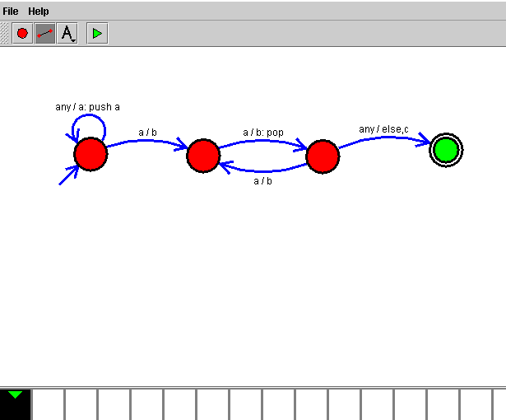

**Result:**

Hence we successfully designed PDA using simulator.