4.Design TM using simulator to accept the input string anbn

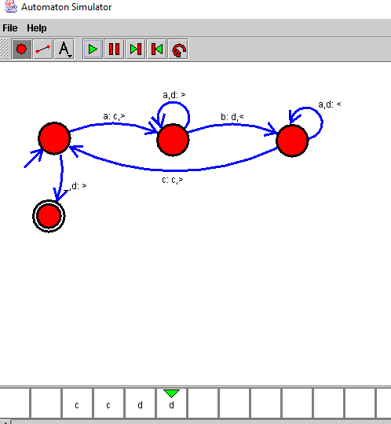

Result:

Hence we successfully designed TM using simulator.