1. Design TM using simulator to accept the input string anb2n

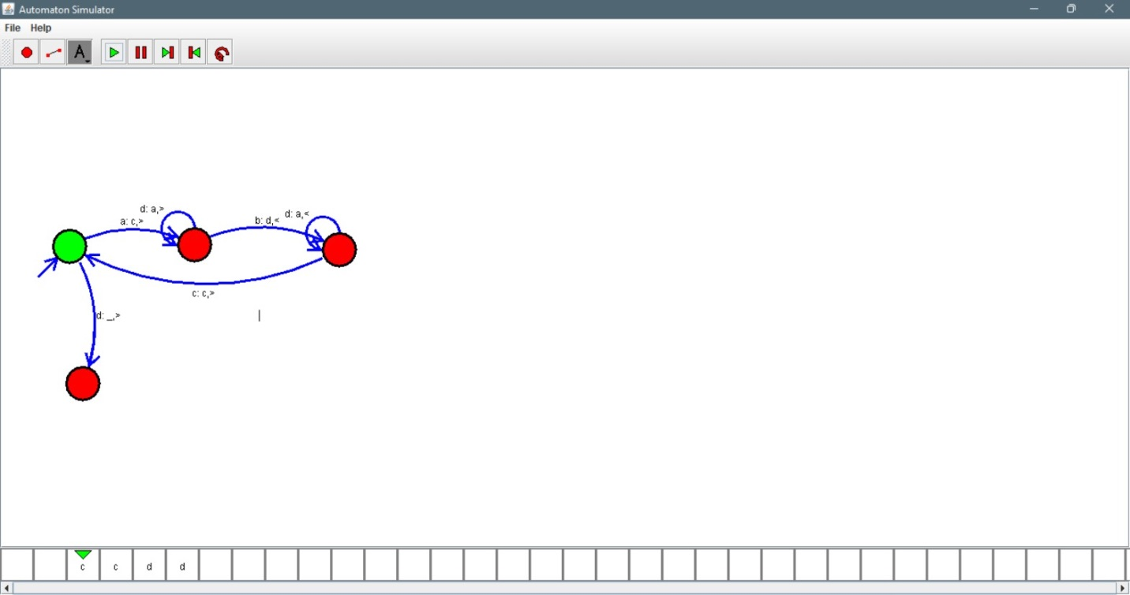

Result:

Hence we successfully designed TM using simulator.