7.Design TM using simulator to accept the input string ww

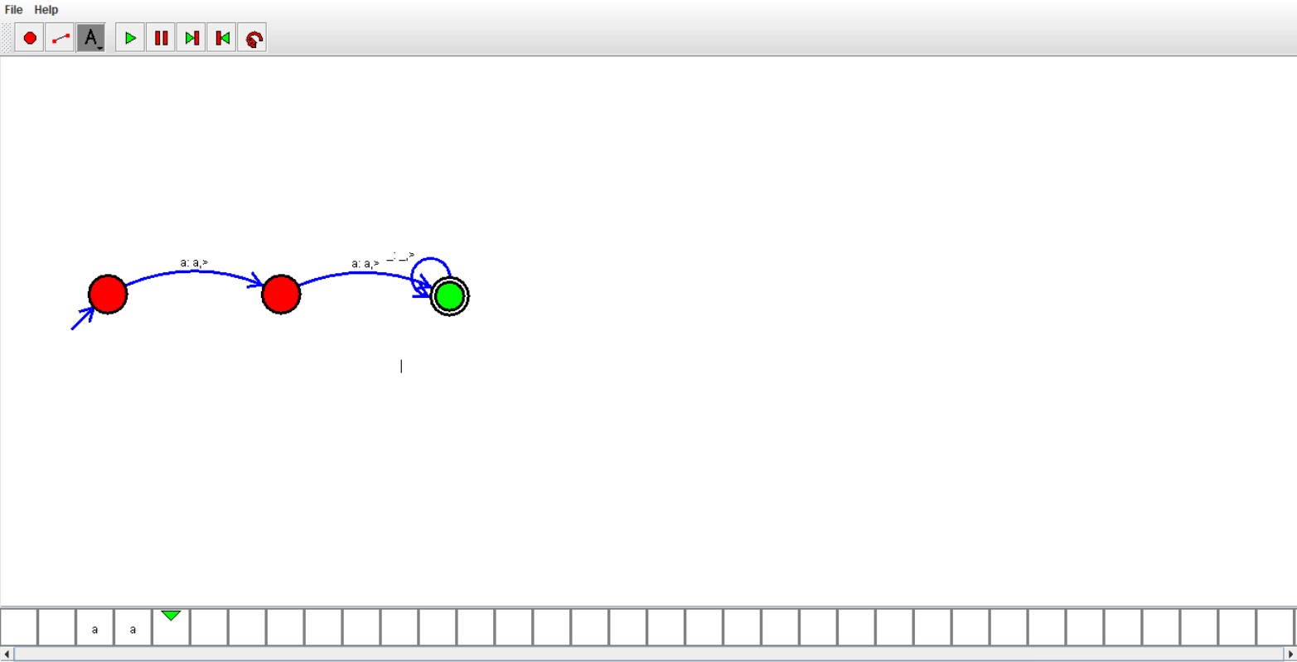

Result:

Hence we successfully designed TM using simulator.