1. Design DFA using simulator to accept even number of a’s.

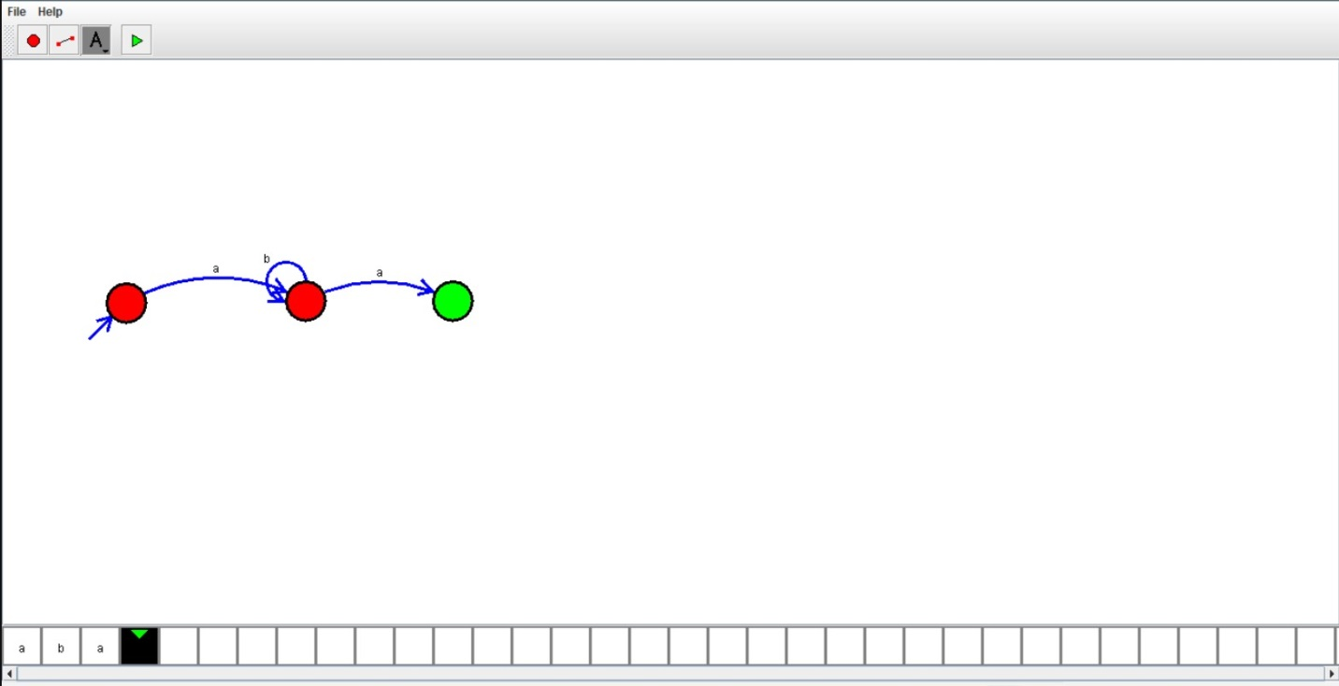  
RESULT:

Hence we designed dfa using simulator to accept the string.