22} Design DFA using simulator to accept odd number of a’s

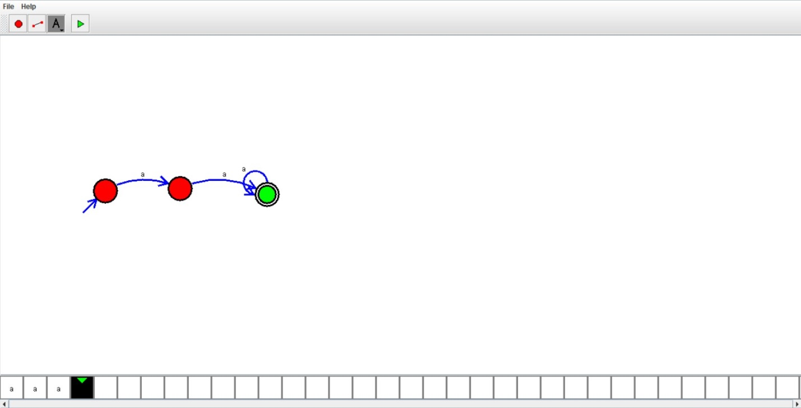

RESULT:

Hence we designed dfa using simulator