1. Design DFA using simulator to accept the string having ‘ab’ as substring over the set {a,b}

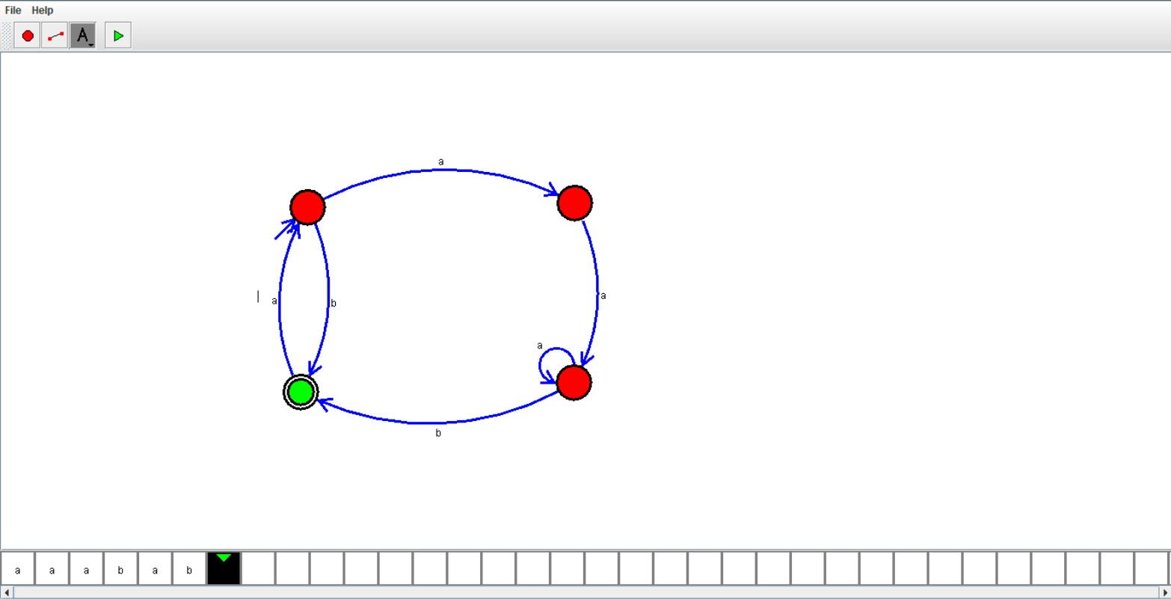

RESULT:

Hence we designed dfa using simulator