1. Design DFA using simulator to accept the string start with a or b over the set {a,b}

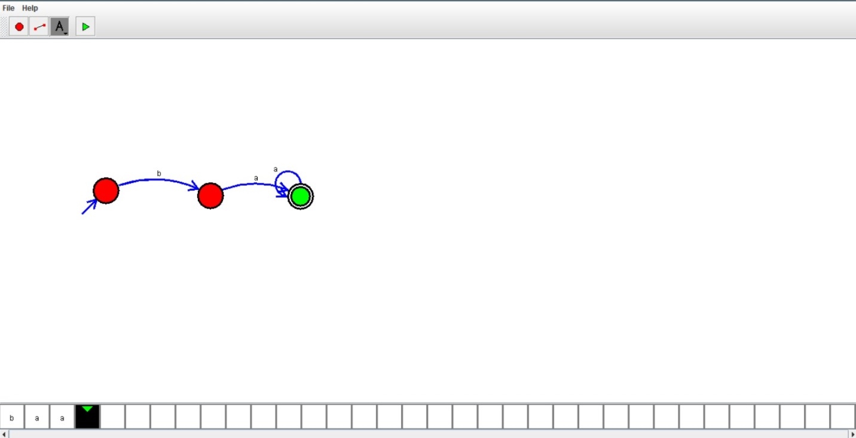

RESULT:

Hence we designed dfa using simulator