1. }Design TM using simulator to accept the input string Palindrome bbabb

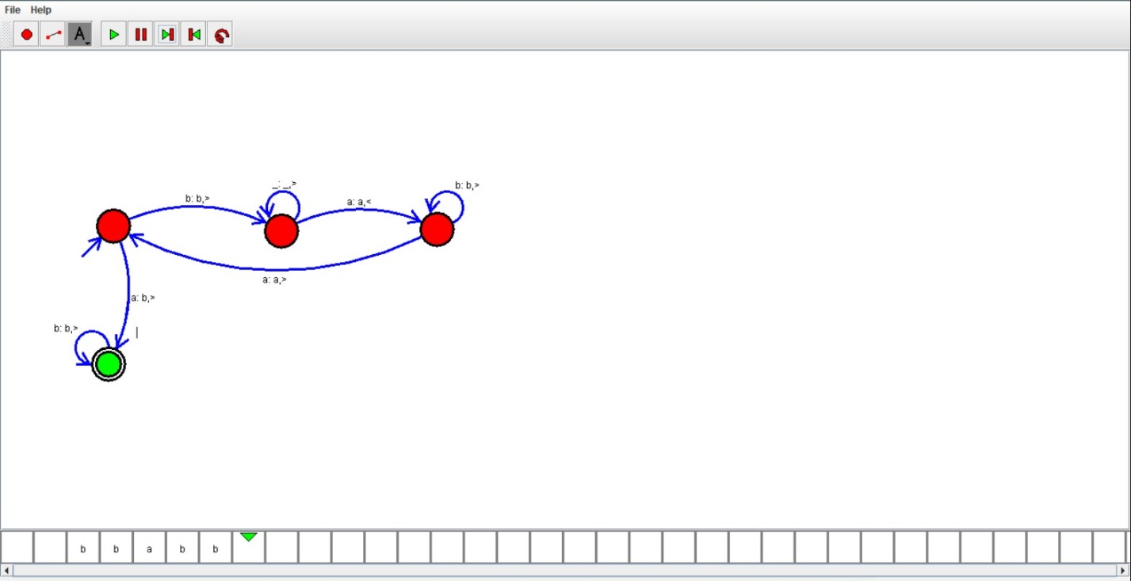

RESULT:

Hence we designed TM using simulator