27}Design TM using simulator to accept the input string wcw

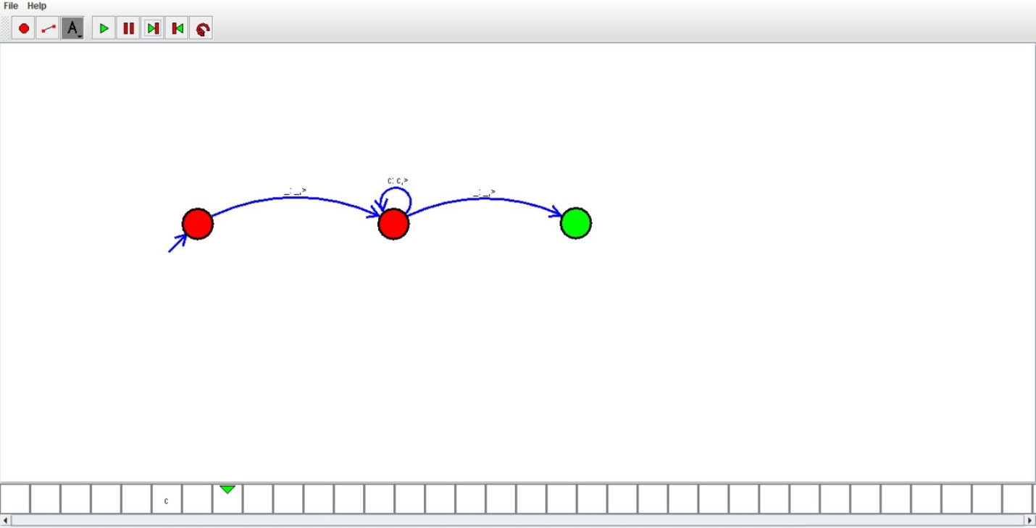

RESULT:

Hence we designed TM using simulator