1. Design DFA using simulator to accept the input string “bc” ,”c”,and ”bcaaa”.

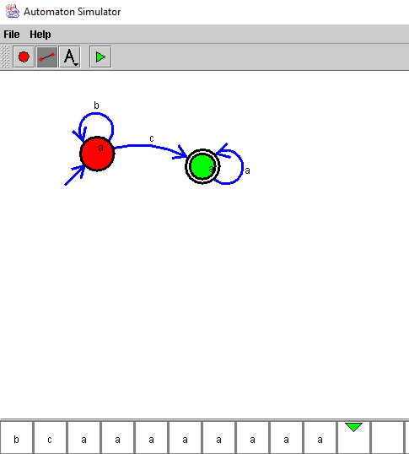

RESULT:

Hence we designed DFA using simulator