1. Design NFA to accept any number of a’s where input={a,b}.

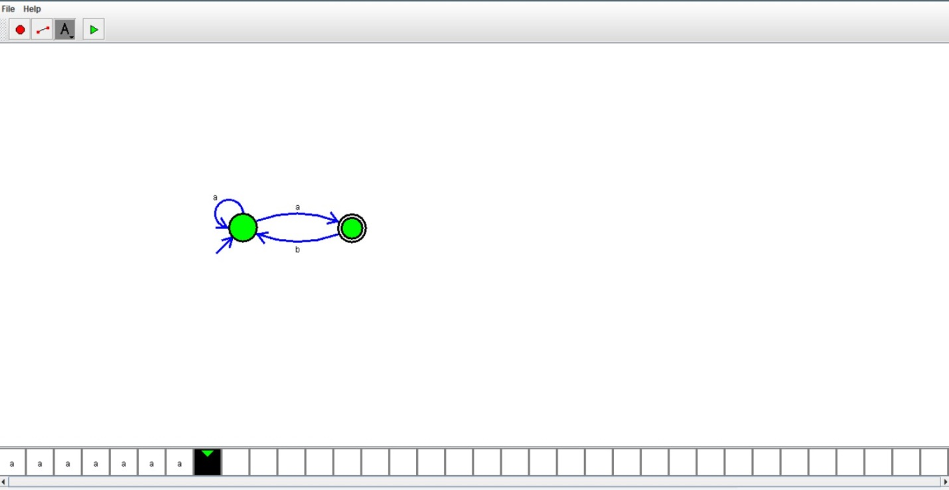

RESULT:

Hence we designed NFA using simulator