1. Design PDA using simulator to accept the input string anbn

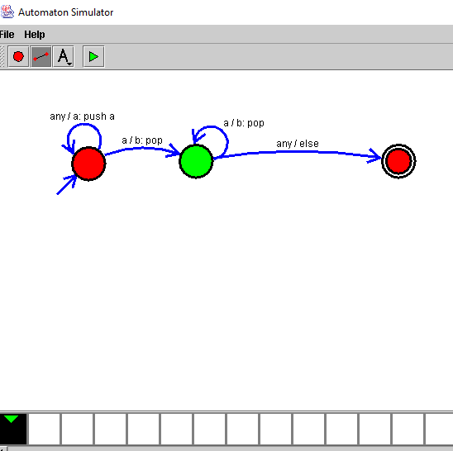

RESULT:

Hence we designed PDA using simulator