32.Design TM using simulator to perform string comparison where w={aba aba}

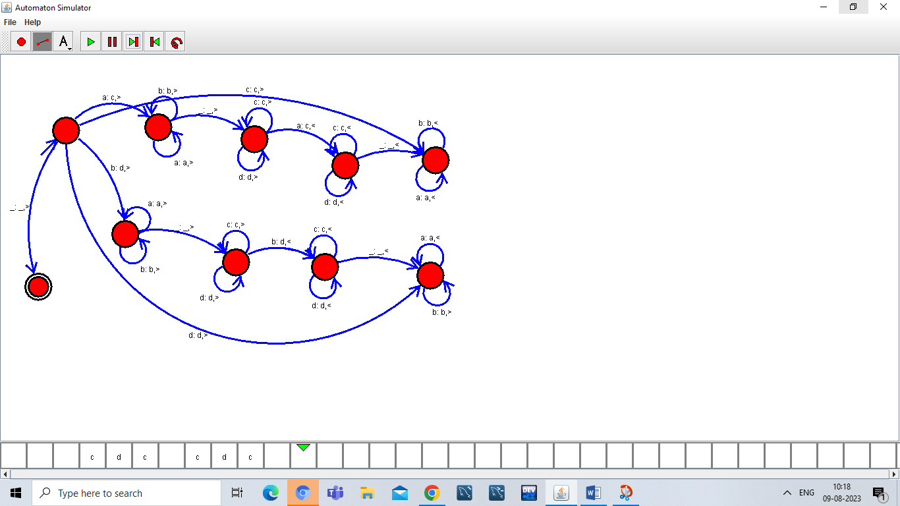

Result:

1. Hence ,we successfully designed and implemented TM to accept string.