1. Design DFA using simulator to accept even number of c’s over the set {a,b,c}

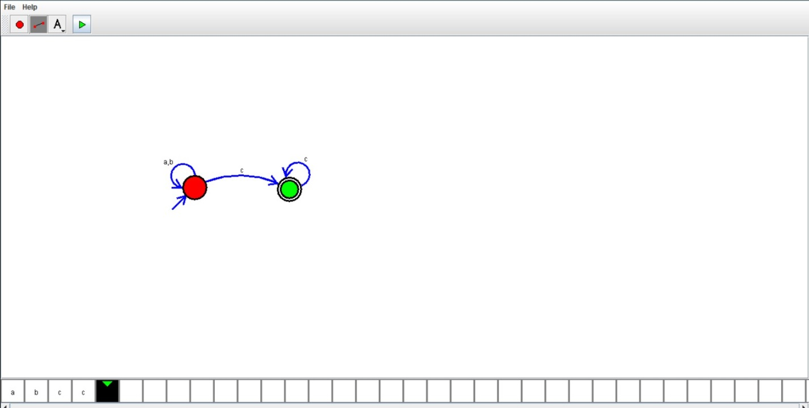

Result:

We designed dfa using simulator