1. Design NFA using simulator to accept the input string “bbc” ,”c”,and ”bcaaa”.

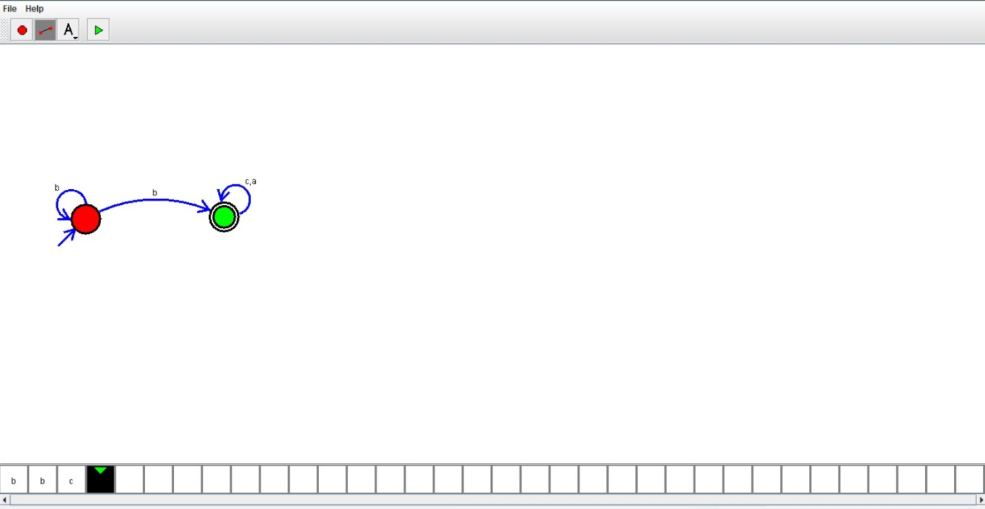

RESULT:

We designed NFA using simulator