1. Design NFA to accept any number of b’s where input={a,b}.

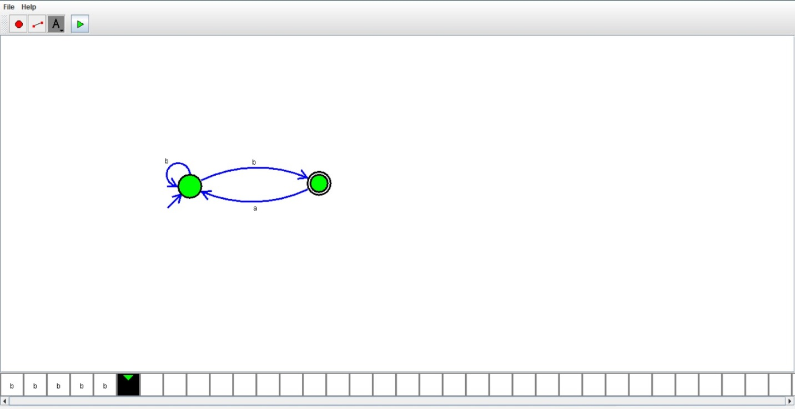

RESULT:

We designed NFA using simulator