DATABASE DESIGN & SQL / NOSQL IMPLEMENTATION ASSIGNMENT
Set 1 – Retail Inventory and Product Reviews
Relational Normalization (3NF), SQL Server Schema & DML Operations, and MongoDB Document Modeling
Student Name: D.V. Sai Kumar | Assignment Module: Assignment Set 1
Database Systems: Microsoft SQL Server (T-SQL) & MongoDB | Submission Date: November 12, 2026

1. Business Scenario & Normalization to 3NF
In the existing operational workflow, the retailer tracks all stock details inside a single flat spreadsheet containing the attributes: (SKU, product_name, category, supplier_name, supplier_phone, warehouse, quantity, reorder_level), alongside unstructured customer reviews stored as free text. Because product details, supplier contact information, and warehouse stock quantities are combined into a single relation, the dataset suffers from severe data redundancy and modification anomalies.
1.1 Anomalies Identified in the Unnormalized Spreadsheet
- Insertion Anomaly: A new supplier cannot be added to the system unless they already supply at least one product with an assigned SKU and warehouse stock entry. Similarly, a newly opened warehouse cannot be registered until inventory is placed there.
- Update Anomaly: If a supplier changes their phone number, every single row associated with that supplier across all products and warehouses must be updated. Missing even one row results in inconsistent contact records.
- Deletion Anomaly: If the last remaining stock record of a product in a warehouse is deleted (for instance, when clearing out a discontinued SKU), all metadata regarding the product's name, category, and its supplier is permanently lost.
1.2 Step-by-Step Normalization to Third Normal Form (3NF)
Normal Form | Transformation Applied | Resulting Relations & Keys
1NF (First Normal Form) | Eliminated repeating groups and separated free-text customer reviews into a dedicated document store (MongoDB). Identified composite primary key (SKU, Warehouse) for stock rows. | Inventory_Flat(SKU, Warehouse, Product_Name, Category, Supplier_Name, Supplier_Phone, Quantity, Reorder_Level)
2NF (Second Normal Form) | Removed partial dependencies where attributes depended only on SKU (product_name, category, supplier details) rather than the full composite key (SKU, Warehouse). | Products(SKU [PK], Product_Name, Category, Supplier_Name, Supplier_Phone)  Inventory_Stock(SKU [FK], Warehouse [PK], Quantity, Reorder_Level)
3NF (Third Normal Form) | Removed transitive dependencies (SKU -> Supplier_Name -> Supplier_Phone) and standardized warehouse locations into a lookup entity with surrogate keys. | Suppliers(supplier_id [PK], supplier_name, supplier_phone)  Warehouses(warehouse_id [PK], warehouse_code, location)  Products(sku [PK], product_name, category, supplier_id [FK], is_discontinued)  Inventory_Stock(stock_id [PK], sku [FK], warehouse_id [FK], quantity, reorder_level)

1.3 Entity-Relationship (ER) Diagram
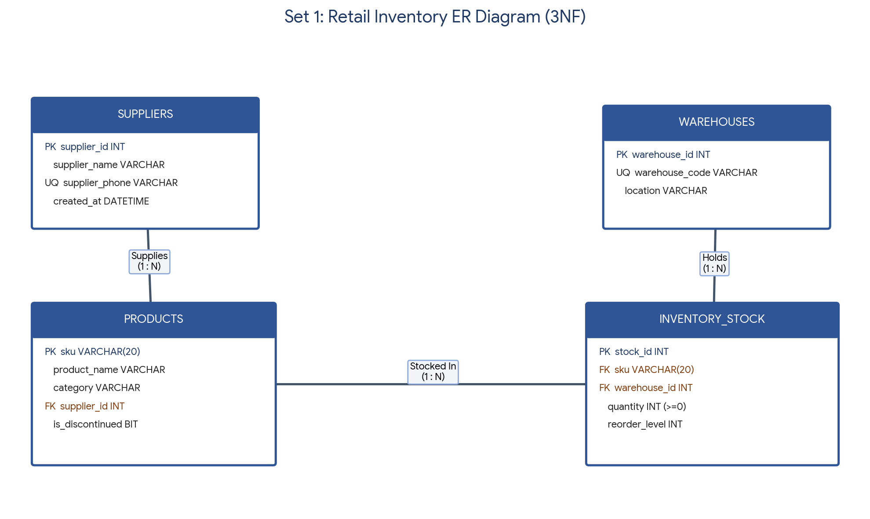
2. SQL Server Database & Table Schema (schema.sql)
The following T-SQL script creates the RetailInventoryDB database and enforces entity and referential integrity using PRIMARY KEY, FOREIGN KEY, UNIQUE, CHECK (quantity >= 0), DEFAULT constraints, and explicit referential actions (ON UPDATE CASCADE, ON DELETE NO ACTION / CASCADE).
File / Script: schema.sql
CREATE DATABASE RetailInventoryDB;
GO
USE RetailInventoryDB;
GO
-- 1. Suppliers Table
CREATE TABLE Suppliers (
supplier_id INT IDENTITY(1,1) PRIMARY KEY,
supplier_name VARCHAR(100) NOT NULL,
supplier_phone VARCHAR(20) NOT NULL UNIQUE,
created_at DATETIME NOT NULL DEFAULT GETDATE()
);
-- 2. Warehouses Table
CREATE TABLE Warehouses (
warehouse_id INT IDENTITY(1,1) PRIMARY KEY,
warehouse_code VARCHAR(20) NOT NULL UNIQUE,
location VARCHAR(100) NOT NULL
);
-- 3. Products Table
CREATE TABLE Products (
sku VARCHAR(20) PRIMARY KEY,
product_name VARCHAR(120) NOT NULL,
category VARCHAR(50) NOT NULL,
supplier_id INT NOT NULL,
is_discontinued BIT NOT NULL DEFAULT 0,
CONSTRAINT FK_Products_Suppliers FOREIGN KEY (supplier_id)
REFERENCES Suppliers(supplier_id)
ON UPDATE CASCADE
ON DELETE NO ACTION
);
-- 4. Inventory_Stock Table
CREATE TABLE Inventory_Stock (
stock_id INT IDENTITY(1,1) PRIMARY KEY,
sku VARCHAR(20) NOT NULL,
warehouse_id INT NOT NULL,
quantity INT NOT NULL DEFAULT 0 CHECK (quantity >= 0),
reorder_level INT NOT NULL DEFAULT 10 CHECK (reorder_level >= 0),
CONSTRAINT UQ_SKU_Warehouse UNIQUE (sku, warehouse_id),
CONSTRAINT FK_Stock_Products FOREIGN KEY (sku)
REFERENCES Products(sku)
ON UPDATE CASCADE
ON DELETE CASCADE,
CONSTRAINT FK_Stock_Warehouses FOREIGN KEY (warehouse_id)
REFERENCES Warehouses(warehouse_id)
ON UPDATE CASCADE
ON DELETE NO ACTION
);
GO

3. Data Seeding & Constraint Verification (seed_data.sql)
Each normalized table is populated with 10 valid records, followed by four deliberately failing INSERT statements designed to verify constraint enforcement across Primary Keys, Foreign Keys, CHECK constraints, and NOT NULL columns.
File / Script: seed_data.sql (Part A: Inserts & Constraint Tests)
USE RetailInventoryDB;
GO
-- Insert 10 Suppliers
INSERT INTO Suppliers (supplier_name, supplier_phone) VALUES
('Apex Electronics Ltd', '9840112201'), ('Zenith Home Goods', '9840112202'),
('Metro Apparel Co', '9840112203'), ('FreshHarvest Foods', '9840112204'),
('Prime Office Supplies', '9840112205'),('Vanguard Sports Gear', '9840112206'),
('Lumina Lighting Corp', '9840112207'), ('Nova Footwear Inc', '9840112208'),
('Aura Cosmetics Group', '9840112209'), ('Craftsman Tools Pvt', '9840112210');
-- Insert 10 Warehouses
INSERT INTO Warehouses (warehouse_code, location) VALUES
('WH-CHN-01', 'Chennai North'), ('WH-CHN-02', 'Chennai South'),
('WH-BLR-01', 'Bengaluru East'), ('WH-BLR-02', 'Bengaluru West'),
('WH-HYD-01', 'Hyderabad Central'),('WH-MUM-01', 'Mumbai Port'),
('WH-DEL-01', 'Delhi NCR'), ('WH-PUN-01', 'Pune Industrial'),
('WH-KOL-01', 'Kolkata Hub'), ('WH-COI-01', 'Coimbatore Logistics');
-- Insert 10 Products
INSERT INTO Products (sku, product_name, category, supplier_id, is_discontinued) VALUES
('SKU-1001', 'Wireless Mechanical Keyboard', 'Electronics', 1, 0),
('SKU-1002', 'Ceramic Coffee Mug Set', 'Home', 2, 0),
('SKU-1003', 'Cotton Crew Neck T-Shirt', 'Apparel', 3, 0),
('SKU-1004', 'Organic Almond Butter 500g', 'Grocery', 4, 0),
('SKU-1005', 'Ergonomic Mesh Office Chair', 'Furniture', 5, 0),
('SKU-1006', 'Carbon Fiber Badminton Racket','Sports', 6, 0),
('SKU-1007', 'Smart LED Desk Lamp', 'Lighting', 7, 0),
('SKU-1008', 'Running Shoes Pro v2', 'Footwear', 8, 0),
('SKU-1009', 'Hydrating Aloe Face Gel', 'Beauty', 9, 1), -- Discontinued
('SKU-1010', 'Cordless Drill Driver 18V', 'Hardware', 10, 1); -- Discontinued
-- Insert 10 Inventory Stock Records
INSERT INTO Inventory_Stock (sku, warehouse_id, quantity, reorder_level) VALUES
('SKU-1001', 1, 150, 25), ('SKU-1002', 2, 300, 50), ('SKU-1003', 3, 420, 60),
('SKU-1004', 4, 85, 20), ('SKU-1005', 5, 40, 10), ('SKU-1006', 6, 110, 15),
('SKU-1007', 7, 95, 20), ('SKU-1008', 8, 210, 30), ('SKU-1009', 9, 12, 15),
('SKU-1010', 10, 5, 10);
-- ============================================================================
-- FOUR DELIBERATELY FAILING INSERTS (CONSTRAINT DEMONSTRATION)
-- ============================================================================
-- 1. Duplicate Key Violation (PRIMARY KEY violation on 'SKU-1001')
INSERT INTO Products (sku, product_name, category, supplier_id)
VALUES ('SKU-1001', 'Duplicate Keyboard', 'Electronics', 1);
-- 2. Missing Parent Violation (FOREIGN KEY violation: supplier_id 999 does not exist)
INSERT INTO Products (sku, product_name, category, supplier_id)
VALUES ('SKU-9999', 'Orphan Gadget', 'Electronics', 999);
-- 3. Negative Quantity Violation (CHECK constraint violation: quantity >= 0)
INSERT INTO Inventory_Stock (sku, warehouse_id, quantity, reorder_level)
VALUES ('SKU-1001', 2, -15, 10);
-- 4. Null in Mandatory Column Violation (NOT NULL constraint on product_name)
INSERT INTO Products (sku, product_name, category, supplier_id)
VALUES ('SKU-1011', NULL, 'Electronics', 1);
GO

Test Case | Violated Constraint | SQL Server Error Behavior
Duplicate SKU ('SKU-1001') | PK_Products (PRIMARY KEY) | Msg 2627: Violation of PRIMARY KEY constraint. Cannot insert duplicate key in object 'dbo.Products'.
Missing Parent (supplier_id = 999) | FK_Products_Suppliers (FOREIGN KEY) | Msg 547: The INSERT statement conflicted with the FOREIGN KEY constraint 'FK_Products_Suppliers'.
Negative Stock (quantity = -15) | CK__Inventory__quant (CHECK) | Msg 547: The INSERT statement conflicted with the CHECK constraint 'quantity >= 0'.
NULL Product Name | NOT NULL on product_name | Msg 515: Cannot insert the value NULL into column 'product_name'; column does not allow nulls.

4. UPDATE & DELETE Operations with Before/After Verification
To maintain accurate vendor records and purge discontinued items, SELECT queries are executed before and after running targeted UPDATE and DELETE statements with WHERE predicates.
File / Script: seed_data.sql (Part B: UPDATE & DELETE Verification)
-- A. Correct Supplier Phone Number (Apex Electronics Ltd)
SELECT supplier_id, supplier_name, supplier_phone FROM Suppliers WHERE supplier_id = 1;
UPDATE Suppliers
SET supplier_phone = '9840998877'
WHERE supplier_id = 1;
SELECT supplier_id, supplier_name, supplier_phone FROM Suppliers WHERE supplier_id = 1;
-- B. Remove Discontinued SKUs (Cascades automatically to Inventory_Stock)
SELECT p.sku, p.product_name, p.is_discontinued, s.warehouse_id, s.quantity
FROM Products p
LEFT JOIN Inventory_Stock s ON p.sku = s.sku
WHERE p.is_discontinued = 1;
DELETE FROM Products
WHERE is_discontinued = 1;
SELECT p.sku, p.product_name, p.is_discontinued, s.warehouse_id, s.quantity
FROM Products p
LEFT JOIN Inventory_Stock s ON p.sku = s.sku
WHERE p.is_discontinued = 1;
GO

Operation | Before Execution (SELECT Output) | After Execution (SELECT Output)
UPDATE Suppliers Phone | supplier_id: 1 | Apex Electronics Ltd | 9840112201 | supplier_id: 1 | Apex Electronics Ltd | 9840998877
DELETE Discontinued SKUs | 2 rows returned: SKU-1009 (Qty 12) & SKU-1010 (Qty 5) | 0 rows returned (removed from Products & Inventory_Stock)

5. MongoDB Document Design & Collection Operations (collections.js)
5.1 Data Placement Justification (One-Line Each)
- Product Reviews: Customer reviews vary widely in length, nested media attachments, and category-specific rating attributes, making MongoDB's flexible document schema ideal without requiring sparse columns or expensive joins.
- Search Activity: High-velocity user search logs contain nested filter facets and clickstream arrays that require rapid write throughput and horizontal scaling better suited to MongoDB than transactional SQL tables.
File / Script: collections.js
// Switch to retail_nosql database
use retail_nosql;
// 1. Create 'reviews' collection with $jsonSchema validator
db.createCollection("reviews", {
validator: {
$jsonSchema: {
bsonType: "object",
required: ["sku", "customer_name", "rating", "review_text", "created_at"],
properties: {
sku: { bsonType: "string", description: "Must match product SKU string" },
customer_name: { bsonType: "string" },
rating: { bsonType: "int", minimum: 1, maximum: 5 },
review_text: { bsonType: "string" },
verified_purchase: { bsonType: "bool" },
attributes: { bsonType: "object" },
created_at: { bsonType: "date" }
}
}
}
});
// 2. insertMany: Add sample product reviews
db.reviews.insertMany([
{
sku: "SKU-1001", customer_name: "Arjun Mehta", rating: 5,
review_text: "Tactile switches feel amazing and battery lasts weeks.",
verified_purchase: true, attributes: { switch_type: "Brown", backlit: true },
created_at: new Date("2026-10-15T10:30:00Z")
},
{
sku: "SKU-1001", customer_name: "Priya Nair", rating: 4,
review_text: "Great keyboard, slightly heavy for travel.",
verified_purchase: true, created_at: new Date("2026-10-22T14:15:00Z")
},
{
sku: "SKU-1005", customer_name: "Karthik R", rating: 2,
review_text: "Lumbar support adjustment lever arrived stiff.",
verified_purchase: false, created_at: new Date("2026-11-01T09:00:00Z")
}
]);
// 3. find: Retrieve verified reviews for SKU-1001 with rating >= 4
db.reviews.find({ sku: "SKU-1001", verified_purchase: true, rating: { $gte: 4 } });
// 4. updateOne: Update Karthik's review after replacement part was sent
db.reviews.updateOne(
{ sku: "SKU-1005", customer_name: "Karthik R" },
{ $set: { rating: 4, review_text: "Replacement lever fixed the issue. Comfortable chair." } }
);
// 5. deleteOne: Remove an unverified or spam review
db.reviews.deleteOne({ sku: "SKU-1005", verified_purchase: false });

5.2 Comparison of SQL Server vs. MongoDB Operations Used
Operation Type | SQL Server (T-SQL) | MongoDB (MQL) | Architectural Purpose in Set 1
Schema Enforcement | CREATE TABLE with PK, FK, CHECK, NOT NULL | db.createCollection() with $jsonSchema validator | Enforces strict relational integrity on stock vs. flexible validation on reviews.
Create / Insert | INSERT INTO ... VALUES (...) | db.reviews.insertMany([...]) | Adds normalized rows in SQL and nested review documents in MongoDB.
Read / Query | SELECT ... FROM ... JOIN ... WHERE | db.reviews.find({ filter }) | Joins product/warehouse tables in SQL; queries nested fields in MongoDB.
Modify / Update | UPDATE table SET col = val WHERE ... | db.reviews.updateOne({ filter }, { $set }) | Updates supplier phone in SQL; modifies specific review text/rating in MongoDB.
Remove / Delete | DELETE FROM table WHERE ... | db.reviews.deleteOne({ filter }) | Purges discontinued SKUs with cascade in SQL; removes single review in MongoDB.

