Day 3 – Agile and Scrum Foundations
Topics covered: Agile Overview · Scrum Roles, Events and Artifacts · User Stories, Backlog and Estimation

Set 2 – Insurance Claims Portal
Prepared by: D V Sai Kumar Programme: Hexaware Training Day: 3
Business Scenario | An insurer is building a self-service portal where customers lodge claims, upload documents and track settlement status.
Assumptions | The product is called ClaimEase. The name is chosen for this exercise.  No team details were supplied, so roles are described by title (Product Owner, Scrum Master, Developers) and not by person.  The users are policyholders (customers) and claims officers (insurer staff). Policyholders already have a portal login.  Story points use the Planning Poker values 1, 2, 3, 5, 8 and 13, agreed by the Developers.  Story IDs (CLM-101 and so on) are the team's own IDs. Jira numbers issues automatically, so the team ID is written at the start of each story title.

Task 1 – Product vision and Waterfall versus Agile

Product vision statement
For policyholders who need to make an insurance claim after a loss and are tired of paperwork, phone calls and not knowing what is happening, ClaimEase is a self-service claims portal that lets them lodge a claim, upload documents and follow the settlement online.
Unlike the current paper and call-centre process, our product shows a clear status at every step and tells the customer as soon as the claim is settled.

Waterfall versus Agile
Aspect | Waterfall | Agile (Scrum)
Requirements | Fixed in full before building starts. | Start with a backlog and refine it every sprint.
Delivery | One release at the end of the project. | A working increment every 2 weeks.
Customer feedback | Late, mostly at final testing. | At every Sprint Review.
Change | Slow, through formal change control. | Welcome. The Product Owner reorders the backlog.
Risk | Problems found late, when they cost most. | Found early, in small steps.
Why Agile suits this programme:
- Claim rules, required documents and regulations change, so the requirements cannot be fixed on day one.
- Claims officers and policyholders can see working screens early and correct them, instead of finding gaps at the end.
- Value comes early: claim registration can go live first, and tracking and notifications follow in later sprints.

Task 2 – Four epics and 13 user stories
Epic | Name | Goal
E1 | Claim Registration | A policyholder can lodge a valid claim and get a reference number.
E2 | Document Upload | Supporting documents can be uploaded, checked and verified.
E3 | Claim Tracking | Customers and officers can see and update where a claim stands.
E4 | Settlement Notifications | Customers are told the decision and the settlement details.

ID | Epic | User story (first draft)
CLM-101 | E1 | As a policyholder, I want to select the policy I am claiming against, so that my claim is linked to the correct policy.
CLM-102 | E1 | As a policyholder, I want to enter the incident details (date, place, claim type and description), so that the insurer knows what happened.
CLM-103 | E1 | As a policyholder, I want the claim form to be easy to use and to validate my entries, so that I make no mistakes.
CLM-104 | E1 | As a policyholder, I want to submit my claim and receive a claim reference number, so that I can refer to it later.
CLM-201 | E2 | As a policyholder, I want to upload supporting documents (photos, PDFs and videos) with virus scanning, preview and secure storage, so that the insurer can verify my loss.
CLM-202 | E2 | As a policyholder, I want to see which documents my claim type needs and which are still missing, so that I know what to provide.
CLM-203 | E2 | As a claims officer, I want to view each uploaded document and mark it accepted or rejected with a reason, so that the claim can move forward.
CLM-301 | E3 | As a policyholder, I want to see a list of all my claims with their current status, so that I know where each claim stands.
CLM-302 | E3 | As a policyholder, I want to see the dated status history of one claim, so that I understand what has happened so far.
CLM-303 | E3 | As a claims officer, I want to update the status of a claim, so that the policyholder sees the latest progress.
CLM-401 | E4 | As a policyholder, I want to receive an SMS and an e-mail when my claim is approved or rejected, so that I do not have to keep checking the portal.
CLM-402 | E4 | As a policyholder, I want to see the settlement amount and the expected payment date on my claim, so that I can plan my finances.
CLM-403 | E4 | As a claims officer, I want to calculate the settlement, approve it, pay it into the customer's bank account and notify the customer, so that the claim is closed.

Task 3 – INVEST review and vertical splitting
ID | I | N | V | E | S | T | Result
CLM-101 | ✔ | ✔ | ✔ | ✔ | ✔ | ✔ | Passes all six criteria.
CLM-102 | ✔ | ✔ | ✔ | ✔ | ✔ | ✔ | Passes all six criteria.
CLM-103 | ✔ | ✔ | ✔ | ✔ | ✔ | ✘ | Fails T. "Easy to use" cannot be tested.
CLM-104 | ✔ | ✔ | ✔ | ✔ | ✔ | ✔ | Passes all six criteria.
CLM-201 | ✔ | ✔ | ✔ | ✔ | ✘ | ✔ | Fails S. Three file types, virus scanning, preview and storage are too much for one story.
CLM-202 | ✔ | ✔ | ✔ | ✔ | ✔ | ✔ | Passes all six criteria.
CLM-203 | ✔ | ✔ | ✔ | ✔ | ✔ | ✔ | Passes all six criteria.
CLM-301 | ✔ | ✔ | ✔ | ✔ | ✔ | ✔ | Passes all six criteria.
CLM-302 | ✔ | ✔ | ✔ | ✔ | ✔ | ✔ | Passes all six criteria.
CLM-303 | ✔ | ✔ | ✔ | ✔ | ✔ | ✔ | Passes all six criteria.
CLM-401 | ✔ | ✔ | ✔ | ✔ | ✔ | ✔ | Passes all six criteria.
CLM-402 | ✔ | ✔ | ✔ | ✔ | ✔ | ✔ | Passes all six criteria.
CLM-403 | ✔ | ✔ | ✔ | ✘ | ✘ | ✔ | Fails E and S. Four jobs in one story, and the bank payment link is not yet known.
Stories too large: CLM-201 and CLM-403. CLM-103 is also rewritten because it cannot be tested.

Why the split is vertical and not by technical layer
A horizontal split cuts the story by technical layer (database, then API, then screen). None of the pieces gives the user anything, and nothing can be demonstrated until all layers are done. A vertical split cuts a thin slice through every layer (screen, logic and data), so each slice can be built, tested and shown to the user on its own.
Story | Wrong: split by layer | Right: vertical slices
CLM-201 | Create upload database tables  Build upload API  Build upload screen | CLM-201 Upload a photo (JPG or PNG, up to 5 MB) and see it in the claim's document list.  CLM-204 Upload a PDF (up to 10 MB) in the same way.  CLM-205 An infected file is blocked and the customer sees a message.  Videos and preview are parked for a later release.
CLM-403 | Create settlement database tables  Build payment API  Build settlement screen | CLM-403 Approve or reject a claim and record the settlement amount, so the decision shows on the claim.  CLM-404 Pay the approved amount to the customer's registered bank account and mark the claim Settled.

CLM-103 rewritten: As a policyholder, I want the claim form to show a clear error next to any missing or invalid field (for example, an incident date in the future), so that I can correct it before submitting.
The backlog now has 16 stories: the 13 drafts, with CLM-201 and CLM-403 rewritten, plus the three new slices CLM-204, CLM-205 and CLM-404.

Task 4 – Acceptance criteria for the Claim Registration stories
Scenarios marked (Negative) cover failures. The validation failure scenarios are CLM-102 scenario 2 and CLM-103 scenarios 1 and 2.

CLM-101 – Select the policy for the claim
Scenario | Given | When | Then
1. Policy selected | A logged-in policyholder has two active policies | They open Lodge a claim | Both policies are listed with number and type, and the customer can select one to continue.
2. No active policy (Negative) | A logged-in policyholder has no active policy | They open Lodge a claim | The message "You have no active policy" is shown and the Continue button is disabled.

CLM-102 – Enter the incident details
Scenario | Given | When | Then
1. Valid details | A policy is selected | The customer enters an incident date of today or earlier, the place, a claim type and a description | The details are accepted and the customer can go to the next step.
2. Validation failure (Negative) | The customer is on the incident details form | They enter an incident date in the future or leave the place empty | The field is highlighted with a message such as "Incident date cannot be in the future" and the Next button stays disabled.

CLM-103 – Show clear errors for missing or invalid fields
Scenario | Given | When | Then
1. Missing field (Negative) | The description field is empty | The customer clicks Submit | "Description is required" appears next to the field, the claim is not submitted and all other entries are kept.
2. Invalid date (Negative) | The incident date is set to tomorrow | The customer moves to the next field | The error "Incident date cannot be in the future" is shown next to the date field.
3. All fields valid | All required fields are filled with valid data | The customer reviews the form | No errors are shown and the Submit button is enabled.

CLM-104 – Submit the claim and receive a reference number
Scenario | Given | When | Then
1. Successful submission | A complete and valid claim form | The customer clicks Submit | The claim is saved with status Registered, a unique reference number (for example CLM-2026-000123) is shown and a confirmation is sent.
2. System unavailable (Negative) | A complete and valid form and the server is temporarily down | The customer clicks Submit | The message "We could not submit your claim. Your details are saved, please try again" is shown and no duplicate claim is created.

Task 5 – Planning Poker estimates and total backlog size
Reference story: CLM-301 Claims list with status = 3 points. It is well understood: one screen that lists the customer's claims from the database. Every other story is compared with it. Cards used: 1, 2, 3, 5, 8, 13.
ID | Story | Points | Reason (compared with CLM-301)
CLM-101 | Select policy | 3 | A list of the customer's active policies plus a selection. Similar to 301.
CLM-102 | Incident details form | 3 | One form with a few fields. Similar to 301.
CLM-103 | Field validation and errors | 3 | A few rules to check and error messages to show.
CLM-104 | Submit and reference number | 5 | Saves the claim, generates a unique reference and sends a confirmation.
CLM-201 | Upload a photo | 5 | File storage, type and size checks, and a document list.
CLM-204 | Upload a PDF | 2 | Reuses the upload work of CLM-201, so only a new file type is added.
CLM-205 | Block infected files | 5 | Uses a ready-made virus-scanning service. See the outlier discussion below.
CLM-202 | Required documents checklist | 3 | A list of documents per claim type, with missing ones marked.
CLM-203 | Officer verifies documents | 5 | A new officer screen with accept or reject, a reason and a saved result.
CLM-301 | Claims list with status | 3 | Reference story.
CLM-302 | Status history of a claim | 3 | A dated list of status changes for one claim.
CLM-303 | Officer updates status | 3 | A status change with a saved history entry.
CLM-401 | SMS and e-mail on decision | 5 | Two channels and two message templates, using an external provider.
CLM-402 | Settlement amount and date | 2 | Displays two values that are already stored on the claim.
CLM-403 | Approve or reject, record amount | 5 | An officer decision screen with rules and a saved amount.
CLM-404 | Pay to bank and mark Settled | 8 | Bank integration, failure handling and a status change. See the outlier discussion below.
 | Total backlog size | 63

Recorded discussion on the outliers
Story | Round 1 votes | Round 2 votes | Discussion
CLM-205 Block infected files | 3, 5, 5, 8, 13 | 5, 5, 5, 5, 5 | The voter with 13 thought the team would have to build a virus scanner. The voter with 3 had forgotten the rejection message for the customer. The team agreed to use a ready-made antivirus service and settled on 5.
CLM-404 Pay to bank | 3, 8, 8, 8, 13 | 8, 8, 8, 8, 8 | The voter with 3 assumed the bank API is simple. The voter with 13 was worried about failed payments, retries and matching the payment to the claim. The bank offers a test API and a simple retry is enough, so the team settled on 8.
The votes above are a sample of how the discussion is recorded.

Total backlog size
The total is 63 story points across 16 stories. Per epic: E1 Claim Registration = 14, E2 Document Upload = 20, E3 Claim Tracking = 9, E4 Settlement Notifications = 20. If the team's velocity is about 20 points per sprint (an assumption, because no velocity was given), the backlog is about 3 to 4 sprints of work.

Estimated and ordered backlog
Rank | ID | Story | Epic | Points | Cumulative points
1 | CLM-101 | Select the policy | E1 | 3 | 3
2 | CLM-102 | Enter incident details | E1 | 3 | 6
3 | CLM-103 | Clear errors for invalid fields | E1 | 3 | 9
4 | CLM-104 | Submit claim, get reference | E1 | 5 | 14
5 | CLM-201 | Upload a photo | E2 | 5 | 19
6 | CLM-204 | Upload a PDF | E2 | 2 | 21
7 | CLM-205 | Block infected files | E2 | 5 | 26
8 | CLM-202 | Required documents checklist | E2 | 3 | 29
9 | CLM-301 | Claims list with status | E3 | 3 | 32
10 | CLM-303 | Officer updates status | E3 | 3 | 35
11 | CLM-203 | Officer verifies documents | E2 | 5 | 40
12 | CLM-302 | Status history of a claim | E3 | 3 | 43
13 | CLM-403 | Approve or reject, record amount | E4 | 5 | 48
14 | CLM-402 | Settlement amount and date | E4 | 2 | 50
15 | CLM-404 | Pay to bank, mark Settled | E4 | 8 | 58
16 | CLM-401 | SMS and e-mail on decision | E4 | 5 | 63
 |  | Total |  | 63

Task 6 – JIRA project, board, epics, story states and DoD

How the project was set up
- A Scrum project named "ClaimEase" was created in Jira.
- The four epics were created: Claim Registration, Document Upload, Claim Tracking and Settlement Notifications.
- The 16 stories were created with their team ID in the title, linked to their epic, given story points and ordered in the Backlog by the rank in Task 5.
- The board has four story states: To Do, In Progress, In Review and Done.
- Sprint 1 holds the first five stories (19 points) with the Sprint Goal: "A policyholder can lodge a validated claim, receive a reference number and upload a first photo."
- The Definition of Done is created as a Jira task and attached as a file.

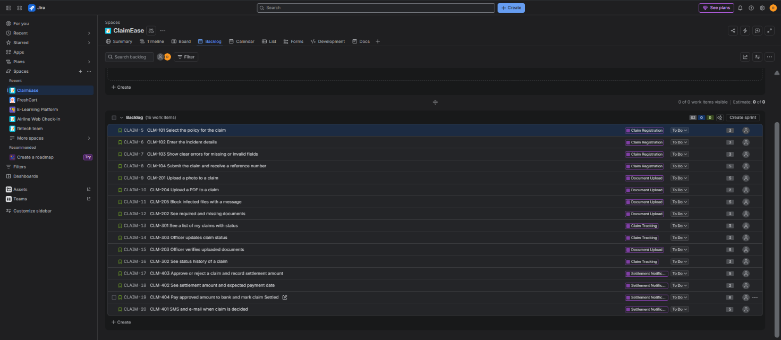

Figure 1: Jira Backlog view with epics, stories and story points
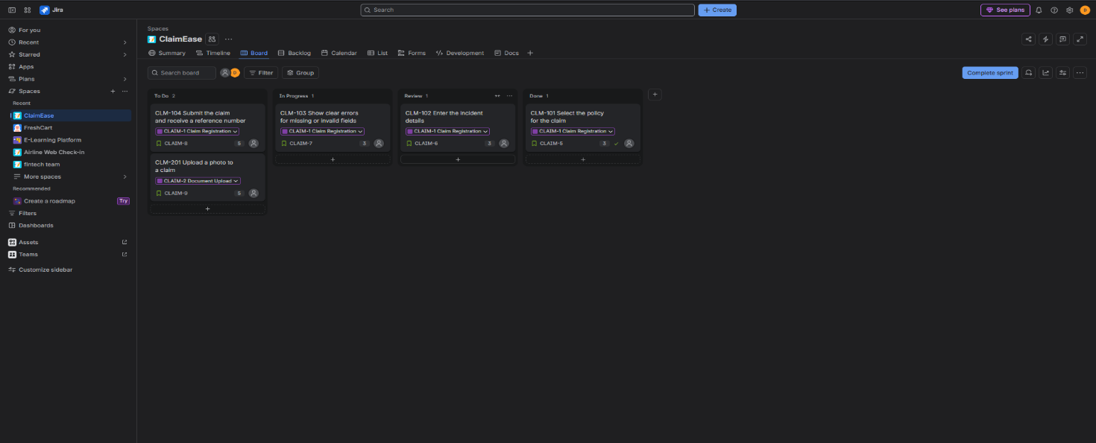
Figure 2.1: Jira board with the story states
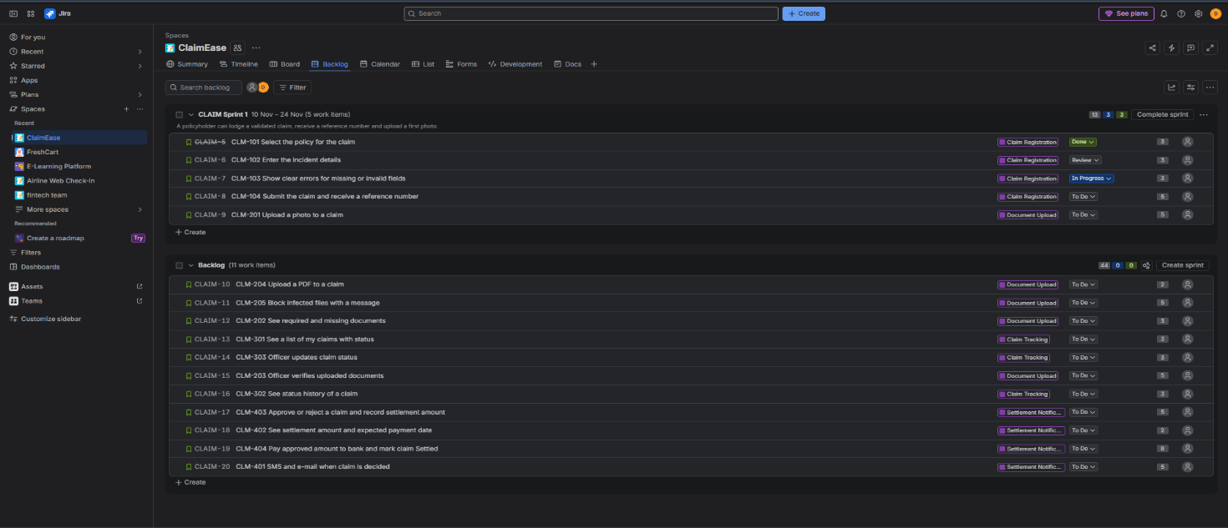
Figure 2.2: Jira board with the story states

Definition of Done (DoD)
A story is done only when all of these are true. The same list is attached to the Jira task "Definition of Done".
# | Criterion
1 | The code is written, follows the coding standard and the pull request is reviewed and approved by a second developer.
2 | Unit tests are written and pass, and new code has at least 80% test coverage.
3 | Every acceptance criterion of the story is tested and passes, including the negative scenarios.
4 | There are no open critical or major defects for the story.
5 | The code is merged, built and deployed to the test environment, and the regression tests still pass.
6 | Security and privacy are met: personal data and uploaded documents are stored securely and no sensitive data appears in logs.
7 | Documentation is updated (API notes and on-screen help text).
8 | The Product Owner has reviewed the story in a demo and accepted it. Only then does the card move to Done.

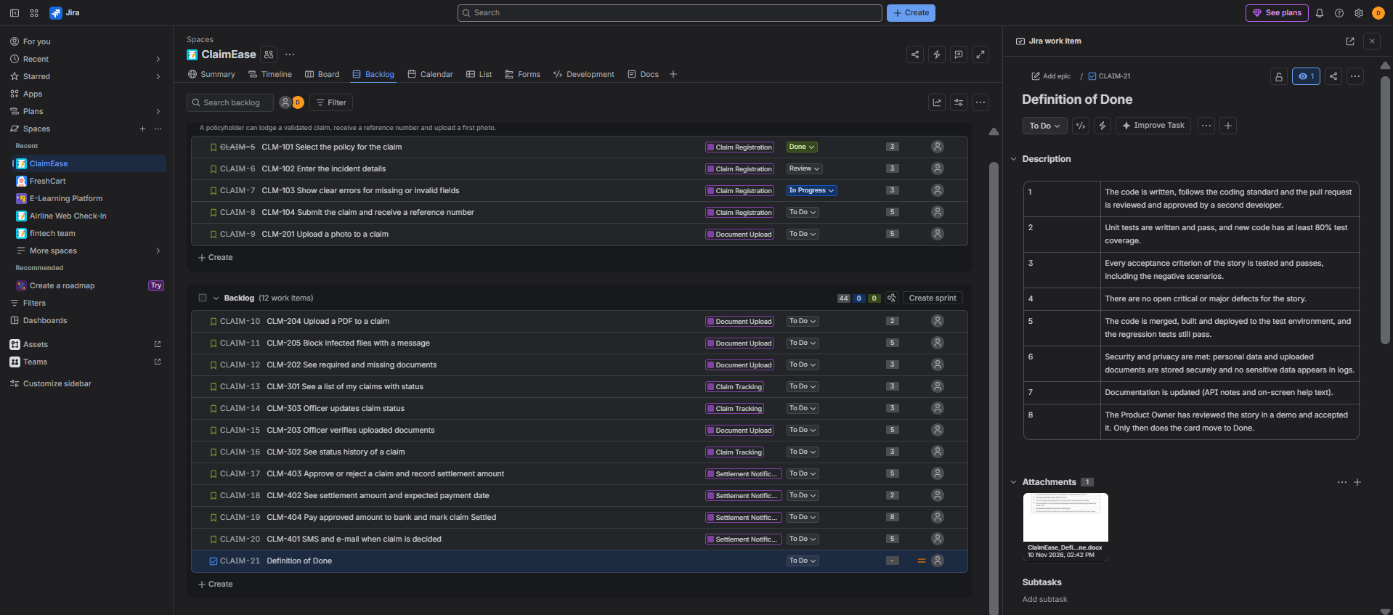
Figure 3: Definition of Done recorded and attached in Jira

Deliverable – One-page note on the roles, events and artifacts used
The ClaimEase programme uses Scrum with 2-week sprints. Jira is the tool that holds the backlog and the board.

Roles
Role | Who | What they do in this project
Product Owner | Head of Claims (assumed) | Owns the vision and the Product Backlog, orders the stories by value and accepts each story at the Sprint Review.
Scrum Master | One team member | Coaches the team in Scrum, runs the events, removes impediments such as a missing bank test account, and keeps the Jira board healthy.
Developers | Developers, testers and a UI designer | Estimate with Planning Poker, split stories vertically, and build and test each story to the Definition of Done.

Events
Event | Usual time-box | Purpose and use here
Sprint | 2 weeks | The container for all other events. Sprint 1 aims to deliver claim registration and a first photo upload.
Sprint Planning | About 4 hours | The team chooses the top stories from the backlog and agrees the Sprint Goal.
Daily Scrum | 15 minutes | Developers plan the next 24 hours and raise blockers, for example waiting for an API.
Sprint Review | About 2 hours | The team shows the working increment, and the Product Owner accepts stories and updates the backlog.
Sprint Retrospective | About 1.5 hours | The team improves its way of working, with one or two actions for the next sprint.
Backlog refinement (splitting and estimating stories) happens during the sprint. It is a regular activity and not a formal event.

Artifacts
Artifact | In this project | Commitment
Product Backlog | 16 ordered stories under 4 epics, 63 story points, kept in Jira. | Product Goal (the product vision).
Sprint Backlog | The stories chosen for Sprint 1 and the plan to deliver them, shown on the board. | Sprint Goal.
Increment | The working, tested part of the portal that meets the Definition of Done. | Definition of Done.

