Day 2 – Problem Solving Techniques and Data Structures – II
Set 3 – Logistics Network and Delivery Windows
Submitted by | D V Sai Kumar
Date | 2 November 2026
Language | Python 3.12 (standard library only; matplotlib just for the three figures)
Topics | Binary search tree, hash maps, graphs (BFS and DFS), sliding window, two pointers
Contents | Problem statement, setup, Tasks 1 to 5 (code, output, observations), figures, decision table
1. Problem statement
Business scenario: A courier company is optimising hub-to-hub routing and delivery-window planning across a national network.
Tasks
- Store hub codes in a BST and implement search and insert; identify the height of the tree for a given insertion order and explain the effect of sorted input.
- Build a lookup of parcel tracking numbers using a hash map; implement a check that reports parcels scanned twice at the same hub.
- Represent 10 hubs and their direct routes as an adjacency list; find the route with the fewest hops between two hubs (BFS) and list every hub reachable from the central depot (DFS).
- Given hourly parcel counts, find the 4-hour window with the highest average using a sliding window.
- Use two pointers to check whether a delivery route description is a palindrome of hub codes, ignoring case and separators.
Deliverables: Code, graph diagram or adjacency list used, output and a short explanation of every algorithm choice.
2. Setup and sample data
The task sheet does not give any data, so I made the data up inside the programs. There are 10 hubs with three-letter codes like the airport codes of Indian cities (NAG for Nagpur is the central depot because it sits in the middle of the country), 11 direct routes between them, a few hand-typed parcel scans plus a bigger generated set, 24 hourly parcel counts for one day, and a list of route descriptions for the palindrome check. The network and the numbers are invented. They are only there so the algorithms have something to work on.
Anything random uses a fixed seed, so the output is the same on every run. The only thing that changes between runs is the timing numbers, because they depend on the computer.
Everything uses the Python standard library. Each task has its own file and main.py runs all five one after another. make_figures.py draws the three figures and is the only file that needs matplotlib.
File | What it does
task1_bst.py | BST of hub codes: insert, search, height, effect of insertion order
task2_scans.py | Parcel lookup with a hash map and the same-hub double scan check
task3_routes.py | Adjacency list of 10 hubs, BFS fewest hops, DFS reachable hubs
task4_window.py | Busiest 4-hour window with a sliding window
task5_palindrome.py | Route palindrome check with two pointers
main.py | Runs everything
make_figures.py | Draws Figure 1 (trees), Figure 2 (network) and Figure 3 (hourly parcels)
How to run
python main.py
Task 1 – BST of hub codes
What I did
Each node holds one hub code with a left and a right child. A code that comes earlier alphabetically goes to the left, a later one goes to the right. Insert walks down from the root until it finds an empty spot. Search does the same walk and stops when it finds the code or falls off the tree. I return the list of hubs it looked at, so the length of that list is the number of steps the search took. Codes are turned to upper case first, and inserting one that is already there is ignored.
For the "given insertion order" I used the order the company opened the hubs: NAG, DEL, BOM, MAA, BLR, HYD, CCU, AMD, GAU, JAI. Then I built the same 10 hubs again in three other orders (alphabetical, reverse alphabetical and middle-first) to see what the order does to the height. I count height in levels, so a tree with only a root has height 1. If your course counts edges instead, subtract one from every height below.
Code (task1_bst.py)
"""
Task 1 - BST of hub codes.

Insert and search, plus the height of the tree for a given insertion order.
Codes are compared in upper case so "maa" and "MAA" are the same hub.
"""

class Node:
def __init__(self, code):
self.code = code
self.left = None
self.right = None

class HubBST:
def __init__(self):
self.root = None
self.size = 0

def insert(self, code):
"""Add a hub code. Returns False if it was already in the tree.
Time: O(h) where h is the height of the tree."""
code = code.upper()
new = Node(code)
if self.root is None:
self.root = new
self.size = 1
return True
cur = self.root
while True:
if code == cur.code:
return False # duplicate, ignore it
if code < cur.code:
if cur.left is None:
cur.left = new
break
cur = cur.left
else:
if cur.right is None:
cur.right = new
break
cur = cur.right
self.size += 1
return True

def search(self, code):
"""Returns (found, path). path = the hubs we looked at on the way down,
so len(path) is the number of steps the search took."""
code = code.upper()
path = []
cur = self.root
while cur is not None:
path.append(cur.code)
if code == cur.code:
return True, path
cur = cur.left if code < cur.code else cur.right
return False, path

def height(self):
"""Number of levels. A tree with only a root has height 1."""
def h(node):
return 0 if node is None else 1 + max(h(node.left), h(node.right))
return h(self.root)

def inorder(self):
out = []

def walk(node):
if node:
walk(node.left)
out.append(node.code)
walk(node.right)
walk(self.root)
return out

def draw(self):
"""Sideways picture: root on the left, right children on top."""
lines = []

def walk(node, depth):
if node:
walk(node.right, depth + 1)
lines.append(" " * depth + node.code)
walk(node.left, depth + 1)
walk(self.root, 0)
return lines

def build(order):
t = HubBST()
for c in order:
t.insert(c)
return t

def balanced_order(sorted_codes):
"""Middle element first, then the middle of each half, and so on.
Inserting in this order gives the shortest tree possible."""
if not sorted_codes:
return []
mid = len(sorted_codes) // 2
return ([sorted_codes[mid]] + balanced_order(sorted_codes[:mid])
+ balanced_order(sorted_codes[mid + 1:]))

def avg_search_steps(tree, codes):
return sum(len(tree.search(c)[1]) for c in codes) / len(codes)

# the 10 hubs, in the order the company opened them (this is the "given" order)
OPENING_ORDER = ["NAG", "DEL", "BOM", "MAA", "BLR", "HYD", "CCU", "AMD", "GAU", "JAI"]

def main():
tree = build(OPENING_ORDER)
print("Insertion order:", ", ".join(OPENING_ORDER))
print(f"Hubs stored: {tree.size}, height = {tree.height()}")
print("Insert 'maa' again ->", tree.insert("maa"), "(duplicate ignored)")

print("\nTree (sideways, root on the left):")
for line in tree.draw():
print(" " + line)
print("\nInorder:", ", ".join(tree.inorder()))

print("\nSearching")
for code in ["GAU", "BLR", "JAI", "GOI"]:
found, path = tree.search(code)
verdict = "found " if found else "NOT found"
print(f" {code} {verdict} after {len(path)} step(s): {' > '.join(path)}")

# now the same 10 hubs in three different orders
alpha = sorted(OPENING_ORDER)
orders = [
("opening order (given)", OPENING_ORDER),
("alphabetical (sorted)", alpha),
("reverse alphabetical", alpha[::-1]),
("middle-first", balanced_order(alpha)),
]
print("\nSame 10 hubs, different insertion order")
print(f" {'order':<24}{'height':>7}{'avg steps to search':>22}")
for name, order in orders:
t = build(order)
print(f" {name:<24}{t.height():>7}{avg_search_steps(t, OPENING_ORDER):>22.1f}")
print(" (the inorder list is the same every time:",
all(build(o).inorder() == tree.inorder() for _, o in orders), ")")

sorted_tree = build(alpha)
print("\nSorted insertion drawn out:")
for line in sorted_tree.draw():
print(" " + line)

if __name__ == "__main__":
main()
Output
Insertion order: NAG, DEL, BOM, MAA, BLR, HYD, CCU, AMD, GAU, JAI
Hubs stored: 10, height = 5
Insert 'maa' again -> False (duplicate ignored)

Tree (sideways, root on the left):
NAG
MAA
JAI
HYD
GAU
DEL
CCU
BOM
BLR
AMD

Inorder: AMD, BLR, BOM, CCU, DEL, GAU, HYD, JAI, MAA, NAG

Searching
GAU found after 5 step(s): NAG > DEL > MAA > HYD > GAU
BLR found after 4 step(s): NAG > DEL > BOM > BLR
JAI found after 5 step(s): NAG > DEL > MAA > HYD > JAI
GOI NOT found after 5 step(s): NAG > DEL > MAA > HYD > GAU

Same 10 hubs, different insertion order
order height avg steps to search
opening order (given) 5 3.6
alphabetical (sorted) 10 5.5
reverse alphabetical 10 5.5
middle-first 4 2.9
(the inorder list is the same every time: True )

Sorted insertion drawn out:
NAG
MAA
JAI
HYD
GAU
DEL
CCU
BOM
BLR
AMD
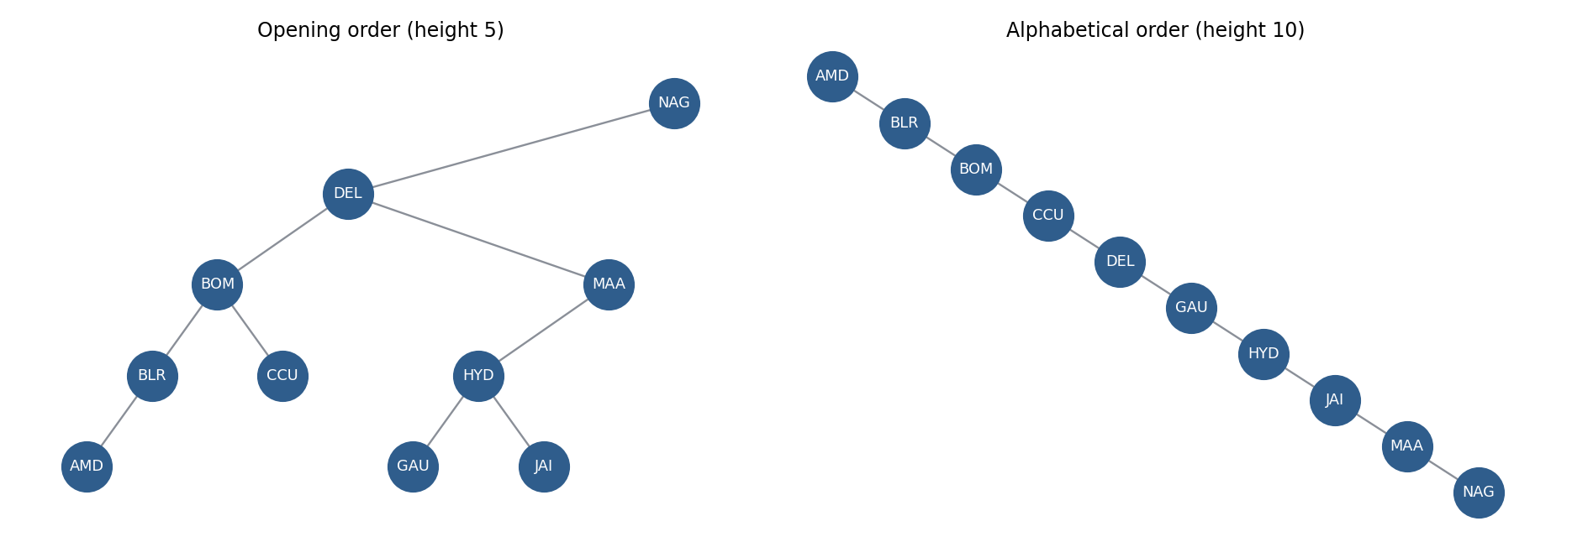
Figure 1. Left: the 10 hubs inserted in the opening order (height 5). Right: the same hubs inserted alphabetically (height 10), which is just a line.
Observations
- For the opening order the height is 5. NAG is the root, DEL goes left of it, BOM goes left of DEL and BLR and then AMD keep going left, so the chain NAG, DEL, BOM, BLR, AMD is five hubs long. The other long chain, NAG, DEL, MAA, HYD, GAU, is also five.
- Sorted input is the bad case. When the codes arrive in alphabetical order, every new code is bigger than everything already in the tree, so it always goes to the right. The tree turns into a line of height 10, which is the number of hubs. Reverse alphabetical gives the same thing mirrored.
- The effect shows up in the search cost. Looking up every hub once takes 3.6 steps on average in the opening-order tree, 5.5 steps in the sorted tree and 2.9 steps in the middle-first tree. With 10 hubs that is a small difference, but a line of 10,000 hubs would need up to 10,000 steps for one search while a balanced tree needs about 14.
- Four levels is the smallest possible height for 10 hubs, because a tree of height 3 can hold at most 7. Inserting the middle code first and then the middle of each half is what gets there.
- The shape changes but the inorder list does not. It is alphabetical in all four trees, and the program checks that.
- I did not build a self-balancing tree (AVL or red-black). Those fix the sorted-input problem by rotating nodes after an insert. I only explain them here.
Why a BST: hub codes have an order, so a BST gives sorted listing for free and a search that skips half of what is left at every step when the tree is balanced. A hash map would find one code faster, but it cannot list the codes in order.
Complexity: insert and search are O(h), where h is the height. That is O(log n) when the tree is balanced and O(n) when it is a line. The tree uses O(n) space.
Task 2 – Parcel tracking lookup and double scans
What I did
The lookup is a Python dict (which is a hash map) from the tracking number to the list of scans for that parcel, each scan being a hub and a time. Looking up a parcel means hashing the tracking number and jumping straight to its slot, so it does not matter whether there are 10 parcels or 100,000.
For the check I make one pass over all the scans. The key is the pair (tracking number, hub) and the value is the list of times that parcel was scanned at that hub. Anything with two or more times is reported, with the count and the times. A parcel scanned at three different hubs is normal, because that is just the journey, so only the same hub twice is flagged.
To be sure the fast version is right I also wrote a brute force check that compares every scan with every other scan, and I ran both on a generated set where I knew which repeats had been planted.
Code (task2_scans.py)
"""
Task 2 - parcel tracking numbers in a hash map, and a check for parcels that
were scanned twice at the same hub.

Python's dict is a hash map, so I use it directly here.
"""
import random
import time

class ParcelBook:
"""tracking number -> list of (hub, time) scans."""

def __init__(self):
self.scans = {}

def add_scan(self, tracking, hub, when):
self.scans.setdefault(tracking, []).append((hub, when))

def lookup(self, tracking):
"""Average O(1) - hash the tracking number, jump to its slot."""
return self.scans.get(tracking)

def __len__(self):
return len(self.scans)

def find_double_scans(scan_list):
"""One pass over the scans. The key is (tracking, hub); the value is the
list of times it was scanned there. Anything with 2 or more times is
reported. Time O(n), extra space O(n)."""
seen = {}
for tracking, hub, when in scan_list:
seen.setdefault((tracking, hub), []).append(when)
return [(t, h, times) for (t, h), times in seen.items() if len(times) >= 2]

def find_double_scans_bruteforce(scan_list):
"""Compare every scan with every other scan. O(n^2). Only here to check
that the hash map version gives the same answer."""
found = {}
n = len(scan_list)
for i in range(n):
for j in range(i + 1, n):
a, b = scan_list[i], scan_list[j]
if a[0] == b[0] and a[1] == b[1]:
found.setdefault((a[0], a[1]), set()).update([a[2], b[2]])
return found

SMALL_SCANS = [
# tracking, hub, time
("TRK1001", "DEL", "08:05"),
("TRK1001", "NAG", "14:20"),
("TRK1001", "NAG", "14:26"), # double scan at NAG, 6 minutes apart
("TRK1002", "BOM", "09:10"),
("TRK1002", "NAG", "16:40"),
("TRK1002", "HYD", "21:05"), # fine, three different hubs
("TRK1003", "CCU", "10:00"),
("TRK1003", "CCU", "10:02"),
("TRK1003", "CCU", "10:03"), # three scans at CCU
("TRK1004", "MAA", "11:30"),
("TRK1005", "BLR", "07:30"),
("TRK1005", "HYD", "12:00"),
("TRK1005", "BLR", "18:45"), # went away and came back to BLR
]

HUBS = ["NAG", "DEL", "BOM", "MAA", "BLR", "HYD", "CCU", "AMD", "PNQ", "JAI"]

def make_scans(n_parcels, seed=3):
"""Each parcel gets 2-4 scans at different hubs. About 1 parcel in 50
gets an extra repeat scan at a hub it already visited."""
rng = random.Random(seed)
scans = []
injected = set()
for p in range(n_parcels):
trk = f"TRK{40000000 + p}"
route = rng.sample(HUBS, rng.randint(2, 4))
for k, hub in enumerate(route):
scans.append((trk, hub, f"{6 + 3 * k:02d}:{rng.randint(0, 59):02d}"))
if rng.random() < 0.02:
hub = rng.choice(route)
scans.append((trk, hub, "23:59"))
injected.add((trk, hub))
rng.shuffle(scans)
return scans, injected

def main():
book = ParcelBook()
for t, h, w in SMALL_SCANS:
book.add_scan(t, h, w)

print(f"{len(SMALL_SCANS)} scans loaded for {len(book)} parcels")
print("\nLookups")
for trk in ["TRK1002", "TRK1004", "TRK9999"]:
print(f" {trk}: {book.lookup(trk)}")

print("\nParcels scanned more than once at the same hub")
dups = find_double_scans(SMALL_SCANS)
print(f" {'tracking':<10}{'hub':<6}{'times':<7}scan times")
for t, h, times in dups:
print(f" {t:<10}{h:<6}{len(times):<7}{', '.join(times)}")

# bigger test: generated data, checked against brute force
scans, injected = make_scans(1500)
fast = {(t, h) for t, h, _ in find_double_scans(scans)}
slow = set(find_double_scans_bruteforce(scans))
print(f"\nGenerated test: {len(scans)} scans, {len(injected)} repeat scans planted")
print(f" hash map found {len(fast)}, brute force found {len(slow)}, "
f"same answer: {fast == slow == injected}")

# speed
print("\nSpeed")
t0 = time.perf_counter()
find_double_scans_bruteforce(scans)
t_brute = time.perf_counter() - t0
t0 = time.perf_counter()
find_double_scans(scans)
t_hash = time.perf_counter() - t0
print(f" {len(scans)} scans: hash map {t_hash*1000:.2f} ms, "
f"brute force {t_brute*1000:.1f} ms (~{t_brute/t_hash:.0f}x slower)")

big, planted = make_scans(100_000, seed=9)
book2 = ParcelBook()
t0 = time.perf_counter()
for t, h, w in big:
book2.add_scan(t, h, w)
t_build = time.perf_counter() - t0
t0 = time.perf_counter()
res = find_double_scans(big)
t_check = time.perf_counter() - t0
t0 = time.perf_counter()
for i in range(0, 100_000, 7):
book2.lookup(f"TRK{40000000 + i}")
t_look = (time.perf_counter() - t0) / len(range(0, 100_000, 7))
print(f" {len(big)} scans, {len(book2)} parcels: built lookup in {t_build:.2f} s, "
f"double-scan check {t_check:.2f} s ({len(res)} reported)")
print(f" matches the planted repeats: {({(t, h) for t, h, _ in res} == planted)}")
print(f" one lookup takes about {t_look*1e6:.2f} microseconds")

if __name__ == "__main__":
main()
Output
13 scans loaded for 5 parcels

Lookups
TRK1002: [('BOM', '09:10'), ('NAG', '16:40'), ('HYD', '21:05')]
TRK1004: [('MAA', '11:30')]
TRK9999: None

Parcels scanned more than once at the same hub
tracking hub times scan times
TRK1001 NAG 2 14:20, 14:26
TRK1003 CCU 3 10:00, 10:02, 10:03
TRK1005 BLR 2 07:30, 18:45

Generated test: 4518 scans, 26 repeat scans planted
hash map found 26, brute force found 26, same answer: True

Speed
4518 scans: hash map 1.42 ms, brute force 412.8 ms (~291x slower)
302156 scans, 100000 parcels: built lookup in 0.28 s, double-scan check 0.49 s (2020 reported)
matches the planted repeats: True
one lookup takes about 0.52 microseconds
Observations
- In the small hand-typed set three parcels are reported. TRK1001 was scanned twice at NAG six minutes apart, TRK1003 was scanned three times at CCU within three minutes, and TRK1005 was scanned at BLR at 07:30 and again at 18:45. TRK1002 passed through three different hubs and is correctly not reported.
- TRK1005 is a judgement call. The parcel went BLR, then HYD, then back to BLR, so it may have been a genuine return trip and not a mistake. The rule in the task is "scanned twice at the same hub", so it is reported, and the times are printed so a person can decide. A real system might also look at the time gap or at the order of the route.
- On the generated set (4,518 scans, 26 planted repeats) the hash map version and the brute force version both found exactly the 26 planted ones.
- The speed difference is large. On those 4,518 scans the hash map check took about 1.7 ms and the brute force check took about 450 ms, roughly 270 times slower. Brute force does about n squared comparisons, so it would get much worse on a bigger set.
- On 302,156 scans for 100,000 parcels, building the lookup took about 0.3 s, the double-scan check took about 0.5 s, and one lookup took well under a microsecond. The check reported the same repeats that had been planted.
- The tracking number "TRK9999" is not in the book, and the lookup gives back None instead of crashing.
Why a hash map: the work is "have I seen this exact pair before?", and a hash map answers that in constant time on average. A list would need a scan of the whole list for every scan. Sorting the scans first and comparing neighbours would also work in O(n log n), but the hash map does it in one pass and is easier to read. Python deals with hash collisions itself, so I did not write my own table here.
Complexity: lookup is O(1) on average. The double-scan check is O(n) time and O(n) extra space for n scans. Brute force is O(n squared) time.
Task 3 – Hub network: BFS and DFS
What I did
The network is stored as an adjacency list, which is a dictionary where each hub maps to the list of hubs it has a direct route to. Routes go both ways, so each route is added in both directions. Every hub starts with an empty list, which is how GAU, a new hub with no routes yet, still shows up. Each list is sorted so that BFS and DFS visit neighbours in the same order every run.
I picked an adjacency list over a matrix because the network is sparse. A matrix for 10 hubs has 100 cells, but the list only has 22 entries for 11 routes, and on a national network with hundreds of hubs the gap gets much bigger.
BFS uses a queue and a parent dictionary. It visits hubs in layers, one hop further out each time, and the first time it reaches the goal is the fewest-hops route. The parent dictionary lets me walk back from the goal to the start to rebuild the path. DFS is a short recursive function that keeps going deeper into the first unvisited neighbour and backs up when it runs out. Starting it at the central depot NAG gives every hub that can be reached.
Code (task3_routes.py)
"""
Task 3 - the hub network as a graph (adjacency list).

BFS finds the route with the fewest hops between two hubs.
DFS lists every hub that can be reached from the central depot.
Direct routes are two-way, so every edge is stored in both directions.
"""
from collections import deque

CENTRAL_DEPOT = "NAG"

# the 10 hubs. GAU (Guwahati) is a new hub that has no direct route yet.
HUBS = ["NAG", "DEL", "BOM", "MAA", "BLR", "HYD", "CCU", "AMD", "GAU", "JAI"]

# direct routes between hubs (made-up network)
ROUTES = [
("NAG", "DEL"), ("NAG", "BOM"), ("NAG", "HYD"), ("NAG", "CCU"),
("DEL", "JAI"), ("DEL", "CCU"),
("JAI", "AMD"), ("AMD", "BOM"),
("HYD", "BLR"), ("BLR", "MAA"), ("MAA", "CCU"),
]

def build_graph(hubs, routes):
g = {h: [] for h in hubs} # start every hub with an empty list so GAU shows up
for a, b in routes:
g[a].append(b)
g[b].append(a)
for hub in g:
g[hub].sort() # same visiting order on every run
return g

def bfs_shortest(graph, start, goal):
"""Fewest-hops route. Returns the list of hubs, or None if no route.
Time O(V + E), space O(V)."""
for h in (start, goal):
if h not in graph:
raise ValueError(f"unknown hub: {h}")
if start == goal:
return [start]
parent = {start: None}
queue = deque([start])
while queue:
hub = queue.popleft()
for nxt in graph[hub]:
if nxt not in parent:
parent[nxt] = hub
if nxt == goal: # walk back to the start
path = [goal]
while parent[path[-1]] is not None:
path.append(parent[path[-1]])
return path[::-1]
queue.append(nxt)
return None

def dfs_reachable(graph, start):
"""Every hub reachable from start, in the order DFS meets them.
Time O(V + E), space O(V)."""
order = []
visited = set()

def visit(hub):
visited.add(hub)
order.append(hub)
for nxt in graph[hub]:
if nxt not in visited:
visit(nxt)
visit(start)
return order

def main():
g = build_graph(HUBS, ROUTES)
print(f"Network: {len(g)} hubs, {len(ROUTES)} direct routes, central depot = {CENTRAL_DEPOT}")
print("\nAdjacency list")
for hub in sorted(g):
print(f" {hub}: {', '.join(g[hub]) if g[hub] else '(no direct routes)'}")

print("\nFewest hops (BFS)")
for a, b in [("JAI", "MAA"), ("AMD", "CCU"), ("BLR", "JAI"),
("NAG", "NAG"), ("JAI", "GAU")]:
path = bfs_shortest(g, a, b)
if path is None:
print(f" {a} -> {b}: no route")
else:
print(f" {a} -> {b}: {' > '.join(path)} ({len(path) - 1} hop(s))")
try:
bfs_shortest(g, "JAI", "XYZ")
except ValueError as e:
print(" JAI -> XYZ: error,", e)

print(f"\nReachable from {CENTRAL_DEPOT} (DFS)")
order = dfs_reachable(g, CENTRAL_DEPOT)
print(" visit order:", " > ".join(order))
print(f" {len(order)} of {len(g)} hubs reachable")
missing = sorted(set(g) - set(order))
print(" not reachable:", ", ".join(missing) if missing else "none")

if __name__ == "__main__":
main()
Output
Network: 10 hubs, 11 direct routes, central depot = NAG

Adjacency list
AMD: BOM, JAI
BLR: HYD, MAA
BOM: AMD, NAG
CCU: DEL, MAA, NAG
DEL: CCU, JAI, NAG
GAU: (no direct routes)
HYD: BLR, NAG
JAI: AMD, DEL
MAA: BLR, CCU
NAG: BOM, CCU, DEL, HYD

Fewest hops (BFS)
JAI -> MAA: JAI > DEL > CCU > MAA (3 hop(s))
AMD -> CCU: AMD > BOM > NAG > CCU (3 hop(s))
BLR -> JAI: BLR > HYD > NAG > DEL > JAI (4 hop(s))
NAG -> NAG: NAG (0 hop(s))
JAI -> GAU: no route
JAI -> XYZ: error, unknown hub: XYZ

Reachable from NAG (DFS)
visit order: NAG > BOM > AMD > JAI > DEL > CCU > MAA > BLR > HYD
9 of 10 hubs reachable
not reachable: GAU
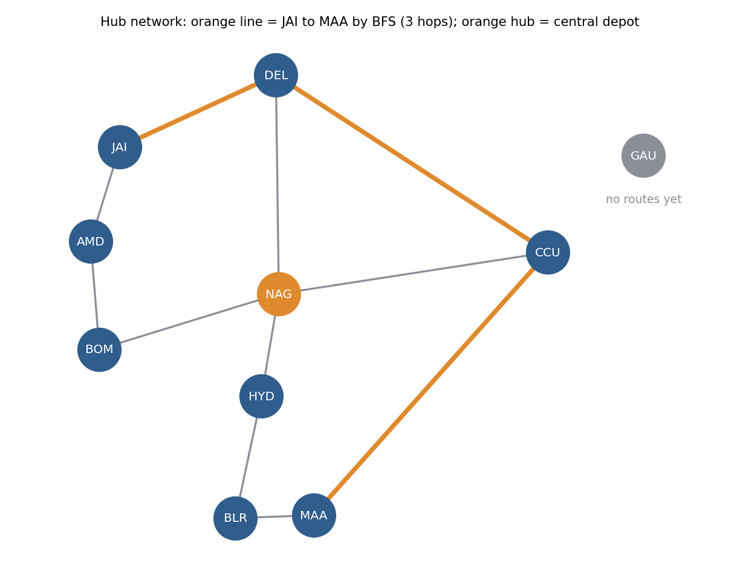
Figure 2. The 10-hub network. The orange hub is the central depot (NAG) and the orange line is the BFS route from JAI to MAA. GAU has no routes yet.
Observations
- JAI to MAA needs 3 hops: JAI, DEL, CCU, MAA. There is no shorter way, because JAI only connects to DEL and AMD and MAA only connects to BLR and CCU.
- AMD to CCU is a tie. AMD, BOM, NAG, CCU and AMD, JAI, DEL, CCU are both 3 hops. BFS reports whichever it finds first, which depends on the neighbour order, and since the lists are sorted it picks the one through BOM. Both are equally good by hop count.
- BLR to JAI takes 4 hops, going through HYD, NAG and DEL. From a hub to itself the answer is just that hub with 0 hops. JAI to GAU returns "no route" because GAU has no connections, and an unknown code like XYZ raises an error instead of giving a confusing answer.
- DFS from NAG visits NAG, BOM, AMD, JAI, DEL, CCU, MAA, BLR, HYD, which is 9 of the 10 hubs. GAU is the one that cannot be reached.
- The DFS order is not a list of distances. HYD has a direct route from NAG but is visited last, because DFS went off down the BOM side first. That is why DFS is fine for "what can I reach" and wrong for "what is the shortest way".
- Hops are not the same as distance or time. A route with fewer hops could still take longer. To use real travel times I would need weighted edges and Dijkstra instead of BFS.
Why BFS for the shortest route and DFS for reachability: the routes have no weights, so "fewest hops" is the same as "fewest layers", which is exactly what BFS gives. DFS can find a long route first and has no reason to stop early. For plain reachability either one works, because both visit every hub in the connected part of the graph. I used DFS because the recursive version is very short.
Complexity: both are O(V + E) time, with V hubs and E routes, and O(V) extra space for the visited set, queue and recursion.
Task 4 – Busiest 4-hour window
What I did
The 24 hourly counts are made up with a pattern: quiet at night, a pickup rush in the morning and a bigger delivery rush in the evening, with a small random wobble added. Each number is the parcels counted in the hour that starts at that time, so the value for 16 covers 16:00 to 17:00.
The sliding window adds up the first 4 hours once. After that, each step adds the new hour at the front and subtracts the hour that just dropped off the back, so the window total is updated with two operations instead of being added up again. I keep the best total and where it started. The question asks for the highest average, but with a fixed window length the highest total and the highest average are always the same window, so I just divide by 4 at the end. If two windows tie, the earlier one wins.
Code (task4_window.py)
"""
Task 4 - busiest 4-hour window in a day of hourly parcel counts.

Sliding window: add the new hour, drop the hour that fell out. The window
never moves back, so the whole day is one pass.
"""
import random
import time

WINDOW = 4

def best_window(counts, k=WINDOW):
"""Returns (start_hour, average). If two windows tie, the earlier one wins.
Time O(n), extra space O(1)."""
if k <= 0:
raise ValueError("window size must be positive")
if len(counts) < k:
raise ValueError(f"need at least {k} hours of data, got {len(counts)}")
total = sum(counts[:k])
best_total, best_start = total, 0
for end in range(k, len(counts)):
total += counts[end] - counts[end - k]
if total > best_total:
best_total, best_start = total, end - k + 1
return best_start, best_total / k

def best_window_bruteforce(counts, k=WINDOW):
"""Re-add k numbers for every start position. O(n * k)."""
best_total, best_start = None, 0
for s in range(len(counts) - k + 1):
t = sum(counts[s:s + k])
if best_total is None or t > best_total:
best_total, best_start = t, s
return best_start, best_total / k

def hourly_counts(seed=5):
"""24 made-up hourly parcel counts: quiet at night, a morning pickup rush
and a bigger evening delivery rush."""
rng = random.Random(seed)
base = [60, 45, 40, 35, 50, 120, 310, 540, 720, 810, 760, 690,
640, 600, 580, 620, 760, 940, 1010, 880, 640, 420, 240, 120]
return [max(0, b + rng.randint(-40, 40)) for b in base]

def main():
counts = hourly_counts()
print("Hourly parcel counts (hour = start of the hour)")
print(f" total for the day: {sum(counts)} parcels")

start, avg = best_window(counts)
print(f"\nBusiest {WINDOW}-hour window: {start:02d}:00 to {start + WINDOW:02d}:00")
print(f" parcels in window: {sum(counts[start:start + WINDOW])}")
print(f" average per hour : {avg:.1f}")

print("\nAverage of every possible window (* = the winner)")
for s in range(len(counts) - WINDOW + 1):
a = sum(counts[s:s + WINDOW]) / WINDOW
print(f" {s:02d}:00-{s + WINDOW:02d}:00 {a:7.1f} {'*' if s == start else ''}")

print("\nBrute force agrees:", best_window_bruteforce(counts) == (start, avg))

# speed on a long list (a year of hourly data)
rng = random.Random(1)
big = [rng.randint(0, 1000) for _ in range(24 * 365 * 5)]
t0 = time.perf_counter(); r1 = best_window(big, 24 * 7); t1 = time.perf_counter() - t0
t0 = time.perf_counter(); r2 = best_window_bruteforce(big, 24 * 7); t2 = time.perf_counter() - t0
print(f"\nSpeed on {len(big)} hourly readings with a 1-week (168 h) window")
print(f" sliding window {t1*1000:.1f} ms, brute force {t2*1000:.1f} ms "
f"(same answer: {r1 == r2}, about {t2/t1:.0f}x slower)")

print("\nEdge cases")
print(" exactly 4 hours ->", best_window([10, 20, 30, 40]))
print(" all hours equal ->", best_window([5] * 10))
print(" tie (first one wins) ->", best_window([9, 1, 1, 1, 1, 9, 1, 1, 1, 1, 1]))
for bad in ([], [1, 2, 3]):
try:
best_window(bad)
except ValueError as e:
print(f" {str(bad):<21} -> error: {e}")

if __name__ == "__main__":
main()
Output
Hourly parcel counts (hour = start of the hour)
total for the day: 11585 parcels

Busiest 4-hour window: 16:00 to 20:00
parcels in window: 3562
average per hour : 890.5

Average of every possible window (* = the winner)
00:00-04:00 60.8
01:00-05:00 39.2
02:00-06:00 64.8
03:00-07:00 128.8
04:00-08:00 239.8
05:00-09:00 411.5
06:00-10:00 572.8
07:00-11:00 689.2
08:00-12:00 740.2
09:00-13:00 723.0
10:00-14:00 679.0
11:00-15:00 639.5
12:00-16:00 610.2
13:00-17:00 650.8
14:00-18:00 731.5
15:00-19:00 822.0
16:00-20:00 890.5 *
17:00-21:00 855.2
18:00-22:00 726.2
19:00-23:00 539.2
20:00-24:00 354.8

Brute force agrees: True

Speed on 43800 hourly readings with a 1-week (168 h) window
sliding window 4.1 ms, brute force 58.7 ms (same answer: True, about 14x slower)

Edge cases
exactly 4 hours -> (0, 25.0)
all hours equal -> (0, 5.0)
tie (first one wins) -> (0, 3.0)
[] -> error: need at least 4 hours of data, got 0
[1, 2, 3] -> error: need at least 4 hours of data, got 3
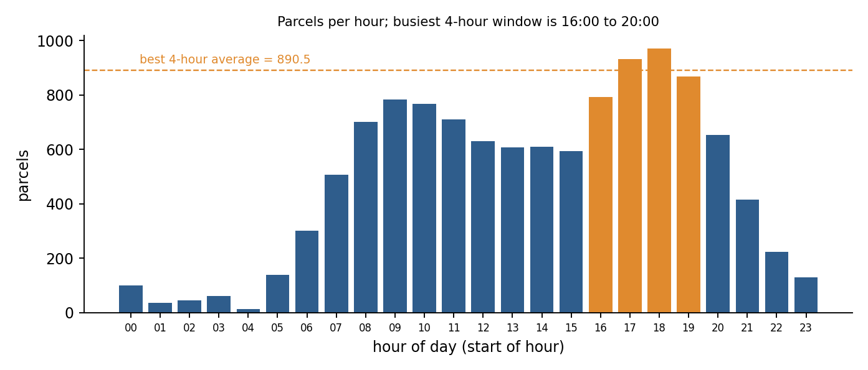
Figure 3. Parcels per hour over the day. The orange bars are the busiest 4-hour window.
Observations
- The busiest window is 16:00 to 20:00, with 3,562 parcels, an average of 890.5 per hour. The next best are 17:00 to 21:00 (855.2) and 15:00 to 19:00 (822.0), so the evening rush is clearly the peak.
- The morning rush is smaller. Its best window, 08:00 to 12:00, averages 740.2 per hour.
- The program prints the average of all 21 possible windows so the winner can be checked by eye, and it also runs a brute force version that adds up each window from scratch. They agree.
- On a longer test of 43,800 hourly readings (five years) with a one-week window, the sliding window took about 4.1 ms and brute force about 63 ms, so around 14 times slower. The gap grows with the window size, because brute force repeats about k additions for every start position.
- Edge cases: exactly 4 hours of data gives that one window, a day where all hours are equal gives the first window, and a tie picks the earliest. Fewer than 4 hours (including an empty list) raises an error instead of returning a wrong answer.
- A limit of this version is that windows do not wrap past midnight, so 22:00 to 02:00 is not considered. That would need the next day's first hours as well.
Why a sliding window: the windows overlap almost completely, so adding all 4 hours again for every start is wasted work. Reusing the previous total is the whole idea of the pattern.
Complexity: O(n) time and O(1) extra space. Brute force is O(n x k).
Task 5 – Route palindrome with two pointers
What I did
A route like NAG – HYD – BLR – HYD – NAG is a there-and-back route, so I treat the hub codes as the units that have to match: first hub with last hub, second with second last, and so on. First I pull the hub codes out of the text. Anything that is not a letter or a digit counts as a separator, so dashes, arrows, commas, slashes and spaces all work, and the codes are turned to upper case. Then one pointer starts at the first hub and the other at the last, and they move towards each other. At the first mismatch the answer is False. If they meet in the middle, it is True.
"Palindrome of hub codes" could also be read as a palindrome of the letters, ignoring the separators, which is the classic version of this problem. So I wrote that as well, with two pointers on the raw string that skip anything that is not a letter or digit. The table in the output shows both, and the hub-level one is the answer I consider correct for this scenario.
Code (task5_palindrome.py)
"""
Task 5 - is a delivery route description a palindrome of hub codes?

"NAG - HYD - BLR - HYD - NAG" reads the same forwards and backwards, so it is
a there-and-back route. Case and separators (-, >, commas, spaces, slashes,
arrows...) are ignored.

Two pointers: one at the first hub, one at the last, move towards each other.
"""

def split_hubs(text):
"""Pull the hub codes out of the description. Anything that is not a
letter or digit counts as a separator."""
hubs, cur = [], ""
for ch in text:
if ch.isalnum():
cur += ch.upper()
elif cur:
hubs.append(cur)
cur = ""
if cur:
hubs.append(cur)
return hubs

def is_route_palindrome(text):
"""Compare hub codes as whole units. Time O(n), space O(n) for the list."""
hubs = split_hubs(text)
left, right = 0, len(hubs) - 1
while left < right:
if hubs[left] != hubs[right]:
return False
left += 1
right -= 1
return True

def is_char_palindrome(text):
"""The classic version: two pointers on the raw string, skipping anything
that is not a letter or digit. Time O(n), space O(1)."""
left, right = 0, len(text) - 1
while left < right:
if not text[left].isalnum():
left += 1
elif not text[right].isalnum():
right -= 1
elif text[left].lower() != text[right].lower():
return False
else:
left += 1
right -= 1
return True

TESTS = [
"NAG-HYD-BLR-HYD-NAG",
"nag > hyd > blr > hyd > NAG",
"MAA // BLR // maa",
"DEL, NAG, DEL",
"NAG-DEL-BOM",
"DEL-NAG-DEL-NAG",
"BLR-MAA-CCU-MAA-BLR-",
"DEL-AA-LED",
"NAG",
"",
" - > - ",
]

def main():
print(f"{'description':<32}{'hub codes':>11}{'char level':>12}")
for t in TESTS:
print(f"{repr(t):<32}{str(is_route_palindrome(t)):>11}{str(is_char_palindrome(t)):>12}")
print("\nSplit example:", split_hubs("nag > Hyd/BLR , hyd-NAG"))
print("\nNote: 'DEL-AA-LED' is True at character level (DELAALED) but False at hub level,")
print("because the first hub DEL is not the same hub as the last one, LED.")

if __name__ == "__main__":
main()
Output
description hub codes char level
'NAG-HYD-BLR-HYD-NAG' True False
'nag > hyd > blr > hyd > NAG' True False
'MAA // BLR // maa' True False
'DEL, NAG, DEL' True False
'NAG-DEL-BOM' False False
'DEL-NAG-DEL-NAG' False False
'BLR-MAA-CCU-MAA-BLR-' True False
'DEL-AA-LED' False True
'NAG' True False
'' True True
' - > - ' True True

Split example: ['NAG', 'HYD', 'BLR', 'HYD', 'NAG']

Note: 'DEL-AA-LED' is True at character level (DELAALED) but False at hub level,
because the first hub DEL is not the same hub as the last one, LED.
Observations
- "NAG-HYD-BLR-HYD-NAG" and "nag > hyd > blr > hyd > NAG" are both True at hub level, so case and separators really are ignored. "MAA // BLR // maa" and "DEL, NAG, DEL" are True too.
- "NAG-DEL-BOM" and "DEL-NAG-DEL-NAG" are False. The second one looks balanced at first glance, but its first hub is DEL and its last is NAG.
- A separator at the end ("BLR-MAA-CCU-MAA-BLR-") does not change the result, because it is skipped when the codes are extracted.
- The two readings do not always agree. "NAG-HYD-BLR-HYD-NAG" is False at character level, because the letters NAGHYDBLRHYDNAG read backwards are GANDYHRLBDYHGAN. And "DEL-AA-LED" is True at character level (DELAALED) but False at hub level, because the hubs DEL and LED are different hubs. For a route, the hub-level answer is the one that matters.
- An empty description, a single hub, and a string that is only separators all give True, because there is nothing left to compare. A real system would probably reject an empty route before it gets to this check.
Why two pointers: the other way is to reverse a copy of the list and compare it with the original, which makes a second list and always compares every element. Two pointers stop at the first mismatch and only need to look at half of the list.
Complexity: the hub-level version is O(n) time and O(n) space for the list of codes. The character-level version is O(n) time and O(1) space, because it works on the original string.
Decision table: problem, data structure / pattern, reason
Task | Problem | Data structure / pattern | Time and space | Reason
1 | Store hub codes in order, search for a hub, see how input order affects the tree | Binary search tree | Insert and search O(h). Balanced O(log n), sorted input O(n). Space O(n) | Smaller codes go left and bigger go right, so each step drops about half of what is left. Sorted input turns the tree into a line (height 10 for 10 hubs), so the order of insertion matters.
2 | Look up a parcel by tracking number and report parcels scanned twice at the same hub | Hash map (dict), key = (tracking number, hub) | Lookup O(1) average. Check O(n) time, O(n) space | Constant time lookup, and one pass can count how many times each pair was seen. Brute force compared every pair of scans and was about 270 times slower on 4,518 scans.
3a | Route with the fewest hops between two hubs | Adjacency list + BFS | O(V + E) time, O(V) space | Routes have no weights, and BFS explores one hop further each layer, so the first time it reaches the goal is the fewest hops.
3b | Every hub reachable from the central depot | Adjacency list + DFS | O(V + E) time, O(V) space | Reachability only needs every hub visited once. DFS is short to write and leaves out the hubs with no route (GAU).
4 | Busiest 4-hour window in a day of hourly counts | Sliding window (fixed size 4) | O(n) time, O(1) space | Neighbouring windows share 3 of their 4 hours, so I add the new hour and subtract the old one instead of re-adding. Brute force was about 14 times slower on a long test.
5 | Is a route description a palindrome of hub codes | Two pointers (one at each end) | O(n) time, O(n) space (O(1) for the character version) | Compares first with last and moves inwards. It stops at the first mismatch and needs no reversed copy.
What I took from this
- Every task has a pattern that fits it. A tree for ordered lookups, a hash map for exact lookups, a graph for routes, a sliding window for a fixed-size stretch of a sequence and two pointers for matching the two ends. Picking the right one meant the speed difference over the brute force version was big in every comparison I measured.
- The tree and the hash map both depend on a condition. The tree needs to stay balanced, and sorted input breaks that without any warning. The hash map needs buckets that are not overloaded, which Python handles by itself.
- BFS and DFS look almost the same in code, but they answer different questions. BFS gives shortest in hops, DFS gives reachable. Mixing them up gives answers that look right but are not.
- The data and the network are invented, so the exact numbers (the busiest window, the number of double scans, the timings) would change with real data. The methods and complexities would not.

