DATABASE DESIGN & SQL / NOSQL IMPLEMENTATION ASSIGNMENT -D V SAI KUMAR
Set 2 – Bank Branch Accounts and Customer Activity
Normalization to 3NF/BCNF, SQL Server Constraints & DDL Comparison, and MongoDB Capped Collections
Student Name: D.V. Sai Kumar | Assignment Module: Assignment Set 2
Database Systems: Microsoft SQL Server (T-SQL) & MongoDB | Submission Date: November 12, 2026

1. Normalization to 3NF / BCNF & Key Identification
The bank branch currently tracks customer accounts using a denormalized sheet with attributes: (customer, address, account_number, account_type, branch, relationship_manager, balance, last_transaction_text). Repeating customer addresses and relationship manager details across multiple accounts introduces update anomalies and transitive dependencies.
1.1 Candidate Keys and Composite Keys
- Candidate Keys (Original Sheet): {account_number} uniquely identifies each account row. If a customer can hold multiple accounts across branches, {customer_id, account_number} forms a superkey, making account_number the minimal candidate key.
- Composite Key (Account Activity / Junction Context): When tracking multi-holder or transaction history entries, {account_id, transaction_timestamp} or {customer_id, account_id} acts as a composite key.
- BCNF Verification: In the normalized schema, every non-trivial functional dependency X -> Y has X as a superkey (e.g., branch_id -> branch_name, city; rm_id -> rm_name, branch_id; account_id -> account_number, customer_id, branch_id, rm_id, balance), satisfying both 3NF and Boyce-Codd Normal Form (BCNF).
Normal Form | Decomposition & Dependency Resolution | Normalized Relations
1NF | Separated unstructured 'last_transaction_text' into an activity log stream (MongoDB) and ensured atomic customer/address columns. | Accounts_Raw(account_number [PK], customer_name, address, account_type, branch_name, rm_name, balance)
2NF & 3NF | Extracted Customer, Branch, and Relationship Manager entities to eliminate transitive dependencies (account_number -> rm_id -> branch_id -> branch_name). | Customers(customer_id [PK], full_name, address, phone)  Branches(branch_id [PK], branch_code, branch_name, city)  Relationship_Managers(rm_id [PK], rm_name, rm_email, branch_id [FK])
BCNF | Ensured Relationship Managers belong strictly to one branch (rm_id -> branch_id) and each Account references valid Customer, Branch, and RM keys. | Accounts(account_id [PK], account_number [UQ], customer_id [FK], branch_id [FK], rm_id [FK], account_type, balance, opened_date)

1.2 Entity-Relationship (ER) Diagram
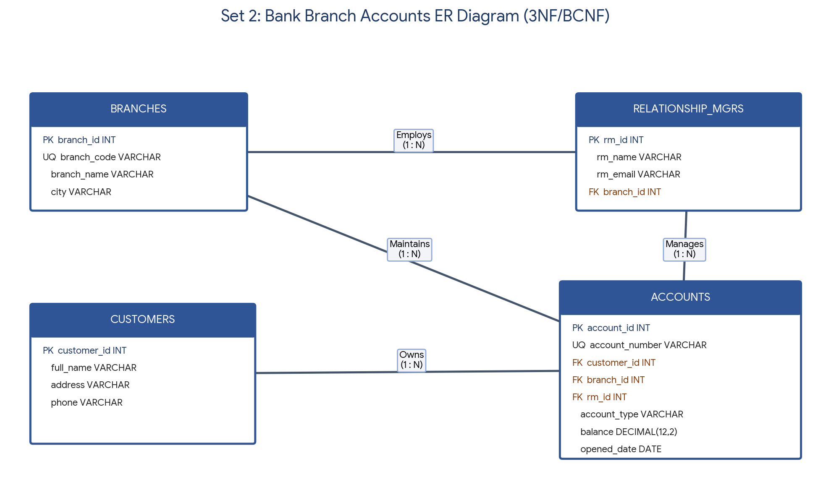
2. SQL Server Schema with Cascading Justification (schema.sql)
2.1 Cascading Rules Chosen & Justification
- ON DELETE NO ACTION (Customers -> Accounts & Branches -> Accounts): In banking systems, deleting a customer or branch must be blocked if active or historical accounts exist, preventing accidental loss of financial audit records.
- ON UPDATE CASCADE (Branches -> Relationship_Managers): If a branch identifier is updated during administrative restructuring, subordinate relationship manager mappings update automatically without breaking referential integrity.
File / Script: schema.sql
CREATE DATABASE BankBranchDB;
GO
USE BankBranchDB;
GO
-- 1. Branches Table
CREATE TABLE Branches (
branch_id INT IDENTITY(100,1) PRIMARY KEY,
branch_code VARCHAR(15) NOT NULL UNIQUE,
branch_name VARCHAR(100) NOT NULL,
city VARCHAR(60) NOT NULL
);
-- 2. Relationship Managers Table
CREATE TABLE Relationship_Managers (
rm_id INT IDENTITY(1,1) PRIMARY KEY,
rm_name VARCHAR(100) NOT NULL,
rm_email VARCHAR(120) NOT NULL UNIQUE,
branch_id INT NOT NULL,
CONSTRAINT FK_RM_Branches FOREIGN KEY (branch_id)
REFERENCES Branches(branch_id)
ON UPDATE CASCADE
ON DELETE NO ACTION
);
-- 3. Customers Table
CREATE TABLE Customers (
customer_id INT IDENTITY(1000,1) PRIMARY KEY,
full_name VARCHAR(100) NOT NULL,
address VARCHAR(250) NOT NULL,
phone VARCHAR(20) NOT NULL UNIQUE
);
-- 4. Accounts Table
CREATE TABLE Accounts (
account_id INT IDENTITY(1,1) PRIMARY KEY,
account_number VARCHAR(20) NOT NULL UNIQUE,
customer_id INT NOT NULL,
branch_id INT NOT NULL,
rm_id INT NOT NULL,
account_type VARCHAR(20) NOT NULL CHECK (account_type IN ('Savings', 'Current', 'Salary')),
balance DECIMAL(12, 2) NOT NULL DEFAULT 0.00,
opened_date DATE NOT NULL DEFAULT CAST(GETDATE() AS DATE),
-- Savings accounts must maintain non-negative balance; Current accounts allow overdraft up to -50000
CONSTRAINT CK_Savings_Balance CHECK (
(account_type = 'Savings' AND balance >= 0) OR
(account_type <> 'Savings' AND balance >= -50000)
),
CONSTRAINT FK_Accounts_Customers FOREIGN KEY (customer_id)
REFERENCES Customers(customer_id)
ON UPDATE NO ACTION
ON DELETE NO ACTION,
CONSTRAINT FK_Accounts_Branches FOREIGN KEY (branch_id)
REFERENCES Branches(branch_id)
ON UPDATE NO ACTION
ON DELETE NO ACTION,
CONSTRAINT FK_Accounts_RM FOREIGN KEY (rm_id)
REFERENCES Relationship_Managers(rm_id)
ON UPDATE NO ACTION
ON DELETE NO ACTION
);
GO

3. Differentiating DROP, TRUNCATE, and DELETE
To evaluate how SQL Server handles table removal, page deallocation, identity seed preservation, and transaction rollback, the following test script was executed on a test table Test_Audit_Log.
File / Script: ddl_dml_comparison.sql
USE BankBranchDB;
GO
CREATE TABLE Test_Audit_Log (
log_id INT IDENTITY(1,1) PRIMARY KEY,
remarks VARCHAR(50)
);
-- Test 1: DELETE inside a Transaction (Supports Rollback & Retains Identity Seed)
INSERT INTO Test_Audit_Log (remarks) VALUES ('Row 1'), ('Row 2');
BEGIN TRANSACTION;
DELETE FROM Test_Audit_Log;
SELECT COUNT(*) AS CountAfterDelete FROM Test_Audit_Log; -- Returns 0
ROLLBACK TRANSACTION;
SELECT COUNT(*) AS CountAfterRollback FROM Test_Audit_Log; -- Returns 2 (Rows restored!)
-- Delete permanently and insert new row to check IDENTITY behavior
DELETE FROM Test_Audit_Log;
INSERT INTO Test_Audit_Log (remarks) VALUES ('Row 3');
SELECT log_id, remarks FROM Test_Audit_Log; -- log_id is 3 (Identity NOT reset)
-- Test 2: TRUNCATE inside a Transaction (Supports Rollback in SQL Server & Resets Identity)
BEGIN TRANSACTION;
TRUNCATE TABLE Test_Audit_Log;
ROLLBACK TRANSACTION;
SELECT COUNT(*) AS CountAfterTruncateRollback FROM Test_Audit_Log; -- Returns 1 (Restored!)
-- Permanent TRUNCATE and insert new row
TRUNCATE TABLE Test_Audit_Log;
INSERT INTO Test_Audit_Log (remarks) VALUES ('Row After Truncate');
SELECT log_id, remarks FROM Test_Audit_Log; -- log_id is 1 (Identity RESET to seed 1!)
-- Test 3: DROP TABLE (Removes structure + data; also rollback-capable in T-SQL DDL transactions)
DROP TABLE Test_Audit_Log;
GO

Feature / Aspect | DELETE | TRUNCATE | DROP
Command Type | DML (Data Manipulation Language) | DDL (Data Definition Language) | DDL (Data Definition Language)
WHERE Clause Support | Yes (filters specific rows) | No (removes all rows in table) | No (removes entire table object)
Effect on IDENTITY | Does NOT reset identity counter; next insert continues from last value (e.g., 3). | Resets identity counter back to original seed value (e.g., 1). | Destroys table metadata and identity definition completely.
Transaction Rollback | Fully logged per row; supports ROLLBACK inside BEGIN TRAN. | Page-deallocation logged; supports ROLLBACK inside BEGIN TRAN in SQL Server. | Schema removal logged; supports ROLLBACK inside explicit T-SQL transaction.
Triggers & Speed | Fires DELETE triggers; slower on large tables. | Does NOT fire triggers; very fast execution. | Drops associated triggers and indexes along with table.

4. Sample DML & Complex WHERE Queries (seed_data.sql)
File / Script: seed_data.sql
USE BankBranchDB;
GO
INSERT INTO Branches (branch_code, branch_name, city) VALUES
('BR-CHN01', 'Anna Nagar Main', 'Chennai'),
('BR-BLR02', 'Indiranagar Branch', 'Bengaluru'),
('BR-HYD03', 'Banjara Hills', 'Hyderabad');
INSERT INTO Relationship_Managers (rm_name, rm_email, branch_id) VALUES
('Suresh Menon', 'suresh.m@bank.in', 100),
('Ananya Rao', 'ananya.r@bank.in', 101),
('Vikram Sethi', 'vikram.s@bank.in', 102);
INSERT INTO Customers (full_name, address, phone) VALUES
('D.V. Sai Kumar', '14 MG Road, Chennai', '9840011122'),
('Meera Krishnan', '22 12th Main, Bengaluru', '9840033344'),
('Rohan Deshmukh', '8 Jubilee Hills, Hyderabad', '9840055566'),
('Sneha Kapoor', '45 Adyar, Chennai', '9840077788');
INSERT INTO Accounts (account_number, customer_id, branch_id, rm_id, account_type, balance, opened_date) VALUES
('SB-2026-001', 1000, 100, 1, 'Savings', 145000.00, '2026-08-15'),
('CA-2026-002', 1001, 101, 2, 'Current', 320000.00, '2026-09-10'),
('SB-2026-003', 1002, 102, 3, 'Savings', 42000.00, '2026-09-25'),
('SL-2026-004', 1003, 100, 1, 'Salary', 95000.00, '2026-05-12'),
('SB-2026-005', 1000, 100, 1, 'Savings', 12000.00, '2026-10-02');
-- UPDATE: Credit quarterly interest to Savings accounts
UPDATE Accounts SET balance = balance + 1500.00 WHERE account_number = 'SB-2026-001';
-- DELETE: Close low-balance duplicate account
DELETE FROM Accounts WHERE account_number = 'SB-2026-005';
-- SELECT using AND, OR, IN, and BETWEEN:
-- Retrieve Savings or Current accounts in Chennai/Bengaluru opened in Q3 2026 with balance > 50,000
SELECT a.account_number, c.full_name, b.branch_name, a.account_type, a.balance, a.opened_date
FROM Accounts a
JOIN Customers c ON a.customer_id = c.customer_id
JOIN Branches b ON a.branch_id = b.branch_id
WHERE (a.account_type = 'Savings' OR a.account_type = 'Current')
AND b.city IN ('Chennai', 'Bengaluru')
AND a.opened_date BETWEEN '2026-07-01' AND '2026-09-30'
AND a.balance > 50000.00;
GO

5. MongoDB Capped Collection for Customer Activity Logs (collections.js)
File / Script: collections.js
use bank_activity_db;
// 1. Create a Capped Collection (max 5 MB, max 5000 documents)
db.createCollection("customer_activity_logs", {
capped: true,
size: 5242880,
max: 5000
});
// 2. Insert 20 customer activity log documents
const events = [];
const eventTypes = ["LOGIN", "BALANCE_CHECK", "FUND_TRANSFER", "STATEMENT_DOWNLOAD"];
for (let i = 1; i <= 20; i++) {
events.push({
customer_id: i <= 12 ? 1000 : 1001,
event_type: i % 2 === 0 ? "LOGIN" : eventTypes[i % 4],
ip_address: `192.168.1.${10 + i}`,
device: i % 3 === 0 ? "Android App" : "Web Portal",
status: "SUCCESS",
timestamp: new Date(Date.now() - (20 - i) * 3600000)
});
}
db.customer_activity_logs.insertMany(events);
// 3. Query for the last five LOGIN events of customer_id 1000
db.customer_activity_logs.find({
customer_id: 1000,
event_type: "LOGIN"
})
.sort({ $natural: -1 })
.limit(5);

5.1 Why Customer Activity Logs Are Better in MongoDB Than SQL Server
Customer activity logs (logins, session metadata, IP addresses, device fingerprints, and clickstream telemetry) are high-volume, append-only event streams whose payload attributes vary across web, mobile, and ATM channels. In SQL Server, storing millions of rapid log inserts creates heavy transaction-log contention, index fragmentation, and requires scheduled maintenance jobs to purge old records. MongoDB's capped collections provide native FIFO (First-In, First-Out) circular buffer storage that automatically overwrites the oldest entries once size or document limits are reached, guaranteeing constant-time O(1) write insertion speed and natural insertion-order reads without manual archival overhead.

