**Assignment-1**

1. **creation of Windows Server 2019 Virtual Machine with Ds1-V2 standard.**

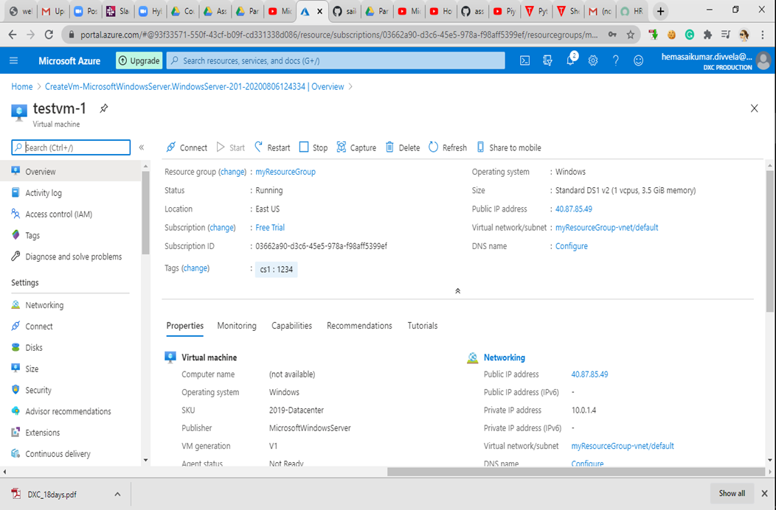

The above image is that I created virtual machine with named **testvm-1** of windows server 2019 OS with Ds1-V2 standard. Username is server_admin.

1. **Attach one data disk of size 50GB and split into 3 inside the VM.**

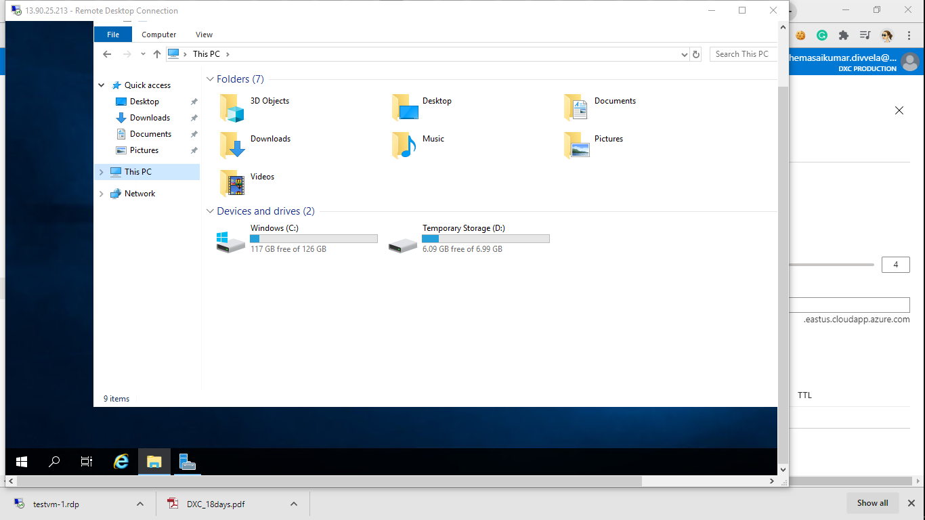

The above image is before creating data disk in the Virtual machine.

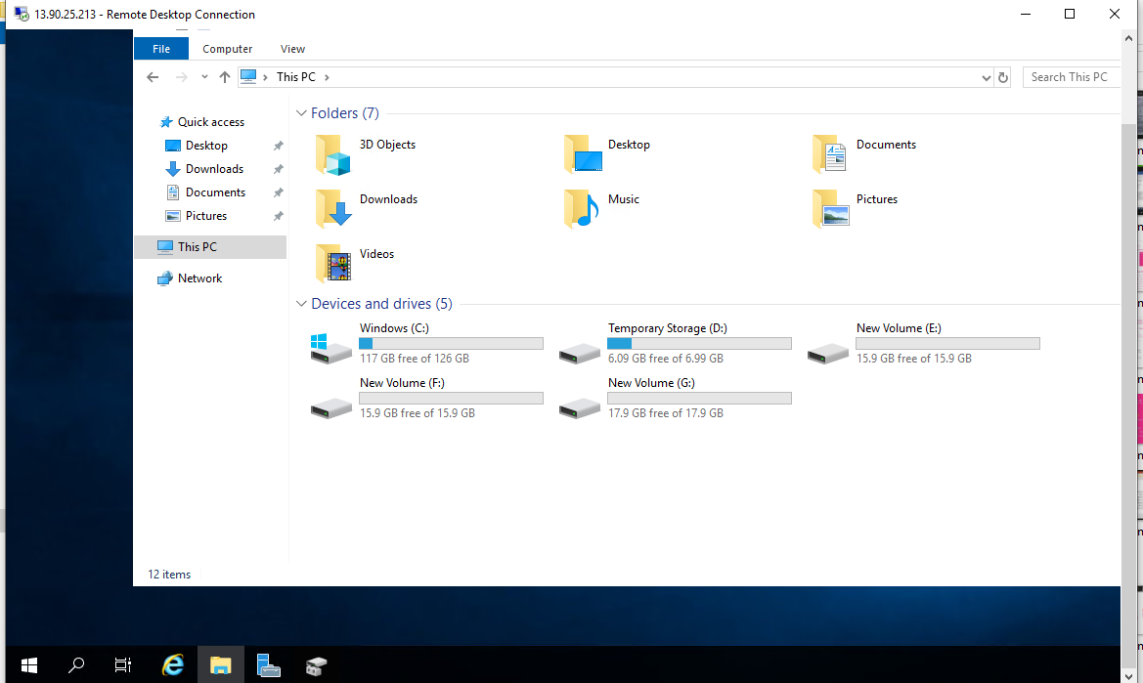

The above image is after creating the data disk of size 50GB and split into three drives inside the VM.

**3. The vm should have enabled auto shut down by 5.00PM IST before that it has to trigger a notification to the mail id**.

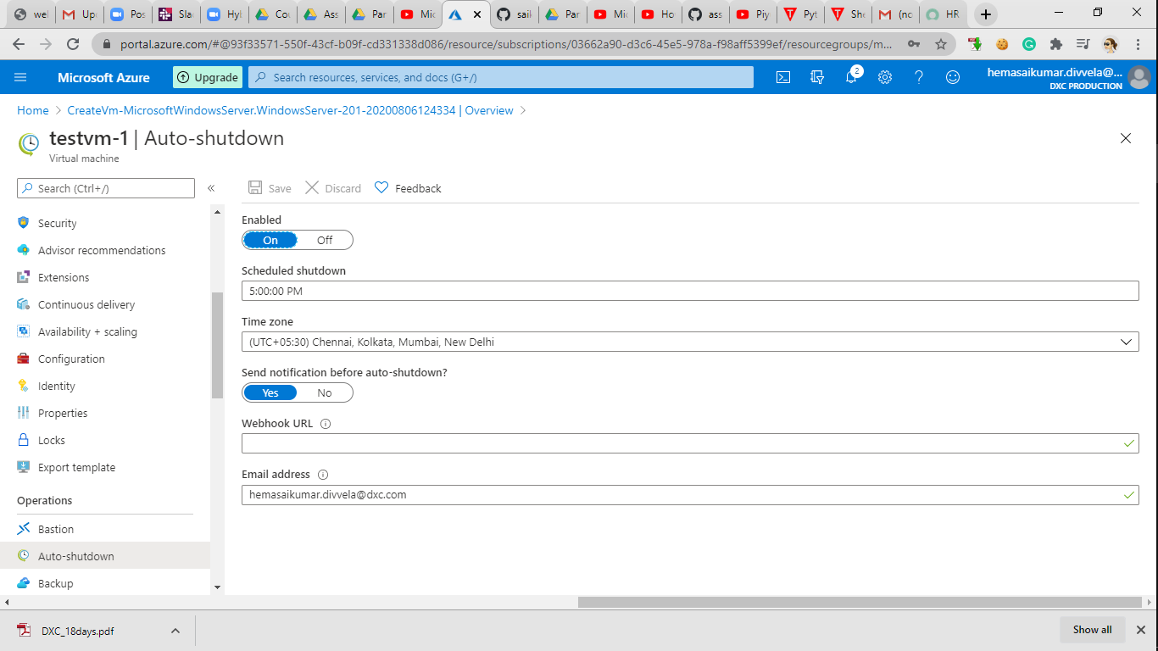

The above image tells that I enabled auto shut down by 5.00PM IST before that it has to trigger a notification to the mail id [hemasaikumar.divvela@dxc.com](mailto:hemasaikumar.divvela@dxc.com).

1. **you should be able to login to the servers with two usernames**

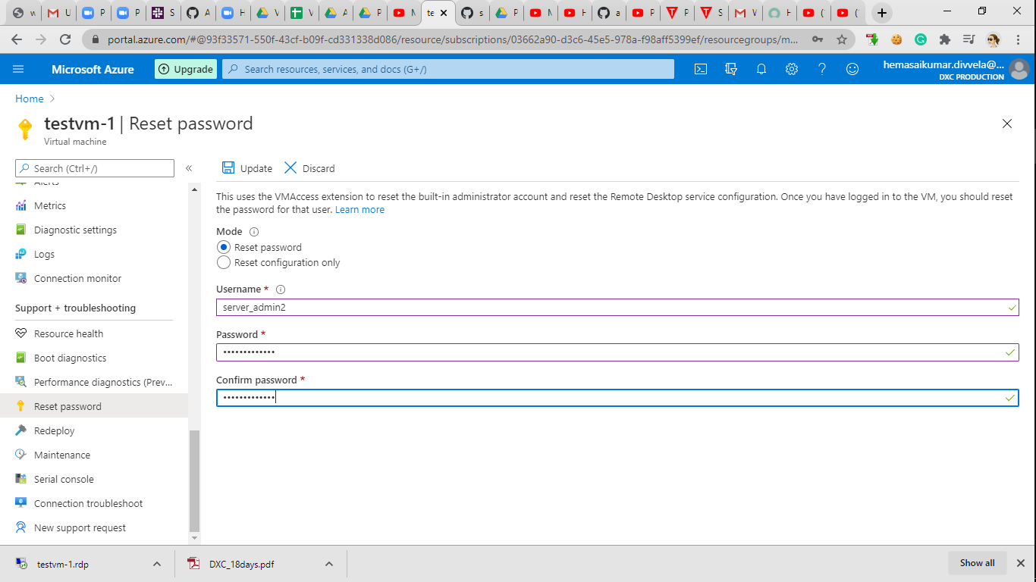

Here I reset the username and password. The new username is server_admin2.

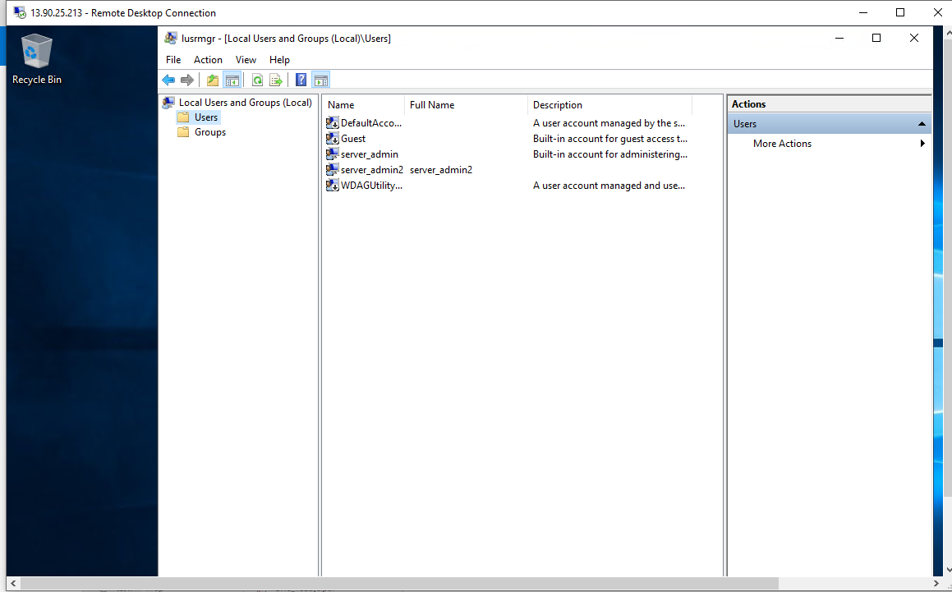

In the above image conclude that I login the virtual machine with new username and password and in the above showed the two usernames server_admin and server_admin2.

1. **install Microsoft antimalware extension in the VM**

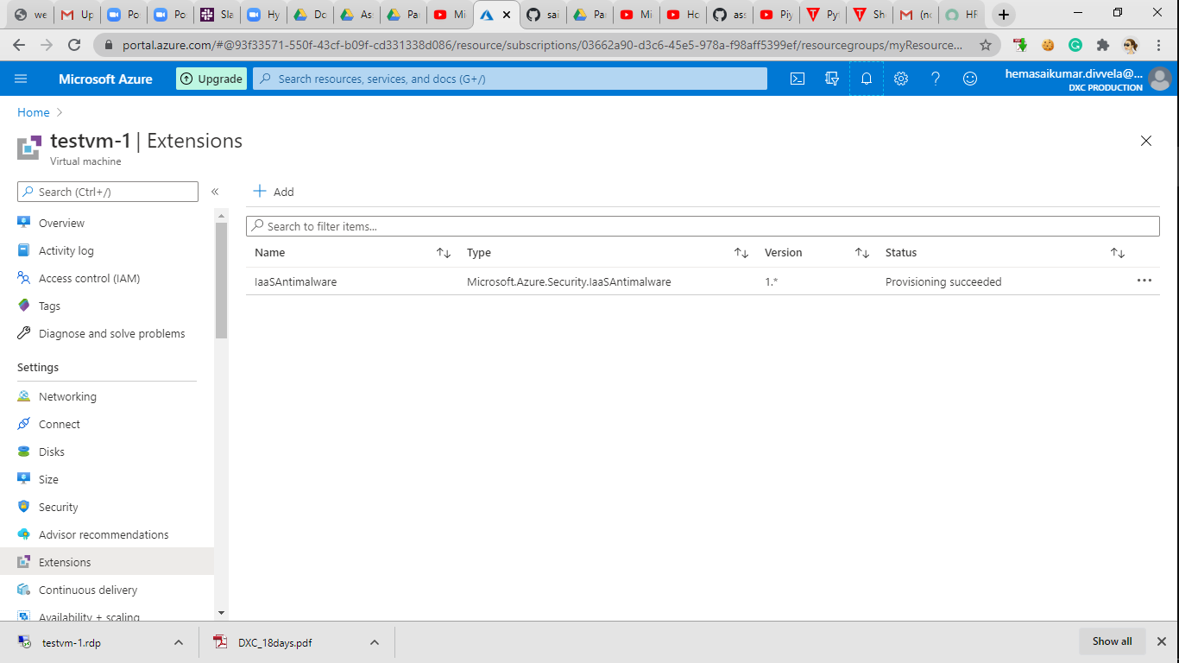

In the above the image I add the extension of **Microsoft antimalware extension** and it will automatically install in the virtual machine.