Assignment-2

1. Creating a scale set with windows OS:

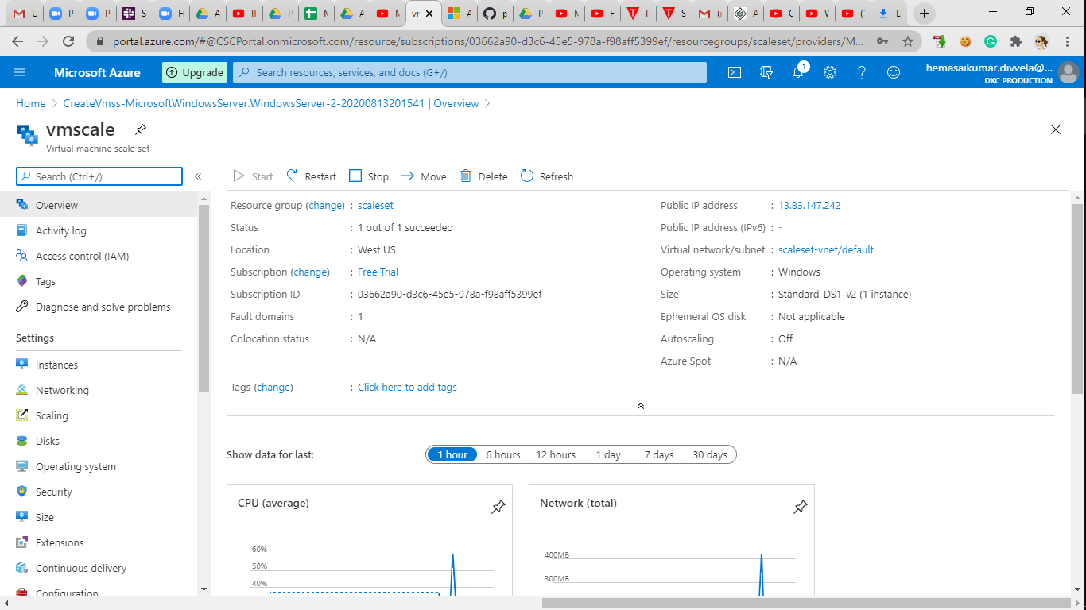

1. Writing a scale out rule using CPU percentage of 70% threshold:

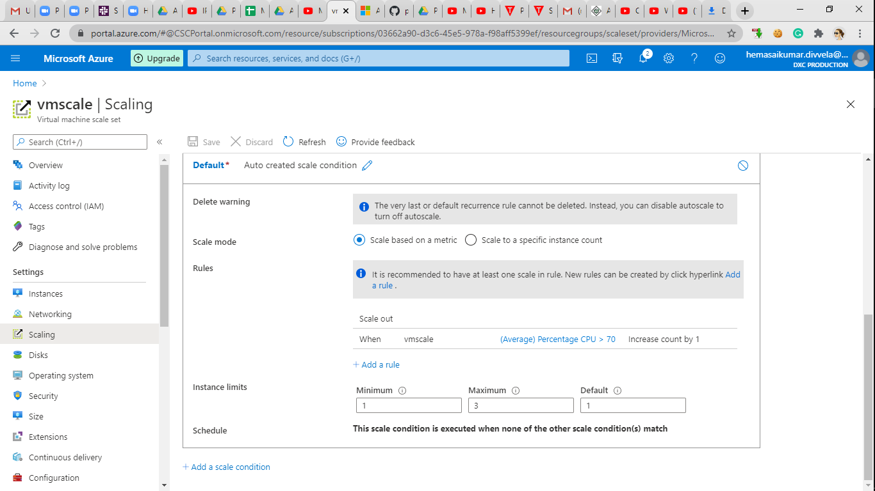

1. Writing a scale in rule using CPU percentage of 40% threshold:

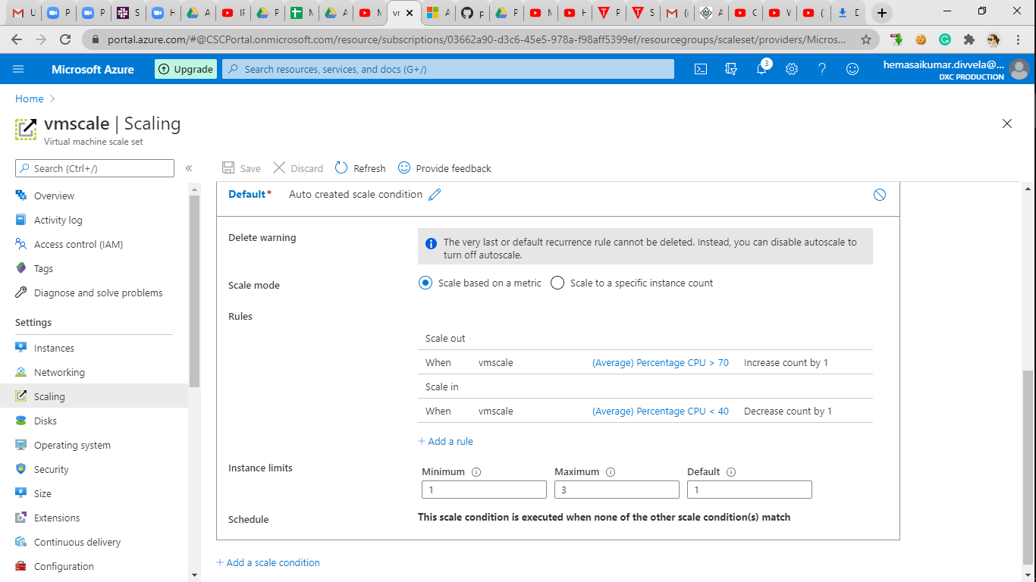

1. Creating a storage account of name sai02: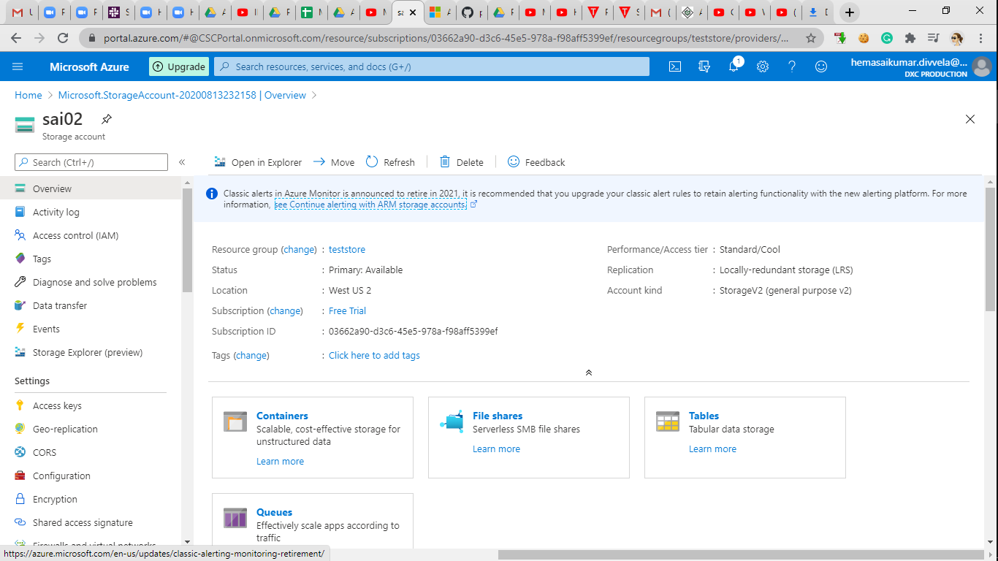

create a container with anonyms access:

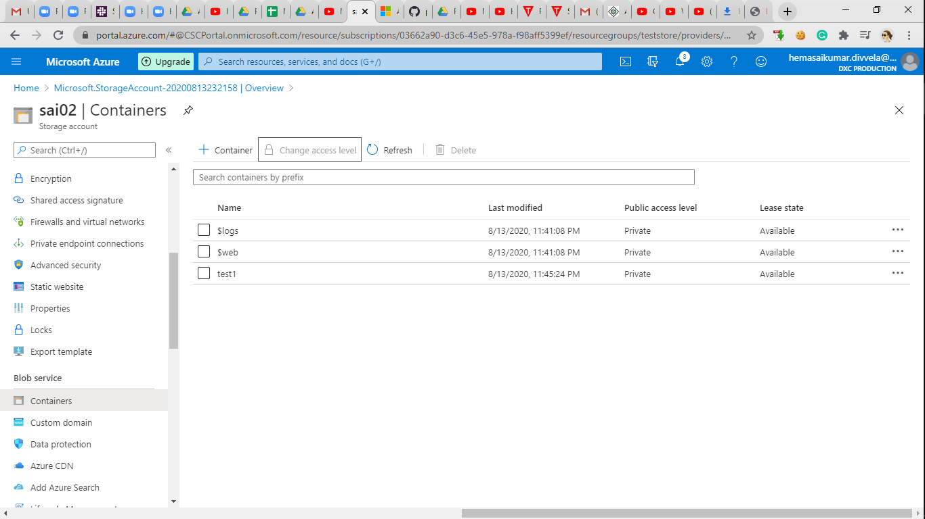

create a static website in the storage account:

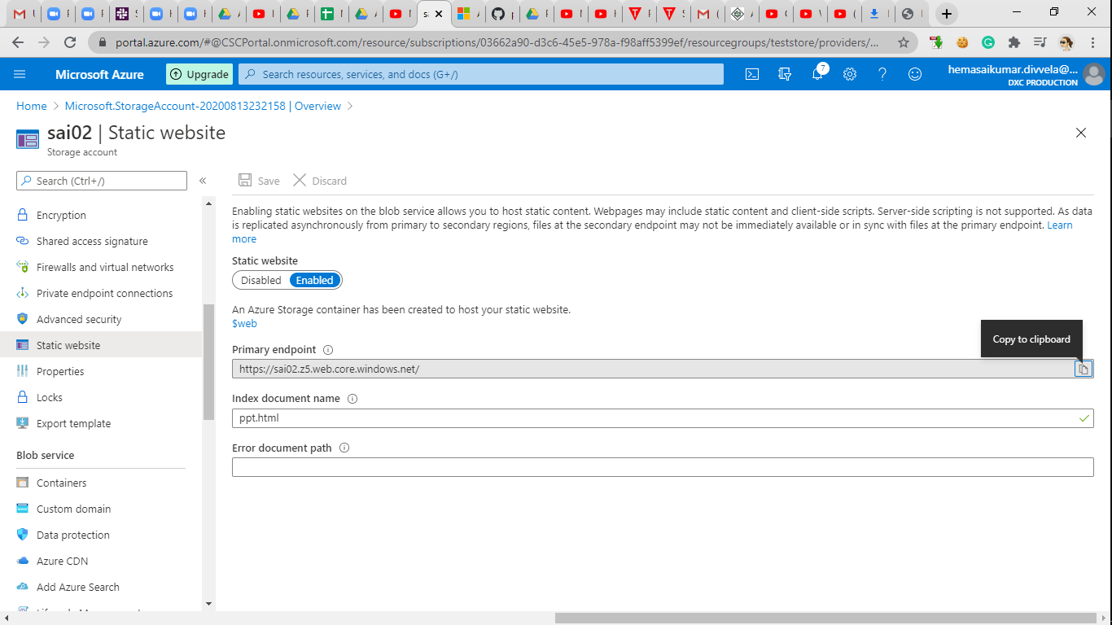

copy the URL of static website and paste in browser to see the static web page:

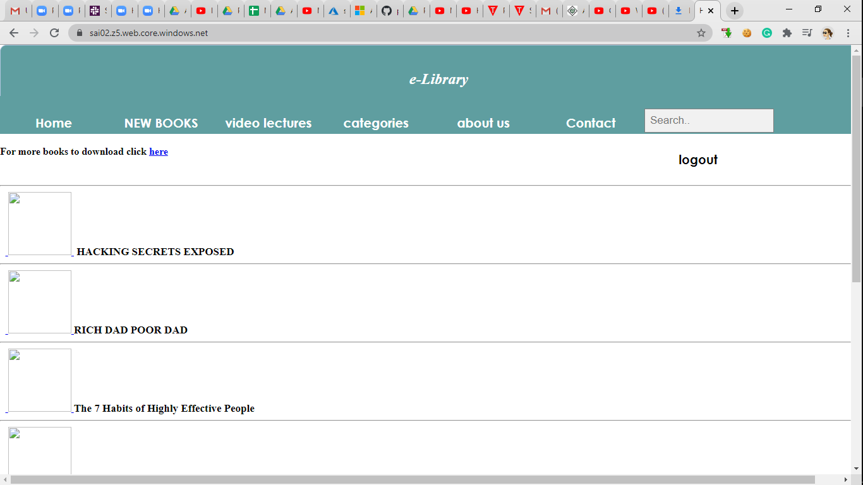

1. Create an two virtual machines with no public ip’s:

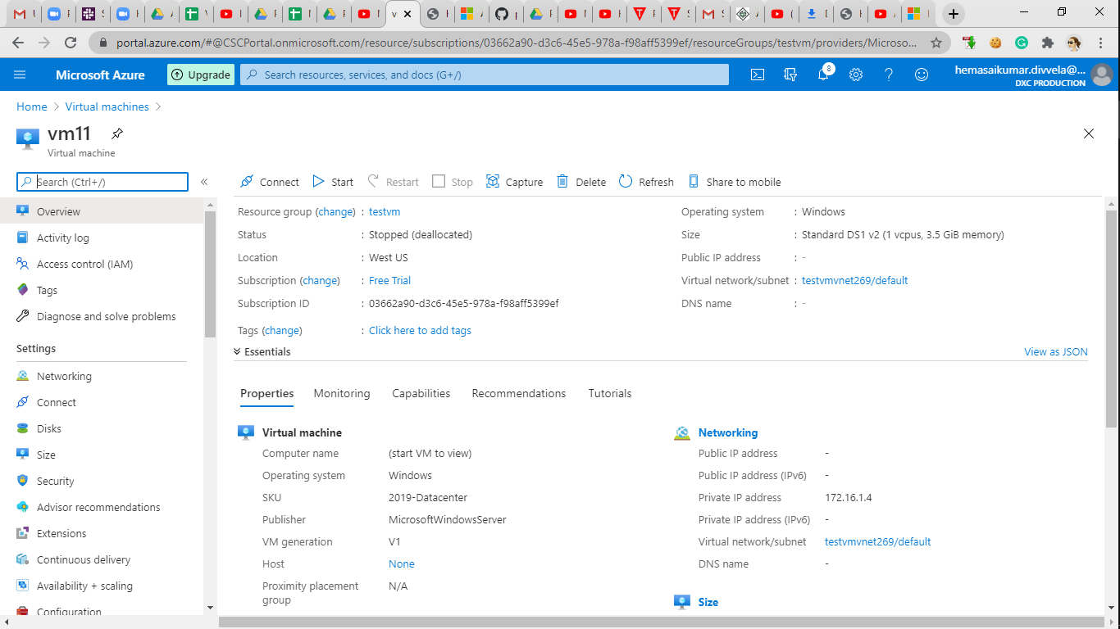

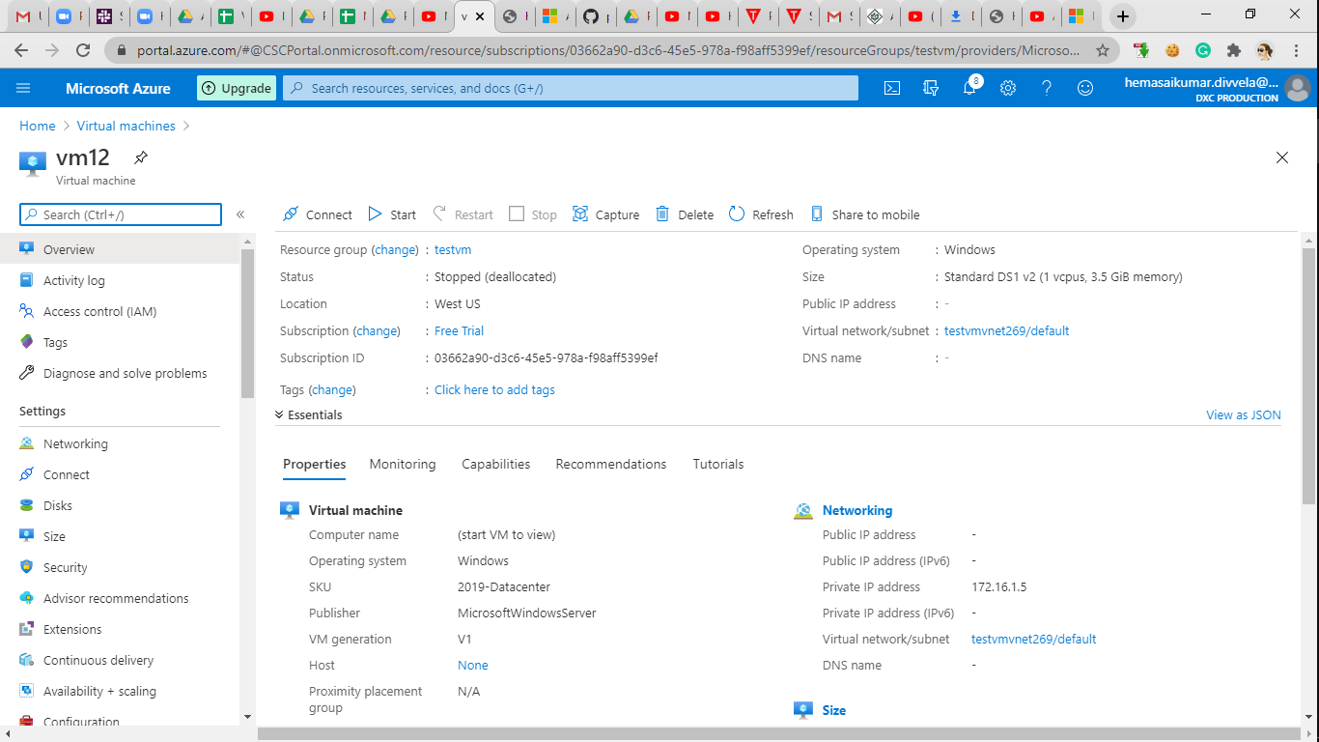

1. Attach the machines to the load balancer and block the 3389 port use 50010 port:

