Step 1: Open BuildBinaries.ps1 file in Windows PowerShell ISE

Step 2: Open the BuildBinaries.ps1 file location in my case its in “C:\Users\n.sounthrarajan\Downloads”

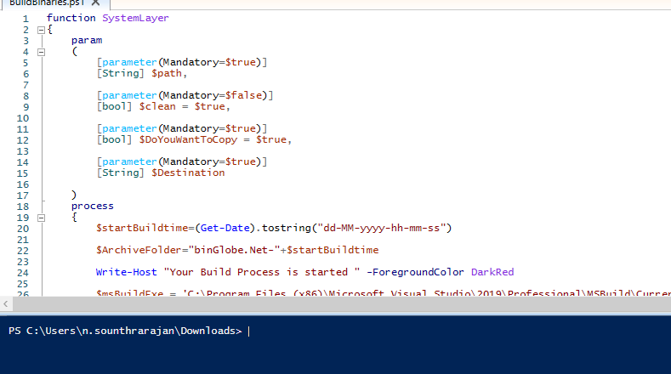

Step 3 : Now type the function name “SystemLayer” space path of **Globe.Net\GlobeNET_DEV**

like this--> SystemLayer D:\BuildE6\Globe.Net\GlobeNET_DEV

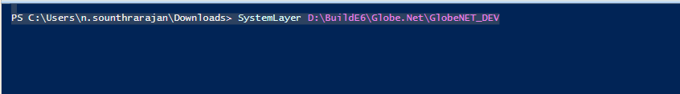

Now hit enter key

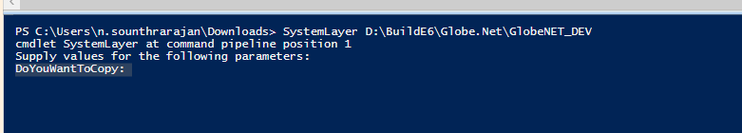

Step 4:

DoYouWantToCopy:**yes**

Hit Enter key

Destination: Give the required specific path

Eg:” D:\Sample”

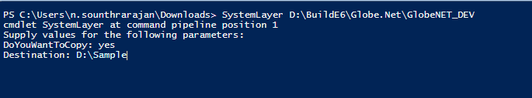

Hit Enter Key

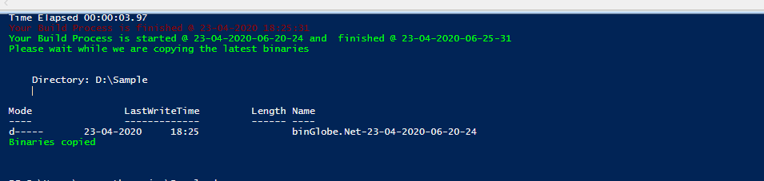

The dll’s will be stored in the specified folder path D:\Sample