Generating Synthetic Images from Text using RNN & CNN

In this project as per your instructions we have utilized CNN and Bi-LSTM algorithms to generate images from text. CNN layers utilized to extract features from images and then Bi-LSTM utilized to extract features from text and then both layers will get trained using sigmoid activation function. BI-LSTM will take text as input and then feed to CNN layer which is responsible to generate images as per text features.

Normally GAN algorithms consider best for text to image generation but we are using CNN and RNN based algorithm so its predicted image will be wrong for few questions.

To train above algorithm we have used FLICKER TEXT and IMAGE dataset which is showing in below screen

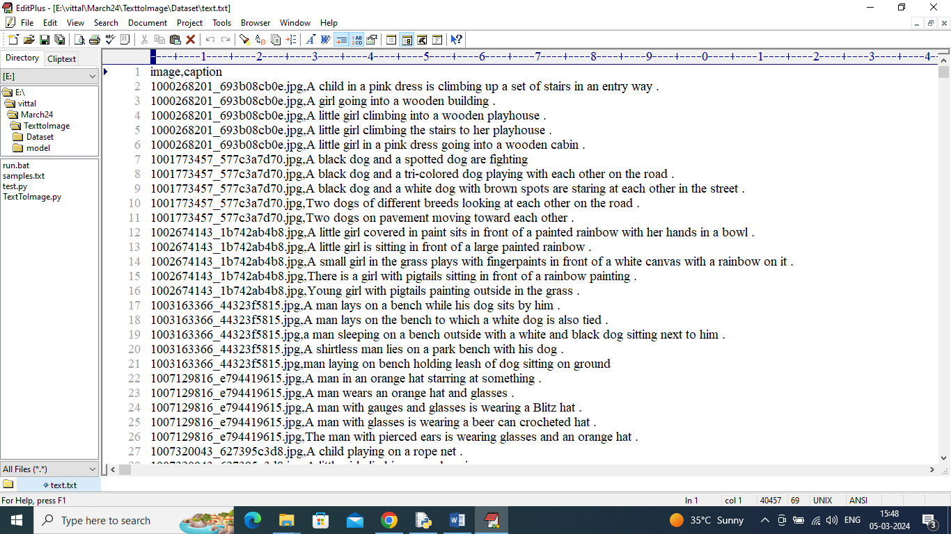

In above dataset each image is associated with some text description and algorithm will get trained with given image and text data and to implement this project we have designed following modules

1. Upload Flickr Text to Image Dataset: using this module will upload dataset to application
2. Pre-process Dataset: this module will read all images and its associated TEXT and then convert text features to numeric vector using TFIDF algorithm and then normalized both vector features and images features and then split data into train and test where application using 80% dataset for training and 20% for testing
3. Generate & Load RNN Model: 80% training data will be input to CNN-RNN algorithm to train a model and this model will be applied on 20% test data to calculate prediction accuracy
4. Text To Image Generation: using this module will input some text and then algorithm will generate image.

In below screen showing code for CNN-Bi-LSTM (RNN) algorithm code

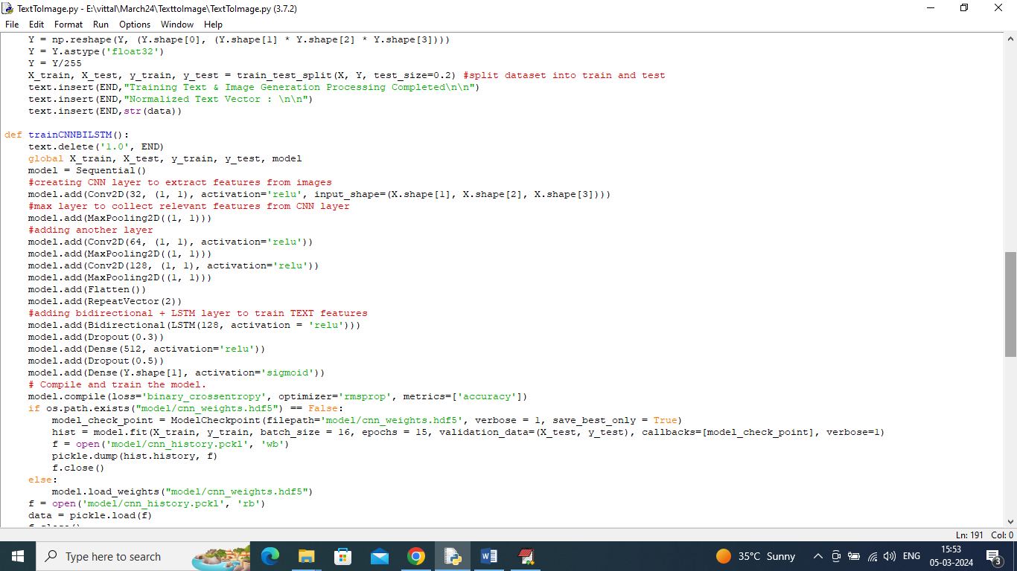

In above screen read red colour comments to know about algorithm.

SCREEN SHOTS

To run project double click on run.bat file to get below screen

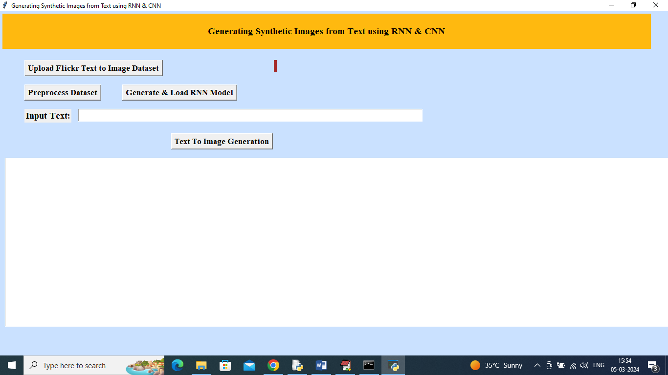

In above screen click on ‘Upload Flickr Text to Image Dataset’ button to upload dataset and get below page

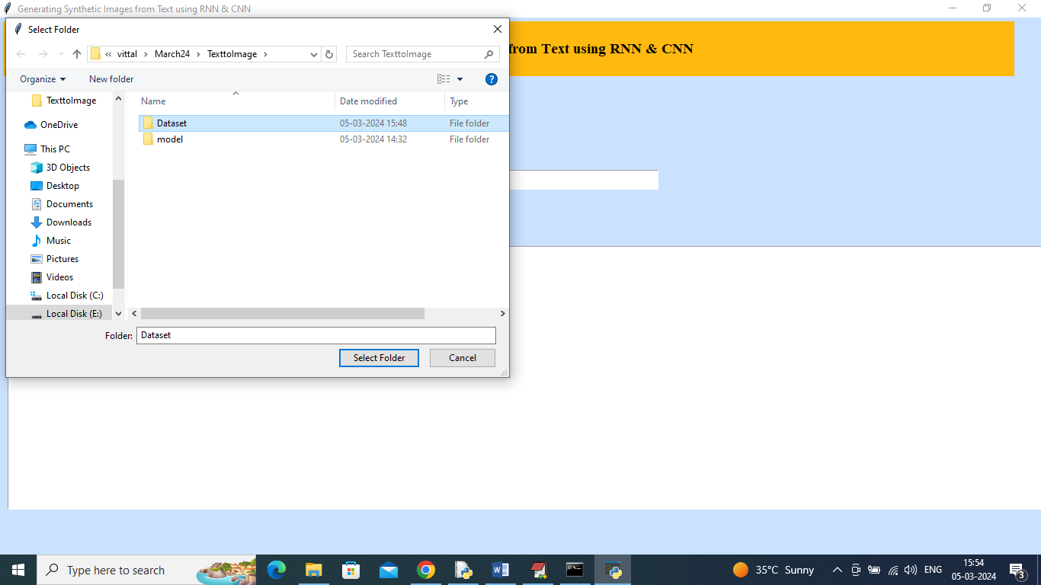

In above screen selecting and uploading ‘Dataset’ folder and then click on ‘Select Folder’ button to load dataset and get below page

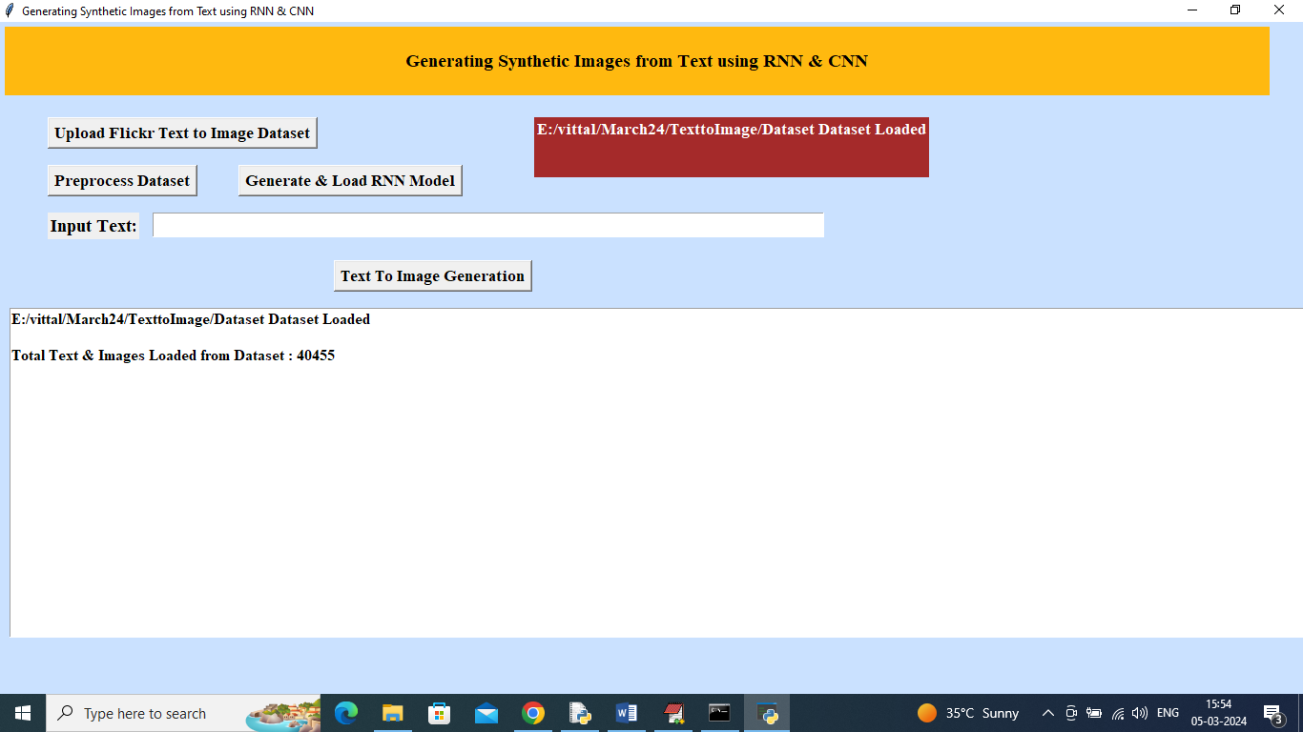

In above screen dataset loaded and now click on ‘Pre-process dataset’ button to read and normalize both TEXT and IMAGE features and get below output

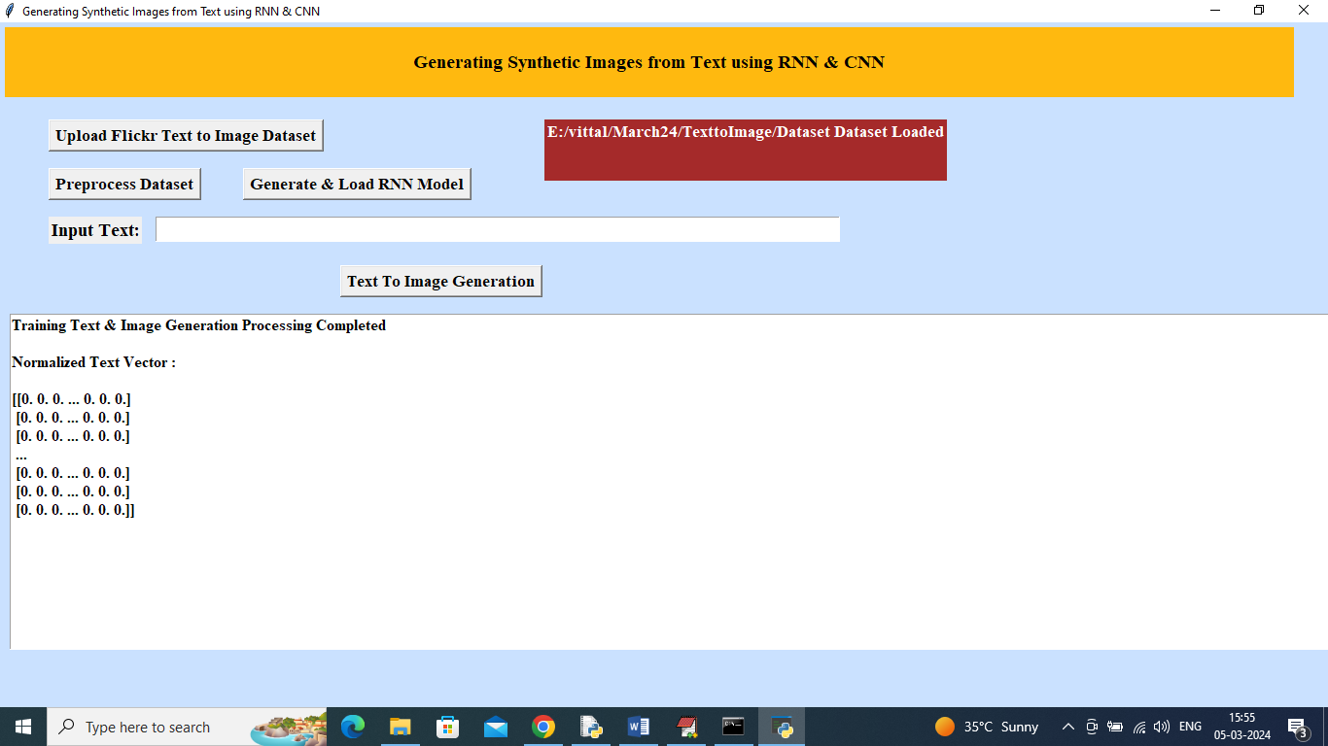

In above screen dataset processing completed and now click on ‘Generate & Load RNN Model’ button to load model and get below page

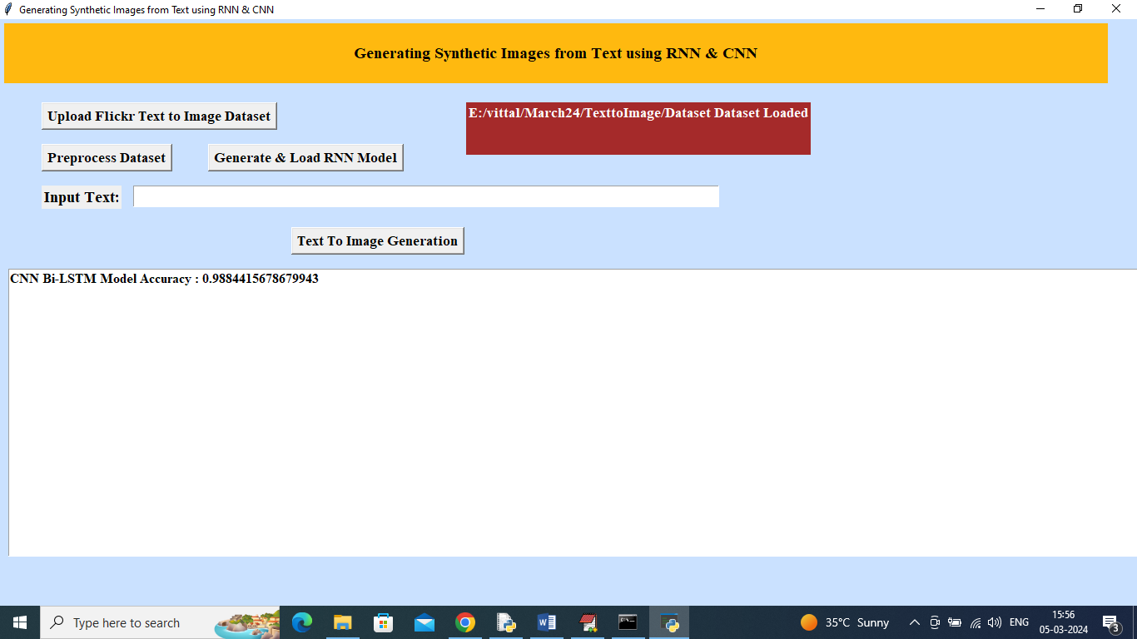

In above screen model training completed and got accuracy as 98% and now enter some text in text field and then click on ‘Text to Image Generation’ button

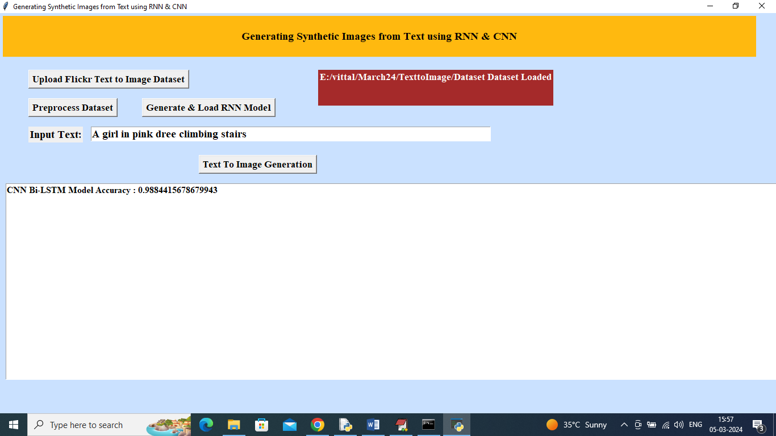

In above screen in text field I entered some text and then press button to get bellow output

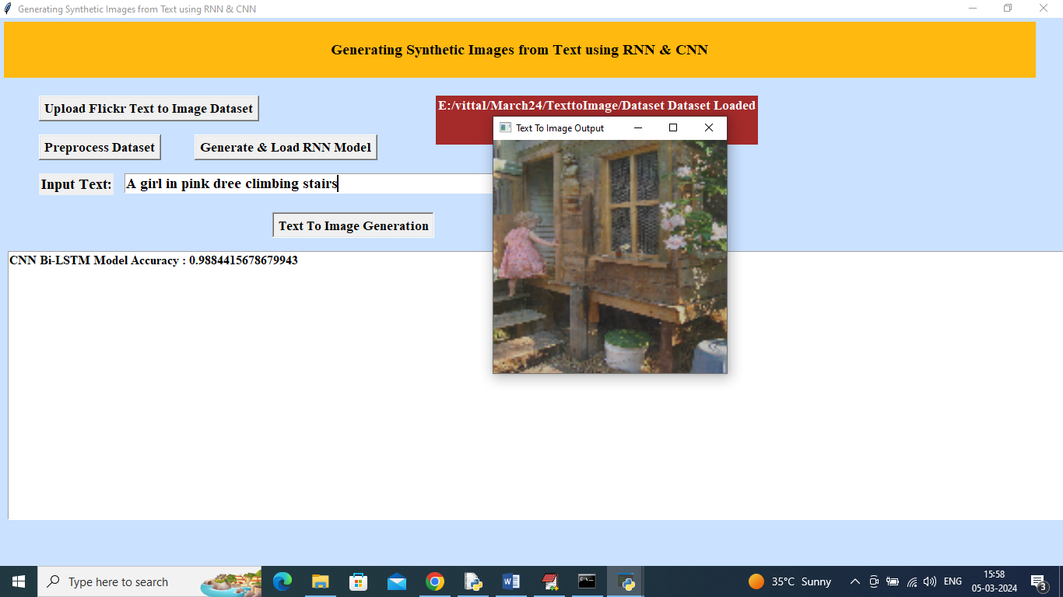

In above screen can see generated image for text ‘A girl in pink dress climbing stairs’. Similarly type some text and get output

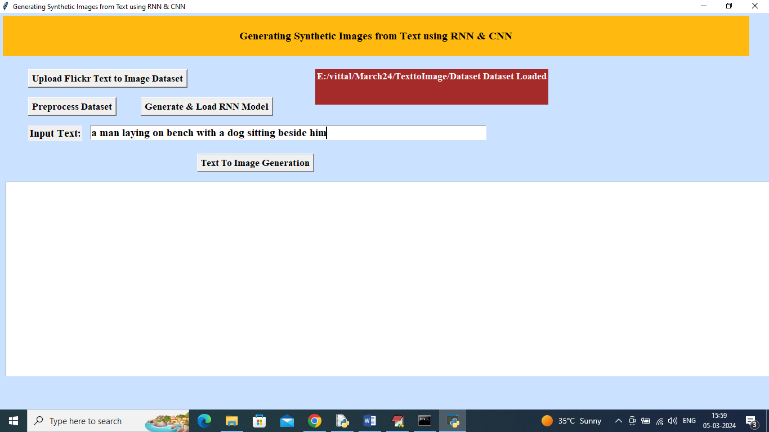

In above screen for given text will get below image

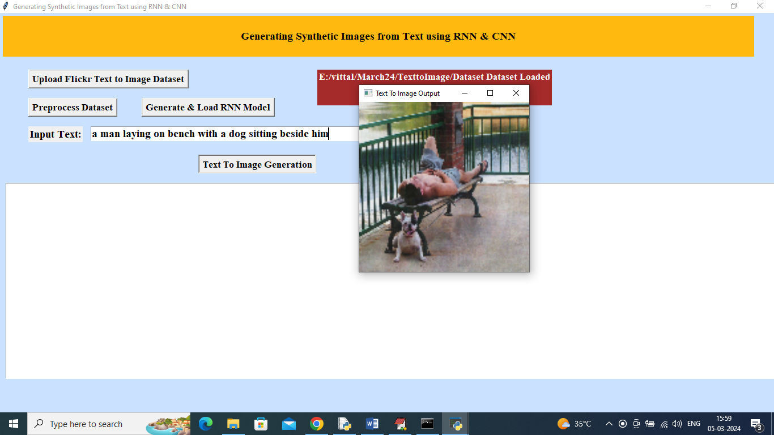

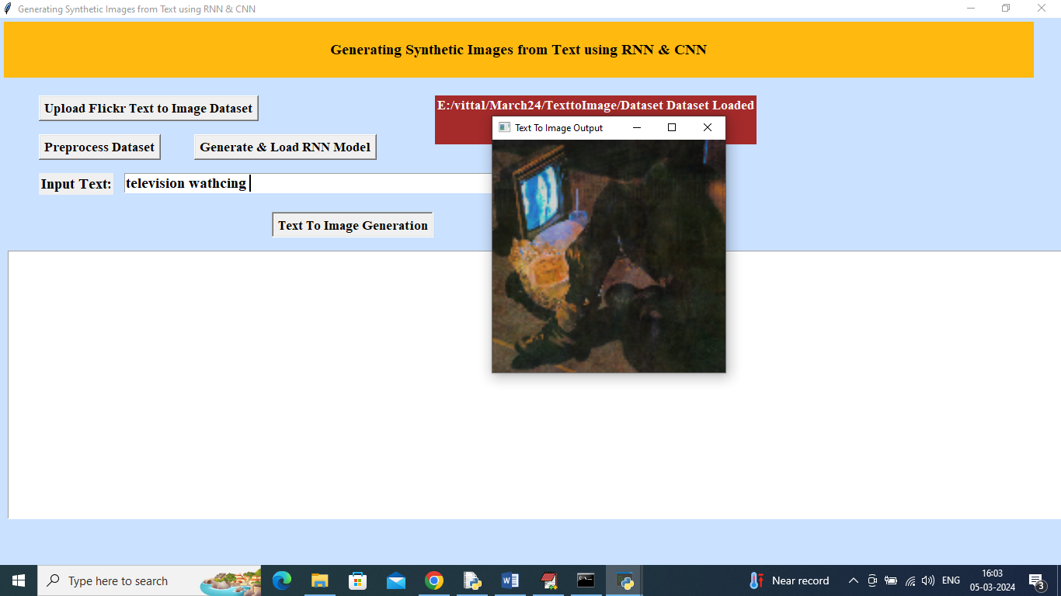

In above screen got image for ‘televsion watching’.

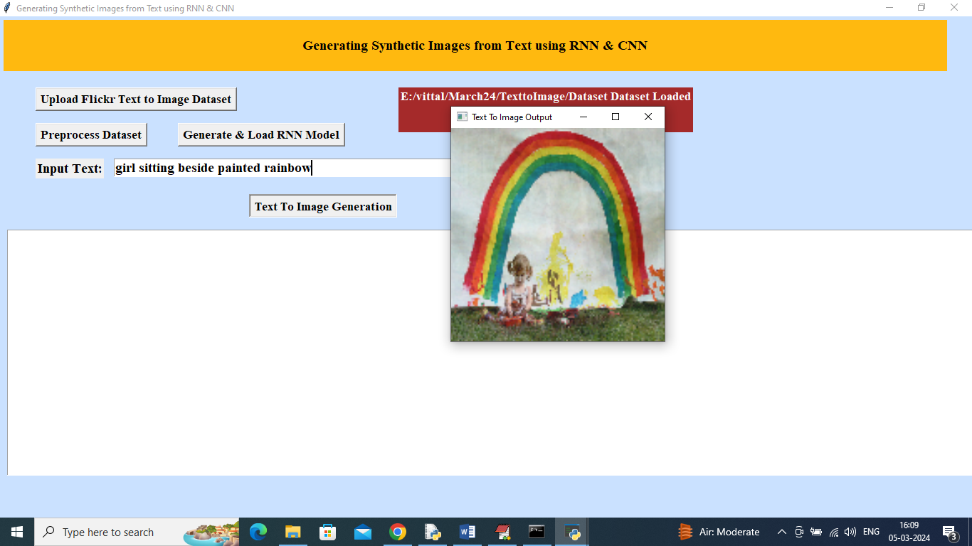

For above sentence we got above image.

Note: For some text we may not get pictures but you can give sentences in any manner from dataset. This algorithms require large amount of training in huge dataset to generate images for all types of questions. While training on large dataset model running out of memory in Google COLAB as well as normal laptops so we trained this model on few images from the dataset.

You can get exact image from all text given in ‘samples.txt’ file