Employee Absenteeism
Sai Kumar V
5 ^{th} September, 2019

Contents
- Introduction
  - Problem Statement
  - Data
- Methodology
  - Pre Processing
    - Outlier Analysis
    - Plots
    - Feature Selection
  - Modeling
    - Model Selection
    - Multiple Linear Regression
    - Regression Trees
- Conclusion
  - Model Evaluation
    - Mean Absolute Error(MAE)
    - Mean Squared Error(MSE)
    - Root Mean Squared Error(RMSE)

References:

- www.stackoverflow.com
- www.medium.com
- www.cookbook-r.com
- www.wikipedia.org
- www.machinelearningmastery.com
- pandas.pydata.org
- www.geeksforgeeks.org

1.1 Problem Statement:
XYZ is a courier company. As we appreciate that human capital plays an important role in collection, transportation and delivery. The company is passing through genuine issue of Absenteeism. The company has shared it's dataset and requested to have an answer on the following areas:
1. What changes company should bring to reduce the number of Absenteeism?
2. How much losses every month can we project in 2011 if same trend of absenteeism continues?

1.2 Data:

Our task is to predict the No. Of hours an Employee will be absent

Columns(1-6)

ID | Reason for absence | Month of absence | Day of the week | Seasons | Transportation expense
11 | 26 | 7 | 3 | 1 | 289
36 | 0 | 7 | 3 | 1 | 118
3 | 23 | 7 | 4 | 1 | 179
7 | 7 | 7 | 5 | 1 | 279

Columns(7-12)

Distance from Residence to Work | Service time | Age | Work load Average/day | Hit target | Disciplinary failure
36 | 13 | 33 | 239554 | 97 | 0
13 | 18 | 50 | 239554 | 97 | 1
51 | 18 | 38 | 239554 | 97 | 0
5 | 14 | 39 | 239554 | 97 | 0

Columns(13-20)

Education | Son | Social drinker | Social smoker | Pet | Weight | Height | Body mass index
1 | 2 | 1 | 0 | 1 | 90 | 172 | 30
1 | 1 | 1 | 0 | 0 | 98 | 178 | 31
1 | 0 | 1 | 0 | 0 | 89 | 170 | 31
1 | 2 | 1 | 1 | 0 | 68 | 168 | 24

The following are the Predictor Variables of our data:

S.No | Feature
1 | ID
2 | Reason for absence
3 | Month of absence
4 | Day of the week
5 | Seasons
6 | Transportation expense
7 | Distance from Residence to Work
8 | Service time
9 | Age
10 | Work load Average/day
11 | Hit target
12 | Disciplinary failure
13 | Education
14 | son
15 | Social drinker
16 | Social smoker
17 | Pet
18 | Weight
19 | Height
20 | Body mass index

Target variable is : Absenteeism time in hours

Chapter 2

Methodology

2.1 Pre Processing

Any predictive modeling requires that we look at the data before we start modeling. However, in data mining terms looking at data refers to so much more than just looking. Looking at data refers to exploring the data, cleaning the data as well as visualizing the data through graphs and plots. This is often called as Exploratory Data Analysis. To start this process we will first try and look at all the probability distributions of the variables. Most analysis like regression, require the data to be normally distributed. We can visualize that in a glance by looking at the probability distributions or probability density functions of the variable.

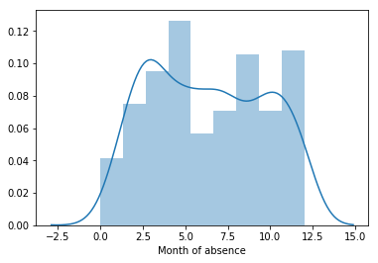
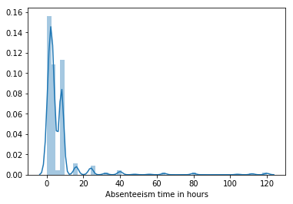

2.1.1 Outlier Analysis

Outlier means observations inconsistent with the rest of the dataset. Causes of outliers are: poor data quality/ contamination, Low quality measurements and correct but exceptional data. We can detect outliers using boxplots. Boxplots clearly show us the outliers.

One of the other steps of pre-processing apart from checking for normality is the presence of outliers. We visualize outliers using Boxplots.

We are checking for outliers for Distance from Residence to Work, Transportation expense, Hit target, Work load Average/day , Absenteeism time in hours etc columns because remaining columns are not continuous. As those columns for which we didn't check outliers are having few categories. So, we made them as categorical columns.
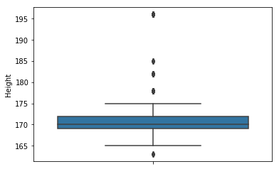

Showing Height variable outliers

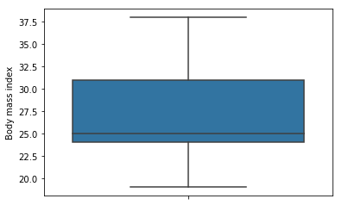
Showing Body mass index variable which doesn't have outliers

As we can see few variables doesn't have outliers.

2.1.2 Plots

Following are the plots which shows us the relationship between the target variable Seasons and other features we have.

The following plot shows how 'Seasons' affects 'Absenteeism time in hours':
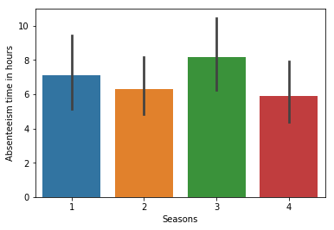
'Seasons' vs 'Absenteeism time in hours'

The below plot shows how 'Month of absence' affects 'Absenteeism time in hours':
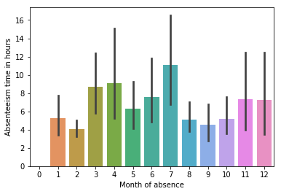
'Month of absence' vs 'Absenteeism time in hours'
2.1.3. Feature Selection:

Feature Selection is selecting relevant features(variables, predictors) to be used in model construction. Features can be selected based on the correlation between the target variable and predictor variables. Following plot reveals the correlation between each feature with other feature along with itself and as well as target variable:

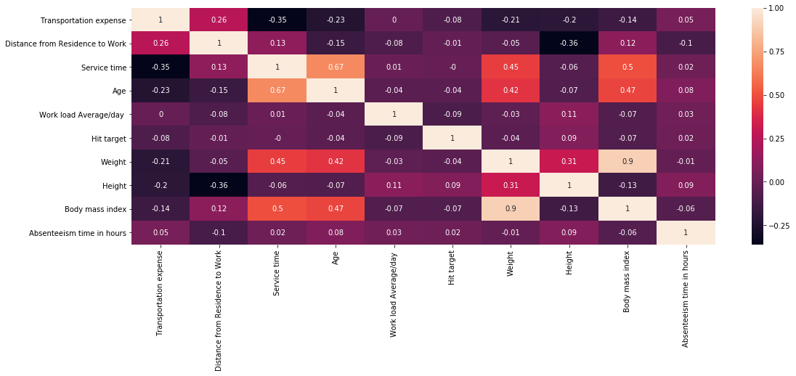

correlation plot using heatmap

2.2 Modeling:

2.2.1. Model Selection:

Till now, we just pre-processed the data and understand completely. So, now we can select a model to predict the Absenteeism time in hours based on the features we have like 'Seasons', 'Hit target', 'Reason for absence', 'Month of absence',etc. As this is a Regression problem, first we check with Linear Regression and then with Decision Tree Regressor, Random Forest Regressor as well. Based on the Error Metrics of the models we built, we select the best model.

2.2.2. Multiple Linear Regression:

In statistics, linear regression is a linear approach to modeling the relationship between a scalar response and one or more explanatory variables. The case of one explanatory variable is called simple linear regression. For more than one explanatory variable, the process is called multiple linear regression. The following illustrated how to implement Linear Regression:

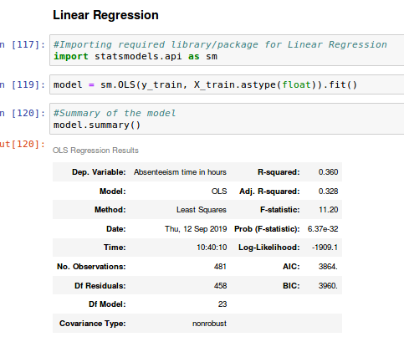

2.2.3 Regression Trees:

Decision tree learning uses a decision tree to go from observations about an item to conclusions about the item's target value. It is one of the predictive modeling approaches used in statistics, data mining and machine learning. It can be used for both Regression and Classification problems.

Decision Tree can be implemented as follows:

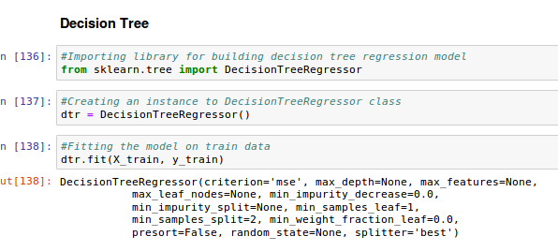
Random Forest can be implemented as follows:

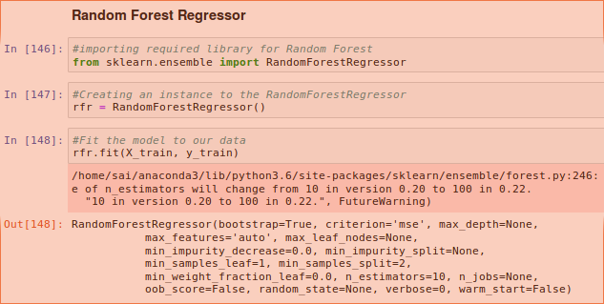

3. Conclusion

3.1 Model Evaluation

Our model is Time Series type. But, as we have knowledge only on the models like Linear Regression, Decision Tree, Random Forest and some ensemble learning algorithms. I have built this model by considering the problem as a Regression type. So, the Evaluation has some metrics for Regression problems. The following are the Regression Evaluation Metrics:

3.1.1 Mean Absolute Error(MAE):

In Regression Analysis, mean absolute error is a measure of difference between two continuous variables. Assume X and Y are variables of paired observations that express the same phenomenon. MAE is one of the error measures used to calculate the predictive performance of the model. We will apply this measure to our models that we have generated in the previous section.

3.1.2 Mean Squared Error(MSE):

In Regression Analysis, the mean squared error or mean squared deviation of an estimator measures the average of the squares of the errors—that is, the average squared difference between the estimated values and what is estimated.

3.1.3 Root Mean Square Error(RMSE):

The root-mean-square deviation or root-mean-square error is a frequently used measure of the differences between values predicted by a model or an estimator and the values observed.

The following will show how to calculate above metrics:

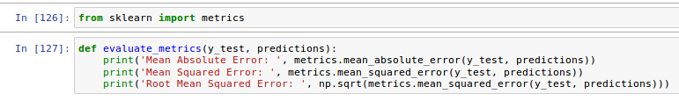

Finally, this dataset has been fitted a little bit for Linear Regression when compared to Decision Tree & Random Forest. But as it is a Time-Series problem, the Algorithms which I applied are not much sufficient to predict the target variable.

The Metrics I noted:

Algorithm | MAE | MSE | RMSE
Linear Regression | 6.28006 | 204.0282 | 14.2838
Decision Tree | 6.2333 | 249.7332 | 15.8029
Random Forest | 5.888 | 229.2037 | 15.1394

After reducing few variables, I got the metrics as follows:

Algorithm | MAE | MSE | RMSE
Gradient Boosting | 7.87 | 311.030 | 17.63
XGBoost | 6.57 | 224.3261 | 14.9775

