Bike Renting
Sai Kumar V
27th July, 2019

Contents
- Introduction
  - Problem Statement
  - Data
- Methodology
  - Pre Processing
    - Outlier Analysis
    - Plots
    - Feature Selection
  - Modeling
    - Model Selection
    - Multiple Linear Regression
    - Regression Trees
- Conclusion
  - Model Evaluation
    - Mean Absolute Error(MAE)
    - Mean Squared Error(MSE)
    - Root Mean Squared Error(RMSE)
    - Mean Absolute Percentage Error(MAPE)

References:

- www.stackoverflow.com
- www.medium.com
- www.cookbook-r.com
- www.wikipedia.org

1.1 Problem Statement:

Bike Sharing systems are new generation of traditional bike rentals where whole process from membership, rental & return back has become automatic.Today, there exists great interest in these systems due to their important role in traffic, environmental & health issues. Bike Rental process is highly correlated to the environmental & seasonal settings. For instance, weather conditions, precipitation, day of the week, season etc can affect the rental behaviours. The task is to Predict bike rental count daily based on the environmental & seasonal settings.

1.2 Data:

Our task is to build Regression model which will predict the number of bikes will be taken for rent based on environmental & seasonal settings. Given below is a sample of the data set that we are using to predict the count of bikes to be taken in total:

Columns(1-6)

instant | dteday | season | yr | mnth | holiday
1 | 2011-01-01 | 1 | 0 | 1 | 0
2 | 2011-01-02 | 1 | 0 | 1 | 0
3 | 2011-01-03 | 1 | 0 | 1 | 0
4 | 2011-01-04 | 1 | 0 | 1 | 0

Columns(7-12)

weekday | workingday | weathersit | temp | atemp | hum
6 | 0 | 2 | 0.344167 | 0.363625 | 0.805833
0 | 0 | 2 | 0.363478 | 0.353739 | 0.696087
1 | 1 | 1 | 0.196364 | 0.189405 | 0.437273
2 | 1 | 1 | 0.200000 | 0.212122 | 0.590435

Columns(13-16)

windspeed | casual | registered | cnt
0.160446 | 331 | 654 | 985
0.248539 | 131 | 670 | 801
0.248309 | 120 | 1229 | 1349
0.160296 | 108 | 1454 | 1562

The following are the Predictor Variables of our data:

S.No | Feature
1 | instant
2 | dteday
3 | season
4 | yr
5 | mnth
6 | holiday
7 | weekday
8 | workingday
9 | weathersit
10 | temp
11 | atemp
12 | hum
13 | windspeed
14 | casual
15 | registered

Target variable is : cnt

Chapter 2

Methodology

2.1 Pre Processing

Any predictive modeling requires that we look at the data before we start modeling. However, in data mining terms looking at data refers to so much more than just looking. Looking at data refers to exploring the data, cleaning the data as well as visualizing the data through graphs and plots. This is often called as Exploratory Data Analysis. To start this process we will first try and look at all the probability distributions of the variables. Most analysis like regression, require the data to be normally distributed. We can visualize that in a glance by looking at the probability distributions or probability density functions of the variable. Following are the plots that show us the skewness: temp, atemp, hum, windspeed columns are plotted(Univariate Analysis)

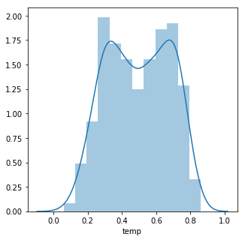
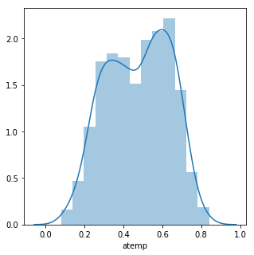

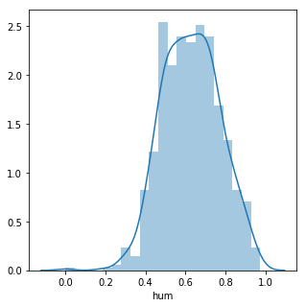
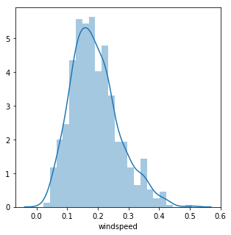

2.1.1 Outlier Analysis

Outlier means observations inconsistent with the rest of the dataset. We can clearly observe from these plots that most of the variables are skewed, for example, season(1,2,3,4), casual, registered. Causes of outliers are: poor data quality/ contamination, Low quality measurements and correct but exceptional data. We can detect outliers using boxplots. Boxplots clearly show us the outliers.

One of the other steps of pre-processing apart from checking for normality is the presence of outliers. We visualize outliers using Boxplots.

We are checking for outliers only for 'casual', 'registered' columns because remaining columns like season(it has values only 1-4), weekday(values only from 0-6), yr(0,1), mnth(1-12), weathersit(1-3).

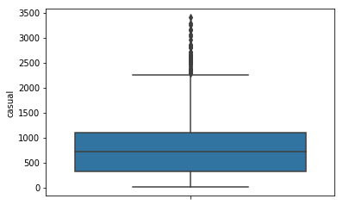

Casual column outlier detection

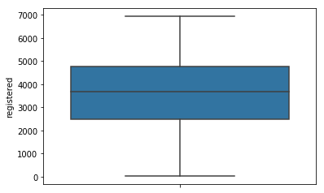
registered column outlier detection

We can clearly see that 'casual' column has outliers. But 'registered' column doesn't have any outliers

2.1.2 Plots

Following are the plots which shows us the relationship between the target variable cnt and other features we have.

The following plot shows how 'season' affects 'cnt':
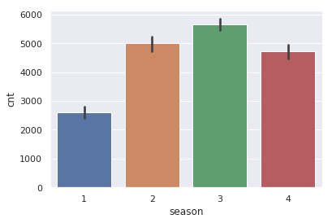
'season' vs 'cnt'
The below plot shows how 'holiday' affects 'cnt':
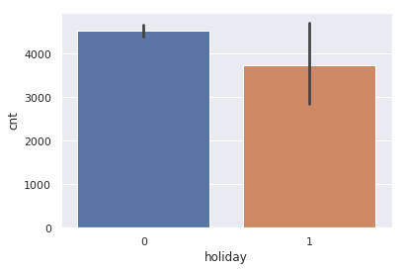
'holiday' vs 'cnt'

The following plot shows how 'weathersit' affects 'cnt':

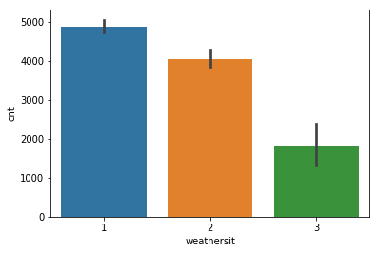

'weathersit' vs 'cnt'

The following plot shows us how 'weekday' affects 'cnt':
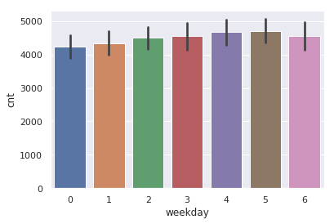
'weekday' vs 'cnt'

2.1.3. Feature Selection:

Feature Selection is selecting relevant features(variables, predictors) to be used in model construction. Features can be selected based on the correlation between the target variable and predictor variables. Following plot reveals the correlation between each feature with other feature along with itself and as well as target variable:

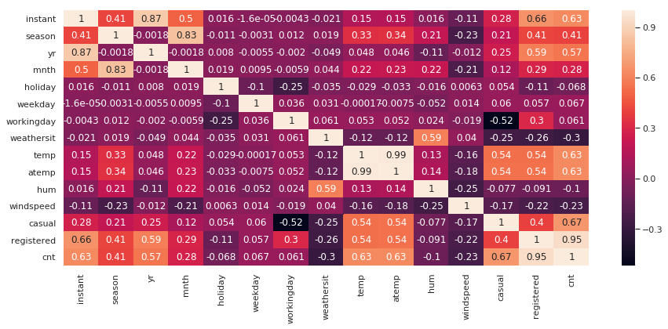
correlation plot using heatmap

2.2 Modeling:

2.2.1. Model Selection:

Till now, we just pre-processed the data and understand completely. So, now we can select a model to predict the bike rental based on environmental & seasonal settings. As this is a Regression problem, first we check with Linear Regression and then with Decision Tree Regressor, Random Forest Regressor as well. Based on the Error Metrics of the models we built, we select the best model.

2.2.2. Multiple Linear Regression:

In statistics, linear regression is a linear approach to modeling the relationship between a scalar response and one or more explanatory variables. The case of one explanatory variable is called simple linear regression. For more than one explanatory variable, the process is called multiple linear regression. The following illustrated how to implement Linear Regression:

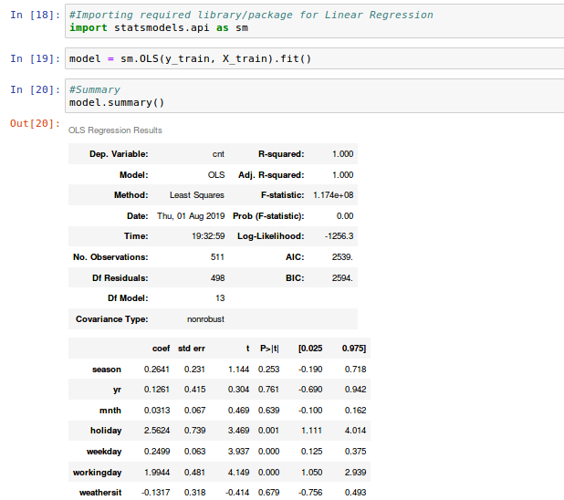
2.2.3 Regression Trees:

Decision tree learning uses a decision tree to go from observations about an item to conclusions about the item's target value. It is one of the predictive modeling approaches used in statistics, data mining and machine learning. It can be used for both Regression and Classification problems.

Decision Tree can be implemented as follows:

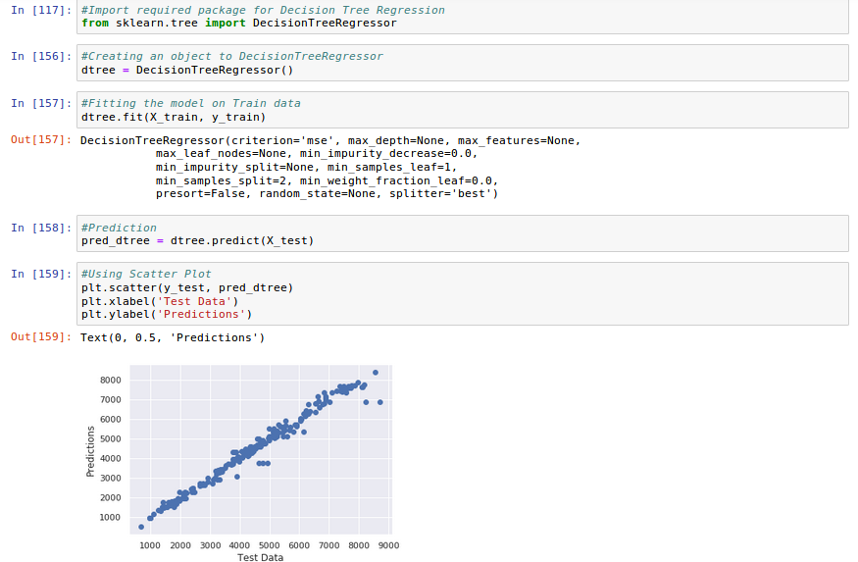

Random Forest can be implemented as follows:

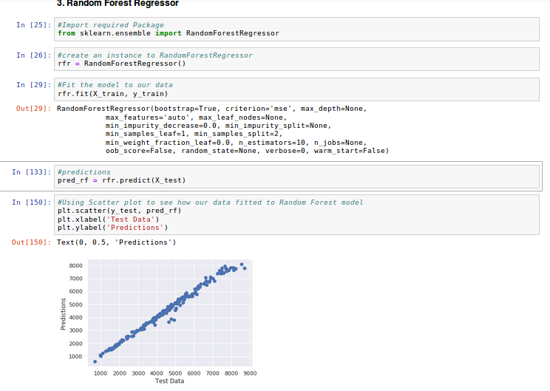

3. Conclusion

3.1 Model Evaluation

Our model is Regression type. So, the Evaluation has some metrics for Regression problems. The following are the Regression Evaluation Metrics:

3.1.1 Mean Absolute Error(MAE):

In Regression Analysis, mean absolute error is a measure of difference between two continuous variables. Assume X and Y are variables of paired observations that express the same phenomenon. MAE is one of the error measures used to calculate the predictive performance of the model. We will apply this measure to our models that we have generated in the previous section.

3.1.2 Mean Squared Error(MSE):

In Regression Analysis, the mean squared error or mean squared deviation of an estimator measures the average of the squares of the errors—that is, the average squared difference between the estimated values and what is estimated.

3.1.3 Root Mean Square Error(RMSE):

The root-mean-square deviation or root-mean-square error is a frequently used measure of the differences between values predicted by a model or an estimator and the values observed.

3.1.4 Mean Absolute Percentage Error(MAPE):

The mean absolute percentage error, also known as mean absolute percentage deviation, is a measure of prediction accuracy of a forecasting method in statistics, for example in trend estimation, also used as a loss function for regression problems in machine learning. It shows the error percentage in the test data.

The following will show how to calculate above metrics:

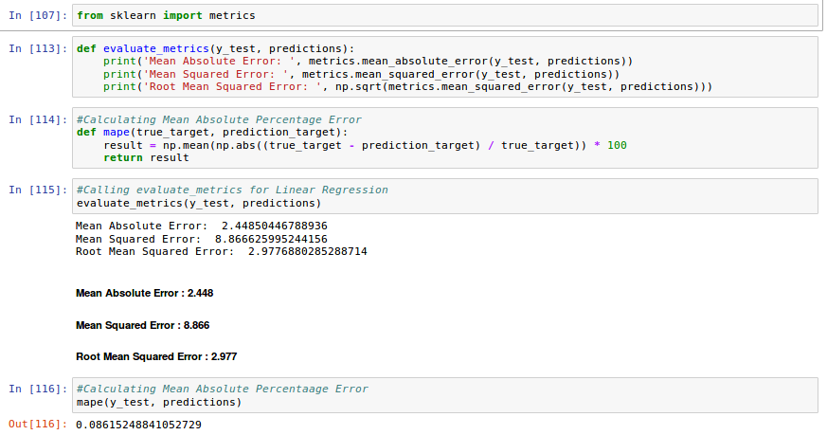

Finally, this dataset has been best fitted for Linear Regression only when compared to Decision Tree & Random Forest

