CHAPTER 1
INTRODUCTION
Project Introduction
Most of the antennas are used for commercial purposes in satellite communications, radar communication, telecommunications etc., but the designed antenna is for smart security purpose and it works at three different frequencies i.e., at 5g and X band frequencies. Smart security means the designed antenna is useful for detecting an object or a human being while tracking. The major advantage of this project is, it is useful for detecting children when they get kidnapped. The microstrip antenna works on the principle of encryption and decryption format. We are already aware of encryption and decryption.
Encryption is the process of translating plain text data (plaintext) into something that appears to be random and meaningless (cipher text). Decryption is the process of converting cipher text back to plaintext.
To encrypt more than a small amount of data, symmetric encryption is used. A symmetric key is used during both the encryption and decryption processes. To decrypt a piece of cipher text, the key that was used to encrypt the data must be used.
The goal of every encryption algorithm is to make it as difficult as possible to decrypt the generated cipher text without using the key. If a good encryption algorithm is used, there is no technique significantly better than methodically trying every possible key. For such an algorithm, the longer the key, the more difficult it is to decrypt a piece of cipher text without possessing the key.
It is difficult to determine the quality of an encryption algorithm. Algorithms that look promising sometimes turn out to be very easy to break, given the proper attack. When selecting an encryption algorithm, it is a good idea to choose one that has been in use for several years and has successfully resisted all attacks.
How can we save the kidnapped children?
Here is a smart trick for detecting the children location by sticking patch to bag. The microstrip chip looks like a tedddy face, but it is a chip which acts as a transmitting device. We must be equipped with a specific receiver to receive the signal to detect the kidnapped persons location. But quiries may arise that when GPS technology is already in use, Then what is the point of using microstrip,the reason for using this microstrip is that, As children do not carry mobile phones,This microstrip helps to track them by inserting this microstrip in a bag and it easily detects the location of the person.
1.1 Project introduction
The main objective of this project is the design of an antenna which works at lower 5G frequency.5G frequency is chosen because of its compatibility and large coverage area when compared to other networks and in the rapid increase of digital communication 5G plays a prominent role. The future depends on how effectively we can communicate through systems in our daily routine. The microstrip patch designed operates at multiple frequency ranges.
The revolution in the digital technology is smart so, the design works at three different frequency ranges, two frequencues works at 3.5 Ghz and 4.5 Ghz which belong to 5G band and the other frequency at which it works is 7.6 Ghz.

CHAPTER 2
5G TECHNOLOGY
2.1 5G- Technology
Radio technologies have evidenced a rapid and multidirectional evolution with the launch of the analogue cellular systems in 1980s. Thereafter, digital wireless communication systems are consistently on a mission to fulfil the growing need of human beings (1G, …4G, or now 5G).So, this article describes the 5G technology emphasizing on its salient features, technological design (architecture), advantages, shortcomings, challenges, and future scope.[1]

Salient Features of 5G
5th Generation Mobile Network or simply 5G is the forthcoming revolution of mobile technology. The features and its usability are much beyond the expectation of a normal human being. With its ultra-high speed, it is potential enough to change the meaning of a cell phone usability.
2.2 What is 5G -Technology?
The 5G technology is expected to provide a new (much wider than the previous one) frequency bands along with the wider spectral bandwidth per frequency channel. As of now, the predecessors (generations) mobile technologies have evidenced substantial increase in peak bit rate. Then — how is 5G different from the previous one (especially 4G)? The answer is — it is not only the increase in bit rate made 5G distinct from the 4G, but rather 5G is also advanced in terms of –[2]
- High capacity to allow more devices connectivity concurrently and instantaneously.
- Lower battery consumption.
- Better connectivity irrespective of the geographic region, in which you are.
- Larger number of supporting devices.
- Lower cost of infrastructural development.
- Higher reliability of the communications.
- High increased peak bit rate.
- Larger data volume per unit area (i.e. high system spectral efficiency).
2.3 Applications of 5G
Some of the significant applications are −
- It will make unified global standard for all.
- Network availability will be everywhere and will facilitate people to use their computer and such kind of mobile devices anywhere anytime.
- Because of the IPv6 technology, visiting care of mobile IP address will be assigned as per the connected network and geographical position.
- Its application will make world real Wi-Fi zone.
- Its cognitive radio technology will facilitate different version of radio technologies to share the same spectrum efficiently.
- Its application will facilitate people to avail radio signal at higher altitude as well.
As researchers say, with the wide range of bandwidth radio channels, it is able to support the speed up to 10 Gbps, the 5G Wi-Fi technology will offer contiguous and consistent coverage − “wider area mobility in true sense.”
Applications Of The Designed Antennas[3]
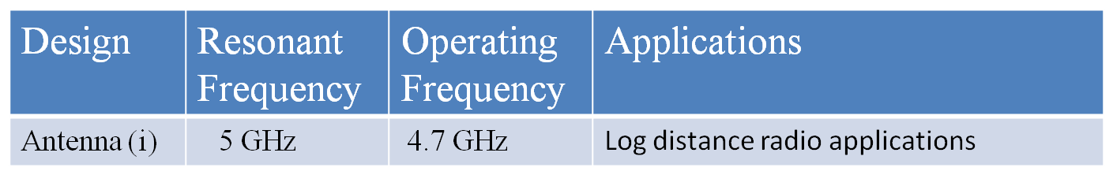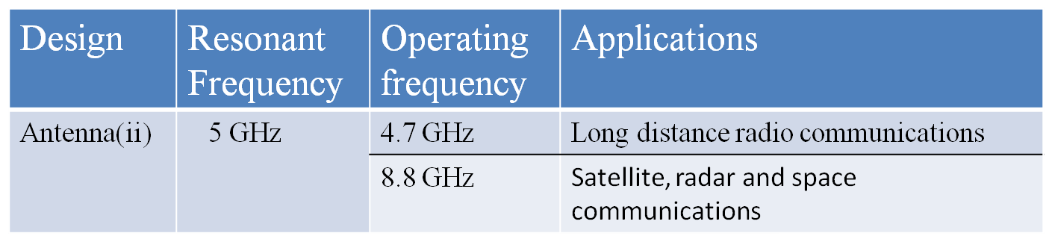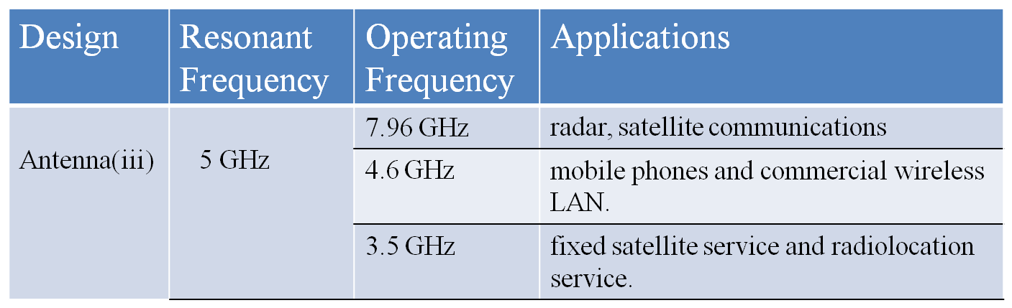
2.4 Advancement
Application of 5G is very much equivalent to accomplishment of dream. It is integrated with beyond the limit advance features in comparison to the previous technologies.[4]
Advanced Features
In comparison to previous radio technologies, 5G has following advancement −
- Feasibility to connect 10 to 100 number of devices.
- Worldwide coverage.
- About 90% reduction in network energy usage.
- Battery life will be much longer.
- Whole world will be in WI-FI zone.
- Practically possible to avail the super speed i.e. 1 to 10 Gbps.
- Latency will be 1 millisecond (end-to-end round trip).
- 1,000x bandwidth per unit area.
2.5 Advantages & Disadvantages
5th generation technology offers a wide range of features, which are beneficial for all group of people including, students, professionals (doctors, engineers, teachers, governing bodies, administrative bodies, etc.) and even for a common man.
2.5.1 Important Advantages
There are several advantages of 5G technology, some of the advantages have been shown in the above Ericsson image, and many others are described below −
- High resolution and bi-directional large bandwidth shaping.
- Technology to gather all networks on one platform.
- More effective and efficient.
- Technology to facilitate subscriber supervision tools for the quick action.
- Most likely, will provide a huge broadcasting data (in Gigabit), which will support more than 60,000 connections.
- Easily manageable with the previous generations.
- Technological sound to support heterogeneous services (including private network).
- Possible to provide uniform, uninterrupted, and consistent connectivity across the world.
Some Other Advantages for the Common People Parallel multiple services, such as
you can know weather and location while talking with other person. You can control your PCs by handsets. Education will become easier − A student sitting in any part of world can attend the class. Medical Treatment will become easier & frugal − A doctor can treat the patient located in remote part of the world. Monitoring will be easier − A governmental organization and investigating offers can monitor any part of the world. Possible to reduce the crime rate. Visualizing universe, galaxies, and planets will be possible. Possible to locate and search the missing person. Possible, natural disaster including tsunami, earthquake etc. can be detected faster.
2.6 Disadvantages of 5G-Technology
Though, 5G technology is researched and conceptualized to solve all radio signal problems and hardship of mobile world, but because of some security reason and lack of technological advancement in most of the geographic regions, it has following shortcomings −
- Technology is still under process and research on its viability is going on.
- The speed, this technology is claiming seems difficult to achieve (in future, it might be) because of the incompetent technological support in most parts of the world.
- Many of the old devices would not be competent to 5G, hence, all of them need to be replaced with new one — expensive deal.
- Developing infrastructure needs high cost.
- Security and privacy issue yet to be solved.
2.7 Challenges
Challenges are the inherent part of the new development; so, like all technologies, 5G has also big challenges to deal with. As we see past i.e. development of radio technology, we find very fast growth. Starting from 1G to 5G, the journey is merely of about 40 years old (Considering 1G in 1980s and 5G in 2020s). However, in this journey, the common challenges that we observed are lack of infrastructure, research methodology, and cost. Still, there are dozens of countries using 2G and 3G technologies and don’t know even about 4G, in such a condition, the most significant questions in everyone’s mind are many. To understand these questions, the challenges of 5G are categorized into the following headings.
- Technological Challenges
- Common Challenges
2.7.1 Technological Challenges
1. Inter-cell Interference − This is one of the major technological issues that need to be solved. There is variations in size of traditional macro cells and concurrent small cells that will lead to interference.
2. Efficient Medium Access Control − In a situation, where dense deployment of access points and user terminals are required, the user throughput will be low, latency will be high, and hotspots will not be competent to cellular technology to provide high throughput. It needs to be researched properly to optimize the technology.
3. Traffic Management − In comparison to the traditional human to human traffic in cellular networks, a great number of Machine to Machine (M2M) devices in a cell may cause serious system challenges i.e. radio access network (RAN) challenges, which will cause overload and congestion.
2.7.2Common Challenges
1. Multiple Services − Unlike other radio signal services, 5G would have a huge task to offer services to heterogeneous networks, technologies, and devices operating in different geographic regions. So, the challenge is of standardization to provide dynamic, universal, user-centric, and data-rich wireless services to fulfil the high expectation of people.
2. Infrastructure − Researchers are facing technological challenges of standardization and application of 5G services.
3. Communication, Navigation, & Sensing − These services largely depend upon the availability of radio spectrum, through which signals are transmitted. Though 5G technology has strong computational power to process the huge volume of data coming from different and distinct sources, but it needs larger infrastructure support.
4. Security and Privacy − This is one of the most important challenges that 5G needs to ensure the protection of personal data. 5G will have to define the uncertainties related to security threats including trust, privacy, cyber security, which are growing across the globe.
5. Legislation of Cyber law − Cybercrime and other fraud may also increase with the high speed and ubiquitous 5G technology. Therefore, legislation of the Cyber law is also an imperative issue, which largely is governmental and political (national as well as international issue) in nature.

2.8 Lower 5G Frequency Bands (future considerations)
The bands 600 MHz-6GHz are considered for traditional coverage applications and new specific usages such as Internet of Things (IoT), Industry Automation Business Critical use cases and Satellite communication. However, “reforming” will be required for most of these bands, hence the time required to have them allocated to 5G will be much longer than the higher bands. Lower 5G bands having less radiation compared to higher 5G bands. Practically lower 5G is better for short distance communication and smart technology. The X-band is the designation for a band of frequencies in the microwave radio region of the electromagnetic spectrum. In some cases, such as in communication engineering, the frequency range of the X band is rather indefinitely set at approximately 7.0 to 11.2 GHz. In radar engineering, the frequency range is specified by the IEEE at 8.0 to 12.0 GHz. [5]
The X band is used for radar, satellite communication, and wireless computer networks.

CHAPTER 3
ANTENNAS
3.1 Antenna
Antennas are a very important component of communication systems. To radiate or receive electromagnetic waves an antenna is required. An Antenna or Aerial is a system of elevated conductors which couples or matches the transmitter or receiver to free space. A transmitting antenna connected to a transmitter by a transmission line, forces electromagnetic waves into free space which travels in space with velocity of light. Similarly, a receiving antenna connected to a radio receiver, receives or intercepts a portion of electromagnetic waves travelling through space. Thus, the Radio antenna or Aerial is defined as the structure associated with the region of transition between a guided wave and a free space wave or between a free space wave and guided waves.
The official definition of the antenna according to the Institution of Electrical and Electronics Engineers is simple a means for radiating or receiving radio waves. Antennas demonstrate a property known as reciprocity, which means that an antenna will maintain the same characteristics regardless if it is transmitting or receiving. An antenna must be tuned to the same frequency band of the radio system to which it is connected; the reception and the transmission will be impaired.
3.2 Antenna Parameters
An antenna is a transformer between a transmission line and free space. To describe an antenna, we must characterize its properties as a transmission line load and the distribution of the electromagnetic energy that it radiates into space. There are a several key parameters and concepts that we can use to describe antenna properties.[6]
Basic Antenna Parameters:
An antenna does not radiate uniformly in all directions. For the sake of a reference, we consider a hypothetical antenna called an isotropic radiator having equal radiation in all directions. A directional antenna is one which can radiate or receive electromagnetic waves more effectively in some directions than in others. The relative distribution of radiated power as a function of direction in space (i.e., as function of and) is called the radiation pattern of the antenna. Instead of 3D surface, it is common practice to show planar cross section radiation pattern. E-plane and H-plane patterns give two most important views. The E-plane pattern is a view obtained from a section containing maximum value of the radiated field and electric field lies in the plane of the section. Similarly, when such a section is taken such that the plane of the section contains H field and the direction of maximum radiation.
3.2.1 Radiation Pattern
A radiation pattern defines the variation of the power radiated by an antenna as a function of the direction away from the antenna. This power variation as a function of the arrival angle is observed in the antenna's far field. Typically, because it is simpler, the radiation patterns are plotted in 2-d. In this case, the patterns are given as "slices" through the 3d plane. The 2D plot of the radiation pattern is shown in the Fig. 3.2.1. Standard spherical coordinates are used, where θ is the angle is measured off the z-axis, and φ is the angle measured counter clockwise off the x-axis. The radiation pattern on X- axis in Fig. 3.2.1 is the elevation pattern, which represents the plot of the radiation pattern as a function of the angle measured off the z-axis. Observing Fig. 3.2.1, we see that the radiation pattern is minimum at 0º and 180º and becomes maximum at broadside to the antenna.
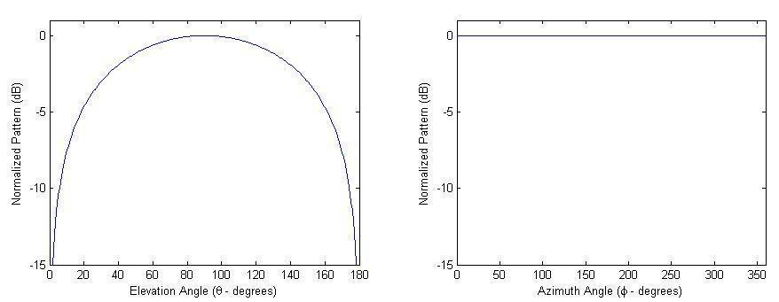
Figure.3.1 2D plot of radiation pattern
The radiation pattern on the X-axis in Fig. 3.1 is the azimuth plot. It is a function of the azimuth angle for a fixed polar angle (90 degrees off the z-axis in this case).
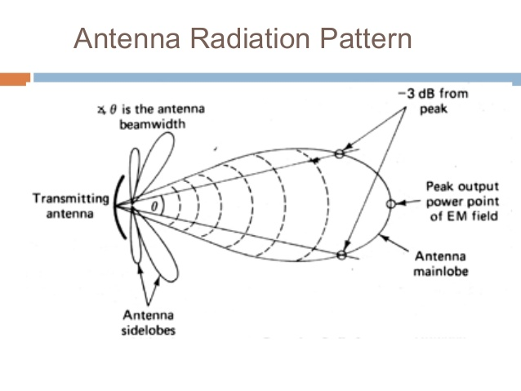
Figure.3.2 Antenna Radiation Pattern
A pattern is "isotropic" if the radiation pattern is the same in all directions. Antennas with isotropic radiation patterns don't exist in practice but are sometimes discussed as a means of comparison with real antennas. The main lobe is the region around the direction of maximum radiation. The side lobes are smaller beams that are away from the main beam. These side lobes are usually radiation in undesired direction which can never be eliminated that is shown in Fig. 3.2
Fig (a) shows a typical radiation pattern plot in polar coordinates and Fig (b) shows the same in rectangle coordinates
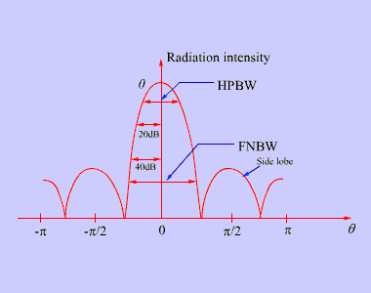
Figure 3.2 (b): Typical radiation pattern in Rectangular Coordinates
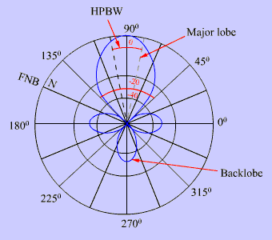
Figure 3.2 (a): Typical radiation pattern in Polar
Coordinates

Fig.2.2 Lobes around antenna

The main lobe contains the direction of maximum radiation. However, in some antennas, more than one major lobe may exist. Lobe other than major lobe are called minor lobes. Minor lobes can be further used to represents radiation in the considered direction and are required to be minimized.
HPBW or half power beam width refers to the angular width between the points at which the radiated power per unit area is one half of the maximum.
Similarly, FNBW (First null beam width) refers to the angular width between the first two nulls as shown in Fig 7.3. By the term beam width, we usually refer to 3 dB beam width or HPBW.
3.2.2 Directivity
We have already mentioned that an antenna does not radiate uniformly in all directions. Directivity function describes the variation of the radiation intensity. The directivity function is defined by
=$\frac{1}{\frac{1}{4π}\int_{0}^{2π}{\int_{0}^{π}{{\left|F\left(θ,ϕ\right)\right|}^{2}\sin{θ}dθ dϕ}}}$(3.1)
Directivity of the antenna is determined by the antenna to focus energy in a particular direction when transmitting or to receive energy better from a particular direction when receiving. To determine the directivity of an antenna, we need a reference antenna with which to compare our antenna's performance.
If P_{r} is the radiated power, the gives the amount of power radiated per unit solid angle. Had this power beam uniformly radiated in all directions then average power radiated per unit solid angle is .
The maximum of directivity function is called the directivity.
(3.2)
3.2.3 Input Impedance
impedance relates the voltage to the current at the input to the antenna. This is extremely important as we will see. At high frequency this section will be a little more advanced. In low-frequency circuit theory, the wires that connect things don't matter. Once the wires become a significant fraction of a wavelength, they make things very different. For instance, a short circuit has an impedance of zero ohms. However, if the impedance is measured at the end of quarter wavelength transmission line, the impedance appears to be infinite, even though there is a dc conduction path.
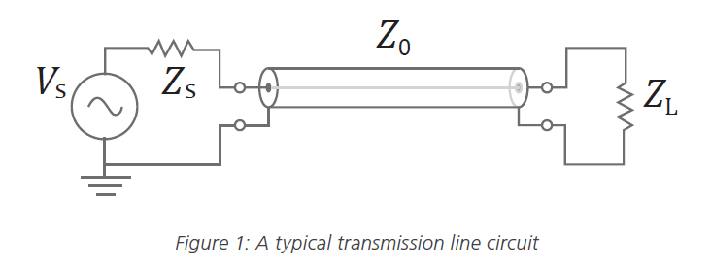
Figure.3.3 Transmission line model
In general, the transmission line will transform the impedance of an antenna, making it very difficult to deliver power, unless the antenna is matched to the transmission line. Consider the situation shown in Fig. 3.3. The impedance is to be measured at the end of a transmission line (with characteristic impedance $Z_{0}$) and Length L. The end of the transmission line is hooked to an antenna with impedance ZA.
The input impedance $z_{in}$ is given by
$Z_{in}=Z_{0}\frac{Z_{A}+ jZ_{0}. \tan{\frac{2πf}{c}}L}{Z_{0}+ jZ_{A}. \tan{\frac{2πf}{c}}L}$(3.3)
If the antenna is matched to the transmission line (Z_{A}=Z₀), then the input impedance
does not depend on the length of the transmission line.
3.2.4. Axial ratio
Axial ratio is the ratio of orthogonal components of an E-field. A circularly polarized field is made up of two orthogonal E-field components of equal amplitude (and 90 degrees out of phase). Because the components are equal magnitude, the axial ratio is 1 (or 0 dB). The axial ratio for an ellipse is larger than 1 (>0 dB). The axial ratio for pure linear polarization is infinite, because the orthogonal components of the field are zero. Axial ratios are often quoted for antennas in which the desired polarization is circular. The ideal value of the axial ratio for circularly polarized fields is 0 dB. In addition, the axial ratio tends to degrade away from the main beam of an antenna, so the axial ratio may be indicated in a spec sheet (data sheet) for an antenna as follows: "Axial Ratio: <3 dB for +/-30 degrees from main beam". This indicates that the deviation from circular polarization is less than 3 dB over the specified angular range.
3.2.5 Bandwidth
Bandwidth is another fundamental antenna parameter. Bandwidth describes the range of frequencies over which the antenna can properly radiate or receive energy. Often, the desired bandwidth is one of the determining parameters used to decide upon an antenna. For instance, many antenna types have very narrow bandwidths and cannot be used for wide band operation.
3.2.6 VSWR
A radio (transmitter or receiver) delivers power to an antenna, the impedance of the radio and transmission line must be well matched to the antenna's impedance. The parameter VSWR is a measure that numerically describes how well the antenna’s impedance is matched to the radio or transmission line to which it is connected. VSWR stands for Voltage Standing Wave Ratio and is also referred to as Standing Wave Ratio. VSWR is a function of the reflection coefficient, which describes the power reflected from the antenna. If the reflection coefficient is given by, then the VSWR is defined as
VSWR$= \frac{1+ ⃓Γ⃓}{ 1-⃓Γ⃓}$ (3.4)
The VSWR is always a real and positive number for antennas. The smaller the VSWR is, the better the antenna is matched to the transmission line and the more power is delivered to the antenna.
The minimum VSWR is 1.0. In this case, no power is reflected from the antenna,
which is ideal. Often antennas must satisfy a bandwidth requirement that is given in terms of VSWR. For instance, an antenna might claim to operate from 100-200 MHz with VSWR<3. This implies that the VSWR is less than 3.0 over the specified frequency range.
VSWR specifications also implies that the reflection coefficient is less than 0.5 over the quoted frequency range. Physical Meaning of VSWR is determined from the voltage measured along a transmission line leading to an antenna. VSWR is the ratio of the peak amplitude of a standing wave to the minimum amplitude of a standing wave, as seen in the Fig. 3.4. When an antenna is not matched to the receiver, power is reflected. This causes a "reflected voltage wave", which creates standing waves along the transmission line. The results are the peaks and valleys as seen in Fig. 3.4. If the VSWR = 1.0, there would be no reflected power and the voltage would have a constant magnitude along the transmission line.[7]
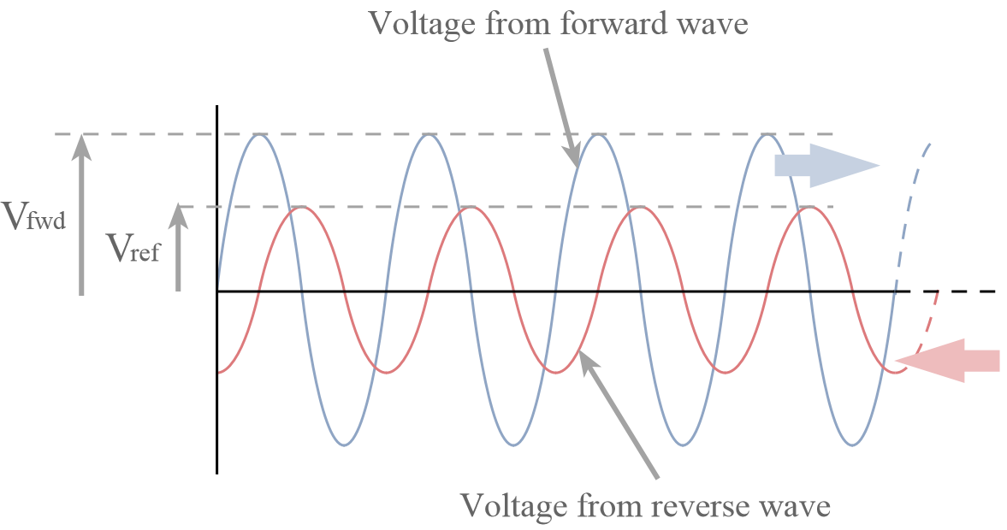
Figure.3.4 Voltage Measured Along a Transmission Line
3.2.7 Return Loss
In telecommunications, return loss is the loss of signal power resulting from the reflection caused at a discontinuity in the transmission line or optical fiber. This discontinuity may be a mismatch with the terminating load or with a device inserted in the line. It is usually expressed as a ratio in decibels (dB). Return loss is related to both standing wave ratio (SWR) and reflection coefficient (Г¹). Increasing return loss corresponds to lower SWR.
Return loss is a measure of how well devices or lines are matched. A match is good if the return loss is high. A high return loss is desirable and results in a lower insertion loss.
3.2.8. Radiation Intensity
In electromagnetism, radiation intensity describes the power density that an antenna creates in a solid angle. A solid angle is a section of the surface of the imaginary sphere around the antenna. Given antenna's power density as P, and radiation density (U) is calculated by multiplying it with the square of the distance (r) from the antenna to the designated solid angle
U=P.r² (3.5)
This is so because unlike power density, radiation intensity does not depend on the distance because radiation intensity is defined as the power through a solid angle, the decreasing power density over distance due to the inverse-square law is offset by the increasing area of the solid angle due to the same law. Therefore, power density can be converted to radiation intensity by multiplying it with r².
This is so because unlike power density, radiation intensity does not depend on the distance because radiation intensity is defined as the power through a solid angle, the decreasing power density over distance due to the inverse-square law is offset by the increasing area of the solid angle due to the same law. Therefore, power density can be converted to radiation intensity by multiplying it with r².
The equation is sometimes referred to as the antenna's radiation efficiency. This distinguishes it from another sometimes-used term, called an antenna's "total efficiency". The total efficiency of an antenna is the radiation efficiency multiplied by the impedance mismatch loss of the antenna, when connected to a transmission line or receiver.
3.2.9 Antenna Gain
The term antenna gain describes how much power is transmitted in the direction of peak radiation to that of an isotropic source. Antenna gain is more commonly quoted in a real antenna's specification sheet because it considers the actual losses that occur. An antenna with a gain of 3 dB means that the power received far from the antenna will be 3 dB higher (twice as much) than what would be received from a lossless isotropic antenna with the same input power. Antenna Gain is sometimes discussed as a function of angle, but when a single number is quoted the gain is the 'peak gain' over all directions.
Antenna Gain (G) can be related to directivity (D) by
G =$ɛr$D (3.6)
3.3 Types of antennas
Almost every antenna in the world can be understood as some combination or derivative of the following antenna types. The fundamental antenna types are
3.3.1 Wire Antennas
A random wire antenna is a radio antenna consisting of a long wire suspended above the ground; whose length does not bear a relation to the wavelength of the radio waves used but is typically chosen more for convenience. The wire may be straight, or it may be strung back and forth between trees or walls just to get enough wire into the air; this type of antenna sometimes is called a zigzag antenna. Such antennas are usually not as effective as antennas whose length is adjusted to resonate at the wavelength to be used. Random wire antennas are a type of monopole antenna and the other side of the receiver or transmitter antenna terminal must be connected to an earth ground.
They are widely used as receiving antennas on the long wave, medium wave, and short wave bands, as well as transmitting antennas on these bands for small outdoor, temporary or emergency transmitting stations, as well as in situations where more permanent antennas cannot be installed.
There are different types of wire antenna, there are
1.Short Dipole Antenna
2.Dipole Antenna
3. Half Dipole Antenna
4. Monopole Antenna
5. Folded Antenna
3.3.1.1 Short Dipole Antenna
A short dipole is a physically feasible dipole formed by two conductors with a total length L substantially less than a half wavelength λ/2. As that length is reduced, the quantitative statements below become exact.
The feed point is usually at the center of the dipole is shown in Fig. 3.5. The current profile in each element, actually the tail end of a sinusoidal standing wave, is approximately a triangular distribution declining from the feed point current to zero at the ends. The far field electric field pattern at a distance r in the direction θ from the antenna's axis is in the θ direction. Radiation pattern of the short dipole compared to the half-wave dipole.
This radiation pattern is like and only slightly less directional than that of the half-wave dipole.
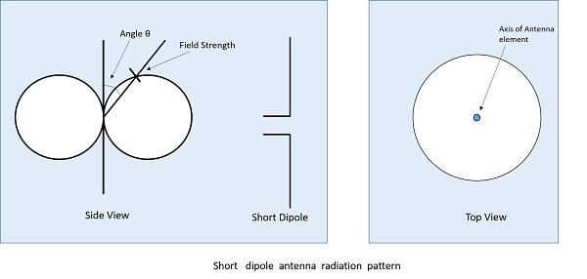
Fig.3.5Radiation pattern of short dipole
P_{total} =$\frac{π}{12}I_{0}^{2}$Z₀${\left(\frac{L}{λ}\right)}^{2}$(3.7)
Using the above expression for the radiation in the far field for a given feed point current, we can integrate over all solid angle to obtain the total radiated power.
3.3.1.2. Dipole Antenna
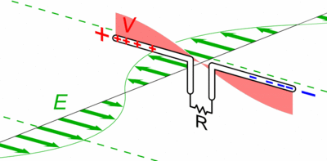
Figure.3.6 Dipole Antenna
In radio and telecommunications, a dipole antenna or double this is the simplest and most widely used class of antenna is shown in Fig. 3.6. It consists of two identical conductive elements. Such as metal wires or rods, which are usually bilaterally symmetrical. The driving current from the transmitter is applied, or for receiving antennas the output signal to the receiver is taken, between the two halves of the antenna.
Each side of the feed line to the transmitter or receiver is connected to one of the conductors. This contrasts with a monopole antenna, which consists of a single rod or conductor with one side of the feed line connected to it, and the other side connected to some type of ground. A common example of a dipole is the "rabbit ears" television antenna found on broadcast television sets.
The most common form of dipole is two straight rods or wires-oriented end to end on the same axis, with the feed line connected to the two adjacent ends. This is the simplest type of antenna from a theoretical point of view.
Dipoles are resonant antennas, meaning that the elements serve as resonators, with standing waves of radio current flowing back and forth between their ends. So, the length of the dipole elements is determined by the wavelength of the radio waves used. The most common form is the half-wave dipole, in which each of the two rod elements is approximately 1/4 wavelength long, so the whole antenna is a half-wavelength long. The radiation pattern of a vertical dipole is Omni-directional; it radiates equal power in all azimuthal directions perpendicular to the axis of the antenna. For a half-wave dipole, the radiation is maximum, 2.15 dB perpendicular to the antenna axis, falling monotonically with elevation angle to zero on the axis, off the ends of the antenna. Several different variations of the dipole are also used, such as the folded dipole, short dipole, cage dipole, bow-tie, and batwing antenna. Dipoles may be used as standalone antennas themselves, but they are also employed as feed antenna (driven element) in many more complex antenna types, such as the Yagi antenna, parabolic antenna, reflective array, turnstile antenna, Log periodic antenna, and phased array.
The dipole was the earliest type of antenna; it was invented by German physicist Heinrich Hertz around 1886 in his pioneering investigations o of radio waves. For a half-wave dipole, the radiation is maximum, 2.15 dB perpendicular to the antenna axis, falling monotonically with elevation angle to zero on the axis, off the ends of the antenna.
3.3.1.3 Monopole Antenna
A monopole antenna is one half of a dipole antenna, always mounted above some sort of ground plane. The case of a monopole antenna of length L mounted above an infinite ground plane. A monopole antenna is a class of radio antenna consisting of a straight rod-shaped conductor, often mounted perpendicularly over some type of conductive surface, called a ground plane.
The driving signal from the transmitter is applied, or for receiving antennas the output signal to the receiver is taken, between the lower ends of the monopole and the ground plane. One side of the antenna feed line is attached to the lower end of the monopole, and the other side is attached to the ground plane which is often the earth. This contrasts with a dipole antenna which consists of two identical rod conductors, with the signal from the transmitter applied between the two halves of the antenna. Common types of monopole antenna are the whip monopole antenna, rubber ducky monopole antenna, helical monopole antenna, random wire monopole antenna, inverted-L monopole antenna, inverted-F monopole antenna, and ground plane monopole antenna is shown in Fig. 3.7.
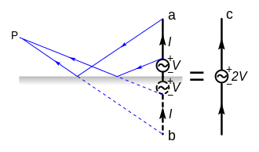
Figure. 3.7 Monopole Perfect Electric Field
3.3.1.4 Folded Dipole Antenna
The standard dipole is widely used in its basic form. However, under several circumstances a modification of the basic dipole, known as a folded dipole antenna provides several advantages.
The folded dipole antenna or folded dipole aerial is widely used, not only on its own, but also as the driven element in other antenna formats such as the Yagi antenna. And its basic form the folded dipole antenna consists of a basic dipole with an added conductor connecting the two ends together to make a complete loop of wire or another conductor. As the ends appear to be folded back, the antenna is called a folded dipole. The basic format for the folded dipole aerial is shown below. As can be seen from this it is a balanced antenna, like the standard dipole, although it can be fed with unbalanced feeder provided that a balun of some form is used to transform from an unbalanced to balance feed structure.
The folded dipole antenna uses an extra wire connecting both ends of the previous dipole as shown. Often this is achieved by using a wire or rod of the same diameter for all sections of the antenna, but this is not always the case. Also, the wires or rods are typically equip-spaced along the length of the parallel elements. To keep the
wires apart. Obviously if they are not insulated it is imperative to keep them from shorting. In some instances, flat feeder can be used.
One of the main reasons for using the folded dipole aerial is the increase in feed impedance that it provides. If the conductors in the main dipole and the second or "fold" conductor are the same diameter, then it is found that there is a fourfold increase (i.e. two squared) in the feed impedance. This can be achieved in several ways. Often for VHF or UHF antennas the rigidity of the elements is enough, but at lower frequencies spacers may need to be employed.
In free space, this gives an increase in feed impedance from 73Ω to around 300Ω ohms. Additionally, the RF antenna has a wider bandwidth.
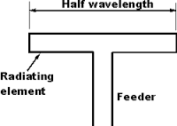
Figure.3.8 Half-wave folded dipole antenna
3.3.2 Aperture Antennas
Slot Antenna, Cavity-Backed Slot Antenna, Inverted-F Antenna, Slotted Waveguide Antenna, Horn Antenna, Vivaldi Antenna, Telescopes etc. all these come under aperture antennas. Slot antennas are used typically at frequencies between 300 MHz and 24 GHz. The slot antenna is popular because they can be cut out of whatever surface they are to be mounted on and have radiation patterns that are roughly Omni-directional. A practical slot antenna is the cavity-backed slot antenna. A horn antenna or microwave horn is an antenna that consists of a flaring metal waveguide shaped like a horn to direct radio waves in a beam. Horns are widely used as antennas at UHF and microwave frequencies, above 300 MHz They are used as feeders (called feed horns) for larger antenna structures such as parabolic antennas, as standard calibration antennas to measure the gain of other antennas, and as directive antennas for such devices as radar guns, automatic door openers, and microwave radiometers.
Their advantages are moderate directivity (gain), low SWR, broad bandwidth, and simple construction and adjustment. A slotted waveguide is a waveguide that is used as an antenna in microwave radar applications. Prior to its use in surface search radar, such systems used a parabolic segment reflector. A slotted waveguide has no reflector but emits directly through the slots. The spacing of the slots is critical and is a multiple of the wavelength used for transmission and reception.
The effect of this geometry is to form a high gain antenna that is highly directional in the plane of the antenna. Without augmentation a slotted waveguide is not as efficient as a parabolic reflector, lacking an ability to focus in the vertical plane, but is much more durable and is less expensive to construct. The antenna's vertical focus is usually enhanced by the application of a microwave lens attached to the front of the antenna. As this, like the companion slotted waveguide, is a one-dimensional device, it too may be made relatively cheaply as compared to a parabolic reflector and feed horn.
There are different types of aperture antenna, like
- Slot Antenna
- Cavity-Backed Slot Antenna
- Inverted-F Antenna
- Slotted Waveguide Antenna
- Horn Antenna
- Vivaldi Antenna
7. Telescopes
3.3.2.1 Slot Antennas
Slot antennas used typically at frequencies between 300 MHz and 24 GHz. The slot antenna is popular because they can be cut out of whatever surface they are to be mounted on and have radiation patterns that are roughly Omni-directional.
3.3.2.2 Horn Antenna
A horn antenna or microwave horn is an antenna shown in fig.3.9. That consists of a flaring metal waveguide shaped like a horn to direct radio waves in a beam.
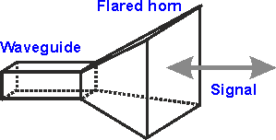
Figure.3.9 Horn Antenna
Horns are widely used as antennas at UHF and microwave frequencies, above 300 MHz, they are used as feeders for larger antenna structures such as parabolic antennas, as standard calibration antennas to measure the gain of other antennas, and as directive antennas for such devices as radar guns, automatic door openers, and microwave radiometers.
Their advantages are moderate directivity, low SWR, broad bandwidth, and simple construction and adjustment.
3.3.2.3 Slotted Waveguide Antenna
A slotted waveguide is a waveguide that is used as an antenna in microwave radar applications. Prior to its use in surface search radar, such systems used a parabolic segment reflector. A slotted waveguide has no reflector but emits directly through the slots. The spacing of the slots is critical and is a multiple of the wavelength used for transmission and reception.
The effect of this geometry is to form a high gain antenna that is highly directional in the plane of the antenna. Without augmentation a slotted waveguide is not as efficient as a parabolic reflector, lacking an ability to focus in the vertical plane, but is much more durable and is less expensive to construct. The antenna's vertical focus is usually enhanced by the application of a microwave lens attached to the front of the antenna. As this, like the companion slotted waveguide, is a one-dimensional device, it too may be made relatively cheaply as compared to a parabolic reflector and feed horn.
3.3.3 Reflector Antennas
In Reflector, Parabolic Reflector is the examples of reflector antennas. A corner reflector is a retro reflector consisting of three mutually perpendicular, intersecting flat surfaces, which reflects waves back directly towards the source, but shifted. The three intersecting surfaces often have square shapes. Optical corner reflectors, called corner cubes, made of three-sided glass prisms, are used in surveying and laser range finding.
A parabolic antenna is an antenna that uses a parabolic reflector, a curved surface with the cross-sectional shape of a parabola, to direct the radio waves. Parabolic antennas have some of the highest gains, that is they can produce the narrowest beam widths, of any antenna type.
In order to achieve narrow beam widths, the parabolic reflector must be much larger than the wavelength of the radio waves used, so parabolic antennas are used in the high frequency part of the radio spectrum, at UHF and microwave (SHF) frequencies.
There are two types of reflector antennas, there are
- Corner Reflector Antenna
2. Parabolic Reflector Antenna
3.3.3.1 Corner Reflector Antenna
Corner reflector antenna is a retro reflector consisting of three mutually perpendicular, intersecting flat surfaces as shown in Fig. 3.10 Which reflects waves back directly towards the source, but shifted.
.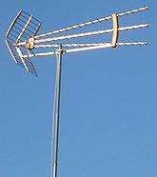
Fig.3.10 Corner reflector
The three intersecting surfaces often have square shapes. Radar corner reflectors made of metal are used to reflect radio waves from radar sets. Optical corner reflectors, called corner cubes, made of three-sided glass prisms, are used in surveying and laser range finding.
3.3.3.2 Parabolic Reflector Antenna
This antenna functions similarly to a searchlight or flashlight reflector to direct the radio waves in a narrow beam or receive radio waves from a direction only. Parabolic antennas have some of the highest gains that are they can produce the narrow beam widths, of any antenna type.
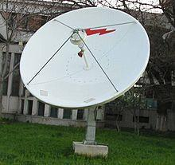
Figure.3.11 Parabolic reflector
In order to achieve narrow beam widths, the parabolic reflector must be much larger than the wavelength of the radio waves used, so parabolic antennas are used in the high frequency part of the radio spectrum, at UHF and microwave frequencies, at which the wavelengths are small enough that conveniently-sized reflectors can be used.
3.3.4 Travelling Wave Antennas
Antenna is a class of antenna that uses a travelling wave on a guiding structure as the main radiating mechanism. Travelling-wave antennas fall into two general categories: slow-wave antennas, and fast-wave antennas. Fast-wave antennas are often referred to as leaky-wave antennas. In slow-wave antennas, the guided wave is a slow wave, meaning a wave that propagates with a phase velocity vp that is less than the speed of light in free space. Such a wave fundamentally radiate by its nature and radiation occurs only at discontinuities.
The propagation wave number of the travelling wave is therefore a real number. Because the wave radiates only at the discontinuities, the radiation pattern is emitted from two sources, one at the beginning and one at the end of the structure. This makes it difficult to obtain highly-directive single-beam radiation patterns. However, moderately-directive patterns having a main beam near end fire can be achieved, although with a significant side lobe level. For these antennas there is an optimum length depending on the desired location of the main beam. Examples include wires in free space or over a ground plane, helixes, dielectric slabs or rods, corrugated conductors.
An independent control of the beam angle and of the beam width is not possible. The wave on a leaky wave antenna (LWA) may be a fast wave, with a phase velocity greater than the speed of light. This type of wave radiates continuously along its length, and hence the propagation wave number is complex, consisting of both a phase and an attenuation constant. Highly-directive beams at an arbitrary specified angle can be achieved with this type of antenna, with a low side lobe level. The phase constant β of the wave controls the beam angle (and this can be varied changing the frequency), while the attenuation constant α controls the beam width. The aperture distribution can also be easily tapered to control the side lobe level or beam shape. Leaky-wave antennas can be divided into two important categories, uniform and periodic, depending on the type of guiding structure.
There are different types of travelling wave antennas, there are
- Helical Antenna
- Yagi-Uda Antenna
- Spiral Antenna
3.3.4.1 Helical Antenna
Helical antenna is an antenna consisting of a conducting wire wound in the form of a helix. In most cases, helical antennas are mounted over a ground plane. The feed line is connected between the bottom of the helix and the ground plane as shown in Fig. 2.16.
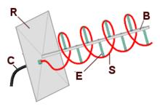
Figure.3.12 Helical Antenna
(B)Central support
(C)Coaxial cable feed line
(R)Reflector ground plane
(S)Helical radiating wire
(E) Insulating supports for the helix
Helical antennas can operate in one of two, there are
- Principal modes
- Normal mode or axial mode
In the normal mode or broadside helix, the dimensions of the helix are small compared with the wavelength. The antenna acts similarly to an electrically short dipole or monopole, and the radiation pattern, like these antennas is omni directional, with maximum radiation at right angles to the helix axis. The radiation is linearly polarized parallel to the helix axis. These are used for compact antennas for portable and mobile two-way radios, and for UHF television broadcasting antennas.
In the axial mode or end-fire helix, the dimensions of the helix are comparable to a wavelength. The antenna functions as a directional antenna radiating a beam off the ends of the helix, along the antenna's axis. It radiates circularly polarized radio waves. These are used for satellite communication.
3.3.4.2 Yagi-UDA Antenna
Yagi-UDA antenna, commonly known as a Yagi antenna, is a directional antenna consisting of multiple parallel elements in a line usually made of metal rods as shown in Fig.3.13. Yagi-UDA antennas consist of a single driven element connected to the transmitter or receiver with a transmission line, and additional transmission linea so-called reflector and one or more directors. The reflector element is slightly longer than the driven dipole; whereas the directors are a little shorter. This design achieves a very substantial increase in the antenna's directionality and gain compared to a simple dipole
Yagi-Uda antenna also called a beam antenna the Yagi is very widely used as a high-gain antenna on the HF, VHF and UHF bands. It has moderate gain which depends on the number of elements used, typically limited to about 17 dB, linear directional, unidirectional (end-fire) beam pattern with high front-to-back ratio of up to 20 dB and is lightweight, inexpensive and simple to construct. The bandwidth of a Yagi antenna, the frequency range over which it has high gain, is narrow, a few percent of the center frequency, and decreases with increasing gain, so it is often used in fixed-frequency applications. The largest and most well-known use is as rooftop terrestrial television antennas, but it is also used for point-to-point fixed communication links, in radar antennas, and for long-distance short-wave communication by shortwave broadcasting stations and radio armatures.
There is a single driven element driven in the center (consisting of two rods each connected to one side of the transmission line), and a variable number of parasitic elements, a single reflector on one side and optionally one or more directors on the other side as shown in Fig.3.13.
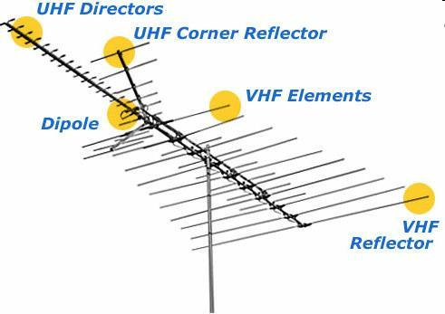
Figure.3.13 Yagi-Uda Antenna.
The Yagi-Uda antenna consists of several parallel thin rod elements in a line, usually half-wave long, typically supported on a perpendicular crossbar or "boom" along their centers. The parasitic elements are not electrically connected to the transmitter or receiver, and serve as parasitic radiators, reradiating the radio waves to modify the radiation pattern. Typical spacing between elements varies from about 1/10 to 1/4 of a wavelength, depending on the specific design.
The lengths of the directors are slightly shorter than that of the driven element, while the reflector(s) are slightly longer. The radiation pattern is unidirectional, with the main lobe along the axis perpendicular to the elements in the plane of the elements, off the end with the directors.
The bandwidth of the antenna is the frequency range between the frequencies at which the gain drops 3 dB (one-half the power) below its maximum. The Yagi-Uda array in its basic form has very narrow bandwidth, 2-3 percent of the center frequency. There is a tradeoff between gain and bandwidth, with the bandwidth narrowing as more elements are used.
3.3.5 Micro strip Antennas
In telecommunication, there are several types of microstrip antennas (also known as printed antennas) the most common of which is the microstrip patch antenna or patch antenna. A patch antenna is a narrowband, wide-beam antenna fabricated by etching the antenna element pattern in metal trace bonded to an insulating dielectric substrate, such as a printed circuit board, with a continuous metal layer bonded to the opposite side of the substrate which forms a ground plane. Common microstrip antenna shapes are square, rectangular, circular and elliptical, but any continuous shape is possible. Some patch antennas do not use a dielectric substrate and instead made of a metal patch mounted above a ground plane using dielectric spacers; the resulting structure is less rugged but has a wider bandwidth. Because such antennas have a very low profile, are mechanically rugged and can be shaped to conform to the curving skin of a vehicle, they are often mounted on the exterior of aircraft and space craft or are incorporated into mobile radio communications devices.
3.3.5.1 Log-Periodic Antennas
In telecommunication, a log-periodic antenna (LP, also known as a log-periodic array or log periodic beam antenna/aerial) is a broadband, multi-element, directional, narrow-beam antenna that has impedance and radiation characteristics that are regularly repetitive as a logarithmic function of the excitation frequency. The individual components are often dipoles, as in a log-periodic dipole array (LPDA). Log-periodic antennas are designed to be self-similar and are thus also fractal antenna arrays. The log periodic antenna was invented by Dwight E. Isbell, Raymond Du Hamel and variants by Paul Mayes.
The University of Illinois at Urbana-Champaign had patented the Isbell and Mayes-Carrel antennas and licensed the design as a package exclusively to JFD electronics in New York. The lengths and spacing’s of the elements of a log-periodic antenna increase logarithmically from one end to the other. A plot of the input impedance as a function of logarithm of the excitation frequency shows a periodic variation.
This antenna design is used where a wide range of frequencies is needed while still having moderate gain and directionality. It is sometimes used for a (VHF/UHF) television antenna.
3.3.5.1 Notch Antennas
The variation of the slot antenna is the notch antenna where an appropriately shaped notch is cut out of the edge of a large metal surface and connected to an RF source. The notch or open-ended slot antenna has been described by Cary and Johnson. It is broad band radiator which is often used to excite the empennage of aircraft as radiators.

CHAPTER 4
TRANSMISSION LINES

4.1 INTRODUCTION
It is usually necessary in various communication systems to interconnect points which are some distance apart from each other. For example, the connection between a transmitter and its antenna or antenna and receiver. The intermediate distance between two points may become an appreciable fraction of wavelength being propagated, at high frequency. It, thus, becomes essential to consider the properties of the inter-connecting wires, as they do not behave as short circuits.
Evidently the separation between wires, their sizes, lengths and general layout must be studied under these conditions. In the applications of antennas, it is necessary to employ transmission lines either in some form or in other form to connect a transmitter or a receiver. Therefore, it is also necessary to know the propagation characteristics of the commonly used transmission lines and the devices constructed from the transmission lines.
The transmission lines or feeders are essential for the antennas for the following three reasons Transmission lines or feeders are almost used for connecting a transmitter and its antenna or antenna and its receiver.
1. Transmission lines are the integral parts of the antenna.
2. Transmission lines principles are applicable in understanding some aspects of antenna theory
4.2 TYPES OF TRANSMISSION LINES
There are four types of transmission lines
- Parallel wire
- Coaxial cable
- Wave guide
- Optical Fiber
4.2.1 Parallel wire
Type of transmission lines are used in telephone, telegraphy, and power lines. These lines are easy to construct and cheaper. Since insulation between line conductors is normally air, the Di-electric loss is extremely small is shown in Fig.4.1. These lines are balanced with respect to earth.
However, there is significant energy loss due to radiation. As a result of which these lines are not suitable for frequencies above 100MHz.
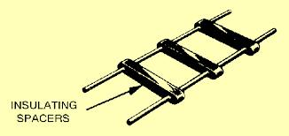
Figure.4.1Parallel wire transmission line
4.2.2 Coaxial cable
This type one conductor is hallowed tube, the second conductor being located inside and coaxial with the tube. The dielectric between the two conductors may be solid or gaseous. To avoid radiation losses taken place in open wire line at frequencies beyond 100MHz, a closed field configuration is employed in coaxial cable by surrounding the inner conductor with an outer cylindrical hallow conductor as shown in Fig. 4.2. Advantage of coaxial is that electric and magnetic fields remain confined within the outer conductor and cannot leak into free space.
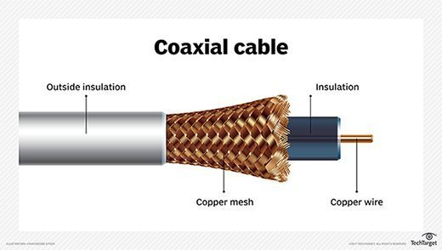
Figure .4.2 coaxial cable
As a consequence of which radiation is eliminated also the outer conductor provides a highly effective electromagnetic shielding against external electromagnetic signals. Coaxial cables are extensively used in the frequency range extending up to 1GHz and at frequencies beyond 1GHz these cables become unusable. These cables are quite costlier as compared to open wire lines or parallel wire lines. Losses in the dielectric increases as the signal frequency are increased.
4.2.3 Wave guides
The transmission line consisting of a suitable shaped hallow conductor, which may be fitted with a dielectric material and is used to guide electromagnetic waves of UHF propagated along its length, is called wave guide. Electromagnetic wave is excited in a wave guide utilizing the electric and magnetic fields associated with electromagnetic wave present in another device such as cavity resonator or microwave tube. A suitable connector is used to interconnect the wave guide to the source of radiation in order to achieve the optimum transfer of energy and to excite the desired transmission mode.
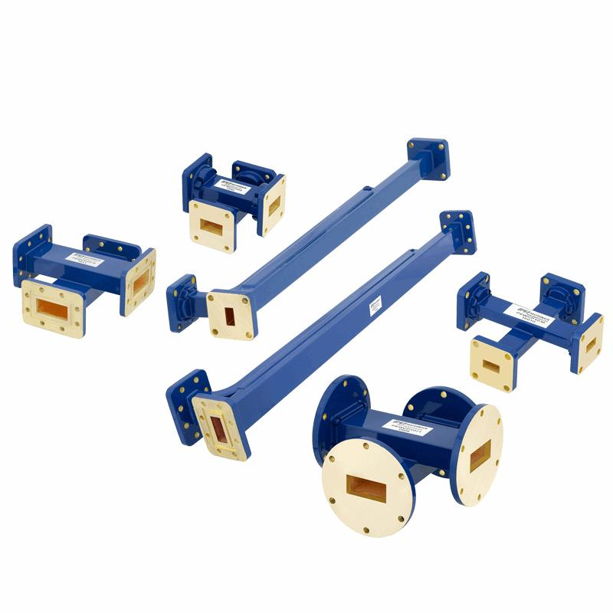
Figure.4.3 Wave guides
The transmitted wave is reflected by the internal walls of waveguide and the resulting distribution associated with the wave causes the transmission mode (transmission mode is any one of an electromagnetic wave of given frequency).
The main types of wave configurations are,
- TE wave(Transverse Electric wave)
- TM wave(Transverse Magnetic wave)
- TEM wave(Transverse Electro Magnetic wave)
Wave guides are widely used in communication network for the transmission of electromagnetic waves. Electromagnetic energy may also be stored by using a section of wave guide, short circuited at each end to form a cavity resonator as shown in Fig. 4.3.
Wave guide allow to be passing different signals simultaneously. However, different signals being propagated through a line must have different frequency, but in a wave guide they can have same frequency provided that each is propagated at different mode. This kind of multiplex transmission power handling capacity of wave guide is higher than coaxial cable. The power loss is low since propagation of energy is by means of reflection from the walls.
4.2.4 Optical fiber
The fibers are increasingly replacing wire transmission lines in communication system as shown in Fig. 4.4. Such optical fiber lines offer several important advantages over wire lines
- Superior transmission quality.
- Higher information carrying capacity.
- Light weight and smaller size.
- High security
Because of optical fibers low attenuation signals can be transmitted for a considerable distance. A single repeater less fiber optical link can replace a coaxial trunk and its 35 to 40 R.F amplifiers and deliver more channels.
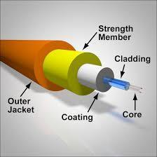
Figure .4.4Optical fiber
Fibers dielectric nature ensures a clean, clear signal not plagued by cross talk or degraded by severe weather. Optical fiber has tremendous bandwidth or information carrying capacity and fiber-optic networks and is not bit rate dependent.
4.3 Primary constants of transmission line
The four-line parameters e.g. R, L, C, G are referred to as primary constants of the transmission line and are defined as below.
Resistance (R) is defined as loop resistance per unit length of line. It is sum of resistance of both the wires for unit line length and its unit is ohm/km.
Inductance (L) is defined as loop inductance per unit length of the line. It is sum of inductance of both wires for unit length and its unit is Henries/km.
Conductance (G) is defined as shunt conductance between the two conductors per unit length of line and its unit is Mho/km.
Capacitance (C) is defined as shunt capacitance between two conductors per unit length of line and its unit is farad/km. The Series impedance (Z) and shunt admittance (Y) of the transmission line per unit length given as
Z = R + jωL (4.1)
Y = G + jωC (4.2)
4.3.1 Characteristic Impedance (Z₀)
Any circuit having series and shunt impedances must have input impedance. For transmission line, this input impedance depends on many factors e.g. type of line, its length and termination at load end or receiving end. In order to simplify description and calculation, the input impedance under certain standard, simple and easily reproducible condition is taken as the reference and is known as characteristic impedance of that line. It is defined as the impedance measured at the input of this line when its length is infinite or impedance looking into an infinite length of the line.
4.4 Properties of feeders
There are mainly two types of properties which are exhibited by the transmission lines.
4.4.1 Reflection Coefficient
When power is applied to the generator at input end to a transmission line of infinite length or to a finite transmission line terminated by its characteristics impedance all the power is absorbed by the load at far end and there exists no reflected wave. However, when the transmission line is terminated by impedance other than characteristic impedance, then only some of the power is absorbed at the load end and rest power will be reflected to generator end and thus reflected waves are set up. This incorrect termination gives rise to inefficiency and the inefficiency is larger, if the difference between characteristic impedance and impedance is large. Thus, reflection of energy occurs whenever there is an impedance irregularly i.e. termination impedance is not equal to characteristic impedance of the line or primary constants of the line are not uniform along the line.
Hence the phenomenon of setting up of a reflected wave at the load due to improper termination or due to impedance irregularity in a line is known as reflection. The reflection occurs in all cases of travelling wave where discontinuity of medium is involved. Reflection co-efficient is defined as the ratio of the reflected voltage or current to the incident voltage or current respectively and it is usually denoted by K or ρ. Reflection co-efficient is a vector quantity having magnitude and direction as well. Let V_{i} and V_{r} be the incident and reflected voltages respectively.
4.4.2 VSWR
When reflections occur in an incorrectly terminated line, the voltage and current vary in magnitude along its length. When the transmission line is not correctly terminated, the travelling electromagnetic wave from generator at the sending end is reflected completely or partially at the termination. The combination of incident and reflected waves gives rise to interference phenomenon and thus standing waves of current and voltage along the line, with definite minima and maxima of current and voltage along the line. If the line loss is small, all the voltage maxima and minima can be assumed to have equal amplitudes and under these conditions the voltage standing wave ratio may be defined as the ratio of maximum to minimum voltage on a line as shown in Eq. 4.3.
VSWR = $\frac{1+|Г|}{1-|Г|}$ (4.3)
Return loss is -S11 where S11 the is reflection coefficient. If you want to increase the antenna gain, the reflection should be very low, which means that the return loss should be high.
Sometimes your return loss is high because your antenna is too lossy. Assume all materials are lossless in your simulation. If return loss drops too much, it means that a considerable fraction of power was being dissipated in the antenna. Check directivity as well. It is independent of the return loss.
Difference between Return Loss and VSWR
This question addresses VSWR (Voltage Standing Wave Ratio) and Return Loss, which are both a measure of the same parameter. That is, the amount of signal reflected by a connector. It is the major factor contributing to the total signal efficiency of the connector.
Return Loss is the portion of a signal that is lost due to a reflection of power at a line discontinuity. Return Loss is like VSWR and is generally preferred in the cable industry to a VSWR specification. Since it is a logarithmic measurement, it is very useful when displaying very small reflections.
VSWR is an acronym for Voltage Standing Wave Ratio. VSWR is the ratio of voltage applied to voltage reflected. VSWR is like Return Loss and is generally preferred in the connector industry to a Return Loss specification. Since it is a linear measurement, it can be useful when displaying larger reflections since small differences are not compressed as they are in a logarithmic measurement.

CHAPTER 5
MICROSTRIP PATCH ANTENNA
Microstrip antennas are attractive due to their light weight, conformability and low cost. These antennas can be integrated with printed strip-line feed networks and active devices. This is a relatively new area of antenna engineering. The radiation properties of micro strip structures have been known since the mid 1950’s. The application of this type of antennas started in early 1970’s when conformal antennas were required for missiles. Rectangular and circular micro strip resonant patches have been used extensively in a variety of array configurations. A major contributing factor for recent advances of microstrip antennas is the current revolution in electronic circuit miniaturization brought about by developments in large scale integration. As conventional antennas are often bulky and costly part of an electronic system, micro strip antennas based on photolithographic technology are an engineering breakthrough.[8]
5. 1 Introduction
In its most fundamental form, a Microstrip Patch antenna consists of a radiating patch on one side of a dielectric substrate which has a ground plane on the other side as shown in Figure 5.1. The patch is generally made of conducting material such as copper or gold and can take any possible shape. The radiating patch and the feed lines are usually photo etched on the dielectric substrate.
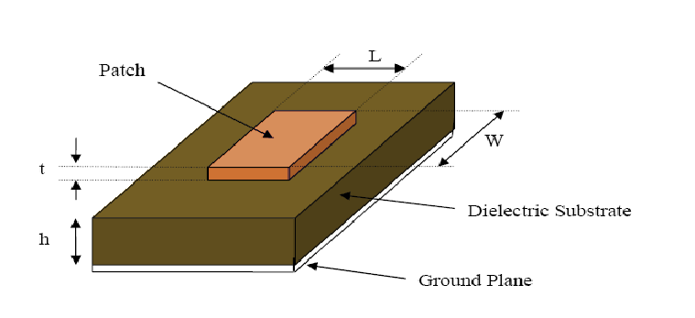
Figure 5.1 Structure of a Microstrip Patch Antenna
5.2 Advantages And Disadvantages Of Patch Antennas
Some of their principal advantages of microstrip patch antennas are given below:
- Low profile planar configuration which can be easily made conformal to host surface.
- Low fabrication cost, hence, it can be manufactured in large quantities.
- Supports both, linear as well as circular polarization.
- Can be easily integrated with microwave integrated circuits (MICs).
- Capable of dual and triple frequency operations.
- Light weight and low volume.
- Mechanically robust when mounted on rigid surfaces.
- Microstrip patch antennas suffer from a number of disadvantages as compared to Conventional antennas. Some of their major disadvantages are given below:
- Narrow bandwidth
- Low efficiency
- Low Gain
9. Extraneous radiation from feeds and junctions
10. Poor end fire radiator except tapered slot antennas
11. Low power handling capacity.
12. Surface wave excitation
Microstrip patch antennas have a very high antenna quality factor (Q). Q represents the losses associated with the antenna and a large Q leads to narrow bandwidth and low efficiency. Q can be reduced by increasing the thickness of the dielectric substrate. But as the thickness increases, an increasing fraction of the total power delivered by the source goes into a surface wave. This surface wave contribution can be counted as an unwanted power loss since it is ultimately scattered at the dielectric bends and causes degradation of the antenna characteristics. However, surface waves can be minimized by use of photonic band gap structure. Other problems such as low gain and low power handling capacity can be overcome by using an array configuration for the elements.
5.3 Feed Techniques
Microstrip patch antennas can be fed by a variety of methods. These methods can be classified into two categories- contacting and non-contacting. In the contacting method, the RF power is fed directly to the radiating patch using a connecting element such as a microstrip line.
In the non-contacting scheme, electromagnetic field coupling is done to transfer power between the microstrip line and the radiating patch. The four most popular
feed techniques used are the microstrip line, coaxial probe (both contacting
schemes), aperture coupling and proximity coupling (both non-contacting schemes).
5.4 Microstrip Line Feed
In this type of feed technique, a conducting strip is connected directly to the edge of the microstrip patch as shown in Figure 5.2. The conducting strip is smaller in width as compared to the patch and this kind of feed arrangement has the advantage that the feed can be etched on the same substrate to provide a planar structure.
Figure 5.2 Microstrip Line Feed
The purpose of the inset cut in the patch is to match the impedance of the feed line to the patch without the need for any additional matching element. This is achieved by properly controlling the inset position. Hence this is an easy feeding scheme, since it provides ease of fabrication and simplicity in modeling as well as impedance matching. However, as the thickness of the dielectric substrate being used, increases, surface waves and spurious feed radiation also increases, which hampers the bandwidth of the antenna. The feed radiation also leads to undesired cross polarized radiation.
5.4.1 Coaxial Feed
The coaxial feed or probe feed is a very common technique used for feeding microstrip patch antennas. As seen from figure 5.3. The inner conductor of the coaxial connector extends through the dielectric and is soldered to the radiating patch while the outer conductor is connected to the ground plane.
The main advantage of this type of feeding scheme is that the feed can be placed at any desired location inside the patch in order to match with its input impedance. This feed method is easy to fabricate and has low spurious radiation. However, its major disadvantages are that it provides narrow bandwidth and is difficult to model since a hole must be drilled in the substrate and the connector protrudes outside the ground plane.
Figure 5.3 Probe fed Rectangular Microstrip Patch Antenna
Thus, making it completely plant for thick substrate (h>0.02λ).Also, for thicker substrates the increased probe length makes the input impedance more inductive, leading to matching problems. It is seen above that for a thick dielectric substrate, which provides broad bandwidth, the microstrip line feed and the coaxial feed suffer from numerous disadvantages. The non-contacting feed techniques discussed below, solve these problems.[9]
5.4.2 Aperture Coupled Feed
In this type of feed technique, the radiating patch and the microstrip feed lines are separated by the ground plane as shown in Figure 5.4. Coupling between the patch and the feed line is made through a slot or an aperture in the ground plane. The coupling aperture is usually centered under the patch, leading to lower cross polarization due to symmetry of the configuration. The amount of coupling from the feed line to the patch is determined by the shape, size and location of the aperture. Since the ground plane separates the patch and the feed line, spurious radiation is minimized. Generally, a high dielectric material is used for bottom substrate and a thick, low dielectric constant material is used for the top substrate to optimize radiation from the patch. The major disadvantage of this feed technique is that it is difficult to fabricate due to multiple layers, which also increases the antenna thickness. This feeding scheme also provides narrow bandwidth.
Figure 5.4. Aperture-coupled feed
5.4.3 Proximity Coupled Feed
This type of feed technique is also called as the electromagnetic coupling scheme. As shown in Figure 5.5. two dielectric substrates are used such that the feed line is between the two substrates and the radiating patch is on top of the upper substrate. The main advantage of this feed technique is that it eliminates spurious feed radiation and provides very high bandwidth (as high as 13%), due to overall increase in the thickness of the microstrip patch antenna. This scheme also provides choices between two different dielectric media, one for the patch and one for the feed line to optimize the individual performances.
Figure 5.5Proximity-coupled Feed
Matching can be achieved by controlling the length of the feed line and the width to-line ratio of the patch. The major disadvantage of this feed scheme is that it is difficult to fabricate because of the two dielectric layers which need proper alignment. Also, there is an increase in the overall thickness of the antenna.
5.4.4 Transmission Line Model
This model represents the microstrip antenna by two slots of width W and height h, separated by a transmission line of length L. The microstrip is essentially a nonhomogeneous line of two dielectrics, typically the substrate and air.
Figure 5.6.Microstrip Lines Figure 5.7.Electric Field Lines
Hence, as seen from Figure 5.6. most of the electric field lines reside in the substrate and parts of some lines in air. As a result, this transmission line cannot support pure transverse-electric-magnetic (TEM) mode of transmission, since the phase velocities would be different in the air and the substrate. Instead, the dominant mode of propagation would be the quasi-TEM mode. Hence, an effective dielectric constant (ε_{reff}) must be obtained in order to account for the fringing and the wave propagation in the line. The value of ε_{reff}is slightly less then ε_{r} because the fringing fields around the periphery of the patch are not confined in the dielectric substrate but are also spread in the air as shown in Figure5.7.above. The expression for ε_{reff}is given by Balanis as:
5.5 Considerations For Patch Antenna[10]
Design a rectangular patch. FR4 substrate (εr =4.4 and d = 1.6 mm)is to be used to make a resonant rectangular patch antenna of linear polarization.
a. Design such an antenna to work at 4.5 GHz for 5G applications.
b. Estimate its directivity.
c. If it is to be connected to a 50 ohm microstrip using the same PCB board, design the feed to this antenna.
d. Find the fractional bandwidth for VSWR <2.
5.6 Calculations
1)Width of the patch is
W=$\frac{c}{2f_{r}}\sqrt{\frac{2}{ε_{r}+1}}$
W=$\frac{3×{10}^{8}}{2×5×{10}^{9}}\sqrt{\frac{2}{4,4+1}}$
W=18.3mm

2)Effective dielectric constant is
$$ε_{reff}=\frac{ε_{r}+1}{2}+\frac{ε_{r}-1}{2×\sqrt{\left(1+12\frac{h}{W}\right)}}$$
$$ε_{reff}=\frac{4.4+1}{2}+\frac{4.4-1}{2×\sqrt{\left(1+12×\frac{1.6}{18.3}\right)}}$$
$$ε_{reff}=3.887$$

3)Effective length is
$$L_{eff}=\frac{c}{2×f_{r}×\sqrt{ε_{reff}}}$$
$$L_{eff}=\frac{3×{10}^{8}}{2×5×{10}^{9}×\sqrt{3.887}}$$
$$L_{eff}=15.2mm$$

4)Extension of length is
$$∆L=0.41h×\left[\frac{\left(ε_{reff}+0.3\right)×\left(\frac{W}{h}+0.264\right)}{\left(ε_{reff}-0.258\right)×\left(\frac{W}{h}+0.8\right)}\right]$$

$$∆L=0.41×1.6×\left[\frac{\left(3.887+0.3\right)×\left(\frac{18.26}{1.6}+0.264\right)}{\left(3.887-0.258\right)×\left(\frac{18.26}{1.6}+0.8\right)}\right]$$
$$∆L=0.73mm$$
5)Length of the patch is
L=$L_{eff}-2∆L$
L=15.2$-2×0.73$
L=13.7mm
6)Width of the ground plane is
$$W_{g}=6h+W$$
$$W_{g}=6×1.6+18.26$$
$$W_{g}=27.8mm$$
7)Length of the ground plane is
$$L_{g}=6h+L$$
$$L_{g}=6×1.6+18.26$$
$$L_{g}=23.37mm$$
5.7 Parameters Of Microstrip Patch Antenna
There are three essential parameters for the design of a rectangular patch Antenna are:
- Frequency of Operation ( $f_{0}$):The resonant Frequency of the antenna must be selected appropriately. The antenna is Designed to operate at 1.5 to 1.6Ghz.Hence the antenna must be able to operate in this frequency range. firstly our antenna dimensioned such that our antenna operates at 1.5 Ghz.
- Dielectric constant of the substrate${(ε}_{R)}$):The dielectric material selection is one of the important parameter in antenna design. The material is selected in such a way that the dielectric constant of the material is very less. so that we will have better radiation and also the size of the antenna decreases. we preferred FR4 epoxy substrate which has a dielectric constant of 4.4.
- Height of Dielectric Substrate(H):For the microstrip patch antenna to be used in cellular phones, it is essential that the antenna is not bulky. Hence, the height of the dielectric substrate is very important parameter.
- In the wide range of antenna models there are different structures of Microstrip antennas, but on the whole we have four basic parts in the antenna. They are
1.The patch
2.Dielectric Substrate
3.Ground Plan
${ ε}_{reff}=\frac{ε_{r}+1}{2}+\frac{ε_{r}-1}{2\sqrt{1+{12d}/W}}$ (5.1)
Where ε_{reff} = Effective dielectric constant
ε_{r} = Dielectric constant of substrate
h= Height of dielectric substrate
W= Width of the patch
Consider Figure 5.8 below, which shows a rectangular microstrip patch antenna of length L, width W resting on a substrate of height h. The co-ordinate axis is selected such that the length is along the x direction, width is along the y direction and the height is along the z direction.
Figure 5.8 Microstrip Patch Antennas
In order to operate in the fundamental TM10 mode, the length of the patch must be slightly less than λ/2 where λ is the wavelength in the dielectric medium and is equal to λ_{o}. √ε_{reff} where λ_{o} is the free space wavelength. The TM10 mode implies that the field varies one λ/2 cycle along the length, and there is no variation along the width of the patch. In the Figure 5.8 shown below, the microstrip patch antenna is represented by two slots, separated by a transmission line of length L and open circuited at both the ends. The fields at the edges can be resolved into normal and tangential components with respect to the ground plane.
Figure 5.9 Top View of Antenna Figure 5.10 Side View of Antenna
The tangential components (seen in Figure 5.10), which are in phase, means that the resulting fields combine to give maximum radiated field normal to the surface of the structure.

CHAPTER 6
HFSS SOFTWARE

6.1 Open HFSS and save a New Project How to start HFSS?
HFSS should be installed on the computer or station you are working on. There should be an HFSS icon on the desktop you can double click on it to launch HFSS, or you can go to “Start” button on the lower left corner of your screen, click on it, then go to “Programs” button and a list of programs will pop up. Go to “Ansoft<< HFSS << HFSS”.[11]

6.1.1 How to Open a New Project?
As you start HFSS project is listed in the project tree in the Project Manager window and is named project1 by default. Project definitions, such as material assignment, boundary conditions, and excitation ports are stored under the project name.

6.1.2 Save the Project
On the File menu, click Save As. Use the file browser to locate the folder in which you want to save the project, such as C:\Ansoft\HFSS9\Projects, and then double-click the folder’s name. Type Patch in the File Name text box and click Save. Now, the project is saved in the folder you selected by the file name with an extension of hfss: patch. 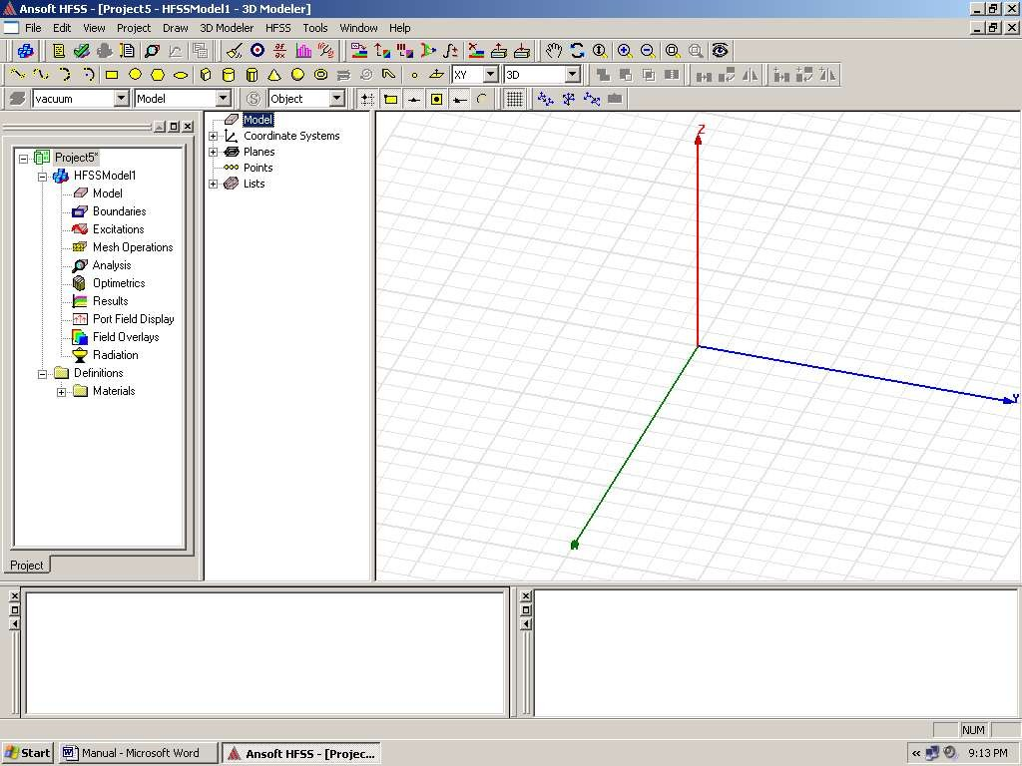
Project Manager Window
History Tree
3D Modeler Window
Figure 6.1: HFSS window

Insert an HFSS Design
project tree. It is named Model by default. The 3D Modeler window appears to the right of the Project Manager.
You can rename the model by right-clicking on the Model and then click Rename. Type the name then press Enter.

6.3 Set the Drawing Units
You will now set the units of measurement for drawing the geometric model.
On the 3D Modeler menu, click Units. In the Set Model Units dialog box, click mm in the Select Units pull-down list, and then click OK.
The ground plane is specified by a perfect electrically conducting boundary condition. The coordinates are assigned as follows. The starting point for the ground plane and substrate is at (0,0,0). The Length, L, of the substrate and the width, W, are chosen as 13.85 mm and 18.3 mm, respectively. As for the patch, the length ~λ0/2 ~18.06 mm and the width of the patch is half that of the ground and substrate = 16 mm. However, the patches’ starting point is at (28.1/4, 32/4, 0). The patch's starting point is located at ¼ of the total width of the ground plane and stretches its length 18.06 mm in the positive x-direction. Similarly, for the y-direction, the patch is at ¼ of the total length of the ground plane located in the x-y plane (z=0). Moreover, the feed line should be located somewhere between the values of the starting point and ending point of the patch.
Although the feed line is located at the midpoint, we have to shift the feed line a little to the upper or lower side to achieve impedance matching. In our case it is the total length of the patch divided by 4 plus the starting point of the patch equals the starting point of the feed: [(18.06/4) +8.9] =13.41mm. The feed's full-length value is chosen to be almost 1/5 of the patch’s length (18.06/5 = 3.612).
Understanding the dimensions of the project is very important. Now follow the following .
6.4Drawing the Model
Drawing the model would now be easy. All you have to do is to fill in the coordinates. First, let’s start by drawing the ground plane. Please refer to the coordinates of the Ground Plane, Table 3. Select the menu item Draw> Box. Using the coordinate entry fields in Table 3, enter the box position (x, y, z) then enter the opposite corner of the base rectangle (dx, dy, dz), where dx, dy, and dz stand for full length, full width, and full height respectively. The dimensions of the ground plane are given. A properties dialog window appears, makes sure you have your coordinates set right in the Position, Xsize, Ysize, and Zsize values. Click on Attribute tab and enter ground in the value of the name. Click on material; assign PEC (Perfect Electric Conductor) material to the object. Then choose the Color and Transparency value of your preference. Click the OK button.
Second, let’s draw the substrate. The substrate has the same dimensions of the ground plane. Remember that the ground plane lies at z = -0.794 and is of zero thickness (dz=0), so the substrate must be of 0.794 mm in thickness and since the starting point was at zero, so the full height is in -z-direction. Draw > Box using the coordinates in Table 4, set the position of the box (x, y, z) and enter the opposite corner of the box (dx, dy, dz). The properties dialog window pops up, make sure all your coordinates are right. Click the Attribute tab; enter Substrate in the name value box. Now assign the material to be FR4 substrate (flame redundant) of relative permittivity 2.2. Click OK. Again, choose Color and Transparency value of your preference. Click the OK button
Third, we create the patch. Knowing that the patch should be in the center, the coordinates are easy to calculate from the ground and substrate dimensions. The center of the patch, the ground plane, and the substrate are the same and is at (28.1/2, 32/2, 0). Subtract the center point coordinates from the substrate coordinates to calculate the starting point and the full length, width and height of the patch are given. Draw > Box using the coordinates in Table 1, set the position of the box (x, y, z) and enter the opposite corner of the box (dx, dy, dz). The properties dialog window pops up, make sure all your coordinates are right. Click the Attribute tab; enter Patch in the name value box. Now assign the material to be PEC. Click OK. Again, choose Color and Transparency value of your preference. Click the OK button.
Fourth, create the microstrip line. The microstrip line's position is chosen somewhere between the ends of the patch. It should be at the middle; however, it is shifted more to one side of the patch for impedance matching purposes. Draw > Box using the coordinates in Table 2, set the position of the box (x, y, z) and enter the opposite corner of the box (dx, dy, dz). The properties dialog window pops up, make sure all your coordinates are right. Click the Attribute tab; enter Strip Line the name value box. Now assign the material to be PEC. Click OK. Again, choose Color and Transparency value of your preference. Click the OK button.
We know that the Patch and Strip Line should be one object. So, we need to unite them. Note that both objects are of the same material. Click on both objects that you need to unite, i.e. Patch and Strip Line in the history tree. Click on one and hold the CTRL key and click on the other. Click 3D Modeler > Boolean > Unite. The two objects are united now. You can always check your steps in the history tree and in case you need to delete a previous step/command, click Edit > Undo.

6.4.1 Assign Boundary
Now the model has been created, we need to assign boundary conditions. In HFSS, radiation boundaries are used to simulate open problems that allow waves to radiate infinitely far into space. HFSS absorbs the wave at the radiation boundary, essentially ballooning the boundary infinitely far away from the structure. In our case, our ABC (Absorbing Boundary condition) is an air box.
Draw > Box using the coordinates in Table 6, set the position of the box (x, y, z) and enter the opposite corner of the box (dx, dy, dz). The properties dialog window pops up, make sure all your coordinates are right. Click the Attribute tab; enter Air in the name value box. Now assign the material to be Air. Click OK. Again, choose Color and Transparency value of your preference. Click the OK button. The boundary condition should satisfy a certain distance from the antenna. Normally, its value is chosen between λ/8 to λ/12, where λ is calculated from λ=c/f, where c is 3 x 108 m/s and f is the frequency in(Hz).

6.4.2 Assign Excitation
Having the entire model set now, the only missing part is the excitation. The excitation is a waveguide port at the beginning of the microstrip line. The reference plane of this port is located directly at the beginning of the radiating plane. Antennas are excited through the port.
We need to create the port. Draw > Box using the coordinates in Table 5, set the position of the box (x, y, z) and enter the opposite corner of the box (dx, dy, dz). The properties dialog window pops up, make sure all your coordinates are right. Click the Attribute tab; enter Port in the name value box. No material is assigned. Click OK. Again, choose Color and Transparency value of your preference. Click the OK button.
Choose the object Port from history tree, right-click and assign excitation. In our case, it is wave port. Click wave port, name it as your preference, then click Next, now define your integration line. Normally, integration line is defined from the
bottom middle point to the upper middle point. Keep other values as default. Click Finish.

6.5 Analysis Setup
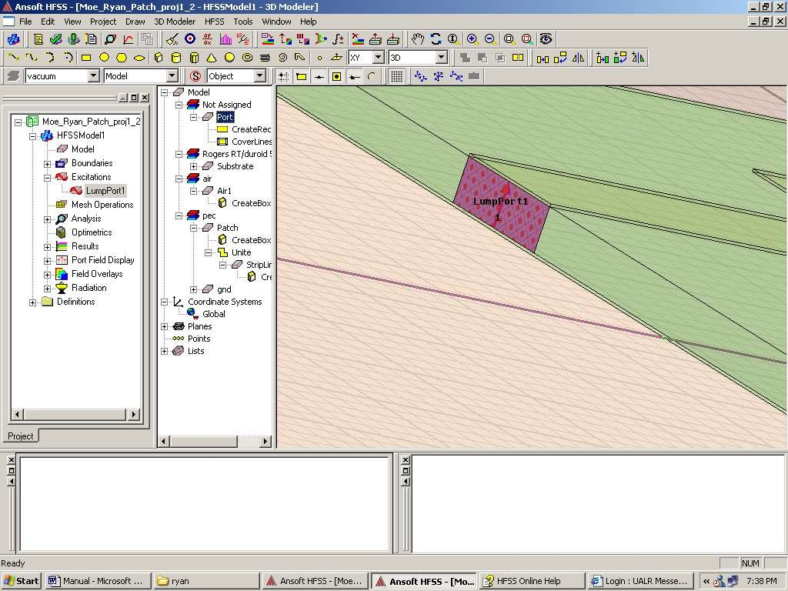
Finally, you have your model ready to run. Now you need to identify your analysis setup. To create an analysis setup, select the menu item HFSS > Analysis Setup > Add Solution Setup. In the Solution Setup window, click the general tab, Solution frequency is 10 GHz, Maximum Number of Passes is 20 and Maximum Delta S per Pass is 0.02. Click the Advanced tab, make sure that Lambda Refinement is checked, and target is 0.3333. Click OK button.

Figure 6.2 The port

Add Frequency Sweep
To add a frequency sweep, select the menu item HFSS > Analysis Setup > Add Sweep. Select Solution Setup: Setup1. Click OK button. Then Edit Sweep Window. Sweep Type: Fast, Frequency Setup Type: Linear Count, start: 5 GHz, Stop: 10 GHz, Count: 500. Click OK button.

Model Validation
To validate the model, select the menu HFSS > Validation Check. Click the Close button. To view any errors or warnings messages, use the Message Manager. To Zoom Out to fit, click CTRL+D.


Figure 6.3.: Validation check window

Save Project
To save the project, in the Ansoft HFSS window, select the menu item File > Save As. From the Save As window, type the file name you want. Click Save button. Your final model should look like this:
Antenna Design 1
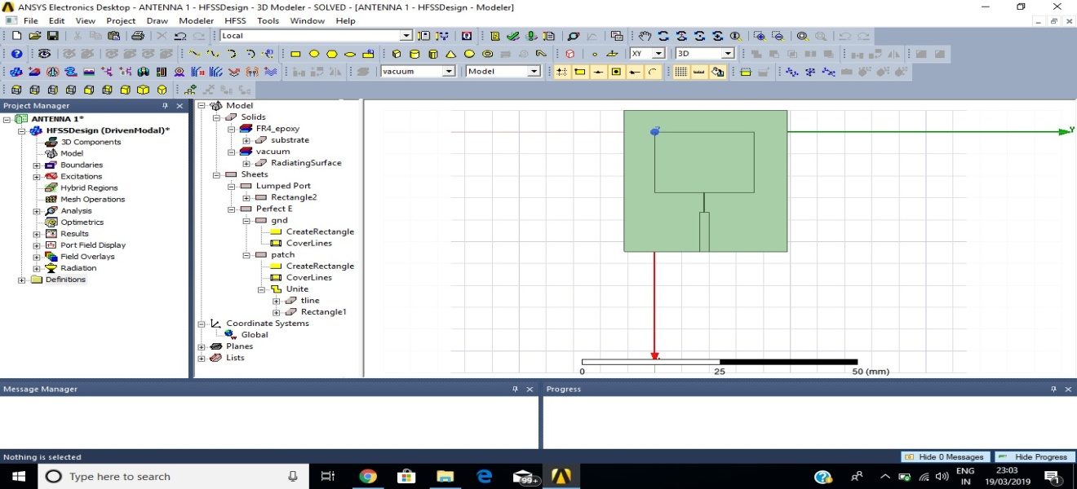
Figure 6.4 top view of antenna design 1
Antenna 1 is designed to work at 5G bands operating at a single frequency.
1. Rectangular patch antenna is designed using fr4 substrate and it is fed with microstrip line feeding technique
Antenna Design 2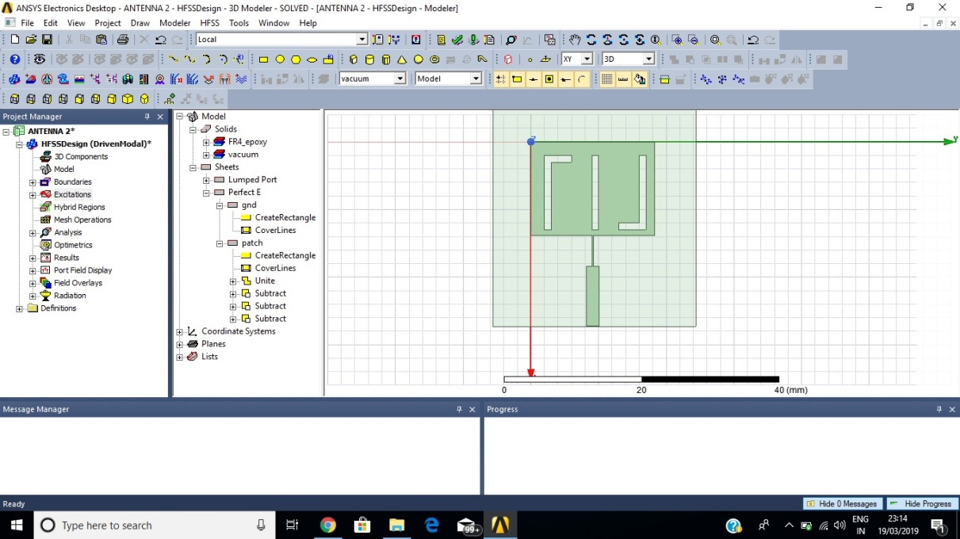
Figure 6.5 Top view of antenna design 2
Antenna 2 is designed by inserting slots on the patch of the antenna operating at two different bands
Antenna Design3
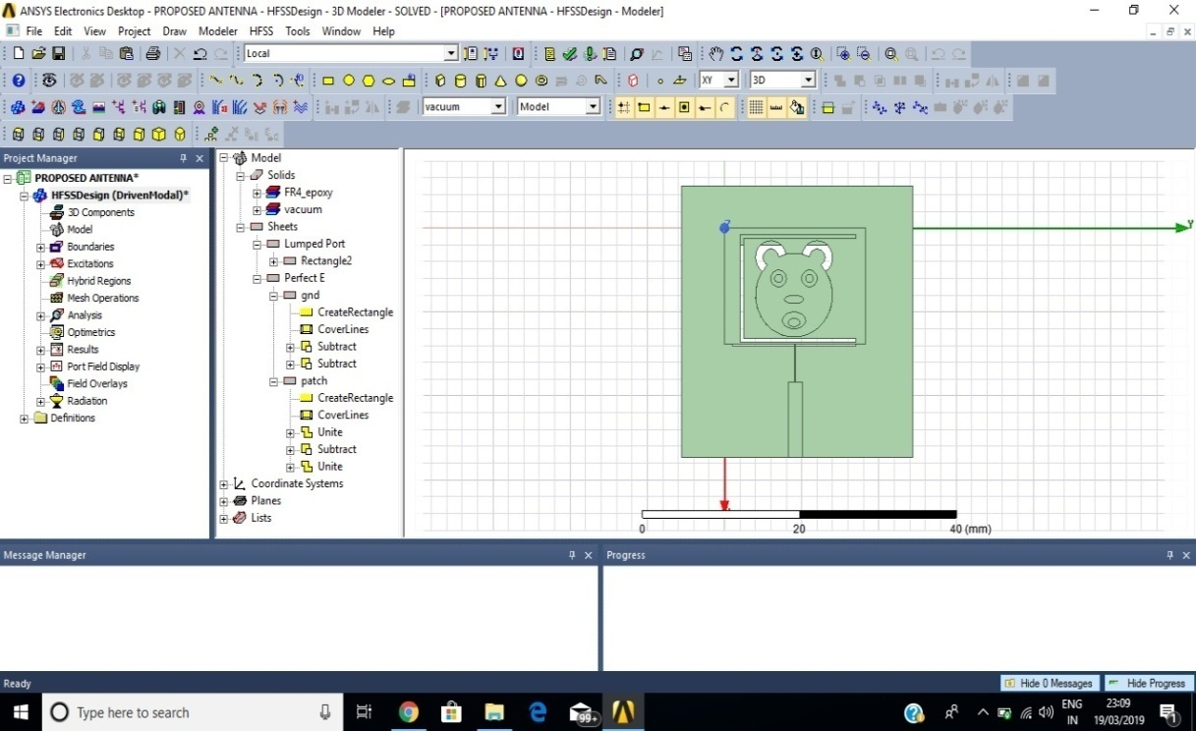
Fig 6.6 top view of antenna design 3
Antenna Design 3
Antenna 3 is designed with a teddy shaped slot in a c shaped slot on the patch ,the ground consists of a rectangular slot embedded with a teddy face operating a three different frequencies.

6.6 Analyze

To start the solution process, select the menu item HFSS > Analyze.


Figure 6.7.Analysis window

Solution Data
To view the Profile/Convergence/Matrix Data, select the menu item HFSS > Results >Solution Data Note: The Solution Data window can be also displayed by right-click on the Setup1 under analysis on the HFSS design tree. Note also that the default view is Profile. Select the Convergence tab first, and then Plot radio button to view a graphical representation of the convergence data. Click Close button.
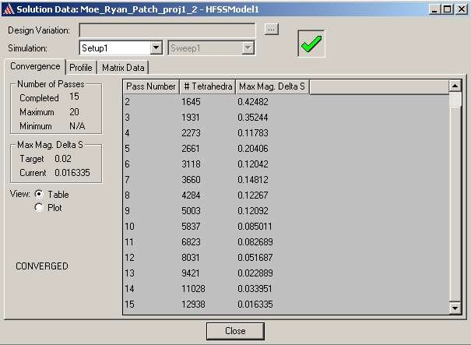

Figure 6.8.: Convergence data
The simulation will stop as soon as the results converge, which is at pass 15.

Create Reports
Create Modal S-Parameter Plot versus Frequency.To create a report, select the menu item HFSS > Results > Create Report. Set Report Type to Modal S Parameters, Display Type to Rectangular then click OK button. In the Traces Window, set Solution to Setup1: Adaptive1. In the Y tab, set Category to S Parameter, Quantity to S (wave port, wave port), Function to dB and click Add Trace button. Click Done button. Note that you can create any type of report it all depends on what you want to analyze specifically. The antenna is resonating around 10 GHz.
Note: More accurate results could be achieved by zooming in the simulation between 7.00 GHz and 8.00 GHz. (Change the Start and Stop values to 7 GHz and 8 GHz, respectively then run simulation again).
Moreover, we notice that Zin at 10 GHz is 50 Ω. To view Zin, go to HFSS<Results<Solution Data click on Z Matrix and drag the frequency menu to 10 GHz and read the Magnitude of the input impedance.
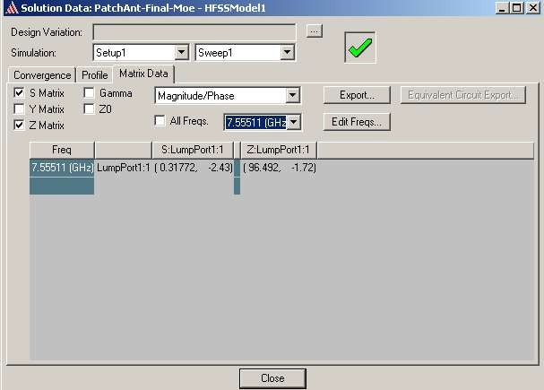
Figure 6.9: Input impedance

6.7 Radiation Pattern:
Create infinite sphere. Then go to HFSS< Results< Create Report. When the new window pops up change the Report Type to Far Field and Display type to 3D Polar Plot. Click Add Trace then click Ok.
An interesting exercise for the reader is to adjust the position of the feed such that the input impedance of the patch is matched to that of the feed line. This can be achieved by creating a parameterized model of the geometry and search for the feed position which will yield a minimum value of the reflection coefficient.

CHAPTER 7
SIMULATION RESULTS
7.1 Reflection Coeffiecient
The Return Loss Defines The Quality Of The antenna and its operating frequency. For a good antenna the return loss should be less than -10dB.The return loss for the design is obtained that is shown in fig7.1
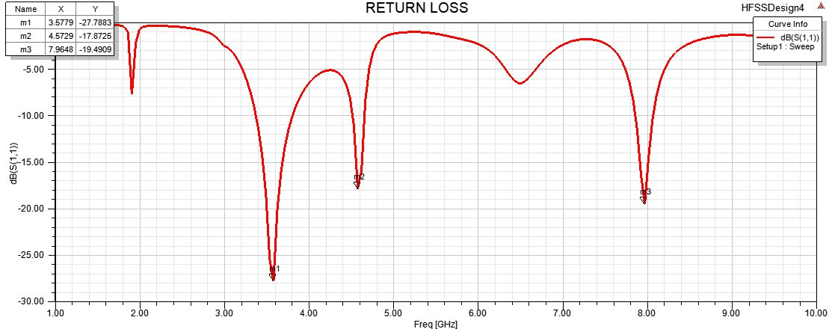
Fig 7.1 RETURN LOSS PLOT

Voltage Standing Wave Ratio(Vswr)
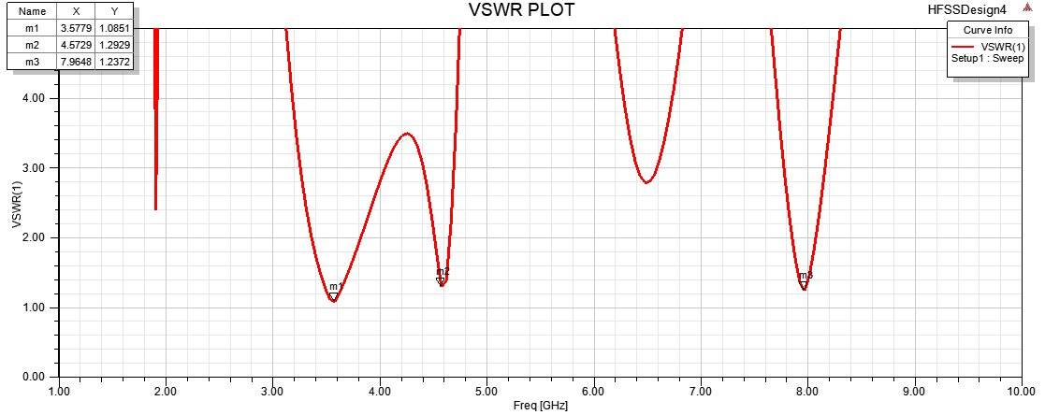
Figure. 7.2 VSWR PLOT
VSWR(Voltage Standing Wave Ratio) : The amount of mismatch between an antenna and the feed line connecting to it.
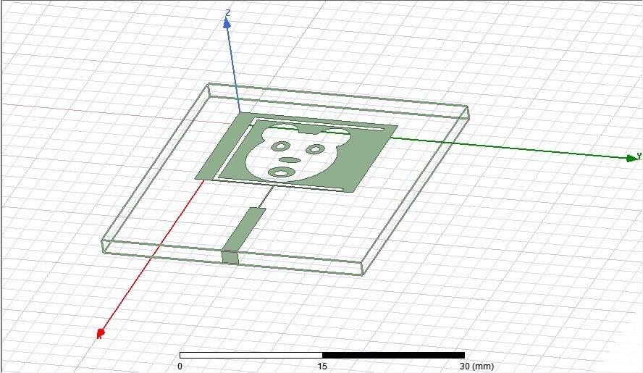
Figure 7.3 Proposed Antenna design
A teddy faced slot is surrounded by c shaped slot, which is implemented on the rectangular patch.
Antenna 3 is working at two 5G frequencies namely 3.5 GHz and 4.6 GHz and one X-band frequency i.e., 7.96 GHz.

CONCLUSION
The antenna consists of a c shaped slot on the rectangular patch with a teddy faced slot on the patch and the ground as well. with the dimensions of 18.3×13.8×1.6mm. It works at three different frequencies namely 3.5GHz, 4.5GHz and 7.9GHz with a return loss of -27.7dB,-17.8dB and -19.4dB and it also bears a good VSWR.

SCOPE
Future is going to be smart and digitalized the environment so, everything is linked with digital communication.5G antennas will play a prominent role in future. This project is further implemented to enhance the specifications and reduce the size of the antenna. This leads to compact in size and simple for better use.
Further implementation of this project is not only for detecting the children when they get kidnapped but, we are focusing on adding the additional features for military purpose. Generally, this design is worked for both 5G and X band frequency. X band is used for military and satellite communication whereas lower 5G is for better communication. Lower 5G covers the wide area compare to other networks and gives fast response also.

REFERENCES
[1] Balanis, Kraus, Rao.: Fundamental Parameters of Antennas, Ranga Rodrigo, may12, 2010.
[3] A. Bondarik and D. Sjoberg, “Investigation of Reconfigurability for a stacked Microstrip patch antenna pattern targeting 5G applications”, in IEEE Topical conference on Antennas and Propagation in wireless communication, pp. 1202-1205, 2015.
[4] Available: http://en.wikipedia.org/wiki/5G
[5] https://www.tutorialspoint.com/5g/5g_technology.html.
[7] https://www.rfpage.com/what-are-5g-frequency-bands/

[2] Houda Werfelli, Khaoula Tayari, Mondher Chaoui. Design of Rectangular Microstrip patch Antenna. Design of Rectangular Microstrip Antenna Patch, 2nd International Conference on Advanced Technologiesfor Signal and Image Processing, (2016).
[6] Microstrip Antenna Design Handbook Ramesh Garg,Prakash Bhartia, Inder Bahl.
[7] R.K.Gupta,“Printed tri-band monopole antenna structures for wireless applications,”Microw, Opt. Technol. Lett., vol. 51, no. 7, pp. 1781–1785, Jul. 2009.
[8] Hussain Al-Rizzo: Simulation Od Microstrip Using HFSS. Technical Report Jan 2004.
[9] Kardam Kaushal Komalprasad1 Vivek Ramamoorthy2 Rajendra Patel3:
Review on Design of Planar Antennas for Satellite Communication Application, IJSRD - International Journal for Scientific Research & Development| Vol. 3, Issue 01, 2015 | ISSN (online): 2321-0613
[10] Microstrip Patch Antenna at 7 GHz for Satellite Communication, Souryendu Das, SunandanGokhroo, International Journal of Engineering Technology Science and Research IJETSR www.ijetsr.com ISSN 2394 – 3386 Volume 2, Issue 11 November 2015.
[11] Comprehensive assessment of 5G technology, Nilesh Padhi, International Journal of Engineering & Scientific Research Vol.4 Issue 11, November 2016, ISSN: 2347-6532 Impact Factor: 5.900

