SENTIMENT ANALYSIS ON PRODUCT & MOVIE REVIEWS

AGASTYA PADMA SAI KUMAR
Dept. of Computer Science and Engineering
KL UNIVERSITY
HYDERABAD, India
chintasaikumar222@gmail.com

Guide Name:
Dr.N.Sunanda
Associate Professor
Department of CSE

SRAVANTH
Dept. of Computer Science and Engineering
KL UNIVERSITY
HYDERABAD, India
sravanthparupalli91@gmail.com
VISHNU
Dept. of Computer Science and Engineering
KL UNIVERSITY
HYDERABAD, India
vishnuvardhan110@gmail.com

Abstract—Online reviews of products and movies are a rich source of public opinion, but their volume makes manual analysis slow and impractical. This paper presents a lightweight sentiment analysis system that classifies English product and movie reviews as positive or negative. The system applies text normalisation, term frequency–inverse document frequency (TF-IDF) feature extraction using unigrams and bigrams, and a Logistic Regression classifier, combined in a single scikit-learn pipeline that is saved with joblib and reused by a web interface. A Streamlit application lets a user choose a review category, enter a review and view the predicted sentiment. The model is evaluated on a held-out, stratified 20% test split using accuracy, precision, recall, F1-score and a confusion matrix. The work shows how unstructured review text can be turned into a quick, interpretable opinion signal, and discusses its limitations, including sarcasm, mixed opinions and dependence on dataset size and quality.
Keywords—sentiment analysis, opinion mining, product reviews, movie reviews, natural language processing, TF-IDF, logistic regression, machine learning

Introduction
Reviews written by customers and viewers have become one of the main ways people decide what to buy and what to watch. Online shopping and movie platforms collect large volumes of free-text reviews, and each one expresses an opinion about a product or a film. Reading them all is not feasible for consumers, sellers or studios, which creates the need for automated sentiment analysis, the task of identifying the polarity of opinions expressed in text [1].
Sentiment analysis of reviews is difficult for several reasons. Reviews contain informal language, spelling errors, negation (“not good”), sarcasm and domain-specific vocabulary. A word such as “unpredictable” is praise in a thriller review but a complaint in a product review about a car or a phone. Product reviews tend to focus on features, quality and value, whereas movie reviews mix opinions about acting, plot and direction with plot summaries that carry little sentiment of their own.
This paper presents a sentiment analysis system for product and movie reviews, built as a complete baseline workflow. The main contributions are: (1) a pipeline from raw review text to a predicted positive or negative label using TF-IDF features and Logistic Regression; (2) a saved, reusable model served through a simple Streamlit web interface; and (3) an evaluation procedure based on a held-out test split with standard classification metrics. The prototype is limited to English-language text and does not scrape review websites.
The specific objectives of the work are:
- to understand the fundamentals of sentiment analysis and natural language processing;
- to prepare review text and convert it into numerical features using TF-IDF;
- to train a supervised machine-learning classifier and evaluate it on test data;
- to predict the sentiment of user-entered product and movie reviews and present it through a simple interface.
The system gives a quick summary signal of the opinion in a review and saves the effort of reading large numbers of reviews one by one. Its intended users are customers comparing products, movie audiences exploring opinions, businesses monitoring customer feedback, and students learning text analytics.
The rest of the paper is organized as follows. Section II reviews related work, Section III describes the dataset and preprocessing, Section IV presents the methodology and system design, Section V gives the experimental setup, results and discussion, and Section VI concludes the paper.

Related Work
Early work treated sentiment classification as a text categorization problem. Pang et al. applied Naive Bayes, maximum entropy and Support Vector Machines to movie reviews and found that bag-of-words features with machine learning outperformed hand-built rules [2]. Surveys by Pang and Lee [3] and Liu [1] describe the task at document, sentence and aspect levels and discuss its main challenges.
Distributed word representations improved results by capturing semantic similarity between words. Maas et al. learned word vectors that encode sentiment and released the widely used IMDb review dataset [4]. Recurrent networks such as the LSTM [5] model word order and long-range dependencies, while convolutional networks over word vectors were shown to be effective for sentence classification [6]. Socher et al. showed that modelling compositional structure helps with phenomena such as negation [7].
More recently, transformer models pre-trained on large text corpora have become the standard approach. BERT [8], built on the attention mechanism [9], produces contextual representations and reaches strong results on sentiment benchmarks after fine-tuning. Large-scale product review collections such as the Amazon review data [10] have enabled the study of sentiment across many product categories. Despite these advances, linear models over TF-IDF features remain a strong, interpretable and efficient baseline for text classification, which motivates the approach taken in this work.

Dataset and Preprocessing

Dataset
The system is trained on a labelled review dataset stored as a CSV file (reviews.csv) with two columns: review, the text written by a user, and sentiment, the correct label, either positive or negative. The file holds both product reviews and movie reviews, for example “The product works great and the quality is excellent” (positive) and “The film was boring and the story was weak” (negative). After loading, rows without valid review text or label are dropped, labels are converted to lower case and stripped of whitespace, and only the positive and negative labels are kept. Training stops with an error if either class is missing. A neutral class can be added if neutral-labelled examples are available. For meaningful performance, a larger, balanced and correctly labelled dataset should be used.

Text Preprocessing
Preprocessing is performed by the TF-IDF vectorizer inside the saved pipeline, so exactly the same steps are applied during training and prediction:
- conversion of all text to lowercase and tokenization into words;
- removal of common English stop words using the built-in scikit-learn list;
- generation of unigram (single-word) and bigram (word-pair) features, restricted to the 20,000 most frequent terms.
Over-cleaning can remove useful sentiment information, so cues such as negation words need careful handling (see Section V-F).

Methodology

Feature Extraction
Each review is represented as a sparse vector of unigram and bigram features weighted by term frequency–inverse document frequency (TF-IDF) [11]. Terms that occur in many reviews receive a lower weight, while terms that are more distinctive to a review receive a higher weight. The weight of term t in document d is given by
w(t, d) = tf(t, d) × [ ln((1 + N) / (1 + df(t))) + 1 ] (1)
where tf(t, d) is the number of times t occurs in d, df(t) is the number of reviews containing t, and N is the total number of reviews. This is the smoothed form used by scikit-learn [12], and each resulting vector is normalised to unit length.

Logistic Regression Classifier
Logistic Regression is a supervised linear classifier. It learns a weight for each TF-IDF feature and estimates the probability that a review x is positive as
P(y = 1 | x) = 1 / (1 + e^{−(w·x + b)}) (2)
where w is the weight vector and b is the bias. A review is labelled positive when this probability exceeds 0.5 and negative otherwise. The model is trained with the default L2 regularization of scikit-learn and a maximum of 1000 iterations. It is efficient on sparse text features and interpretable, because the learned weights show which terms push a prediction towards each class.

System Architecture and Implementation
The system consists of five parts, shown in Fig. 1. The Streamlit front end collects the review category (Product Review or Movie Review) and the review text. The application layer validates the input; an empty review produces a warning and the model is not called. The NLP pipeline normalises the text and applies the TF-IDF transformation, the Logistic Regression model predicts the sentiment, and the result is displayed to the user as a positive or negative label.
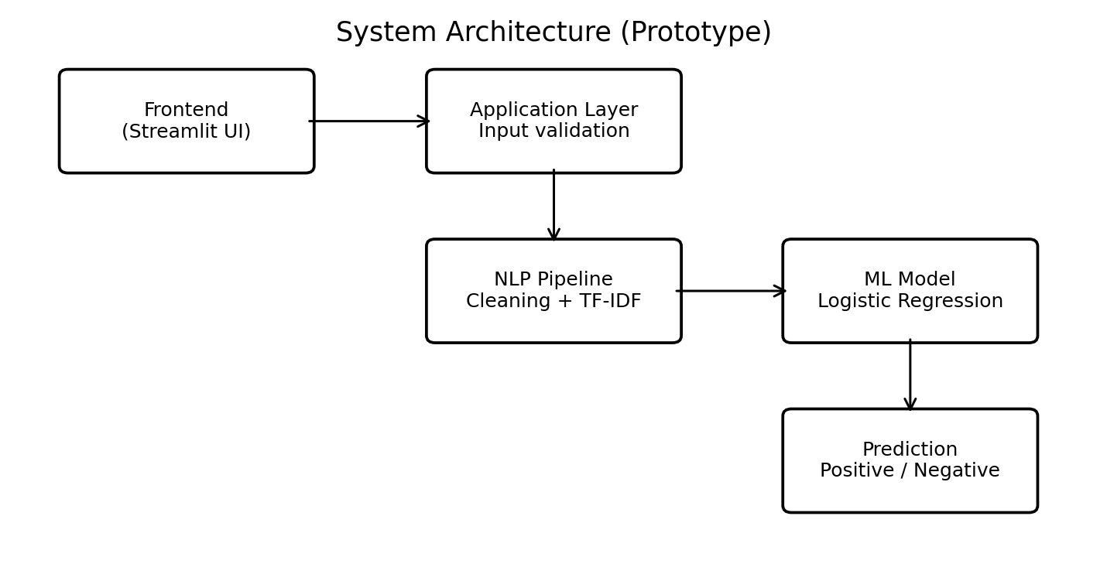
- System architecture of the sentiment analysis prototype.
The vectorizer and classifier are combined in a single scikit-learn Pipeline [12], so raw text is converted directly into a label. The implementation is organised in four files. The dataset reviews.csv is read with pandas [13]. The script train_model.py trains and evaluates the pipeline and saves it with joblib [14] as sentiment_model.joblib. The web application app.py loads this file once using the resource cache of Streamlit [15], so the model is not reloaded on every interaction. An optional script, predict.py, gives command-line prediction. The prototype runs locally, calls no external API, uses no database server, and requires no authentication because it stores no user data.

Features and Workflow
Table I summarises the main features of the application from the user’s perspective and the technical mechanism behind each. The category selection is informational: the same trained model is used for both review types.
- Main Features of the Application
Feature | Technical description
Review input | A text area collects the review; an empty review shows a warning and the model is not called.
Category selection | A select box offers Product Review or Movie Review.
Preprocessing | The saved pipeline lowercases text, removes English stop words and builds TF-IDF features from words and word pairs (at most 20,000 features).
Prediction | The Logistic Regression classifier predicts positive or negative.
Result display | A success message is shown for positive and an error-style message for negative sentiment.
Model evaluation | train_model.py reports accuracy, a classification report and a confusion matrix on the 20% test split.

Evaluation Metrics
Performance is measured with accuracy, precision, recall, F1-score and a confusion matrix. With TP, FP, TN and FN denoting true positives, false positives, true negatives and false negatives, precision is TP / (TP + FP), recall is TP / (TP + FN), and the F1-score is their harmonic mean:
F1 = 2 × Precision × Recall / (Precision + Recall) (3)
For imbalanced datasets accuracy alone can be misleading, so the F1-score and the confusion matrix are reported alongside it.

Experimental Setup and Results

Experimental Setup
The labelled data is divided into 80% training and 20% test sets with a stratified split and a fixed random seed (42), so both sets keep similar class proportions and the experiment is reproducible. The pipeline is fitted on the training set only, and the unseen test set is then used to compute accuracy, a per-class classification report and a confusion matrix, all produced by train_model.py. The system is implemented in Python 3.10 or later with pandas, scikit-learn, joblib and Streamlit, and runs on a standard computer with a dual-core processor and 4 GB of RAM.

Test-Set Performance
The precision, recall and F1-score of each class, the overall accuracy and the confusion matrix are computed on the held-out test set by the same script.
Final scores depend on the size and quality of the dataset. With a small dataset the model can overfit, so the figures should be treated as indicative until the model is validated on a larger and more representative dataset.

Application and Illustrative Predictions
In the web interface (Fig. 2) the user selects Product Review or Movie Review, types a review, clicks Analyze Sentiment and reads the predicted sentiment shown below the button. Table II lists sample reviews and the sentiment the model is expected to return. These are illustrative expectations, not measured outputs, and actual predictions depend on the training data.
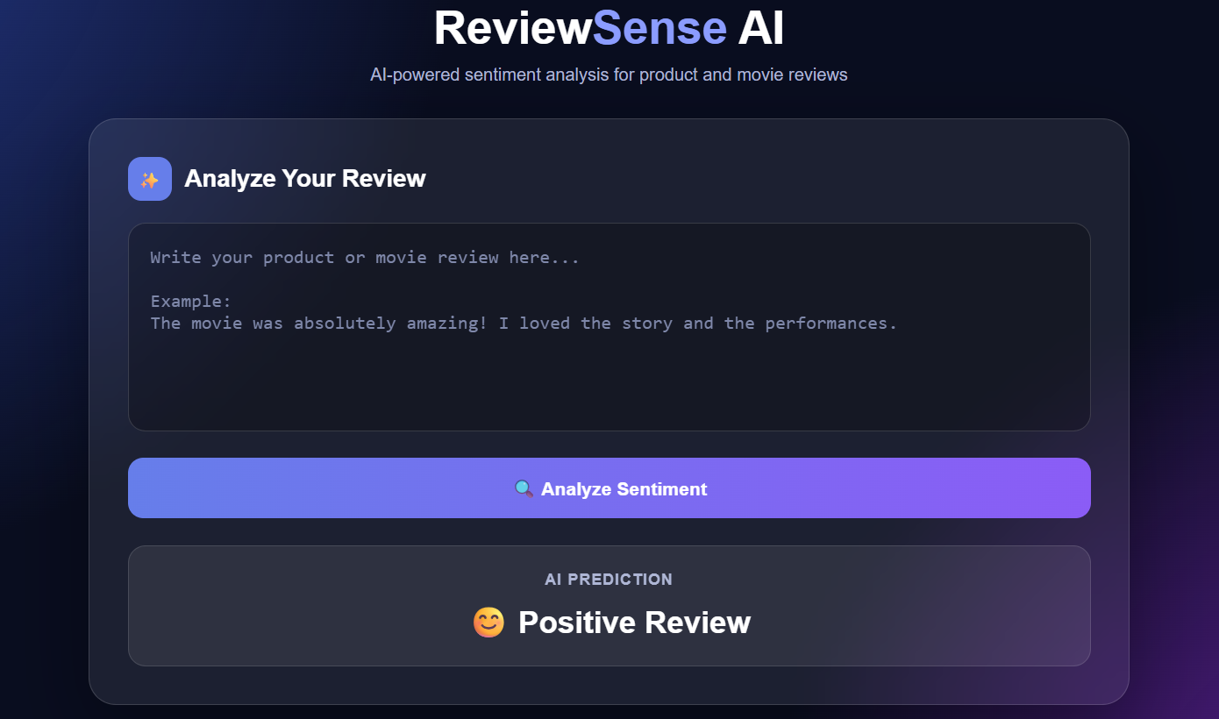
- Application interface showing a positive review prediction.
- Illustrative Reviews and Expected Sentiment
Sample review | Expected sentiment
The product is excellent and easy to use. | Positive
The movie was fantastic and inspiring. | Positive
The product broke quickly and is poor quality. | Negative
The film was boring and disappointing. | Negative

Functional Testing
The application is tested at interface level in a web browser, and the model is evaluated with the scikit-learn metrics described above. Integration testing covers the complete flow from the entered review, through input validation, the NLP pipeline and the classifier, to the displayed result, including the error reported when the trained model file is missing. The test cases are listed in Table III. No REST API is exposed, so API testing with Postman is not applicable.
- Functional Test Cases
ID | Input | Expected behaviour | Status
TC-01 | Positive review | Predict positive | To be tested
TC-02 | Negative review | Predict negative | To be tested
TC-03 | Empty review | Show warning; model not called | Handled in app
TC-04 | Long review | Process text and return a prediction | To be tested
TC-05 | Review with punctuation | Accept text and predict | To be tested
TC-06 | Model file missing | Report loading error; train model first | To be tested

Deployment
The prototype is deployed locally. After installing Python 3.10 or later and the required packages (pandas, scikit-learn, joblib and Streamlit), reviews.csv is placed in the project folder, python train_model.py is run to create sentiment_model.joblib, and streamlit run app.py starts the interface, which opens in a browser at the local address (usually http://localhost:8501). No cloud services or CI/CD pipelines are used; hosting on a cloud platform is left as future work.

Discussion and Limitations
The baseline has several known limitations. Reviews contain spelling mistakes, slang, emojis and informal language, and sarcasm, mixed opinions and domain-specific expressions may be misclassified. The scikit-learn English stop-word list includes negation words such as “not” and “no”, so removing stop words can discard negation cues; a custom stop-word list that keeps them is a straightforward improvement. Product and movie reviews use different vocabulary, yet the category selector is informational and the same model serves both. Class imbalance and a small dataset can bias the predictions, which the stratified split reduces but does not remove. The output is an automated estimate, and users should read the original reviews before making important decisions.
Several measures were applied to these challenges. A stratified split keeps class proportions similar in the training and test sets. Using single words and word pairs lets the model capture short phrases. Rows with missing text or labels are removed, labels are normalised and the training script checks that both classes are present. The application warns on empty input and caches the loaded model for faster responses. Finally, a larger, balanced and correctly labelled dataset is recommended for meaningful performance.

Conclusion and Future Work
This paper described a complete baseline workflow for sentiment analysis of product and movie reviews. Review text is transformed into TF-IDF features of words and word pairs and classified as positive or negative with Logistic Regression. The trained pipeline is saved, reused by a simple Streamlit interface and evaluated on a held-out test split with standard classification metrics. The approach is fast and interpretable, and its results should be validated on a sufficiently large and representative dataset before real-world use.
Future work includes adding a neutral class, training separate or domain-specific models for products and movies, supporting multilingual reviews, and aspect-based analysis of features such as price, quality, acting and story. Further directions are sentiment charts and dataset-level summaries, review history with exportable reports, advanced models such as Linear SVM, LSTM or transformer-based classifiers, and deployment of the application to a cloud hosting platform.

Acknowledgment
The authors would like to thank their guide, Dr. N. Sunanda, Department of Computer Science and Engineering, K L University, for her guidance and support throughout this work.

References
- B. Liu, Sentiment Analysis and Opinion Mining. San Rafael, CA, USA: Morgan & Claypool, 2012.
- B. Pang, L. Lee, and S. Vaithyanathan, “Thumbs up? Sentiment classification using machine learning techniques,” in Proc. Conf. Empirical Methods Natural Lang. Process. (EMNLP), 2002, pp. 79–86.
- B. Pang and L. Lee, “Opinion mining and sentiment analysis,” Found. Trends Inf. Retr., vol. 2, no. 1–2, pp. 1–135, 2008.
- A. L. Maas, R. E. Daly, P. T. Pham, D. Huang, A. Y. Ng, and C. Potts, “Learning word vectors for sentiment analysis,” in Proc. 49th Annu. Meeting Assoc. Comput. Linguistics (ACL), 2011, pp. 142–150.
- S. Hochreiter and J. Schmidhuber, “Long short-term memory,” Neural Comput., vol. 9, no. 8, pp. 1735–1780, 1997.
- Y. Kim, “Convolutional neural networks for sentence classification,” in Proc. EMNLP, 2014, pp. 1746–1751.
- R. Socher et al., “Recursive deep models for semantic compositionality over a sentiment treebank,” in Proc. EMNLP, 2013, pp. 1631–1642.
- J. Devlin, M.-W. Chang, K. Lee, and K. Toutanova, “BERT: Pre-training of deep bidirectional transformers for language understanding,” in Proc. NAACL-HLT, 2019, pp. 4171–4186.
- A. Vaswani et al., “Attention is all you need,” in Proc. Adv. Neural Inf. Process. Syst. (NeurIPS), 2017, pp. 5998–6008.
- J. Ni, J. Li, and J. McAuley, “Justifying recommendations using distantly-labeled reviews and fine-grained aspects,” in Proc. EMNLP-IJCNLP, 2019, pp. 188–197.
- G. Salton and C. Buckley, “Term-weighting approaches in automatic text retrieval,” Inf. Process. Manage., vol. 24, no. 5, pp. 513–523, 1988.
- F. Pedregosa et al., “Scikit-learn: Machine learning in Python,” J. Mach. Learn. Res., vol. 12, pp. 2825–2830, 2011.
- pandas Documentation. [Online]. Available: https://pandas.pydata.org/docs/
- joblib Documentation. [Online]. Available: https://joblib.readthedocs.io/
- Streamlit Documentation. [Online]. Available: https://docs.streamlit.io/

