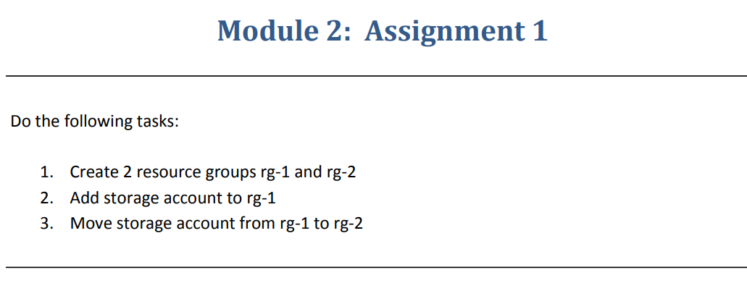

**Step 1** :- Created Two Resource groups rg-1 and rg-2

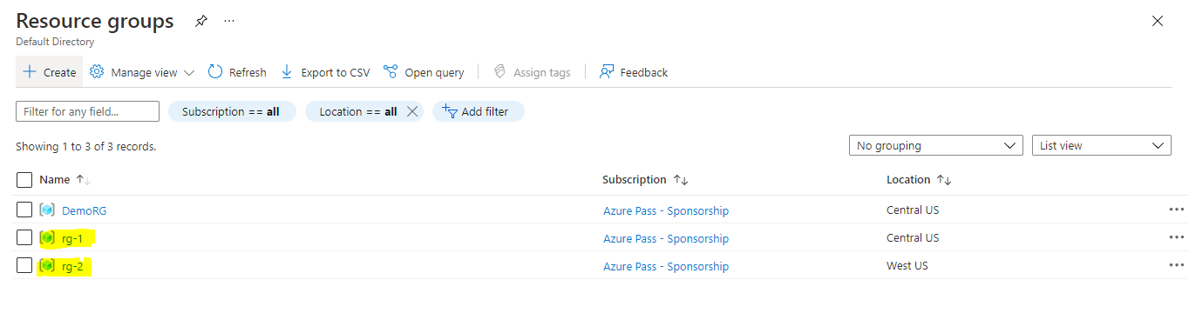

**Step 2**:- Storage account added to rg-1

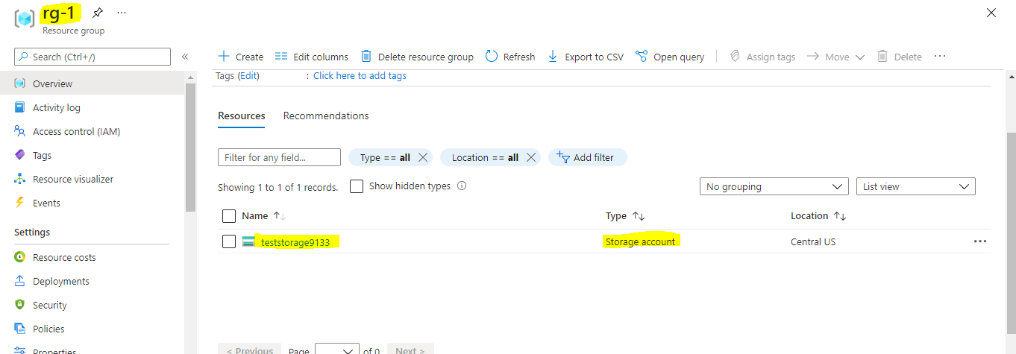

**Step 3**:- Move storage account from rg-1 to rg-2

