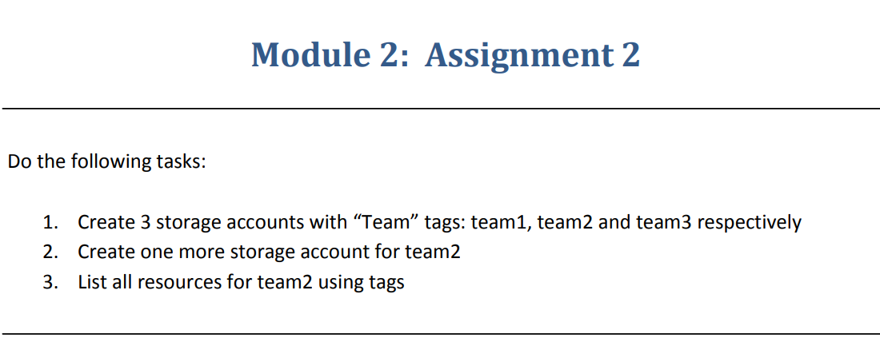

**Step 1** :- Created Three Storage accounts with tags:team1,team2 and team3.

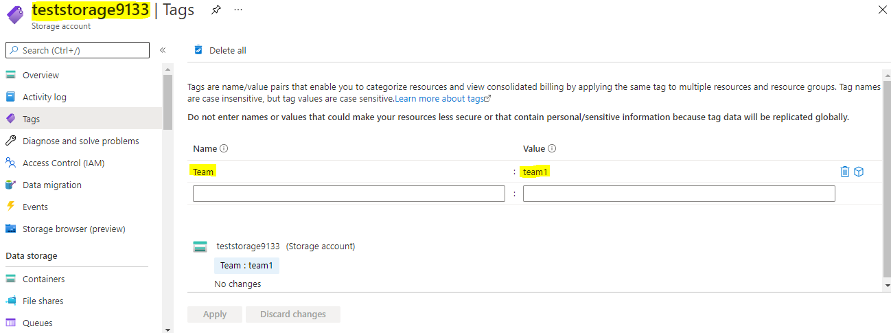

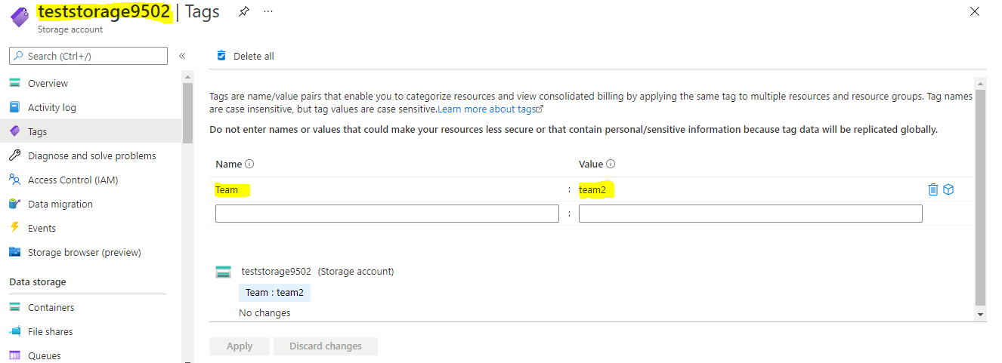

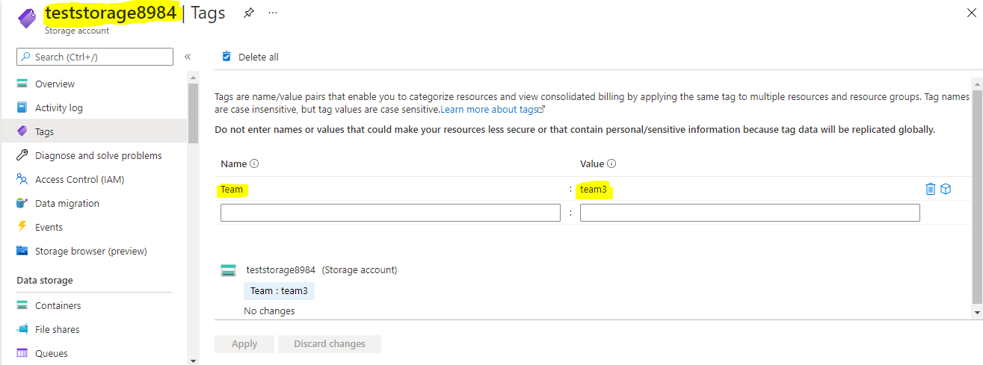

**Step 2**:- Created one more storage account to team2

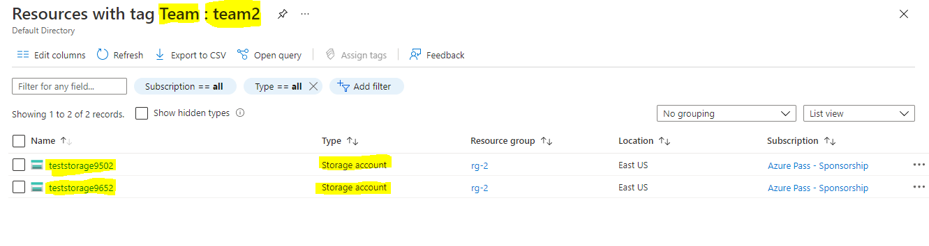**Step 3**:- Listed all resources for team2 using tags.

