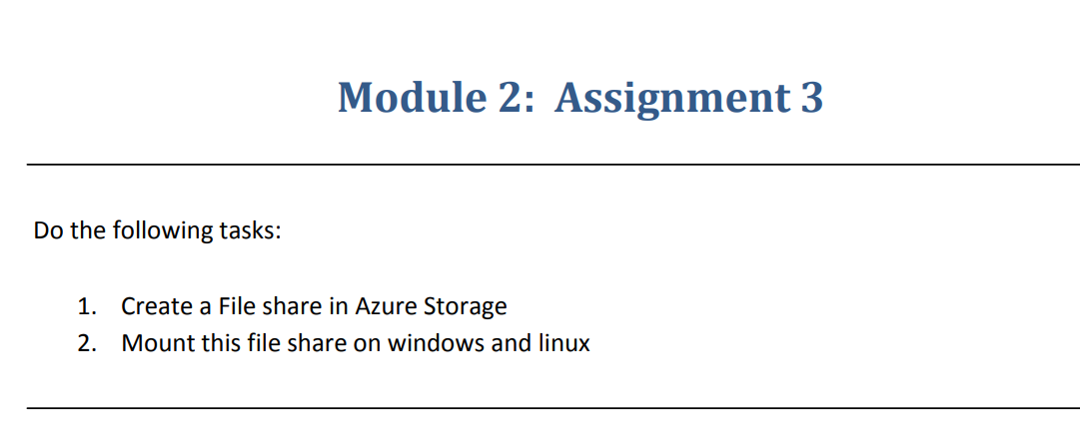

**Step 1**:- Create a file share in Azure storage.

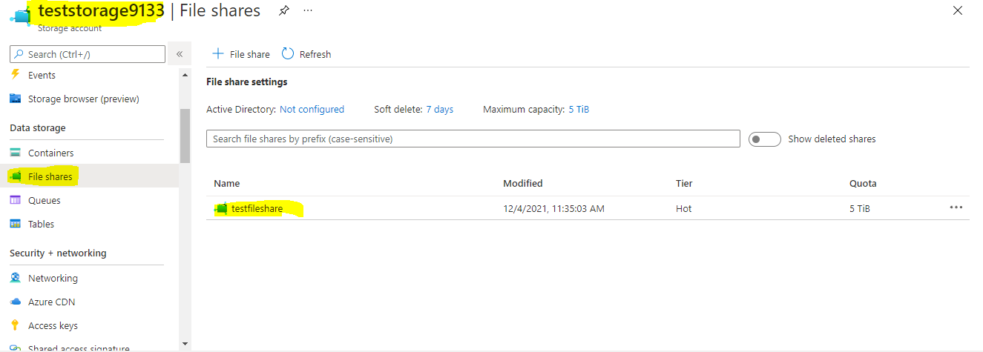

**Step 2**:- Mount this file share on windows.

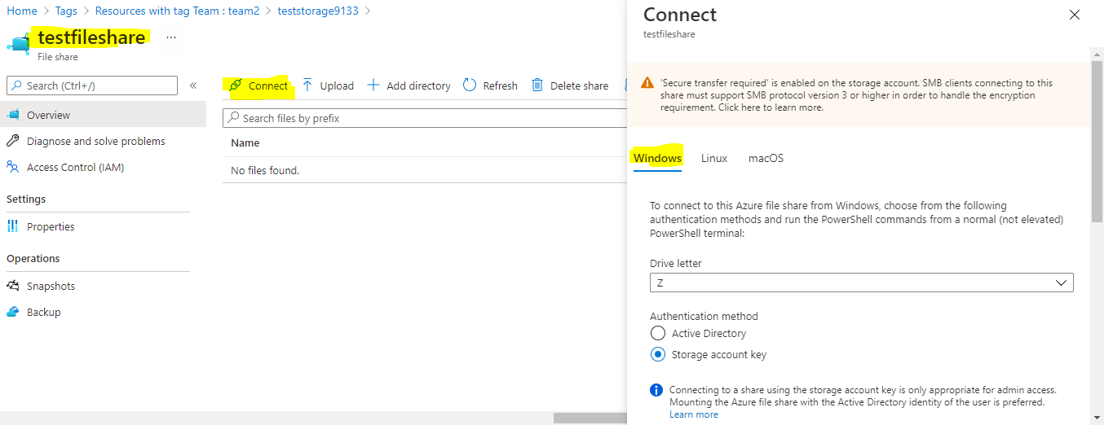

**Step 3**:- Copy the code and take the user name,password and Folder Url

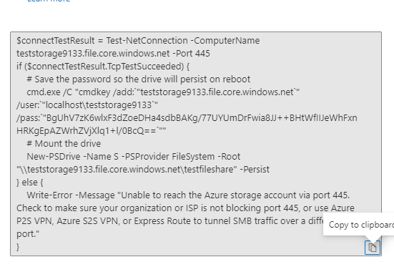

**Step 4**:- These are credentials we required.



**Step 5**:- Open my computer on our windows machine and right click on network and go to **map network drive** give folder URL here.

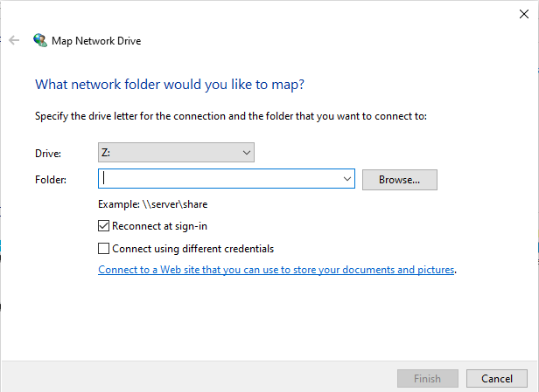

**Step 6**:-We have to provide **Username and password** which we copied from code.

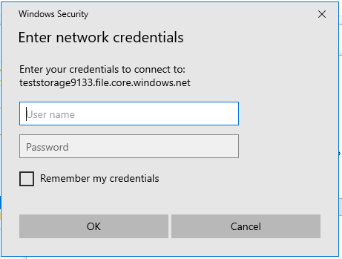

**Step 7**:-File share mounted on windows machine.

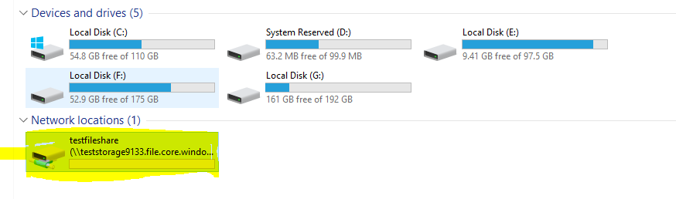

**Step 1**:- Mount this file share on Linux. For that we have to one Linux virtual machine. After that update the Linux machine by giving **sudo apt-get update**.

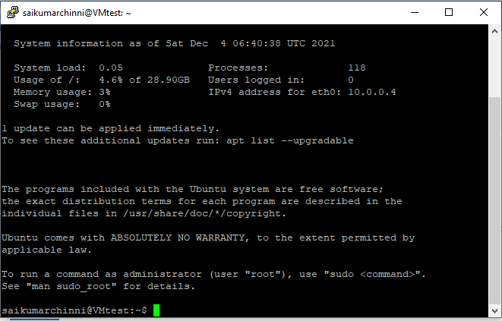

**Step 2**:- Copy the code from file share connect and paste it on Linux machine.

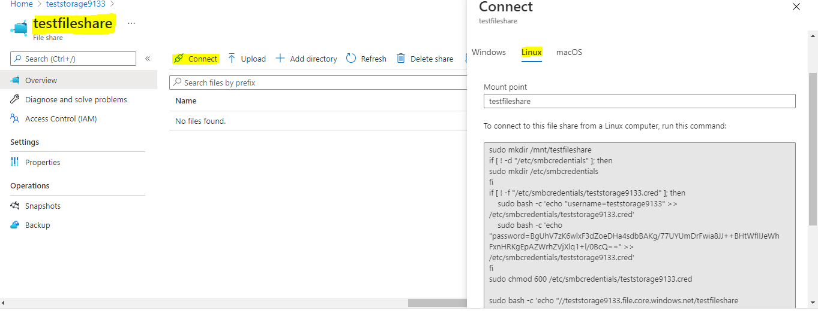

**Step 3**:- On Linux machine the file share is mounted we can cross check by uploading something on to file on azure we can see that upload in Linux machine.

