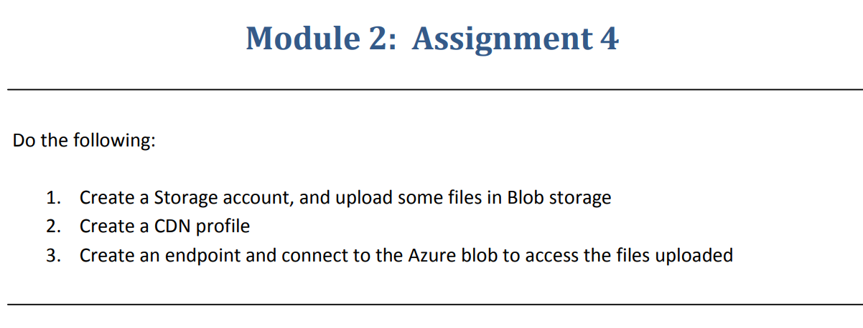

**Step 1**:- Created a storage account and created blob storage and uploaded some files.

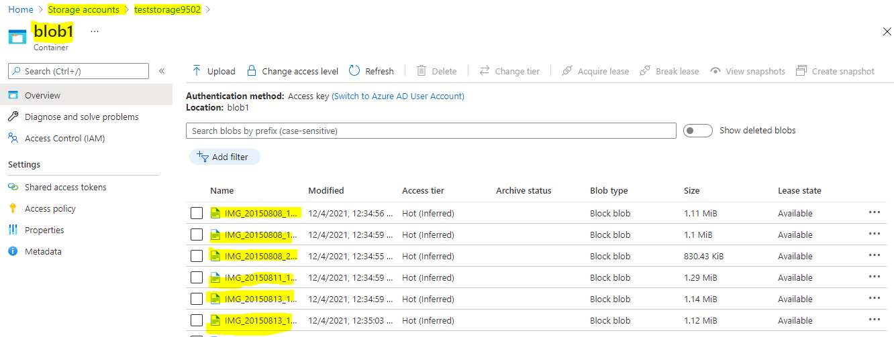

**Step 2**:- Created a CDN profile.

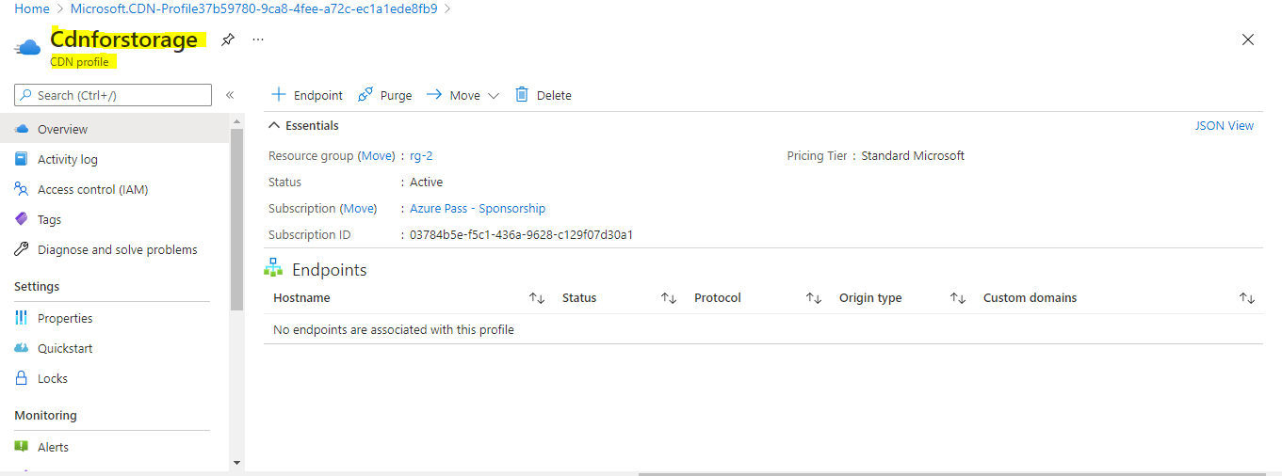

**Step 3**:- Created an Endpoint .

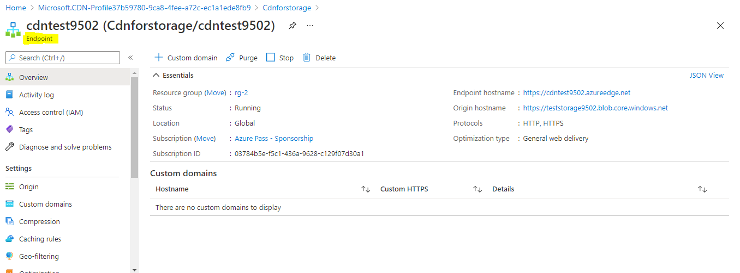

**Step 4**:- After create a Endpoint to access the files

Copy the URL and paste it on the browser and give the container name and image name as an extension

<https://cdntest9502.azureedge.net/blob1/IMG_20150808_145043066.jpg>

URL Container name File name

