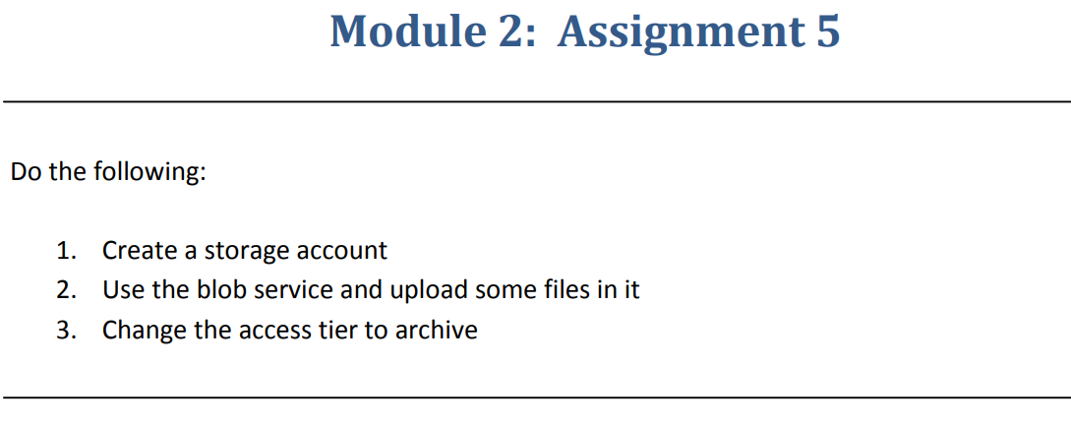

**Step 1**:- Created a storage account.

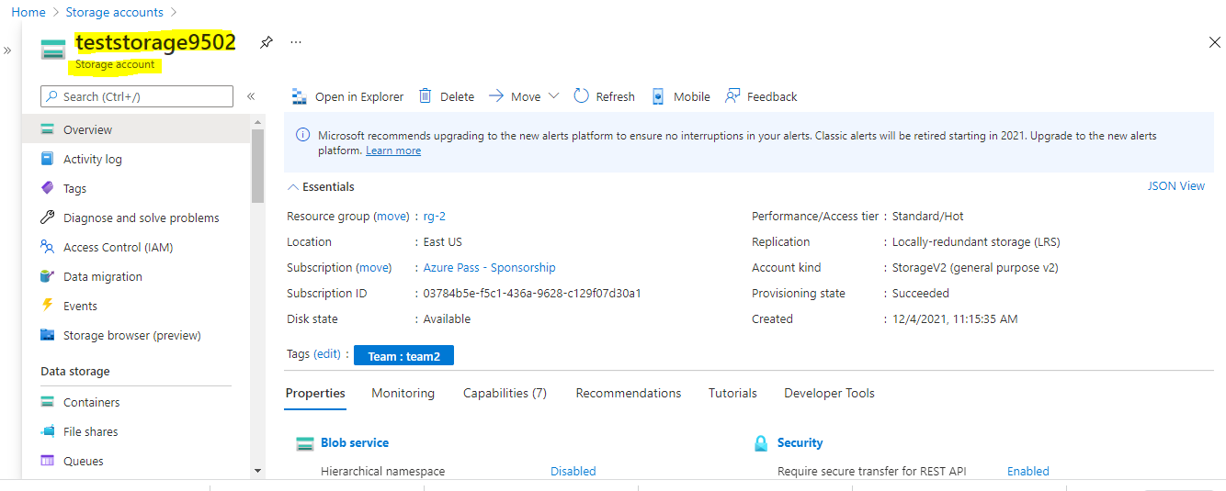

**Step 2**:- Created a blob storage and uploaded some files on it.

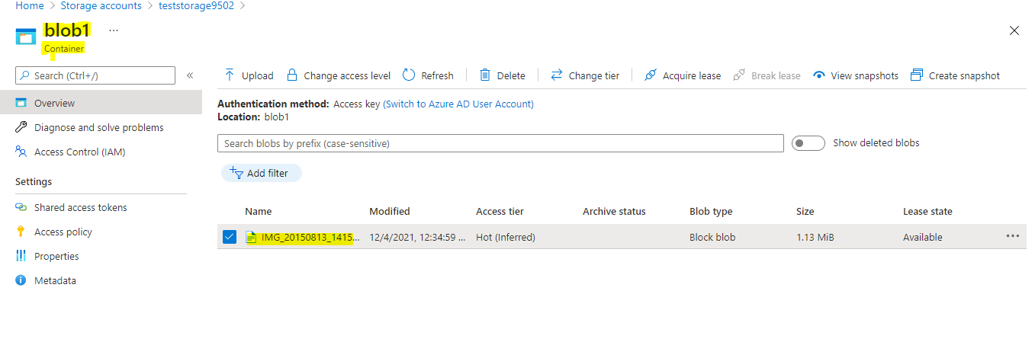

**Step 3**:- Changed the Access tier to Archive

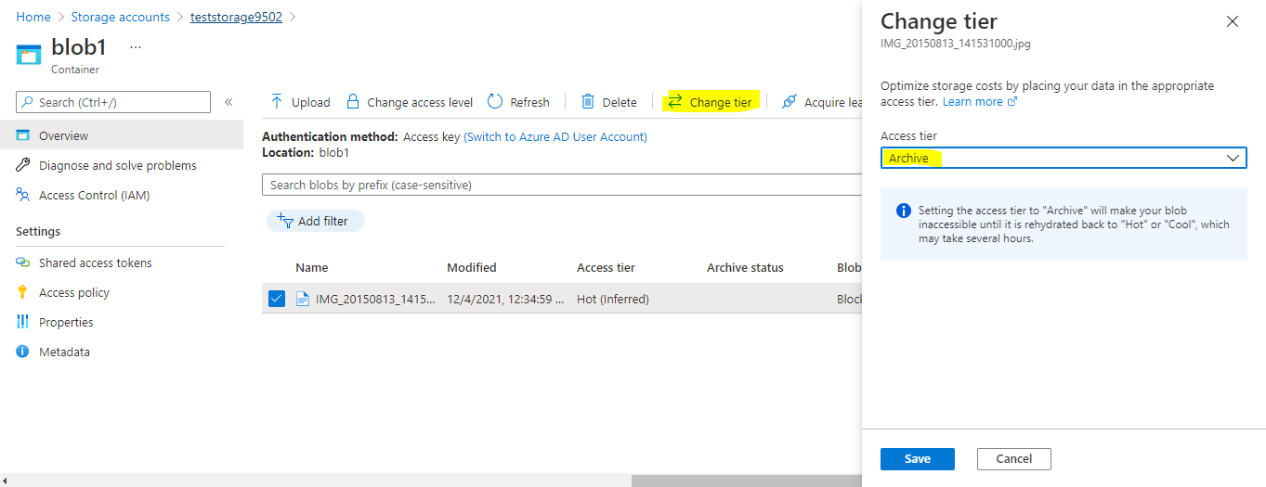

Final Output

