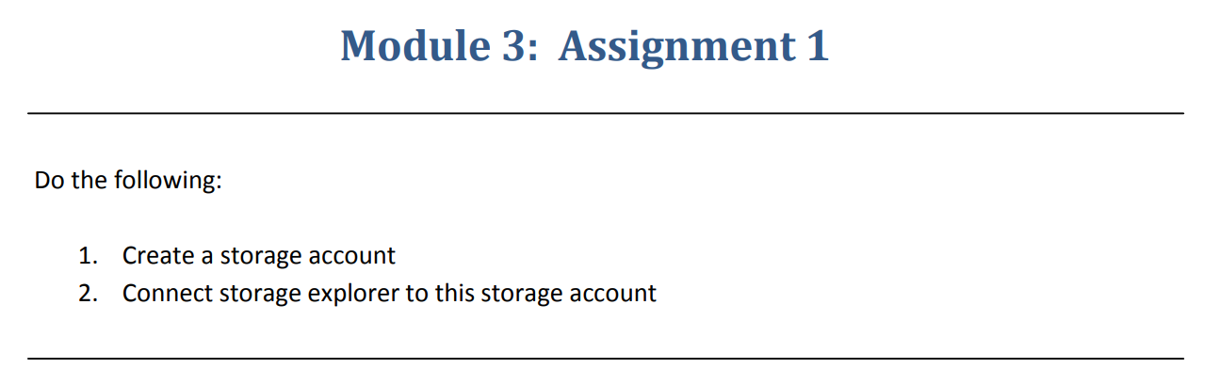

Step 1 :- Created a Storage Account.

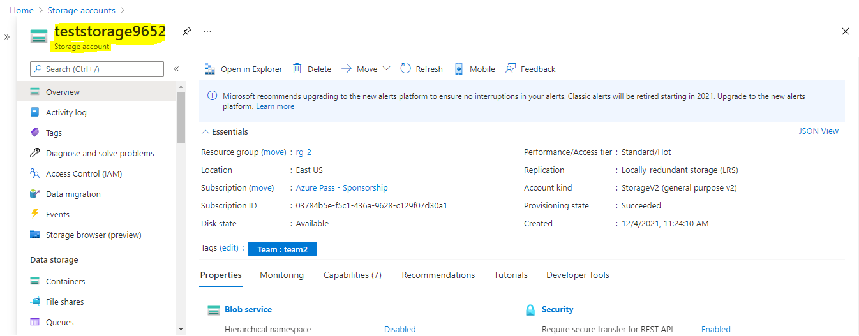

Step 2:- Connected to a Storage explorer .

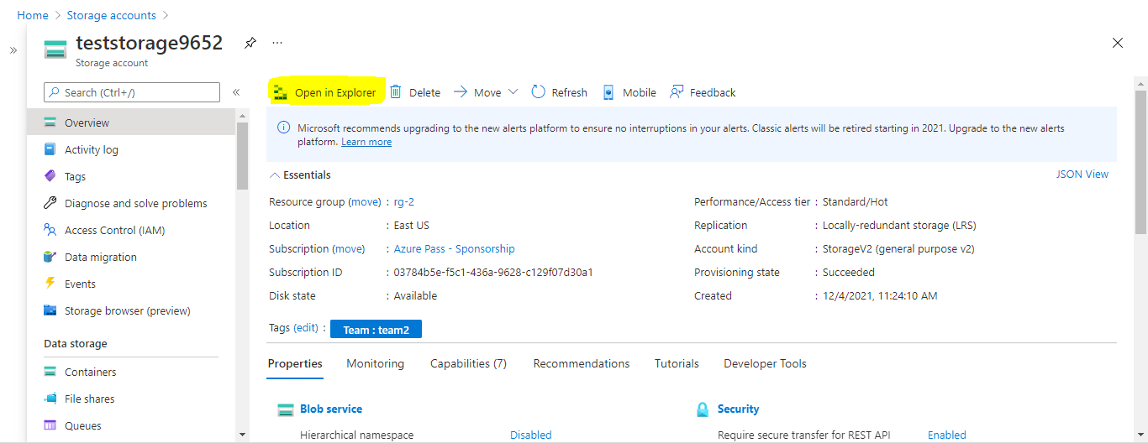

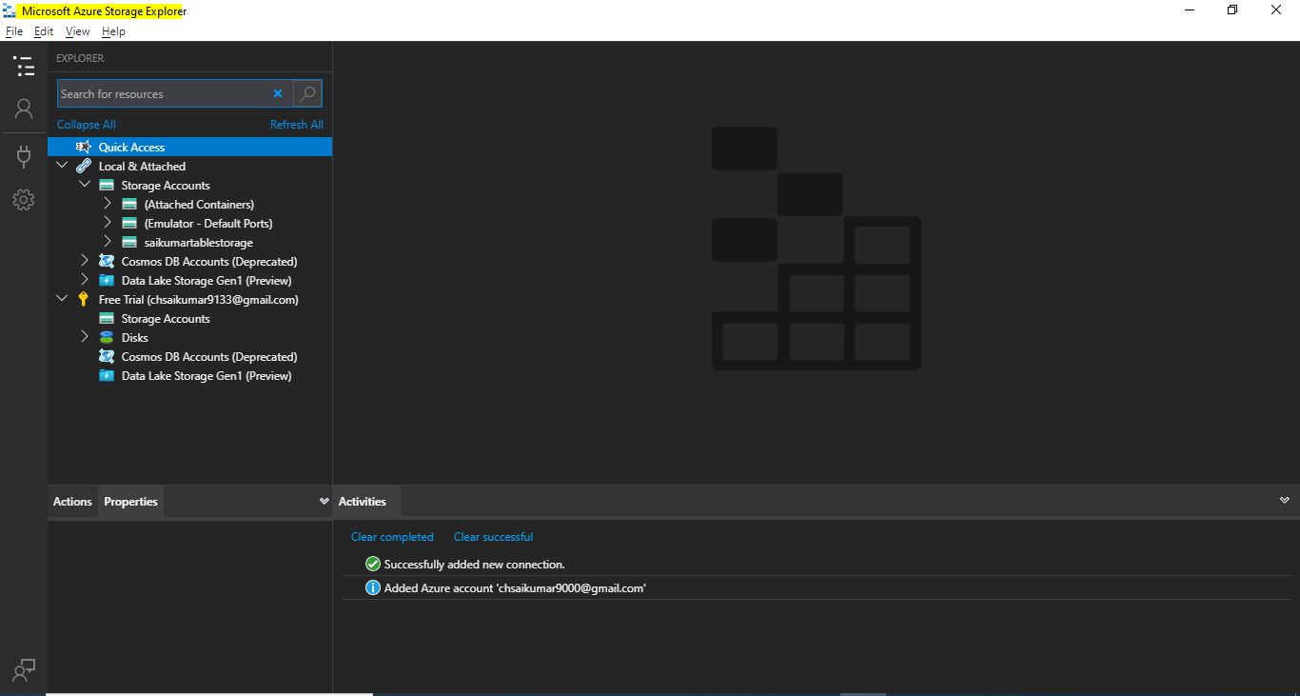

Step 3:- On Microsoft Azure Storage Explorer –Click on Storage accounts and add a storage account to the explorer by using Access keys.

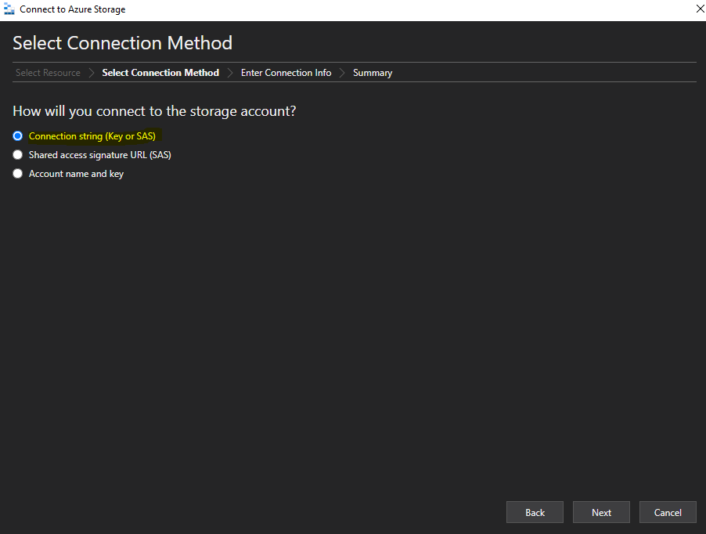

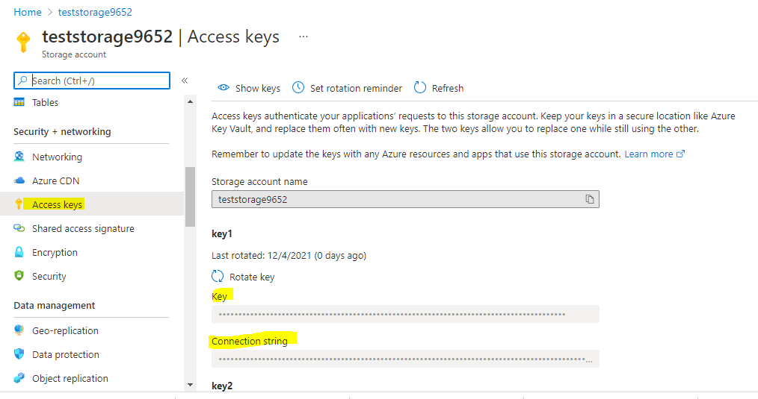

Now the Storage Account is added to explorer

