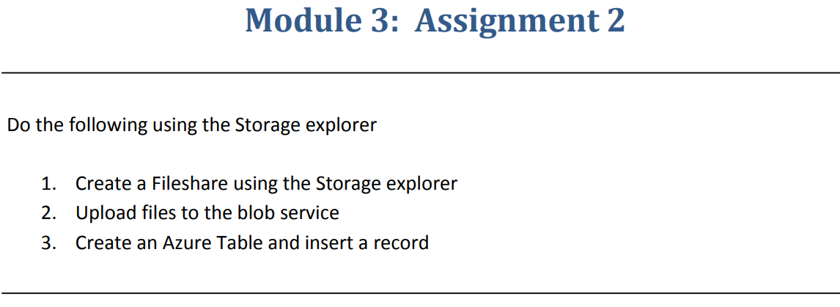

Step 1 :- Created a file share using Storage Explorer.

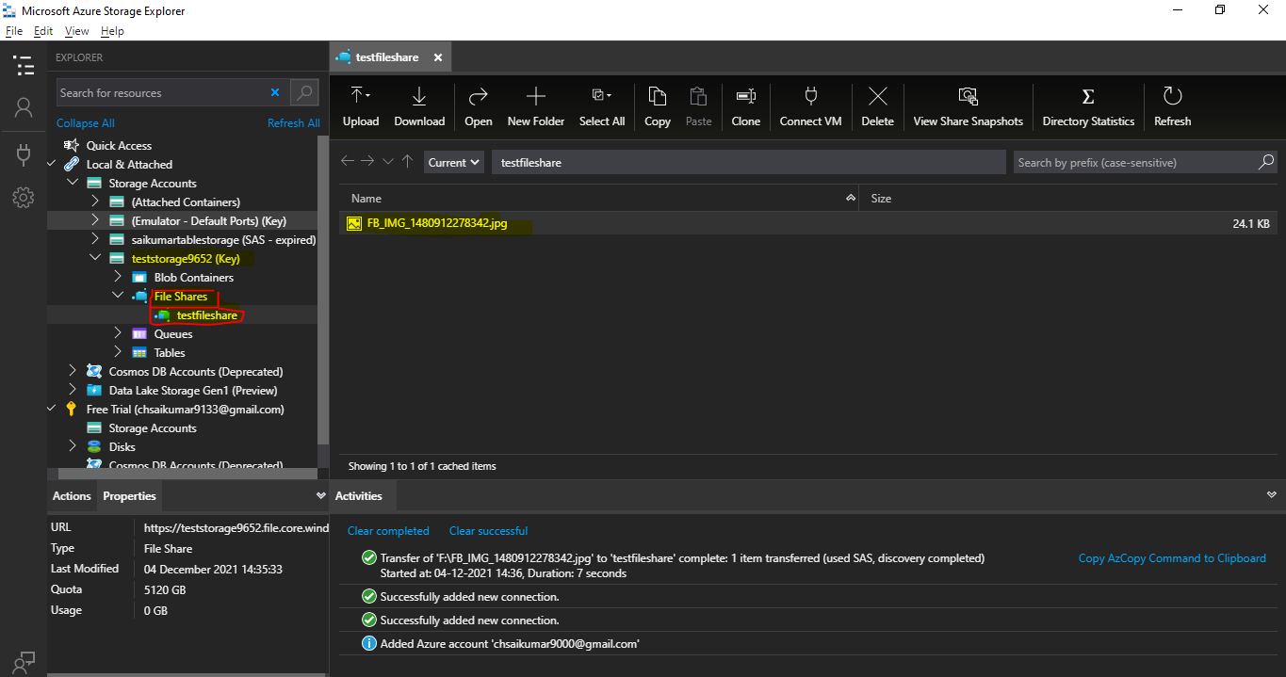

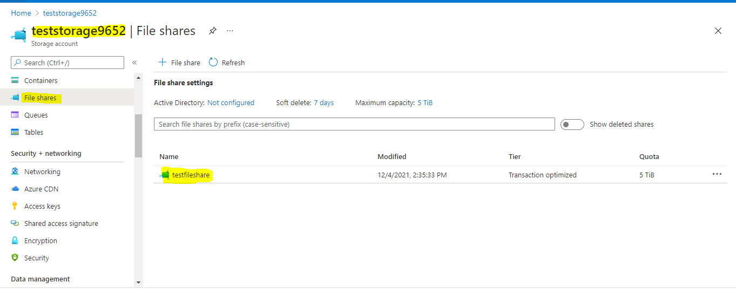

Step 2:- Uploaded the files to blob storage from Storage Explorer.

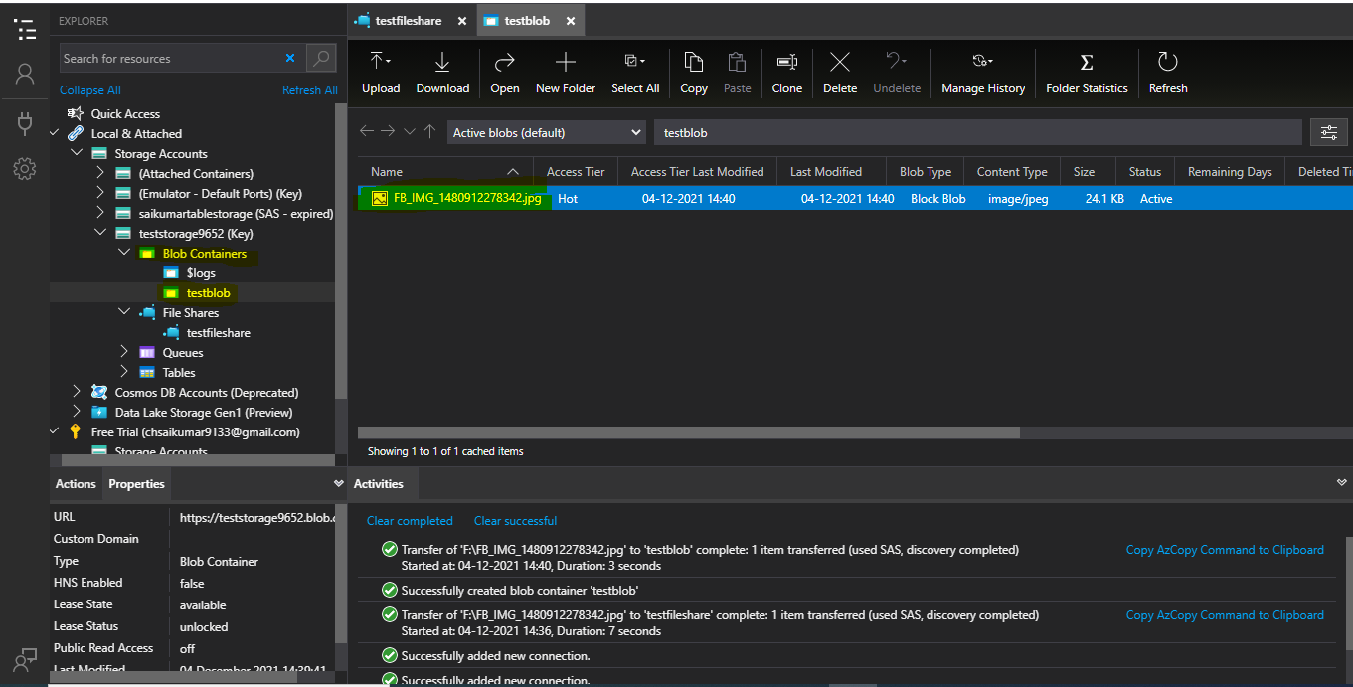

Step 3:- Created a table on Azure portal and connected to Storage Explorer.

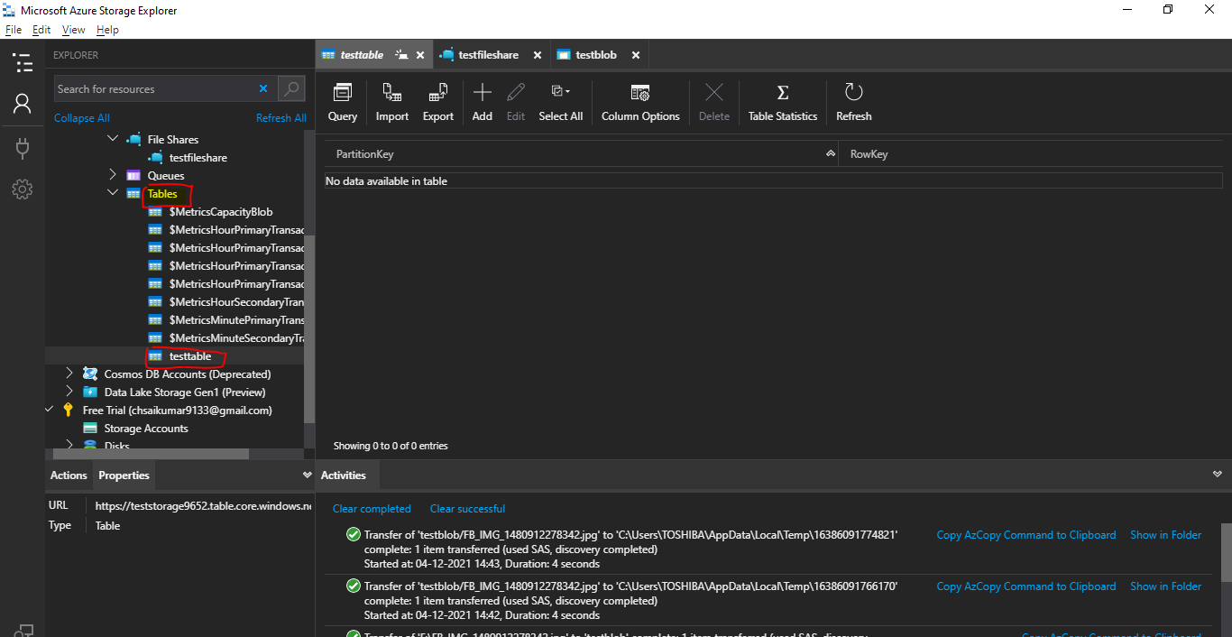

Created a record by Using **Partition Key,RowKey** entities.

