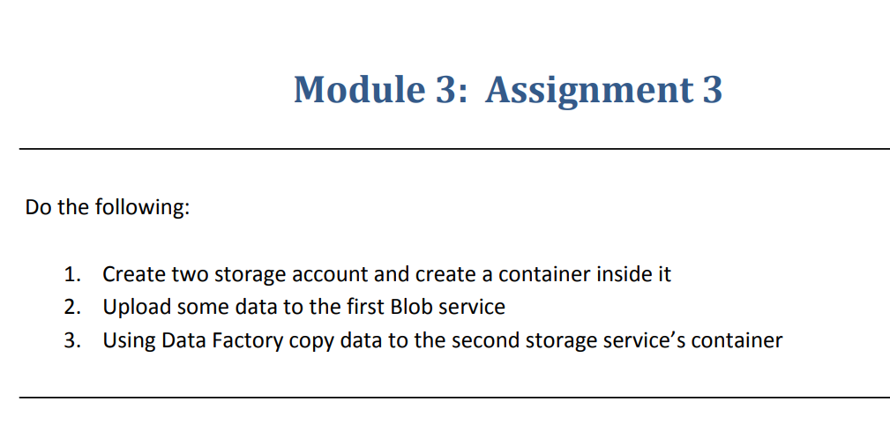

Step 1 :- Created two storage accounts and add a containers in two storage accounts.

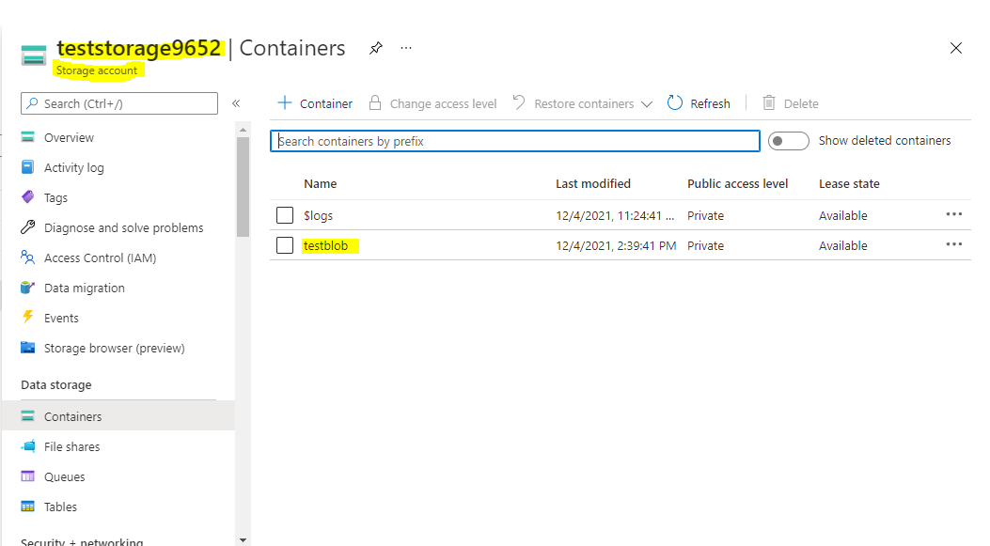

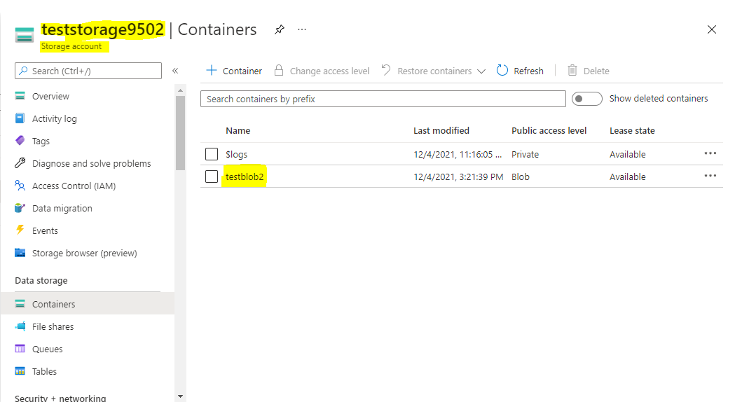

Step 2:- Uploaded some data on to one of the blob storage.

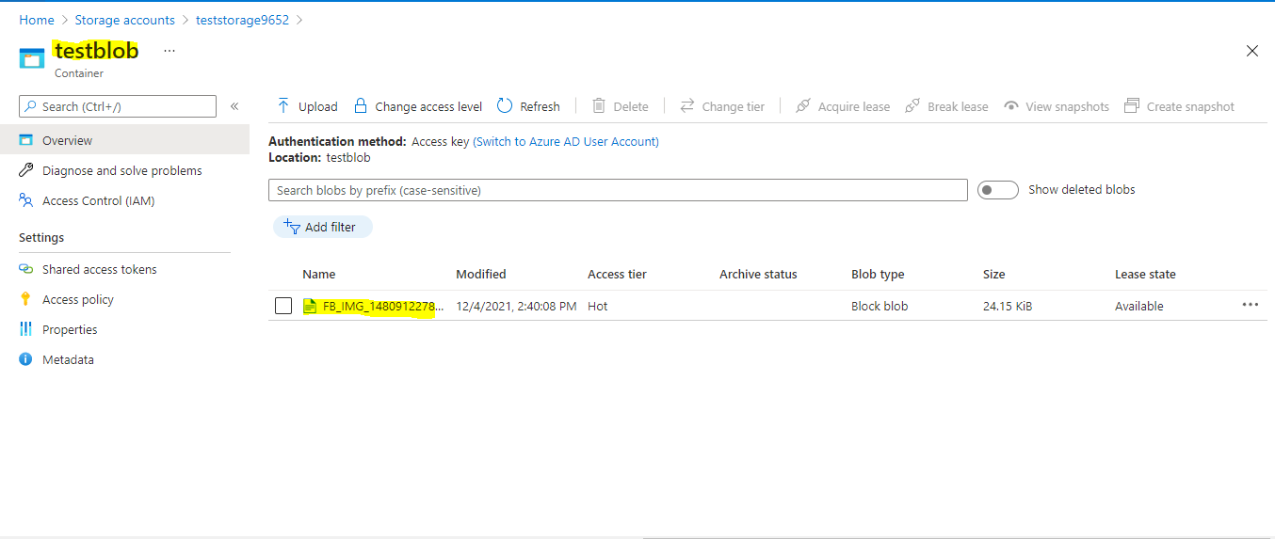

Step 3:- By using Data Factory copy the data to second storage account

Created a data factory

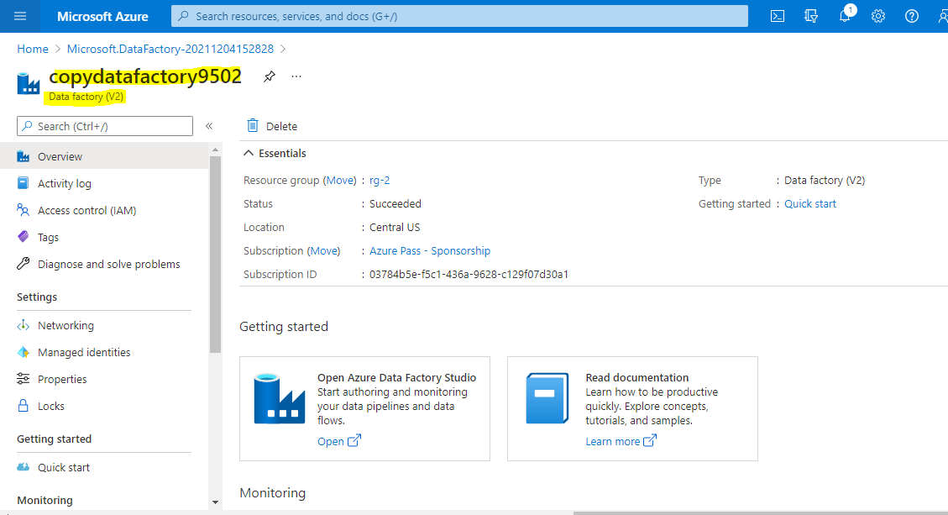

Go to Azure data factory studio.

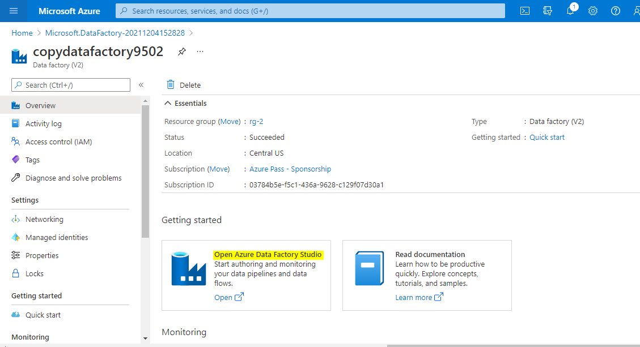

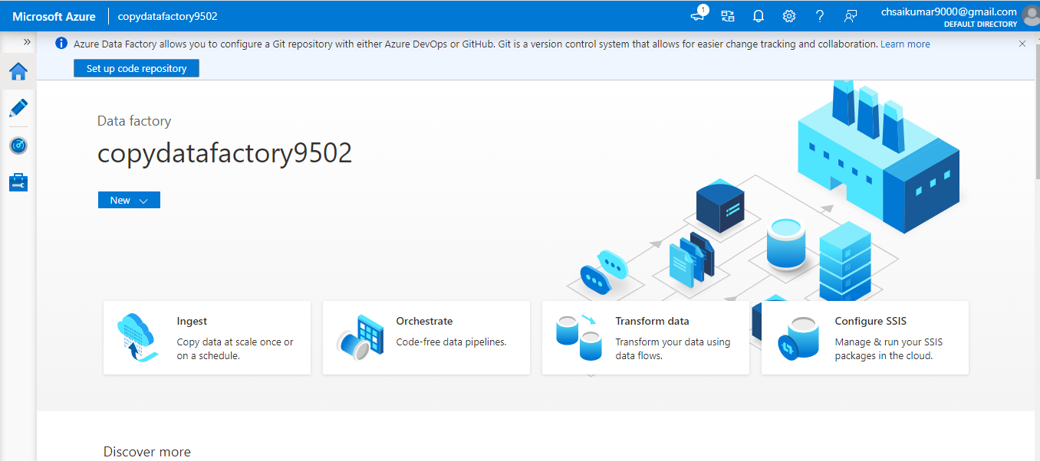

Follow the step by step process where we have to provide source and destination of the data needs to copied.

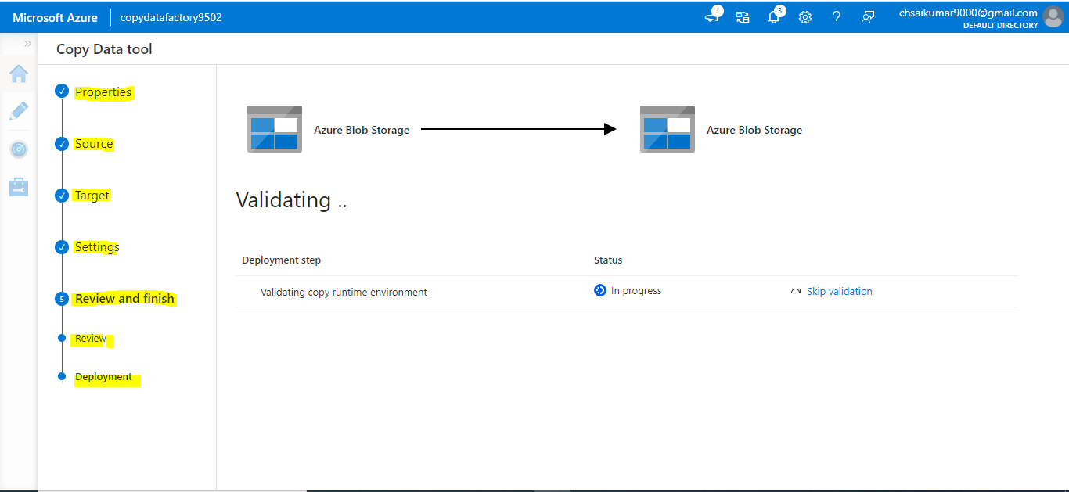

Succesfully copied the data from one storage account to another storage account.

