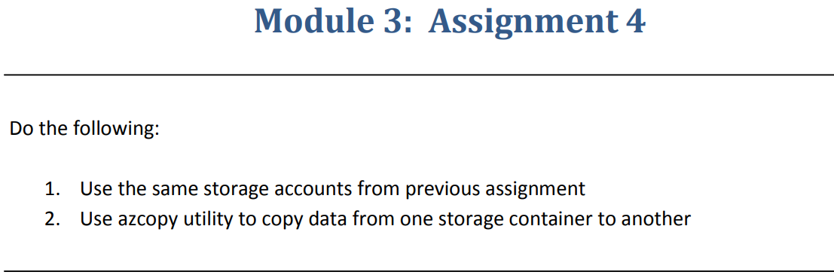

Step 1 :- Created two storage accounts and add a containers in two storage accounts.

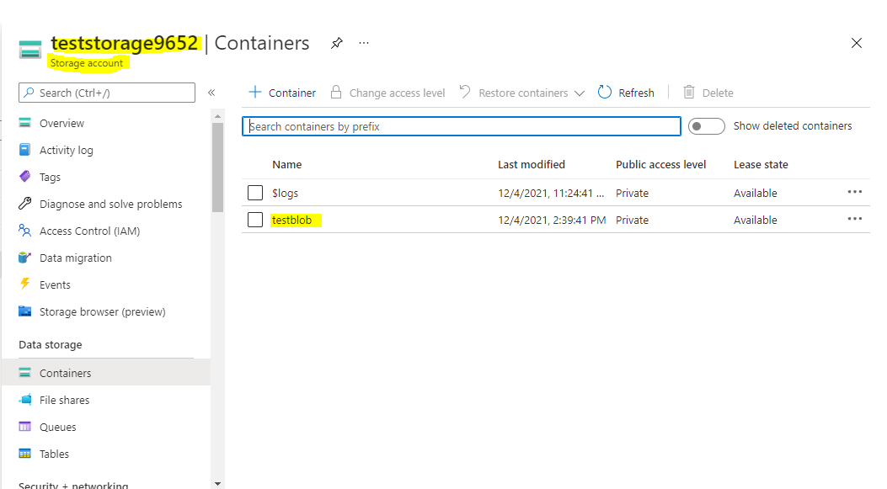

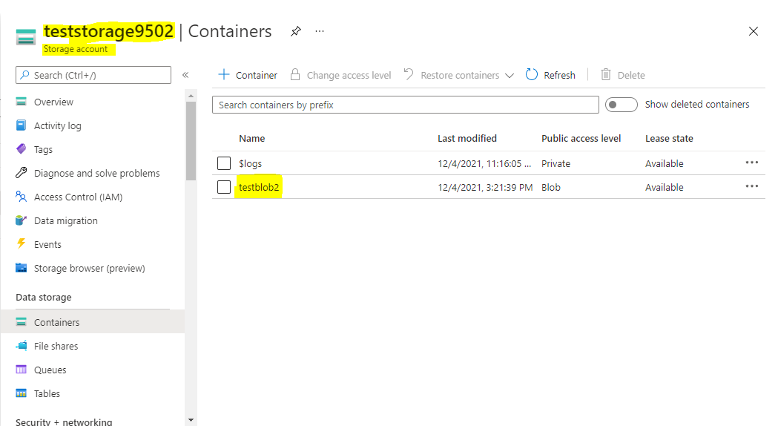

Step 2:- Uploaded some data on to one of the blob storage.

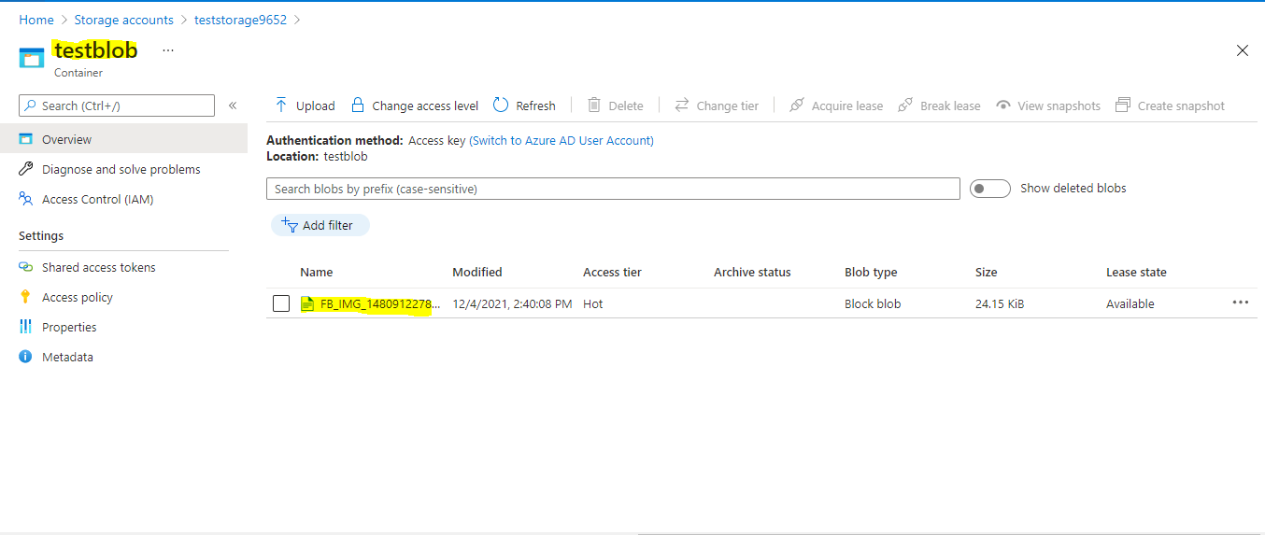

Step 3:- By using AZ copy we have copy the files from one storage account to another storage account

For that we have to generate SAS tokens from both the storage accounts.

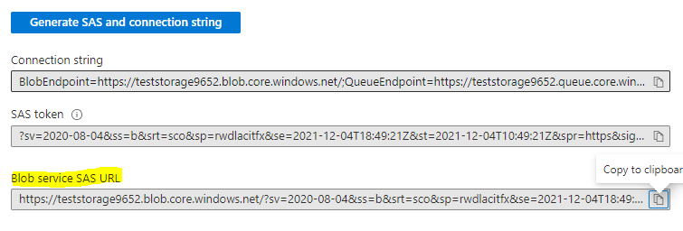

Next we have to install AZ copy from <https://aka.ms/downloadazcopy-v10-windows> site

And open cmd prompt and type cd and copy location where we placed the AZ copy file

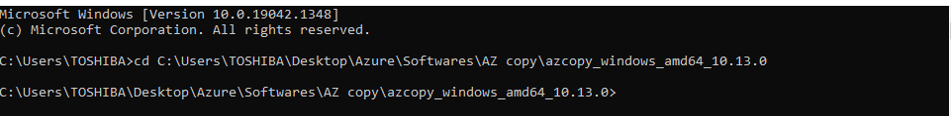

Enter **azcopy login**

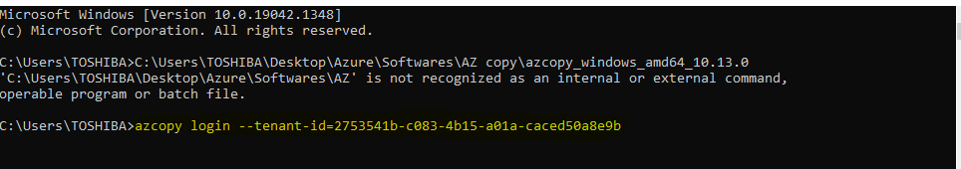

After giving the login it will provide the microsoft URL and passcode by going to the url and enter given passcode then the az copy login is succeseed



After Login succeeded give Azcopy copy “Source SAS token” “Destination SAS token” --recursive

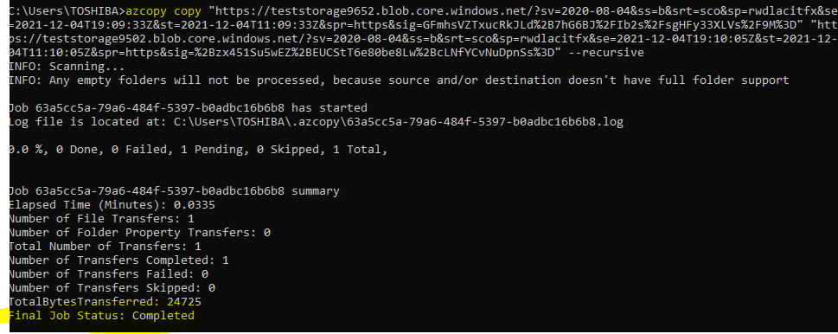

Finally we copied the blob storage from one storage account to another storage account.

