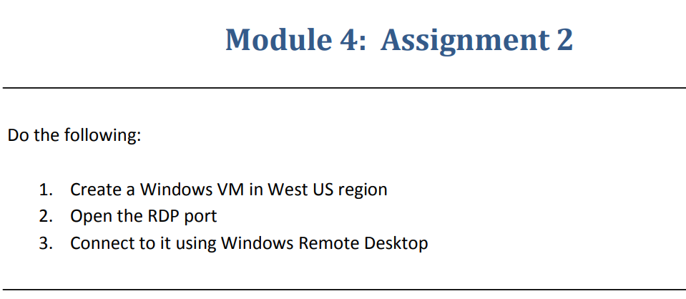

Step-1:-Created VM on **WEST US** region.

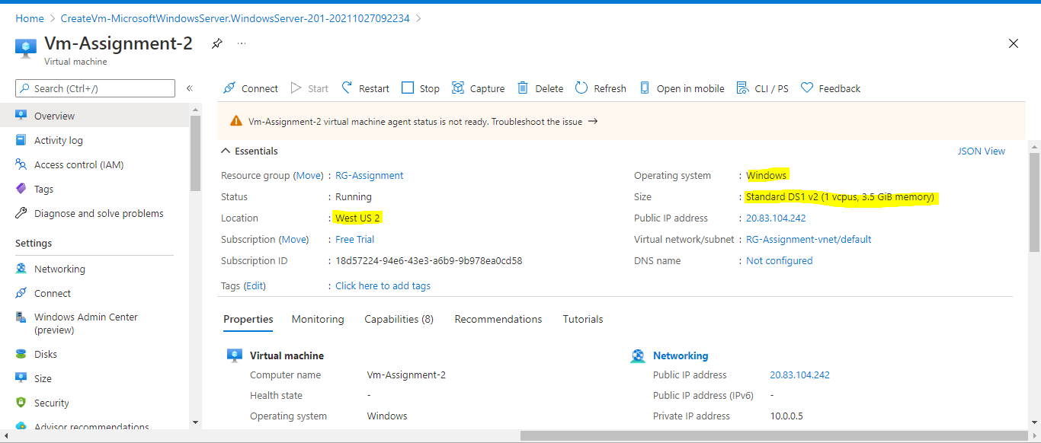

Step-2:-Connected through RDP port.

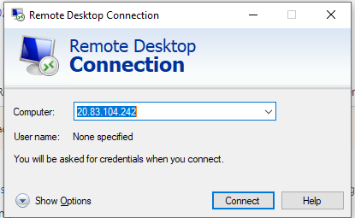

Step-3

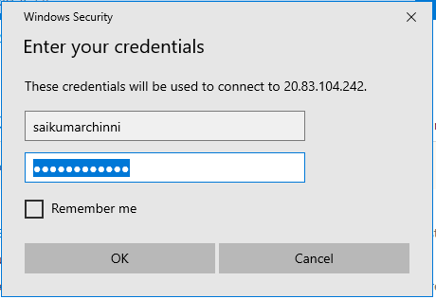

Step-4:-

**Entered into Virtual machine.**