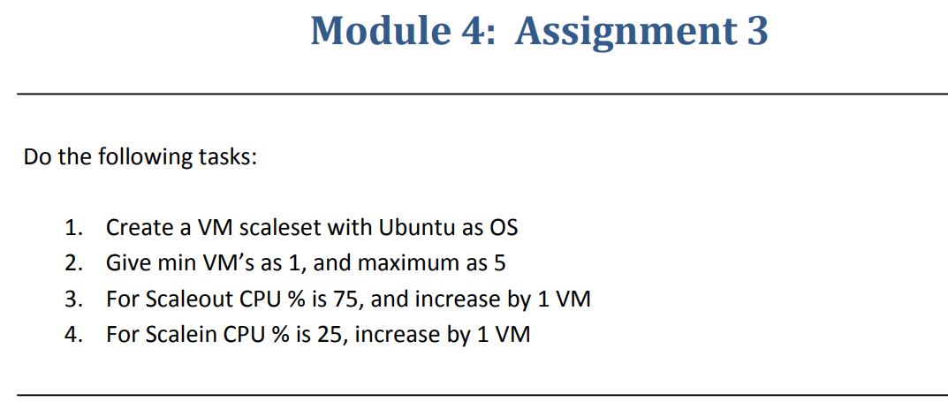

**Step 1**:-Created a VM scale set with Ubuntu OS

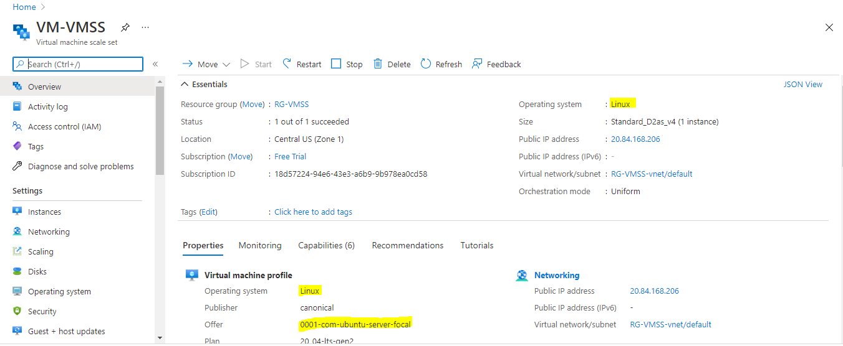

**Step 2**:- Given Min 1 and Max 5 instances.

Given scale out if cpu threshold is 75% and increased by 1 VM.

Given scale in if cpu threshold is 25% and decreased by 1 VM.

